April 2014

’69 CLASS CORRESPONDENT

CAPT Bob Gravino
2 Summer Street
Ipswich, MA 01938
(978) 356-0825 (H)
E-mail: rcgravino@aol.com
Website: http://www.uscga69.org

In Memoriam
Jay MacKenzie Snyder
February 11, 2014

The Class suffered the loss of a good friend and classmate with the death of Jay Snyder. Jay was diagnosed with cancer over 20 years ago. He successfully fought off that first assault and with an excellent treatment plan he had been in remission until recently. A few months ago his health started deteriorating and it was confirmed the cancer had returned. He started a new treatment regime, but his already weakened condition made recovery difficult. He died peacefully on February 11th in Seattle with Jane, son Kirk and daughter Hellie by his side. A prayer service and eulogy was held on February 21st at St. Luke Catholic Church in Shoreline, Washington, for west coast family and friends. A Mass of Christian Burial took place at St. John Neumann Catholic Church in Reston, Virginia, on March 6th, and burial/inurnment will be at Arlington National Cemetery at a later date.

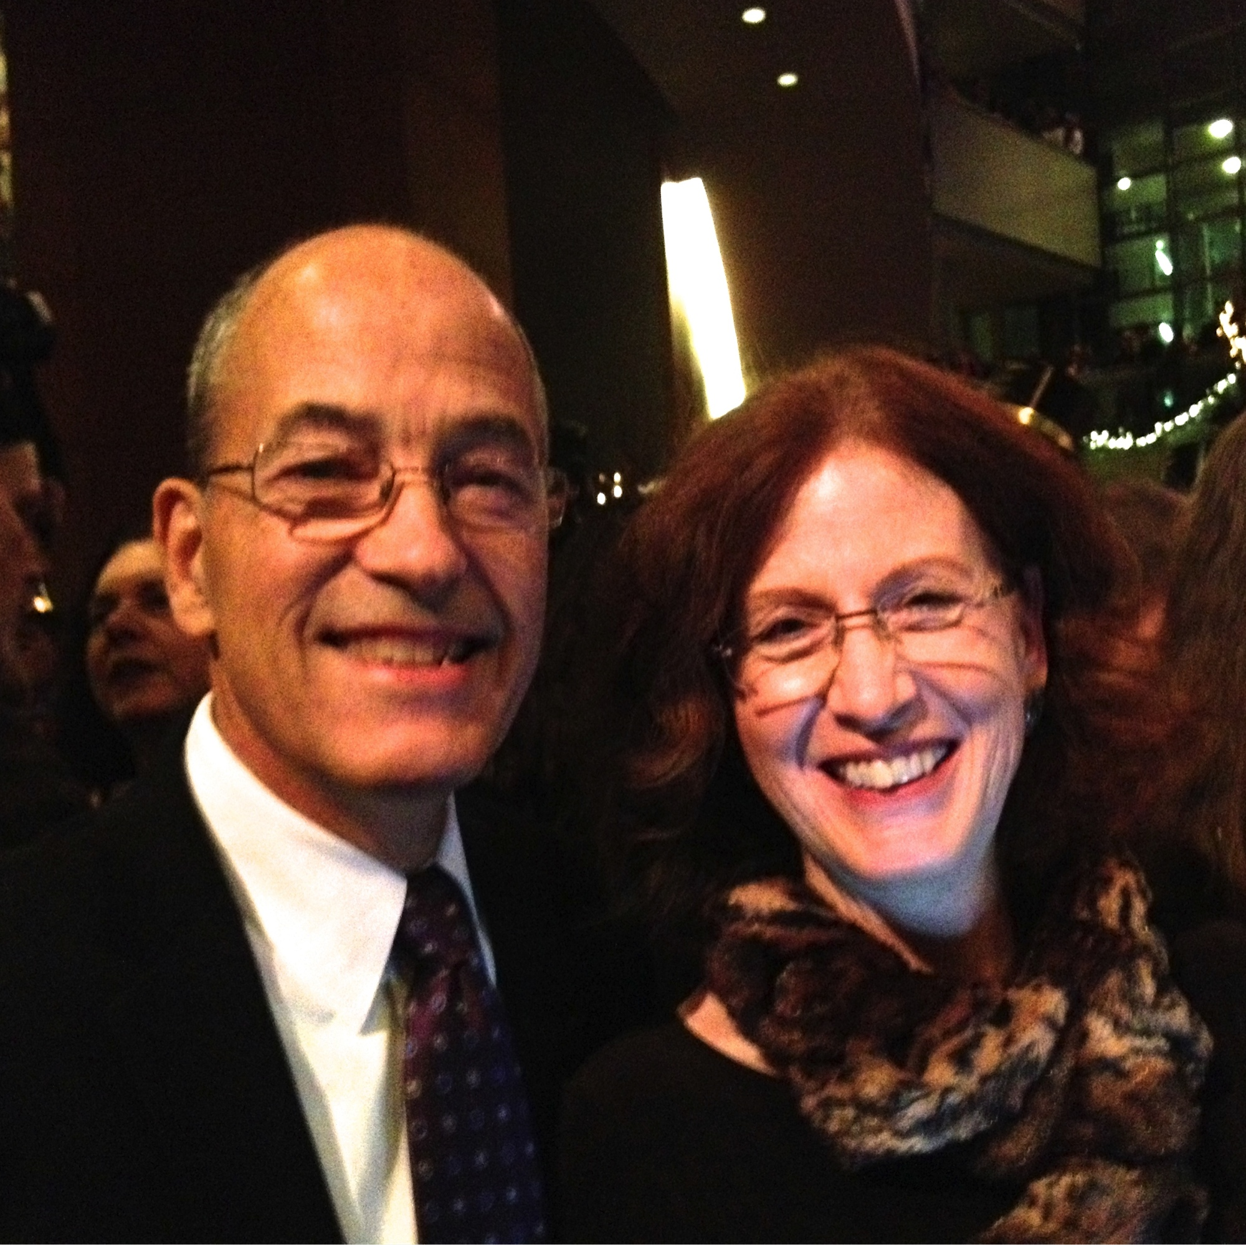

1969: Jay & Jane Snyder

This year is the 75th Anniversary of The Bulletin, and the column will recognize and thank four classmates who have kept the class connected since our graduation 45 years ago.
Wayne Gronlund was our first class correspondent and wrote this column for many years before passing the torch at our 20th Class Reunion. Wayne and Becky have also been key players in organizing class reunions.

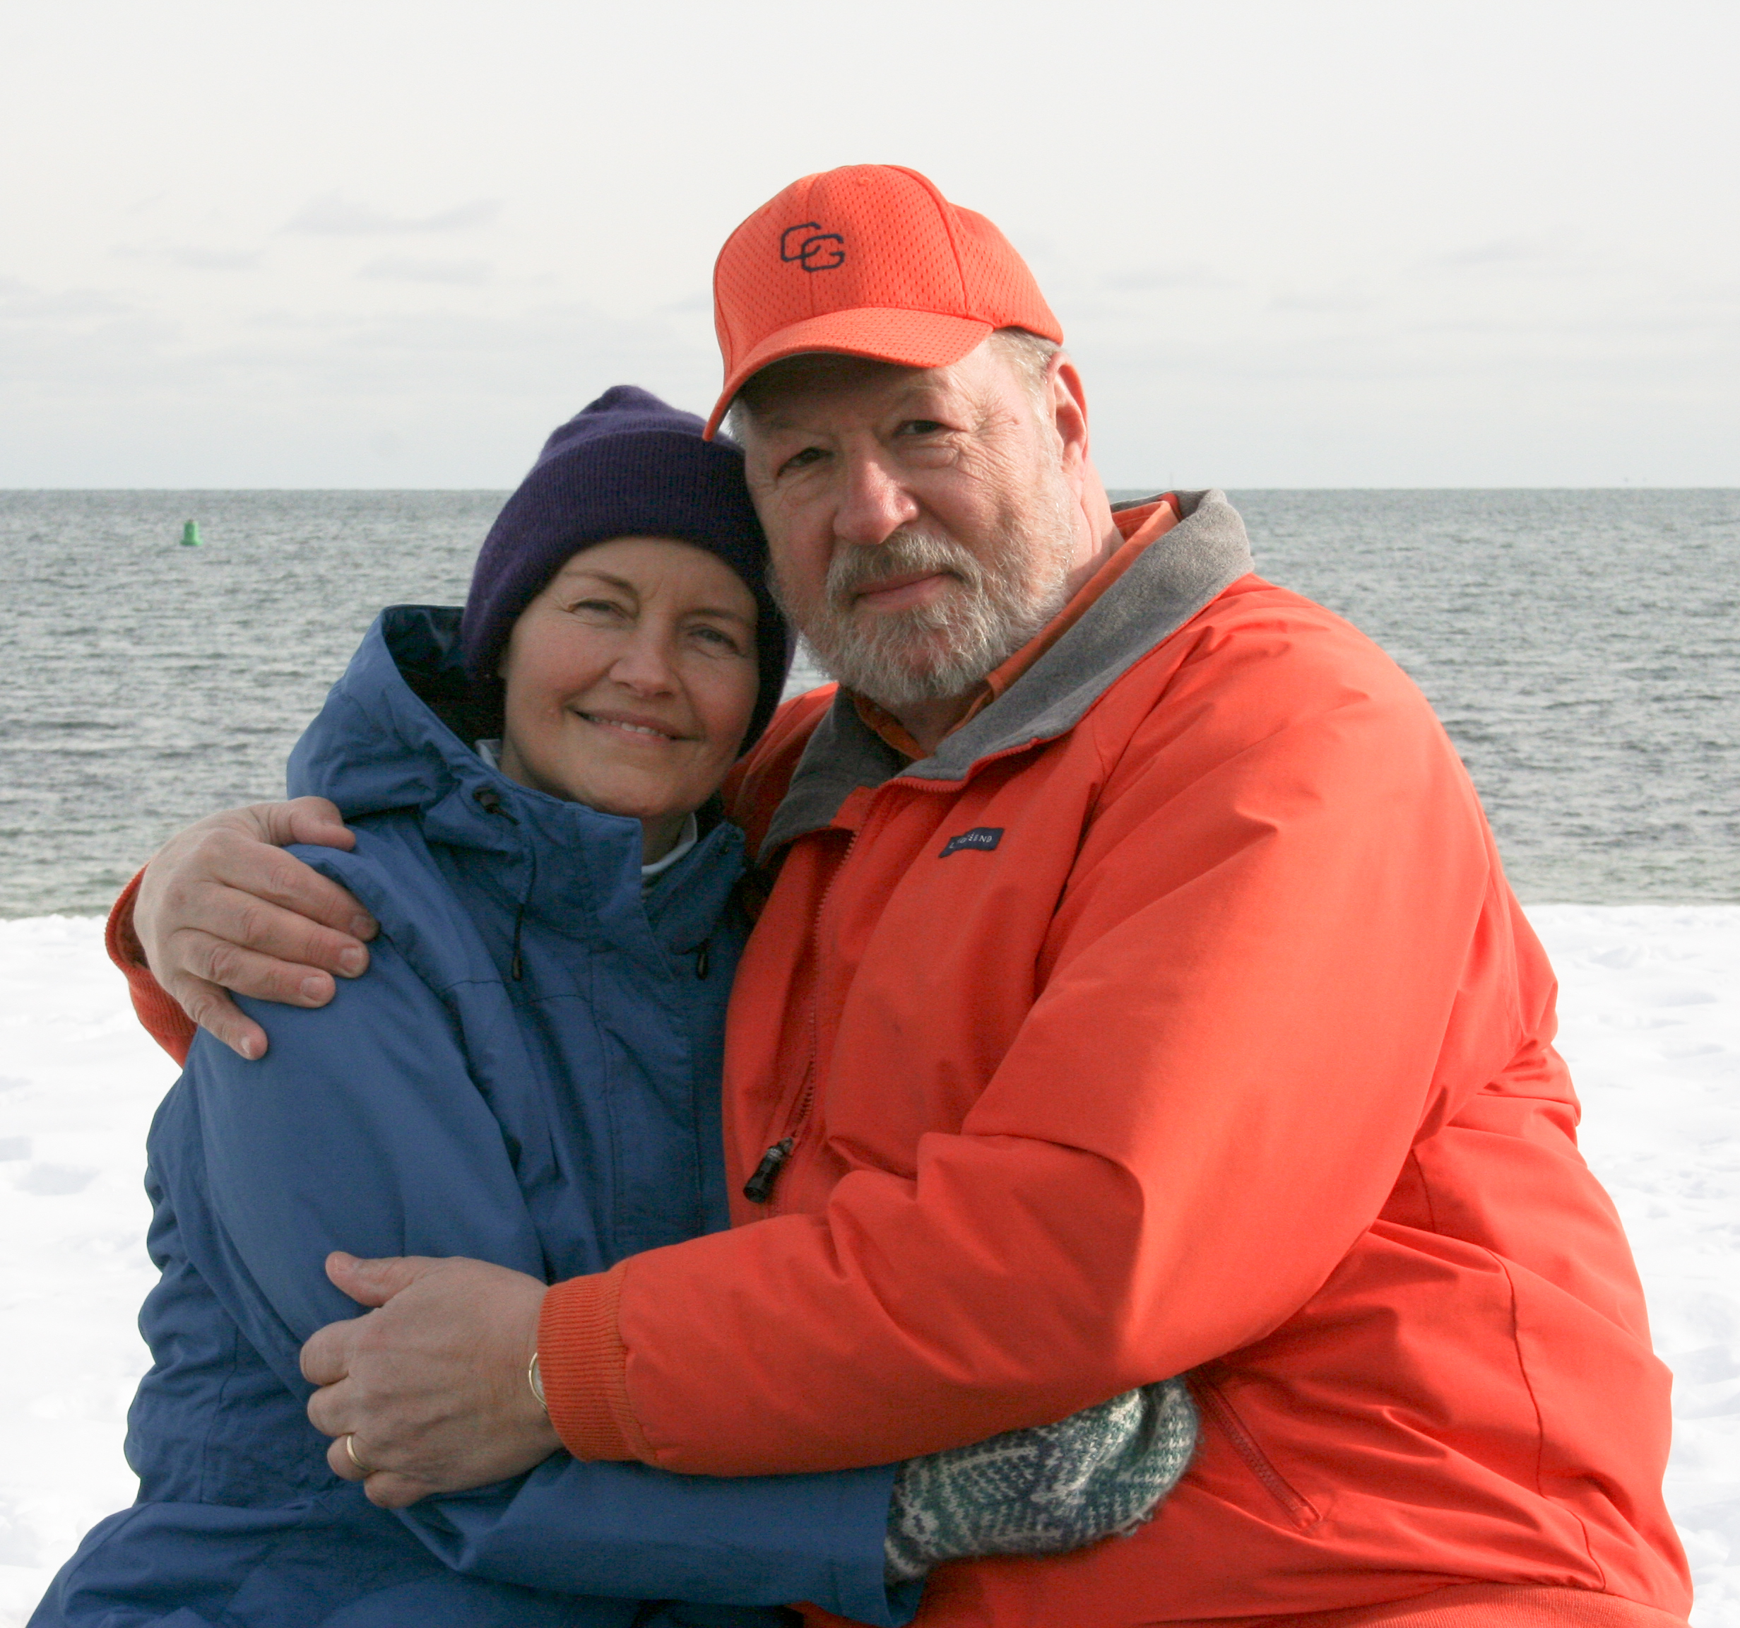

1969: Wayne & Becky Gronlund

Chris Kreiler has been the Class of 1969 web master since he built the site in 1998, allowing classmates to maintain contact with each other and providing current information on our activities and events.

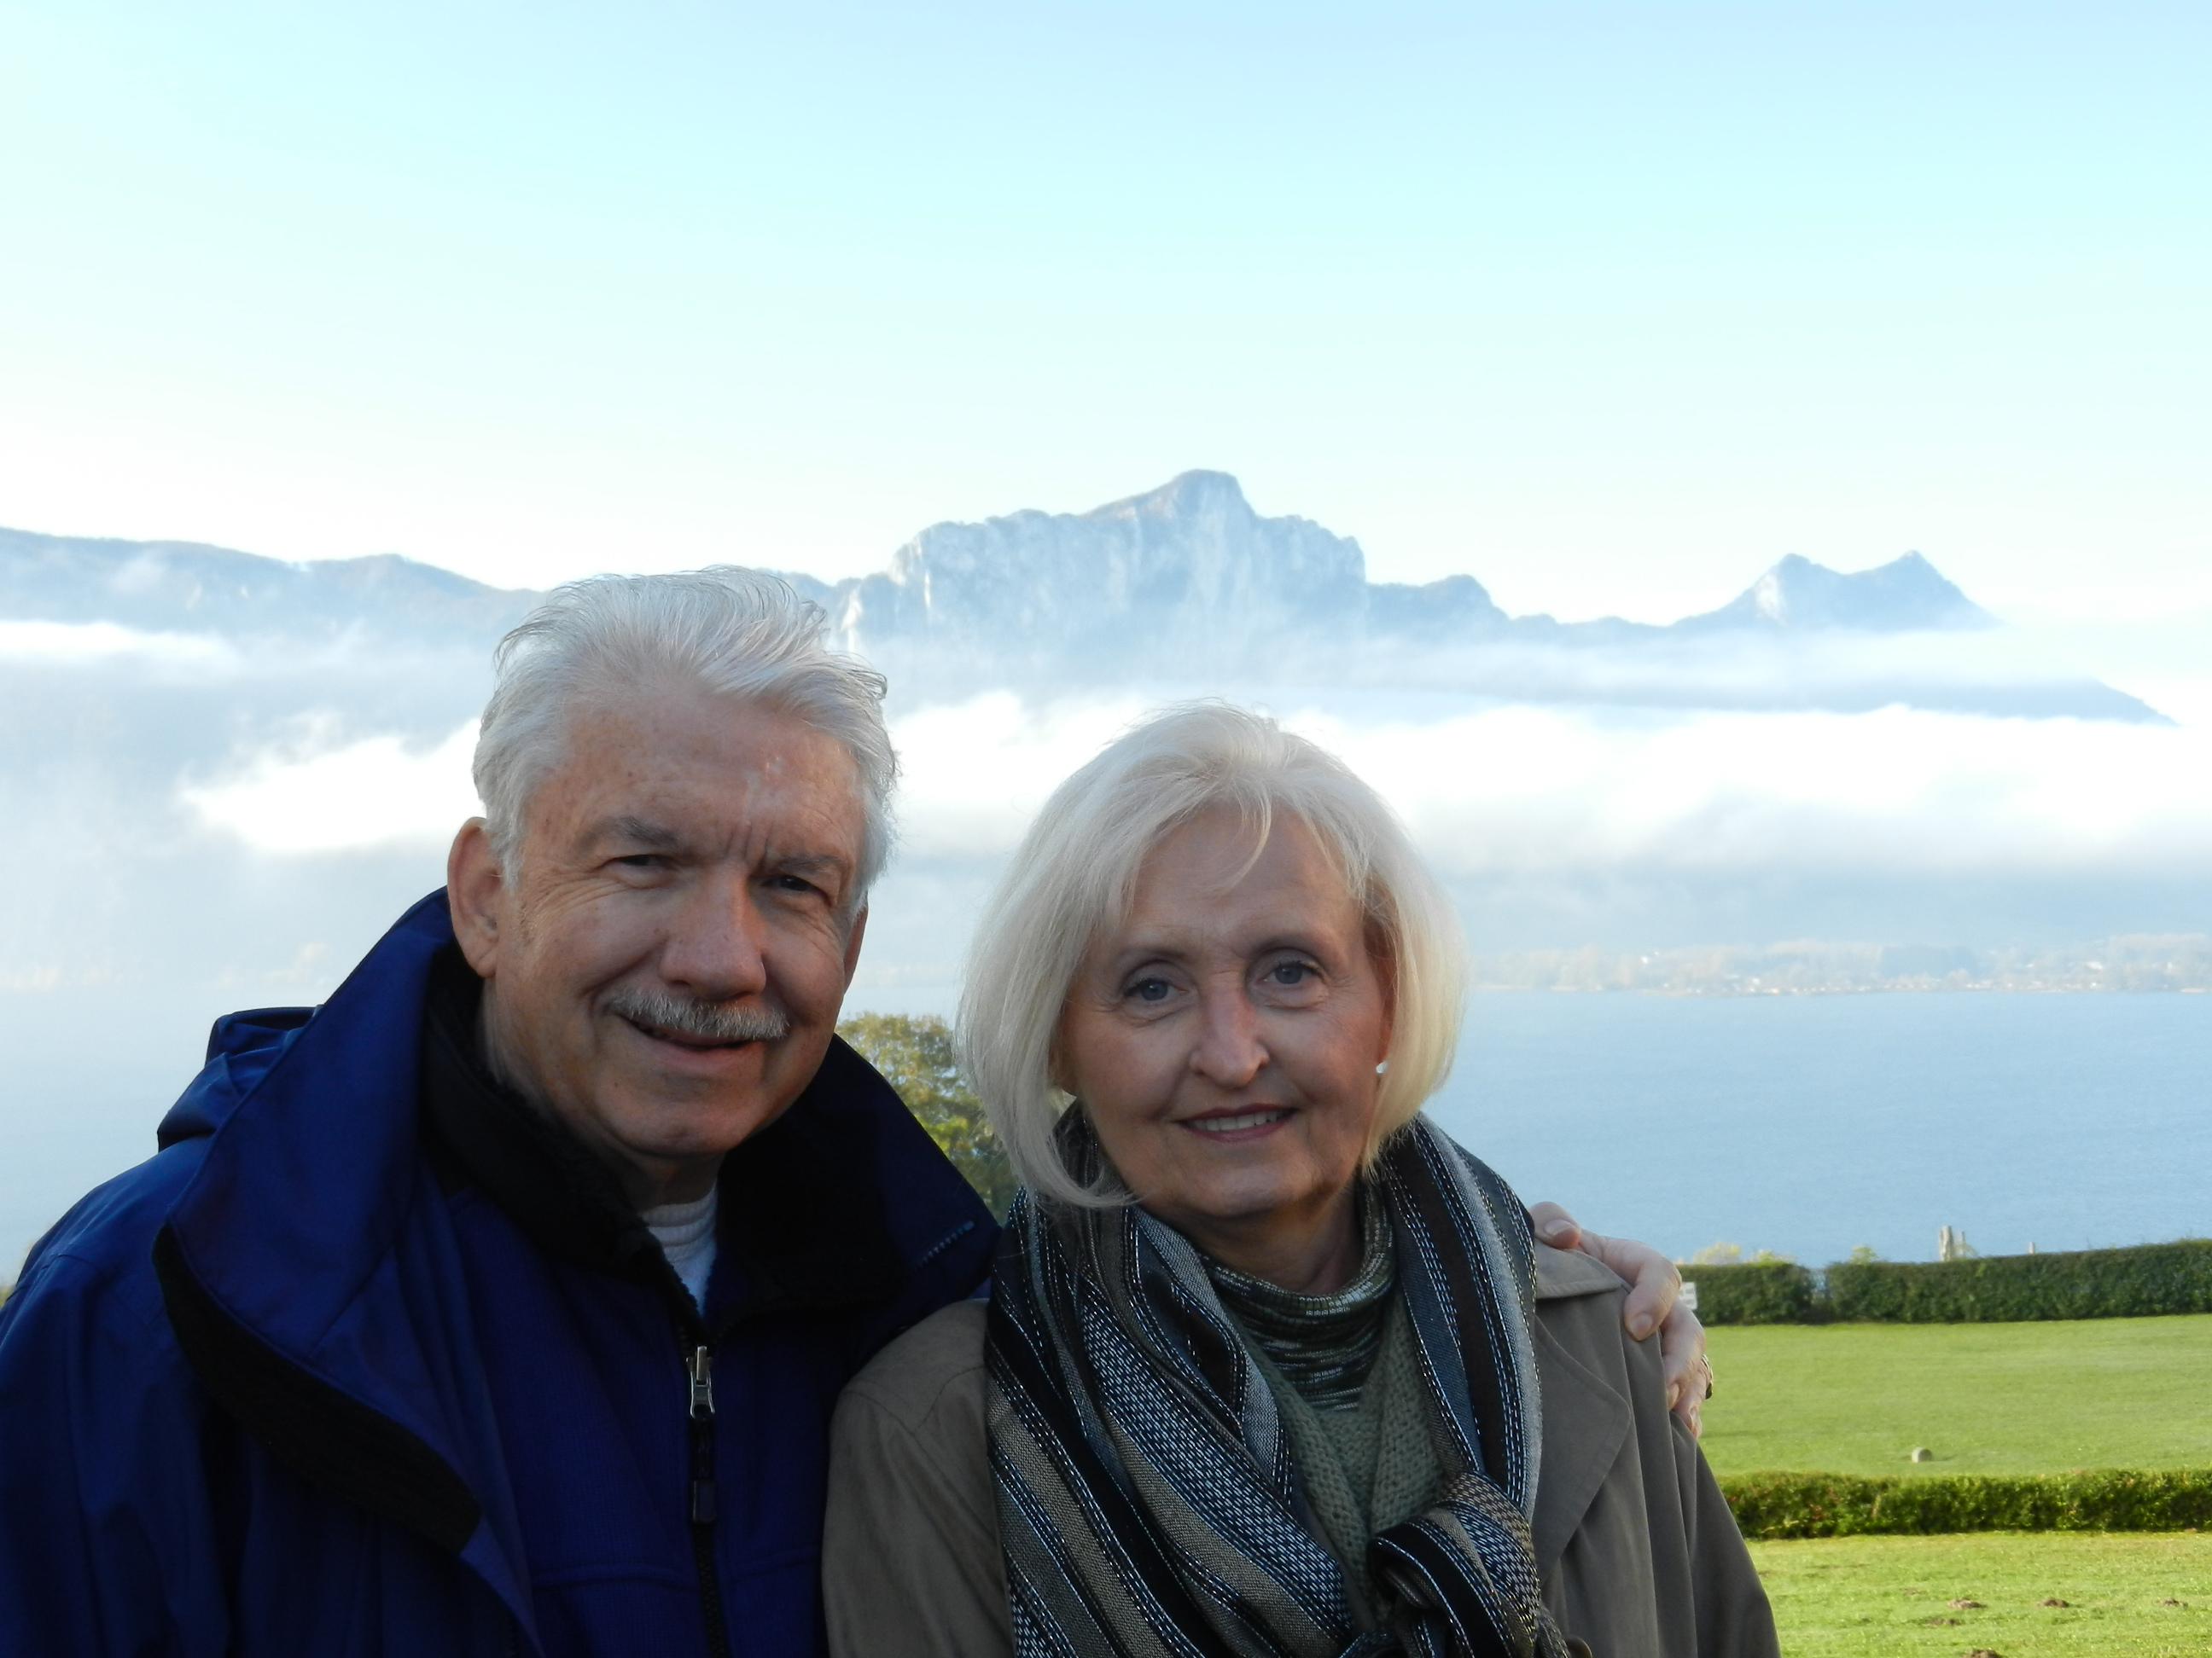

1969: Chris & Judy Kreiler

John and Lesley Miner have organized class cruises over the years, the first being a cruise to Bermuda from New York City in 1989, following our 20th year Reunion. They have also been an excellent source for Class Notes articles from the Tidewater area and the Class golf network.

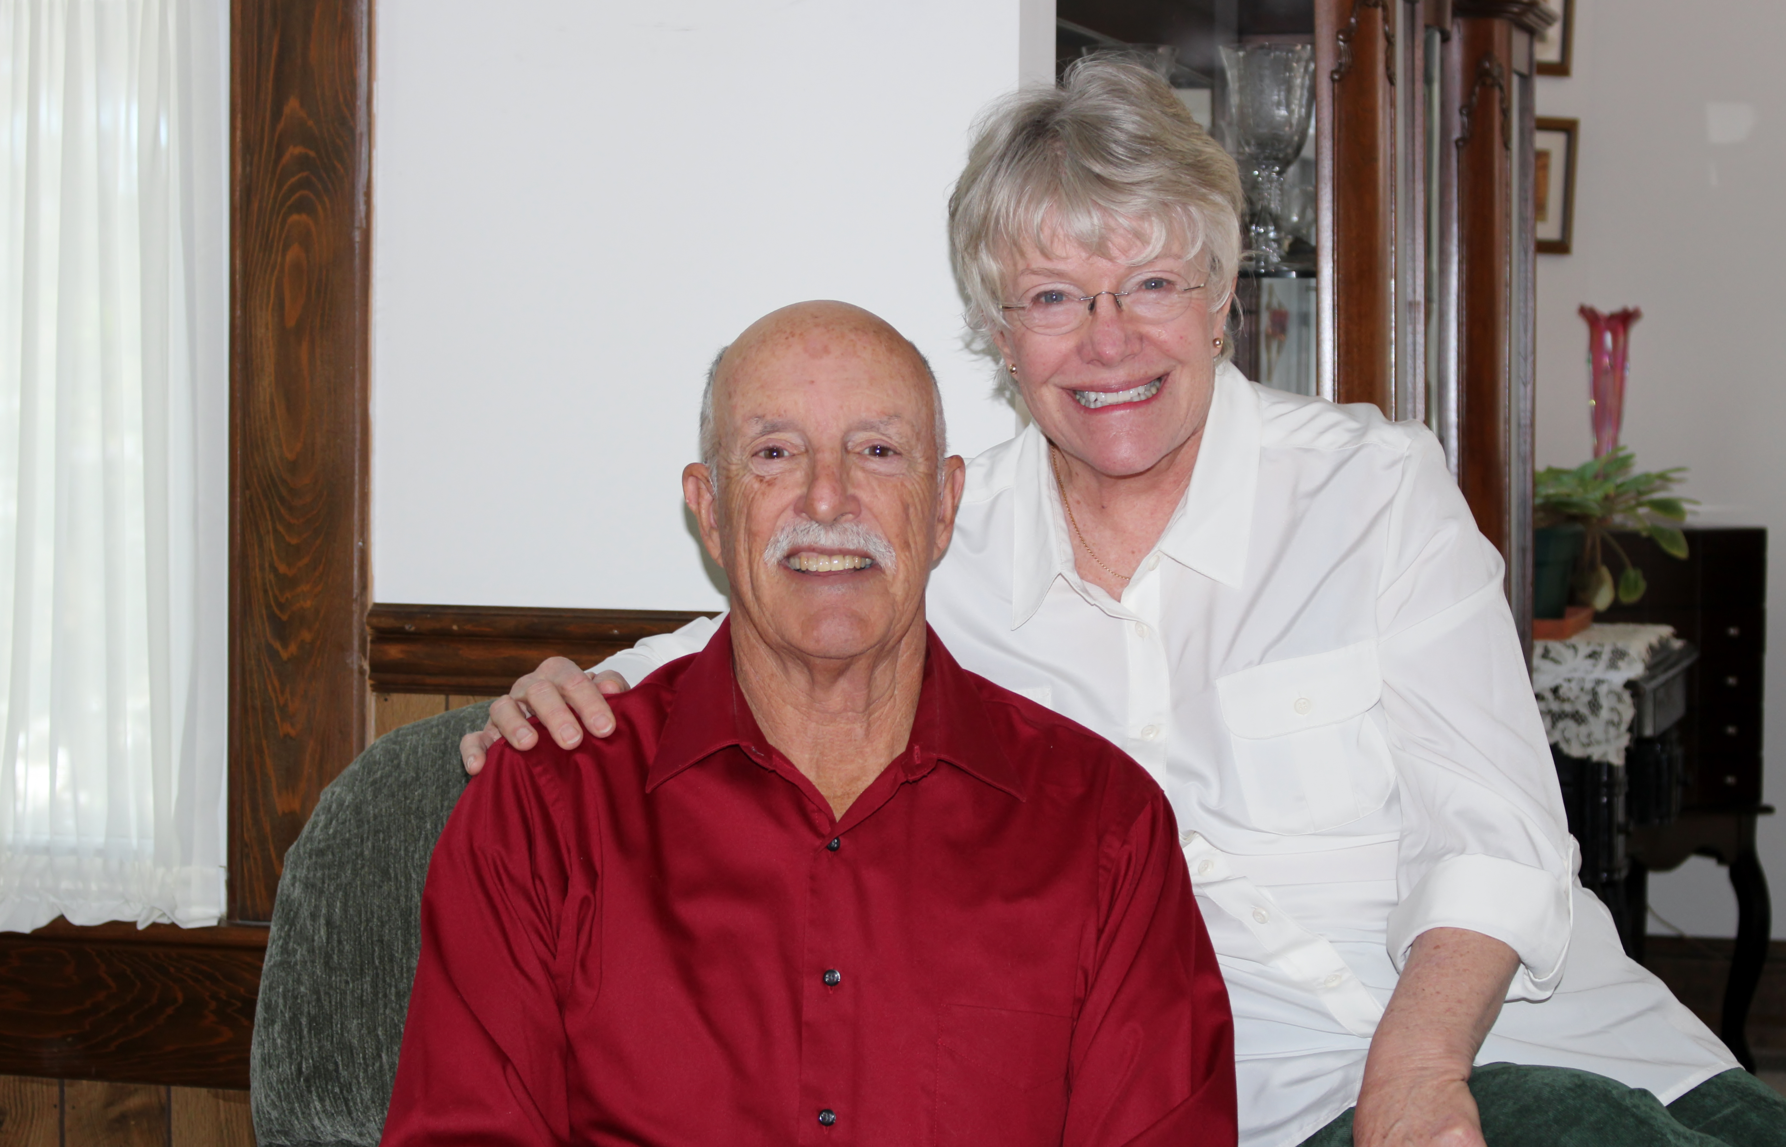

1969: John & Lesley Miner

Bob and Barbara Thorne planned and organized our class reunions, working out details, liaising with the Alumni Association staff, and ensuring that all the bases were covered. Memorable reunions are attributable to their efforts.

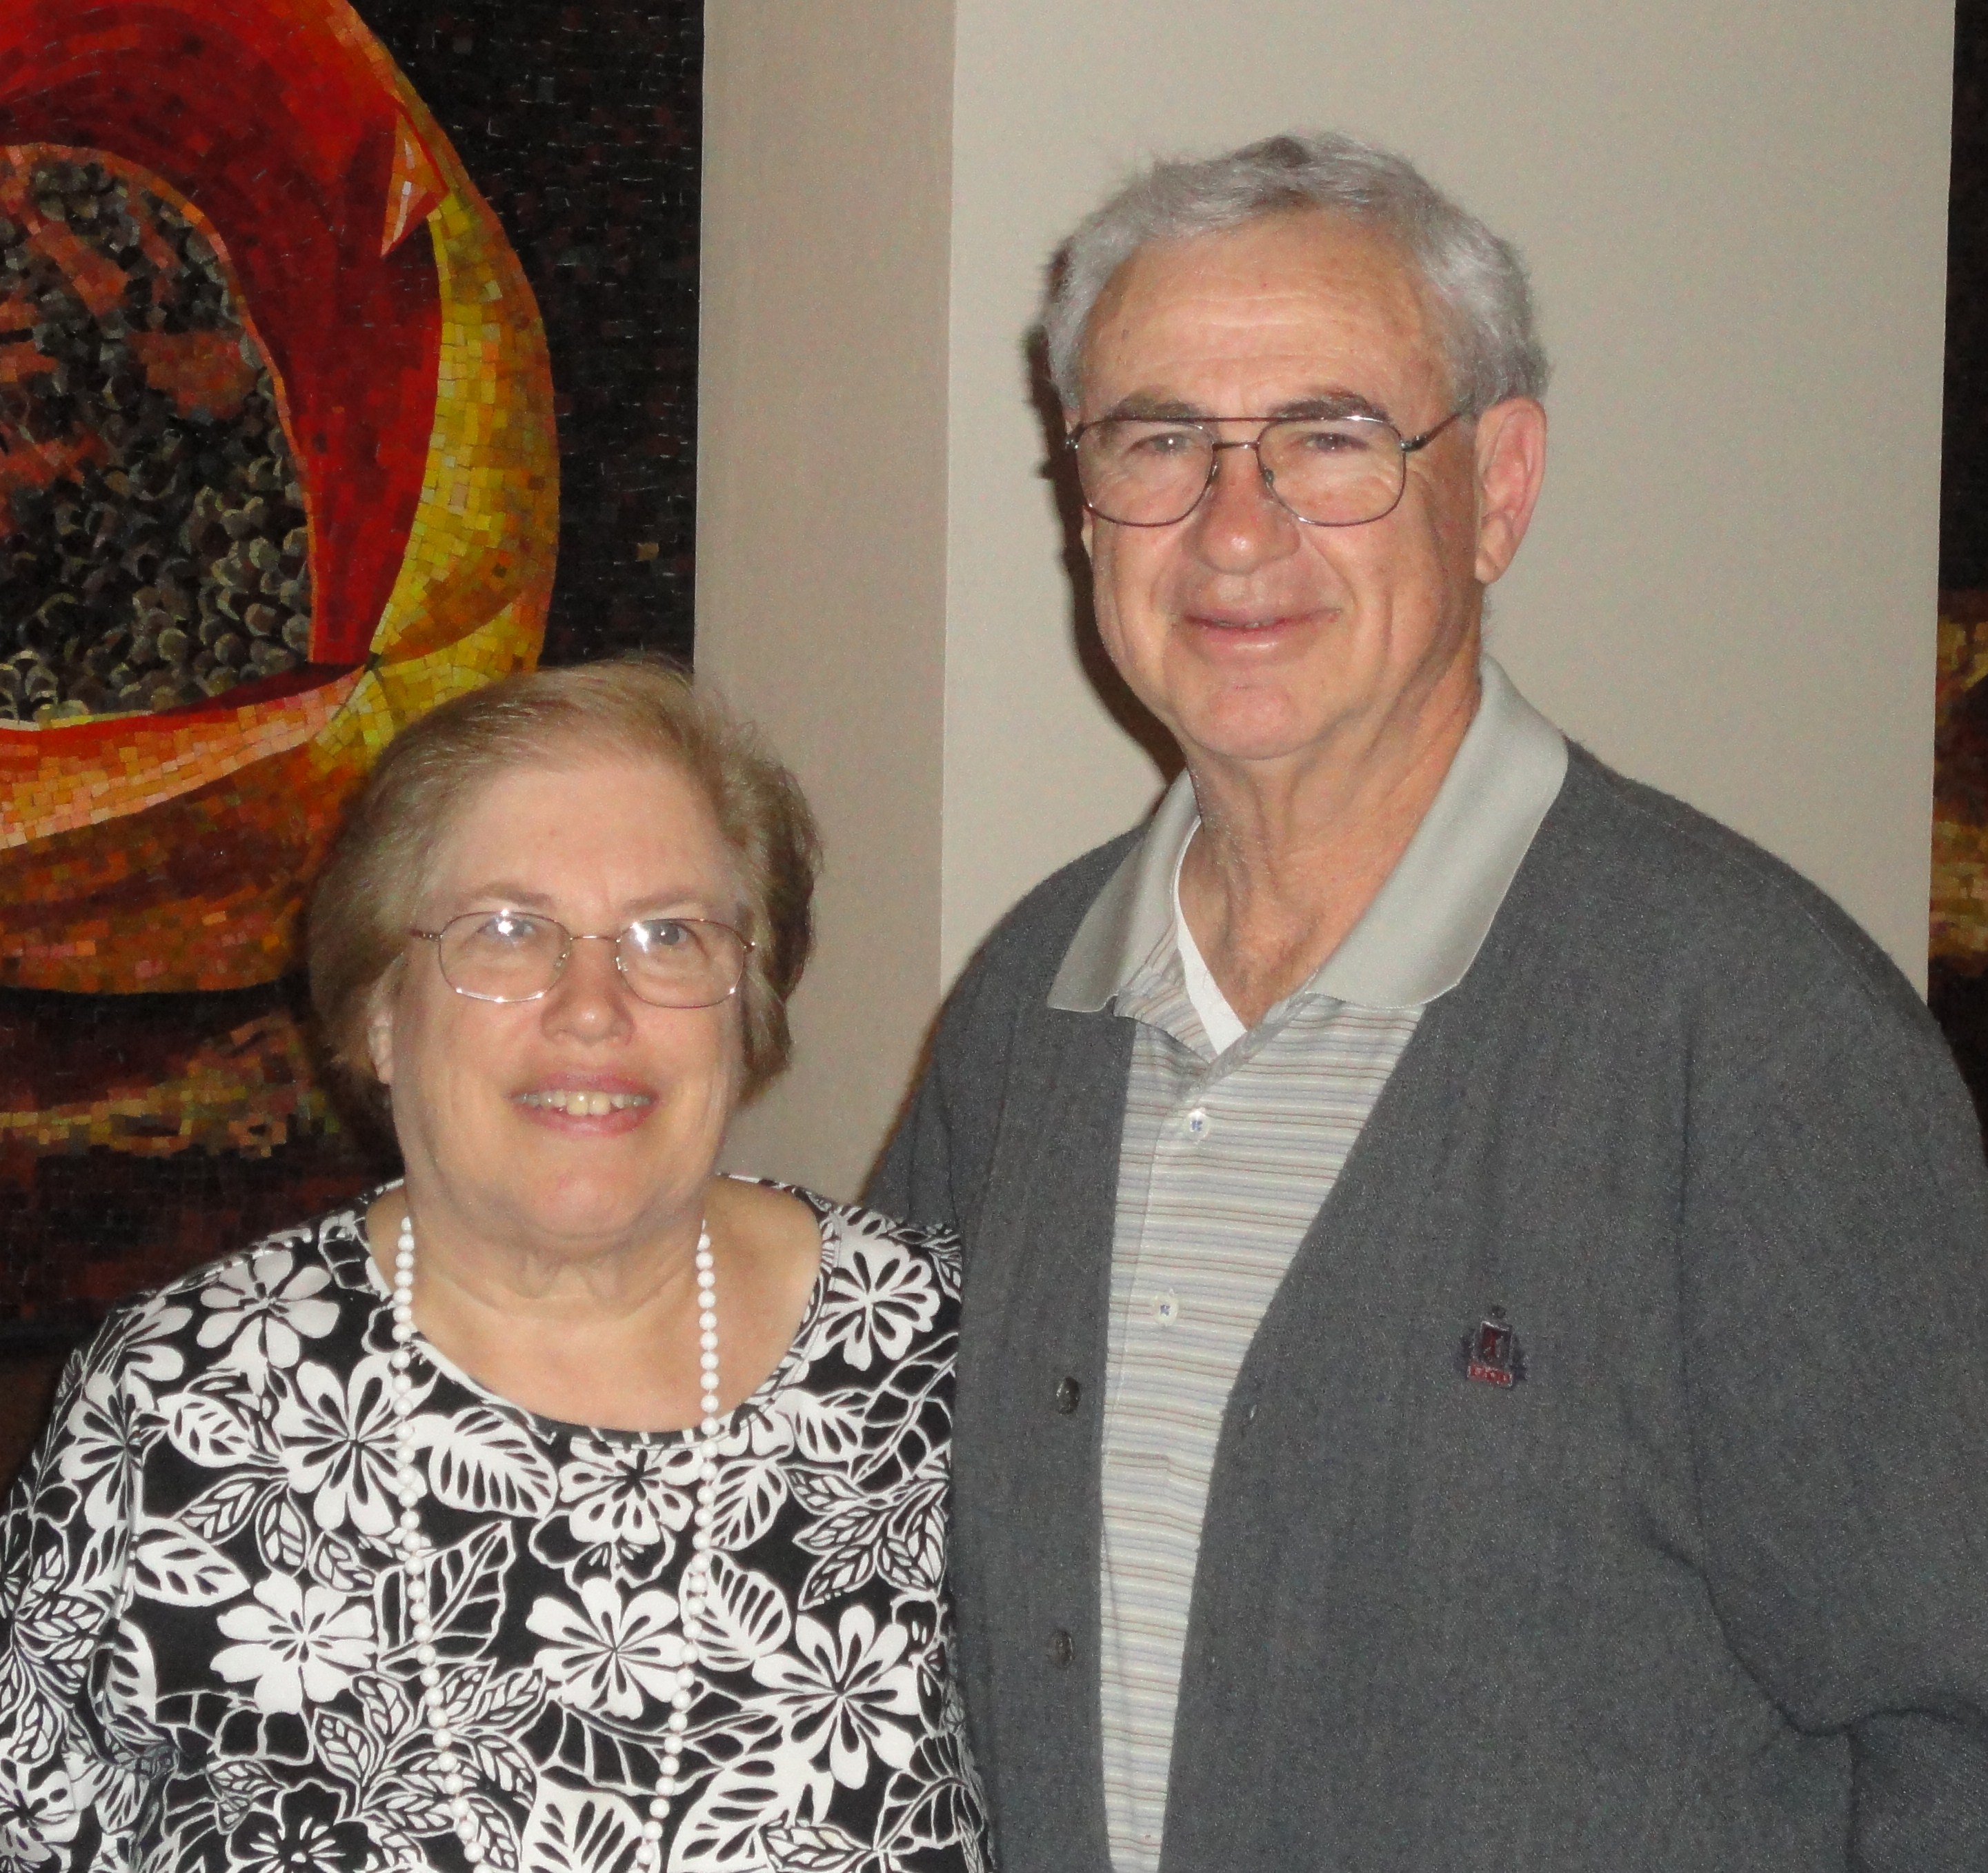

1969: Bob & Barbara Thorne

Our thanks and appreciation to Bob, John, Chris and Wayne for all they've done to keep the Class of '69 going strong, and to Barbara, Lesley, Judy and Becky for being supportive partners and co-workers in support of the Class.

