April 2020
’69 CLASS CORRESPONDENT

CAPT Bob Gravino
2 Summer Street
Ipswich, MA 01938
(978) 356-0825 (H)
E-mail: rcgravino@aol.com
Website: http://www.uscga69.org

An update from Forest Hetland. “How much of a difference can one year out of 73 years make in a person’s life? This past year has been a pivotal year for me. We spent New Year’s Eve 2018 in Krabi, Thailand; Easter sunrise service at St. Paul’s Cathedral in London, England; Greek Orthodox Good Friday service and procession through the streets of Naxos, Greece; and a week in Hawaii with our adult children and their spouses. A quick trip to the east coast to the USCGA Class of 1969 reunion in October. It’s hard to believe that it has been 50 years since graduating, not to mention 50 years of marriage to my best friend forever.” Forest and Pat returned to Chiang Mai, Thailand in early December to continue their missionary work with Remember Nhu, a non-profit, Christian based organization committed to ending child sex slavery throughout the world. On December 10th, Forest suffered an Acute Coronary Event, often referred to as a heart attack. In Forest’s words: “It was not a drop-dead event, rather a moderately severe pain from shoulder to shoulder across the front of my chest. It was not alarming, but I knew something was wrong and needed to be tended to. I was driven to the newest hospital in Chiang Mai where the ER staff quickly stabilized me. The chest pain had subsided by then but was still in the mild to moderate range. The following day, doctors ran a cannula up my arm to my heart and put a stint in the 99% blocked artery. The procedure took less than two hours, and immediately after putting the stint in, my pain was gone and I felt good. I also had a 70% blockage in another vein which was opened up, and the plan is that it will clear through medication. Another night in ICU and then home to Doi Saket with physical limitations. Within two days of the surgery I was feeling better than I have felt in the past few years.”
Jim Smith was asked how he came to be the drummer for The Gents. “I was honored to be the drummer for The Gents for three years at the Academy, and the ‘underclassman’ in the band for those three years. The summer I showed up at the Academy (1964), The Gents already existed. Their former drummer had resigned and I saw a note in the old Rec Hall about try outs. Only two of us applied, and the other cadet-classmate had been a Drum and Bugle Corps marching drummer. Fortunately, I had a drum set in my senior year of high school and a tiny bit of unschooled experience. The other cadet went on to graduate at the top of his class, earn a PhD, become a Coast Guard Flag Officer and a Major General as President of Norwich University. But, for the rest of my life, I WAS THE DRUMMER FOR THE GENTS, and very proud of it!”
Our resident golf pro, Stu White, achieved his first hole-in-one at the beginning of December 2019 at the Pine Needles Golf Club in Southern Pines, North Carolina. It was the #3 hole, par 3, 120 yards uphill and over a rise.
Pat Garrity still lives in Sandwich on Cape Cod and is on the Board of Directors for the Coast Guard Heritage Museum located in Barnstable. The Museum is not open to visitors for the winter months and is using this time to prepare for their 2020 season. Pat writes: “The Museum is retiring our Coast Guard Astronauts exhibit and replacing it with a celebration of Coast Guard Air Station Cape Cod’s 50th Anniversary. Knowing that many readers of the Alumni Association were assigned to the Air Station, the Museum is interested in artifacts, photos or sea stories that they would share as part of the exhibit. The Museum has an extensive audio library of first person accounts for those who would like to share a tale or two, or we can digitize any photographs or images and return the originals. We also want to ensure that we have correct contact information so as to include everyone who may be interested in the forthcoming celebration, which will include an Air Station Cape Cod Open House in September.” You can contact Pat at patriciagarrity@comcast.net.
Al Hindle sent an update and asked that classmates change his e-mail address to ahindle8525@gmail.com. “Cheryl and I recently moved, which is why we did not make it to Homecoming. We were between the proverbial rock and hard place, having bought the new house first and then started to renovate the former place for the market.”
Dick and Bekki Burke attended the annual Sock Hop held by the Baby Boomer Group at their church in Vacaville, California. Dick’s advice: “L’Oréal brown Magic Root Cover Up works for more than roots, and washes out pretty quickly with some effort.”

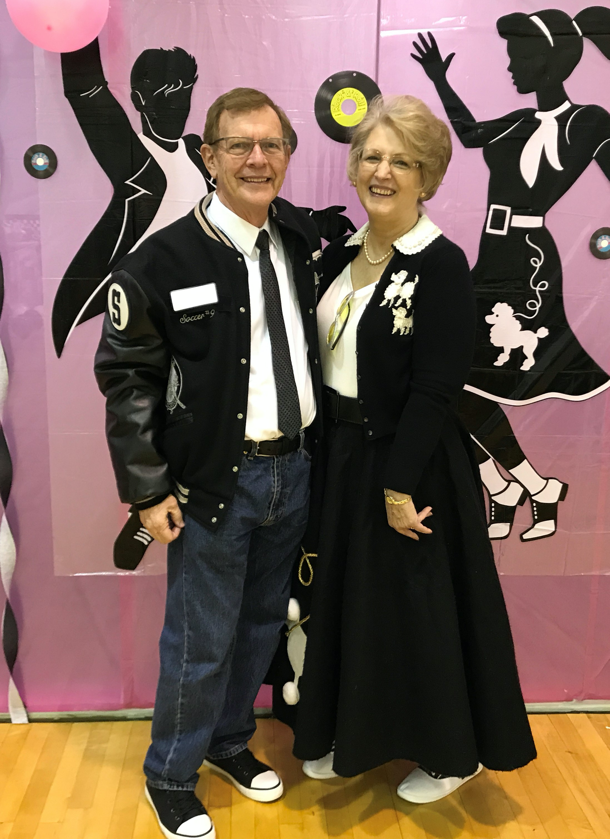

1969: Dick & Bekki Burke at the Sock Hop

Ann Anderson commented on the article in the February/March 2020 Alumni Bulletin on page 58 (‘The Coast Guard in Film’). “Andy was the Executive Officer on the CGC Dauntless in August 1979 when Michael Caine starred in the film The Island in which a handful of pirates commandeered a fictitious Coast Guard cutter. It was a memorable time for Andy, who felt that Michael Caine was a really nice fellow. In 1985, Andy was the Commanding Officer of the Dauntless when Tom Clancy was on board doing research for his drug thriller Clear and Present Danger. Andy was very impressed with Tom Clancy, the questions he asked, and the conversations they had while the author was on the Dauntless. It was definitely a high point in Andy’s career.”

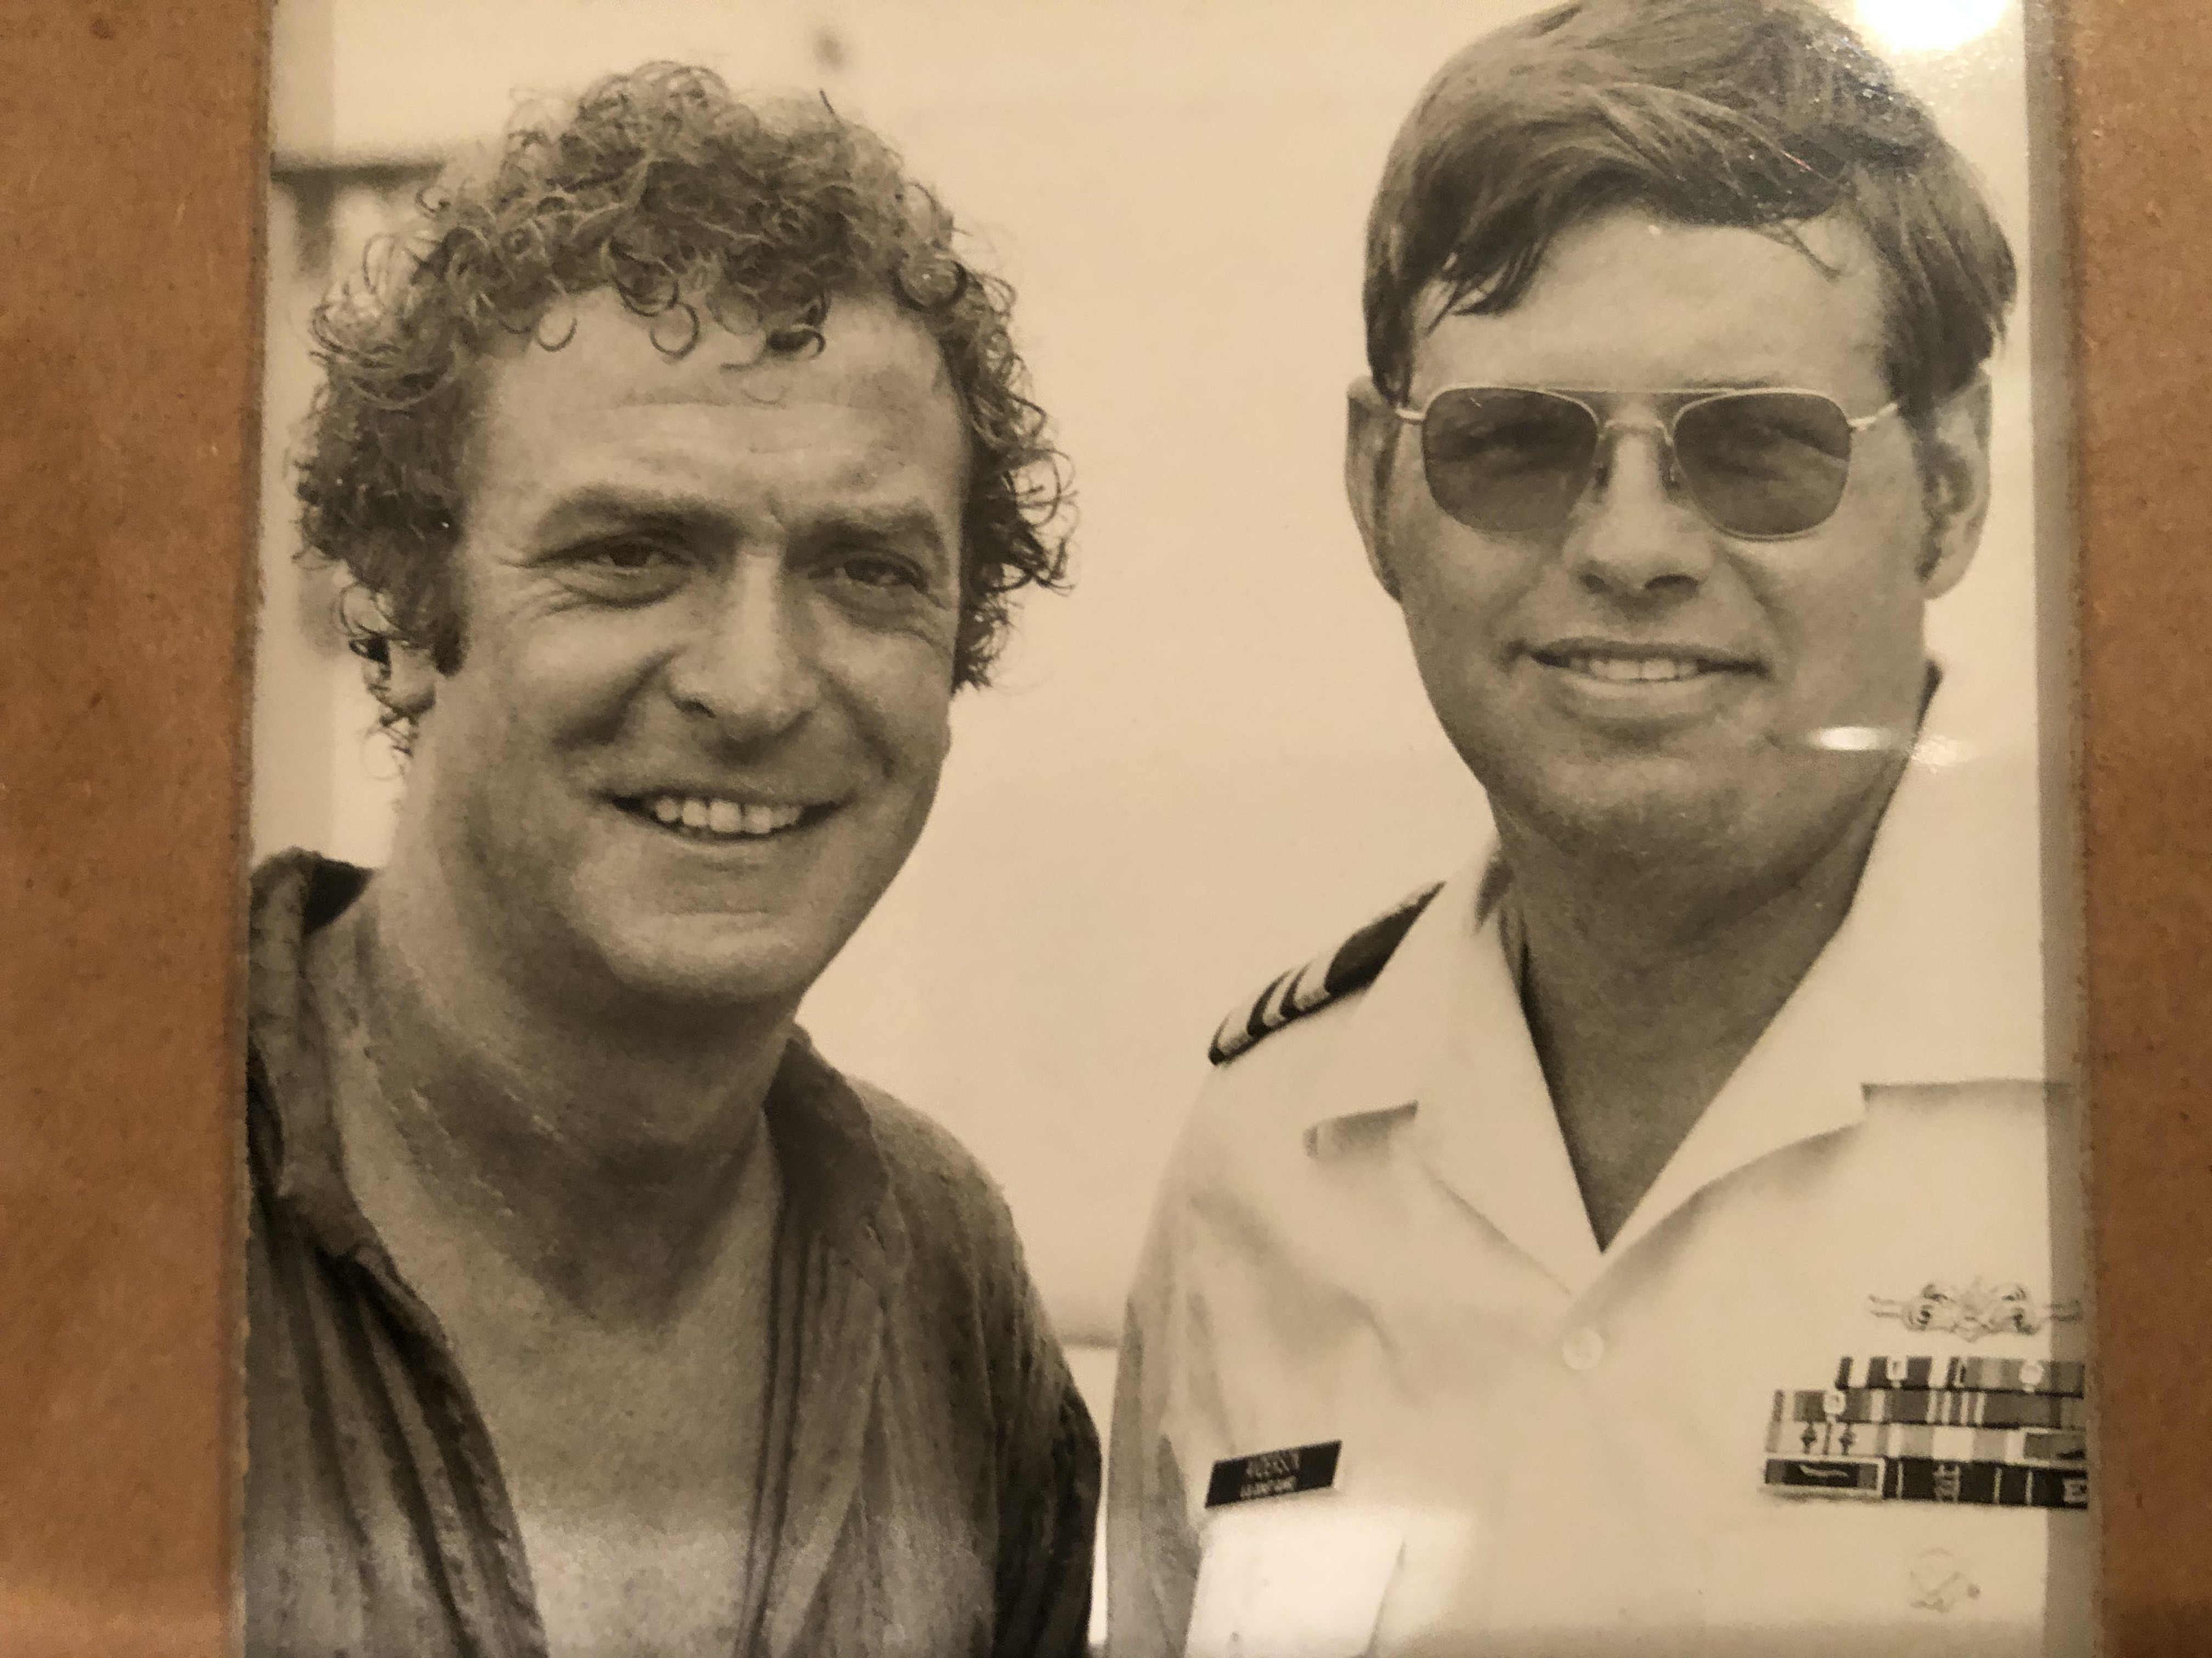

1969: Andy Anderson and Michael Caine on board the CGC Dauntless

Dave Anderson sent a photo taken the Sunday of our reunion weekend. The sea bag was given to him in September by a non Coast Guard buddy who calls Dave Uncle Davey. His friend stenciled Uncle Davey on the WWII vintage bag along with the last four of Dave’s social security number. The COAST GUARD lettering was on the bag when his friend found it.

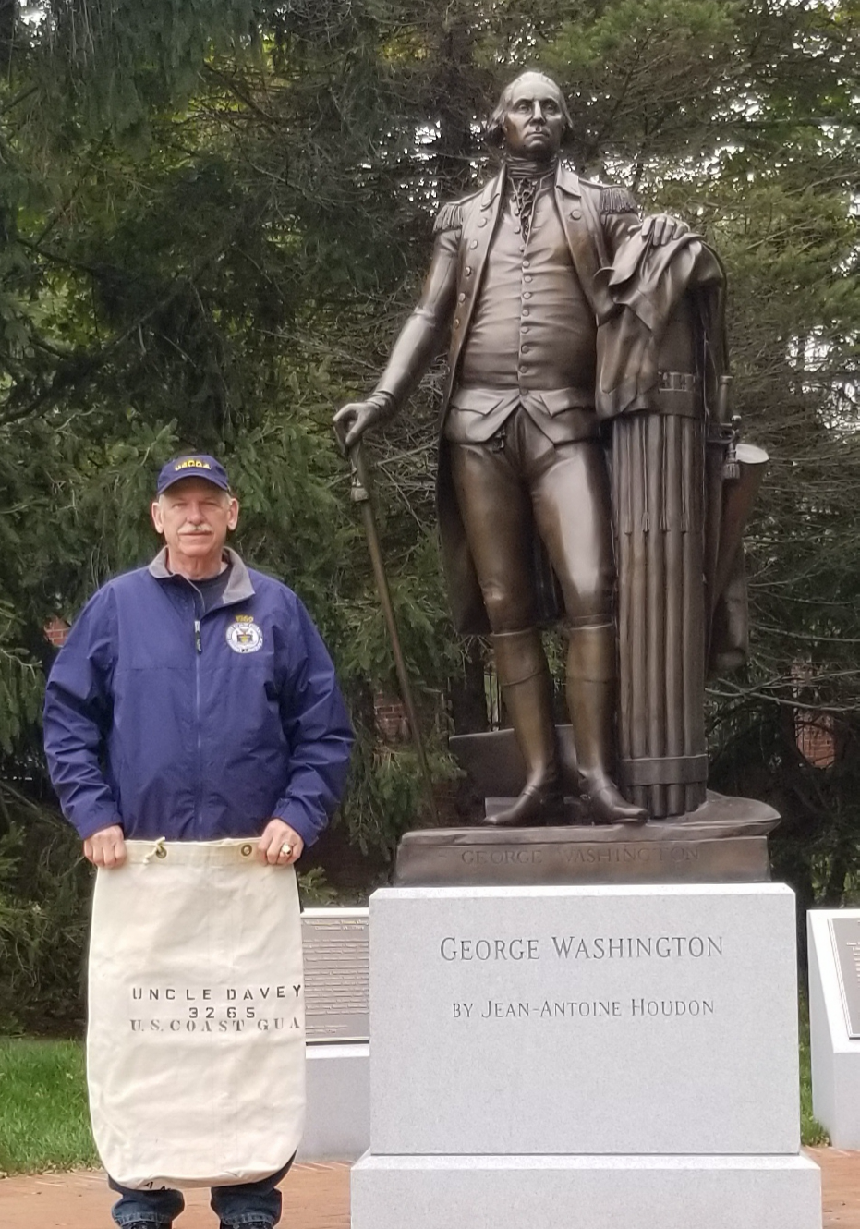

1969: Dave Anderson, George Washington, and the Sea Bag

Dan Carney sent in a photo of himself with Pat and the comment that “things are great here in Leonardtown, Maryland; every day is Saturday now that I have fully retired.” Dan was back in Sag Harbor in September, but found that his former hometown and the old seaport had changed.

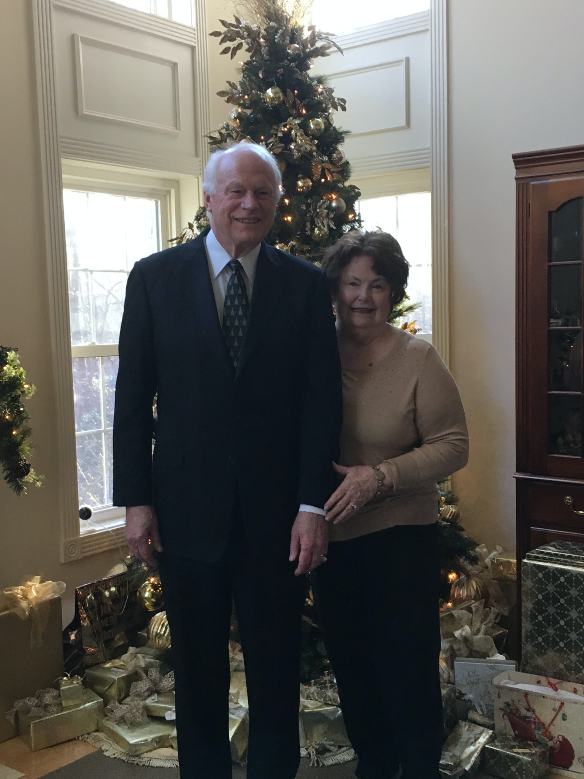

1969: Dan & Pat Carney

Tom and Karen Rutenberg visited Bruce and Gail Griffiths in San Diego in February. They spent time in the desert to the east and visited local tourist sites like the USS Midway.

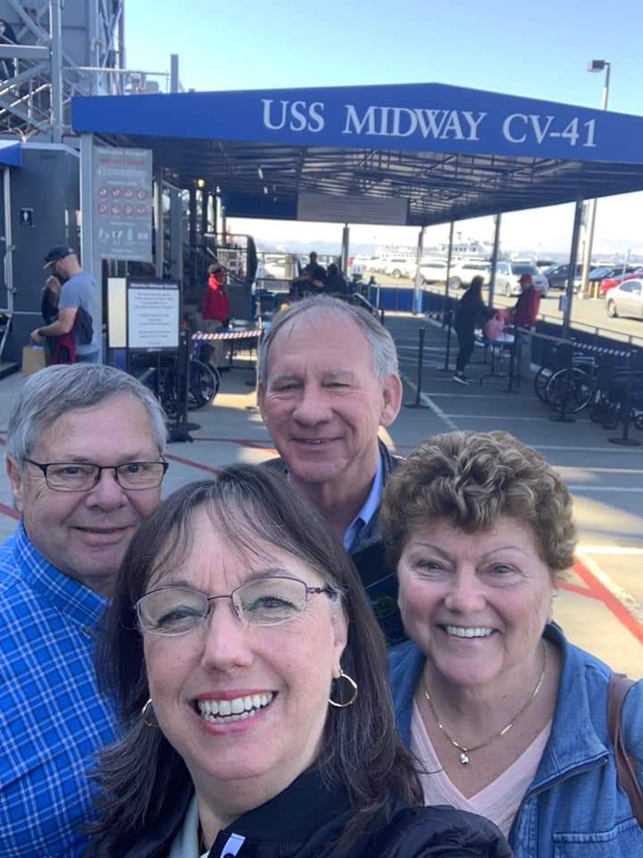

1969: The Rutenbergs & Griffiths in San Diego

Chuck and Norma Hill cruised the Mississippi River in February from New Orleans to Vicksburg, stopping in Natchez and Baton Rouge before the final port call in New Orleans. They toured the USS Kidd, a Fletcher class destroyer that is now a museum ship, and the WWII Museum in New Orleans. Their time in New Orleans coincided with Marti Gras, of which they took full advantage to celebrate with the locals.
Bob and Barbara Thorne, Jim and Marilyn Smith, Bob and Sue Pokress, and Kathy and I took a break from the colder February weather of the Eastern Seaboard and spent a week enjoying sunshine, warmth and memories at the Grand Residences in Puerto Murales, south of Cancun in Mexico.

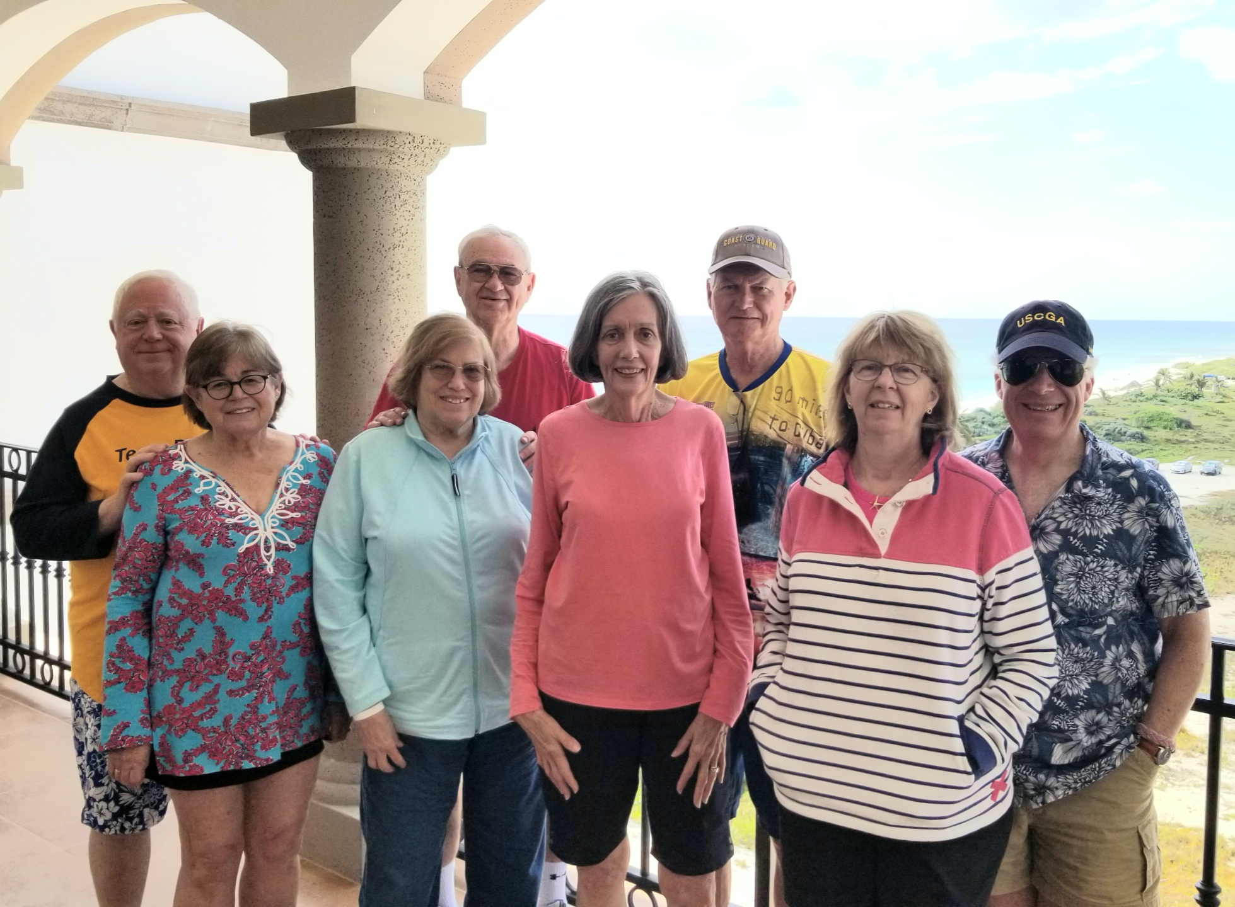

1969: The Cancun 8: Gravinos, Thornes, Smiths & Pokress's

