August 2017

CAPT Bob Gravino
2 Summer Street
Ipswich, MA 01938
(978) 356-0825 (H)
E-mail: rcgravino@aol.com
Website: http://www.uscga69.org

In Memoriam
Donald R. Shrader
June 19, 2017

It is with great sadness that I begin another Class Notes column with the death of a classmate, Doc Shrader. On June 19, 2017, Doc, of Bel Air, Maryland, passed away at the age of 69. Doc medically retired in 1981 as an active duty Lieutenant Commander. He was the son of Gloria Dawn Shrader, and the late Fredric Shrader; husband for over 48 years of Gloria J. Shrader; father of Derek Shrader and wife Elizabeth, Kevin Shrader and wife Michelle, Kristin Smyth and husband John; and grandfather of Ashtyn, Mikayla, Alexis, Nathan, Avery, and Jack. A memorial service was held on June 24th at Lutheran Church of the Good Shepherd in Bel Air. In lieu of flowers, donations may be made in Doc’s name at poppop.asmythco.com to benefit research of Multiple Sclerosis. Doc began a second career as the Director of Facilities and Maintenance at Harford Community College in Bel Air, where he served successful for many years. Doc’s cousin, Jeff Shrader, posted the following on Face Book, and included a collage shared by Doc’s daughter, Kristin. “It is with a very heavy heart that I share this post. My cousin LCDR Donald Raseley Shrader, passed away this morning. You've heard me talk very proudly of him. He had MS and was in a nursing home forever. He handled life with grace and never complained. He will be missed by many. Godspeed Doc; you were loved.” Well said, Jeff; classmates and friends who knew Doc would describe him with the same words: Doc handled life with grace and never complained.

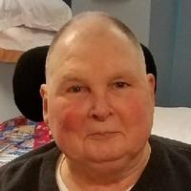

69: Doc Shrader

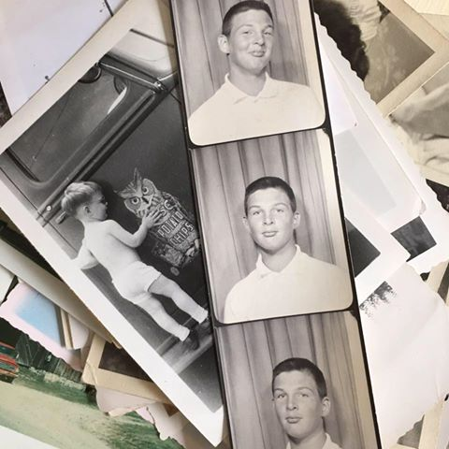

69: Collage of Doc Shrader by his daughter Kristin

Bob Thorne and George Naccara wrote a tribute to Dave DuBois that was sent to the Class and others; if you didn’t receive it, send an email and I will forward a copy. It included comments by classmates and those who were close to Dave during his time at the Academy and after his eleven years of active duty in the Coast Guard. Their comments described Dave’s remarkable athletic accomplishments and included anecdotes from professional basketball Hall of Famer K. C. Jones, Milt Rose (CGA ’67), Thomas (De) Combs (CGA ’57 and the Academy’s pitching coach in 1968 – 1969), Jim Smith, and Bob and George. Dave is considered one of the finest athletes to ever attend the Academy. He held the basketball career scoring record for 26 years, and would most likely still hold the top scoring record if CGA had the three point shot and played as many games per season as are played today. Our special thanks to Dr. Ray Cieplik, former Academy Director of Athletics, who researched the athletic archives to produce the following statistics on Dave.

Dave’s notable Basketball and Baseball records/accomplishments:
Baseball
- 1st Most innings pitched in a career – 271.3
- 3rd Strikeouts in a season – 79
- 1st in innings pitched in a season – 98.3
- Second in most wins in a career – 21
- Second in most wins in a season – 7
- 2nd and 3rd best earned run average in a season – 1.09 and 1.28
- 3rd best winning percentage in a career – .750%
Basketball
- 5th all-time scorer – 1,361 points
- 1st in career points per game – 18.1
- 3rd in points per single season – 20.5
- 3rd in career field goals made – 559

The following note was received from Ed Danner (edkdanner@gmail.com): “Thanks for keeping me in the loop with your emails. It is hard to believe it will soon be 52 years since we heard our first, "SWABS OUT" in July 1965! Time really does fly by quickly. I was particularly saddened to hear of Dave DuBois' passing. He and I played together on the varsity baseball team our Swab year. Dave had a curve ball that would fall off the table.”
Bob Thorne has announced that the 50th Class Reunion is the weekend of Thursday, October 3 thru Sunday, October 6, 2019. Our Reunion Headquarters will be at the Mystic Marriott where the Class stayed for our 45th Reunion. Bob needs to determine an approximation of the number of rooms the Class will require and reserve them soon. If you haven’t already done so, please let Bob know if you plan on attending. This does not commit you, but helps him better estimate room requirements. Bob no longer use Thorne@atlanticbb.net; his working emails are now Quigsthornecga@gmail.com (primary) and Grandmathorne@icloud.com.
Pete Lenes’ son Chad graduated from Southern Mississippi in May and is now employed in the music industry in Austin, Texas. Chad’s twin brother Sean is a senior at Mississippi State in Computer Business Information Systems. Pete is 95% retired and does some consulting in the shipbuilding industry and cares for his home’s two acres of grass and plants. Susan does multi-level marketing and along with Pete enjoys their granddaughter, Saylor, who is a first grader.
Bill Bissell bought a summer home in Branford, Connecticut, right on the harbor so that he can keep track of the buoys and boat traffic. He and Lisa will spend their time in either Connecticut or the San Francisco Bay Area, depending on when he is needed at his California law office. Bill is still working; his small environmental law business has become 95% involved in asbestos litigation, representing a few middle men who are now defendants because the original manufacturers are bankrupt. Lisa is retired and their two sons, Jeff and Matt, both work in San Francisco. Bill sails on other people's boats in Long Island Sound, but the survival conditions of windy San Francisco Bay have become too strenuous for him to continue sailing on the waters there.

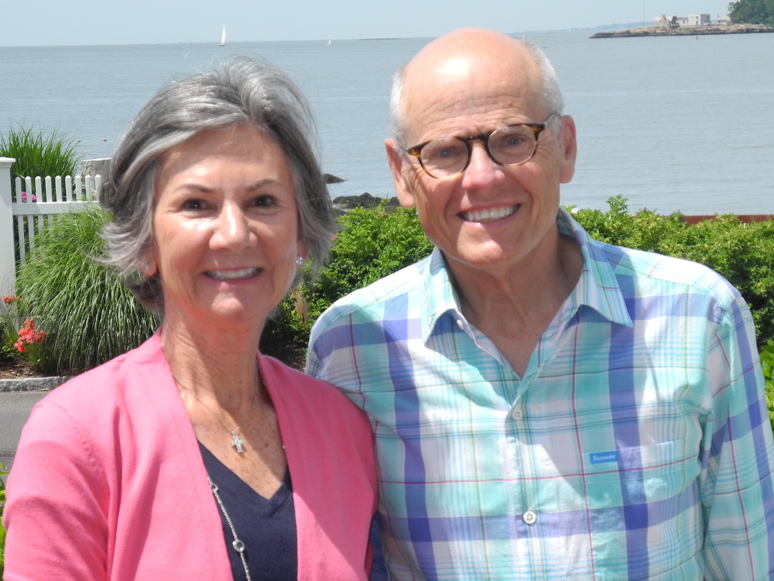

69: Bill & Lisa Bissell

Chuck and Paula More recently moved from Rhode Island to Virginia, and are enjoying their new home and farm in Green Bay. They have 28 acres, four horses, two cats and a dog. Paula rides and exercises her horses daily, and Chuck plays senior league golf twice a week, year round, at the municipal course in Farmville.
Steve Hungness married Marlies Fetsch in Sedona, Arizona on July 2, 2017. The ceremony was held at Dry Creek Vista with a reception following at Agave Wedding Center and two days of activities with Steve’s two children and four grandchildren and Marlies' two children and five grandchildren. Marlies and Steve met in 2015 at a Barnes and Noble bookstore, while he was living in Glenview, Illinois, and they will be moving to St. John, Indiana. Marlies was born in Hanover, Germany and came to the United States in 1968. She retired as an HR specialist for a major hospital network in the Chicago Metro area. Since his retirement from the Coast Guard in 1991, Steve has been working for the Chicago District Corps of Engineers, serving as Chief of the Operations Branch and supervising 45 professionals involved in civil engineering. He will retire in April 2018 with over 30 year’s civilian federal service. Steve and Marlies plan to attend the 50th Class Reunion.



69: Steve Hungness & Marlies Fetsch

Bob Pokress and grandson Nate spent a week in London and received visitors’ passes that allowed them free range within Parliament. They visited the House of Lords and watched the debate on the Brexit issue. What they saw first-hand in the House of Lords made the front page of the New York Times and Washington Post the next day as well as the front pages of the British papers.

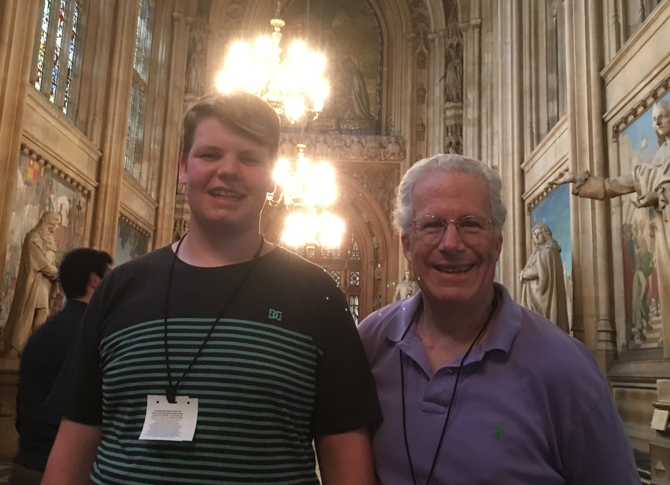

69: Bob Pokress & grandson Nate

Paul and Molly Prokop and Kathy and I met for dinner in Boston in June as the Prokop’s were passing through the area on their way to Vinalhaven, where one of Molly’s Connecticut College (CC ’70) classmates has a summer place and holds an annual mini-reunion for four classmates and spouses.

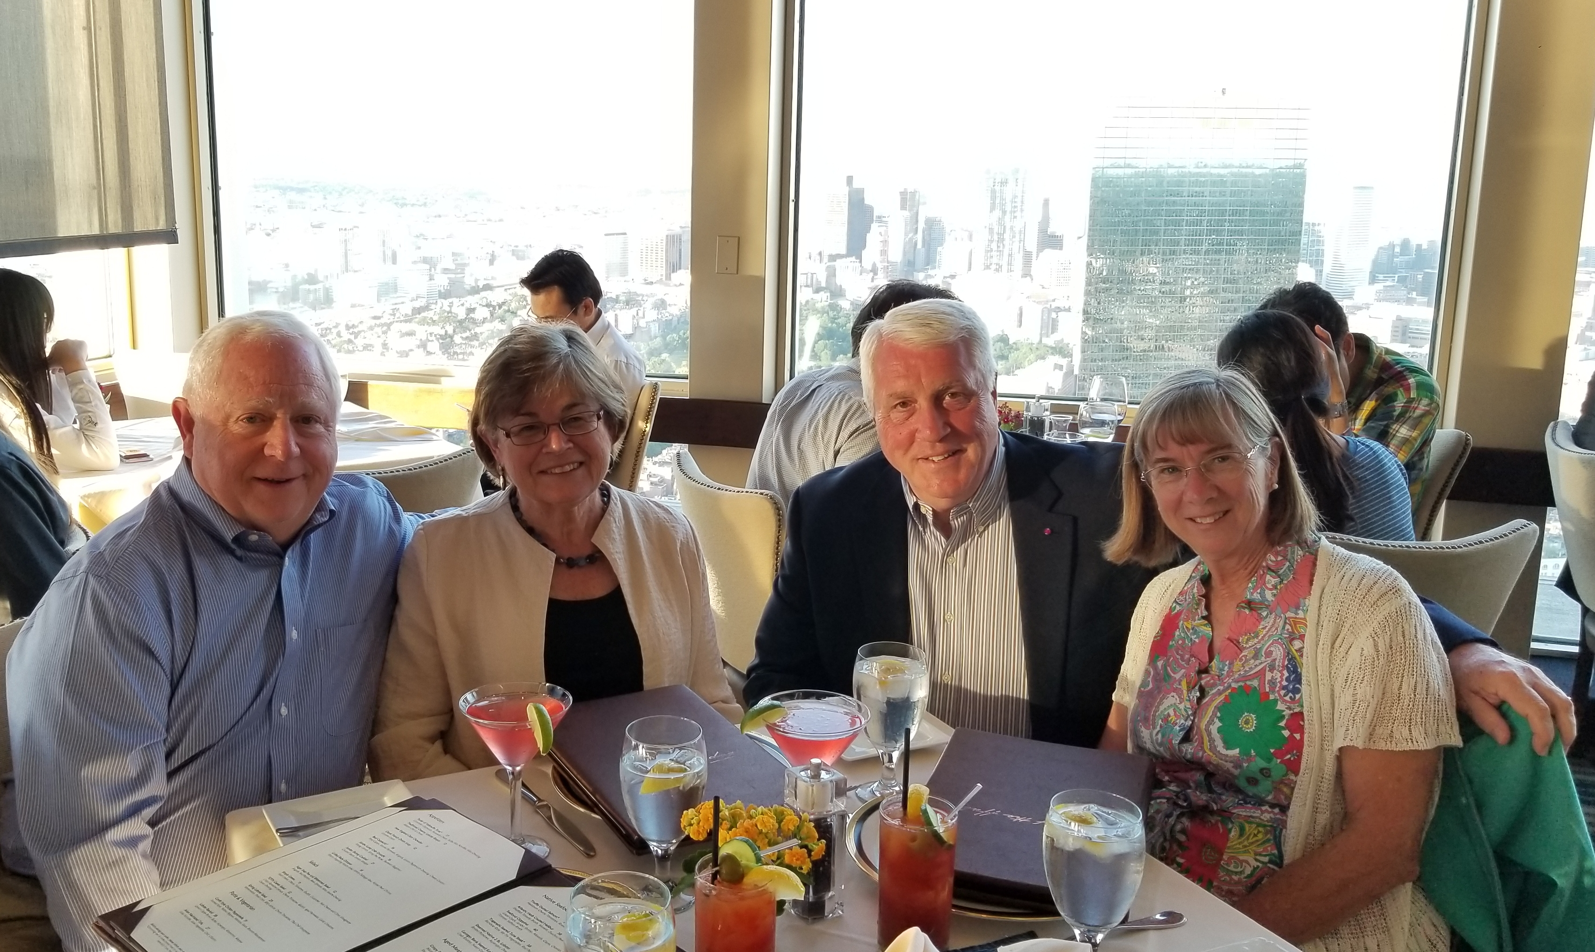

69' Paul & Molly Prokop and Bob & Kathy Gravino

Mark and Paula Present took a cruise in May from Abu Dhabi to Athens. The cruise was to celebrate turning 70 and for Paula to visit the World Heritage site of Petra in Jordan. They lucked out with their time in Israel, as President Trump arrived the week after them and all the sites they wanted to visit were not closed due to security. Their next adventure will be Cuba in October 2017.
The following was from Ann Anderson after she received the Class email in June about Normandy Beach. “This is amazing, Bob! I hadn't heard about this project but it means a lot. Andy and I were married on 6/6/69 @ 6pm--the 25th anniversary of D Day (2 days after CGA '69 graduation and 2 days before mine at Connecticut College). Our dads were WWII vets, as were uncles and other guests. At some point during the reception they stood around reminiscing and telling war stories, and....lo and behold...our dads discovered they had crossed paths in northern France and had actually spoken to each other just before D-day!!!”
A Norwich University friend sent me an article from the NU Alumni Magazine about the 25 year reign of Rich Schneider (CGA ’68) as President of Norwich. From the feedback received from the significant number of Norwich friends living in the Boston area, Rich is a terrific leader at the school and is respected and admired by all. He is my savior whenever alumni rivalry arises with Norwich friends: “And what military academy did the President of Norwich University graduate from?”
Included in the alumni magazine is a short article noting the resurrection of the “Little Army-Navy Game” football rivalry between Norwich and the Academy, with their first meeting scheduled for Norwich’s Homecoming on September 23rd. The Bears will play six home games and renew several old rivalries as New England Women's and Men's Athletic Conference (NEWMAC) football debuts this season. Coast Guard competed in the New England Football Conference (NEFC) for the past 11 seasons before the conference's final season in 2016. The annual battle for the Secretaries' Cup between Coast Guard and Merchant Marine has been moved to the final game of the season and will be played on Veteran's Day, November 11th. The game will be broadcast by the ESPN Family of Networks. Both schools played the final game of the season from 1991-2005 before the Bears joined the New England Football Conference. The Academy will renew rivalries with Union in a non-conference game as well as Norwich, Springfield and WPI in NEWMAC play this season. Coast Guard last played Springfield in 2003 and Union, Norwich and WPI in 2005.

