August 2019
’69 CLASS CORRESPONDENT

CAPT Bob Gravino
2 Summer Street
Ipswich, MA 01938
(978) 356-0825 (H)
E-mail: rcgravino@aol.com
Website: http://www.uscga69.org

By the time you receive this Bulletin, there will be less than a month until the 50th Reunion in New London. Bob Thorne and the Reunion Committee will be sending out more instructions on Reunion activities, and Chris Kreiler will be immediately posting them on the Class Website (http://www.uscga69.org) should you miss e-mails sent on the Class bang list. If you missed the invitation, Bob Glynn has opened his Westbrook beach house on Thursday, October 3, for a kick-off activity to Homecoming. All CGA '69 classmates and wives/partners are invited to a picnic at the beach at Bob Glynn’s house on Thursday, 3 October beginning late in the morning. The grill will be on at 1300. The house is 19 miles from the Academy at 85 Chapman Avenue, Westbrook. Please RSVP to Bob Glynn at boglynn@cox.net or (619) 980-2225, and he can provide directions if needed. Dan Garrison reported in early July that tremendous progress on the Class Gift Site has occurred, with construction ahead of schedule. The Statue, with associated replica plaques and granite pedestals, have arrived at the art studio in Woburn, Massachusetts and have been inspected by Bob Pokress. Bob gives rave reviews to the work to date, and Dan has a small subcommittee developing input to the unveiling ceremony program.

Rich Vlaun sent a photo of his family on a fishing outing on Chesapeake Bay, as part of a week-long celebration of Rich and Beth’s 50th wedding anniversary. From left to right: Anderson, CAPT Mark Vlaun CGA ‘94, Keira, Col Brian Vlaun AFA ‘98, Megan, Grant, Beth, CAPT Richard Vlaun CGA ‘69, Brooke, and Kristen. Their actual anniversary was on June 7th, but they had to delay their get together since both of their sons and families were packing out that day. Mark, Kristen, Brooke, and Anderson were moving from Miami to Jacksonville, Florida, where Mark took over as Sector Commander Jacksonville. Brian, Megan, Keira, and Grant were in the middle of a transfer from NATO Madrid, Spain to Minot, North Dakota where Brian will be the 5th Bomb Wing Vice Wing Commander.

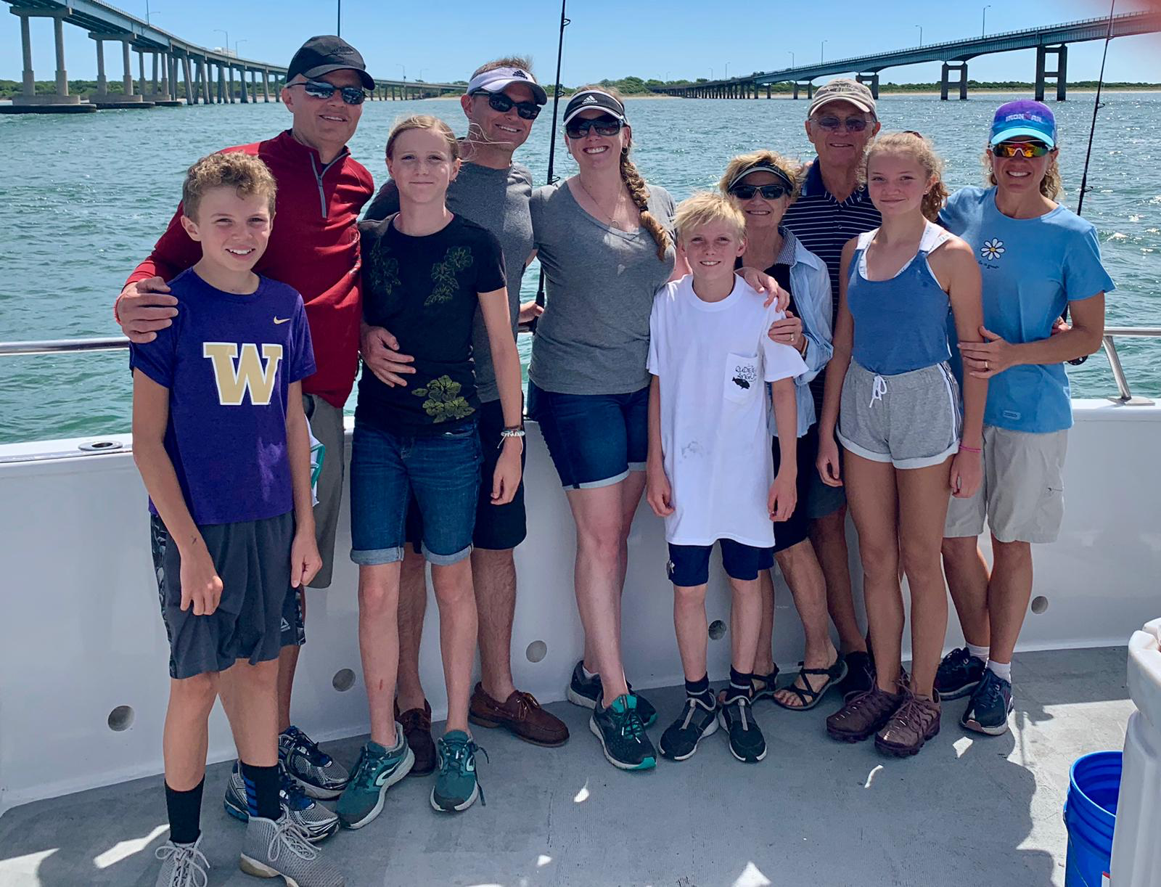

1969: Rich & Beth Vlaun celebrating their 50th Wedding Anniversary on Chesapeake Bay with sons and families

GARY PAVLIK made contact with Jeff Kelly (jeffkelly@mac.com), who left second semester 3/c year and did five years in the Marine Corps as an officer. Jeff said he was the OCS honor graduate and credited swab summer for achieving this honor. Gary invited Jeff to attend the 50th Reunion.

Bob and Lois Acker celebrated their 50th anniversary on Sanibel Island, with all three of their kids and their respective families. Sanibel has been a yearly vacation trip for them since 1980 when they were stationed in District 7 and living in Lauderhill, Florida. “We love getting the family together for a week of sun and fun.”

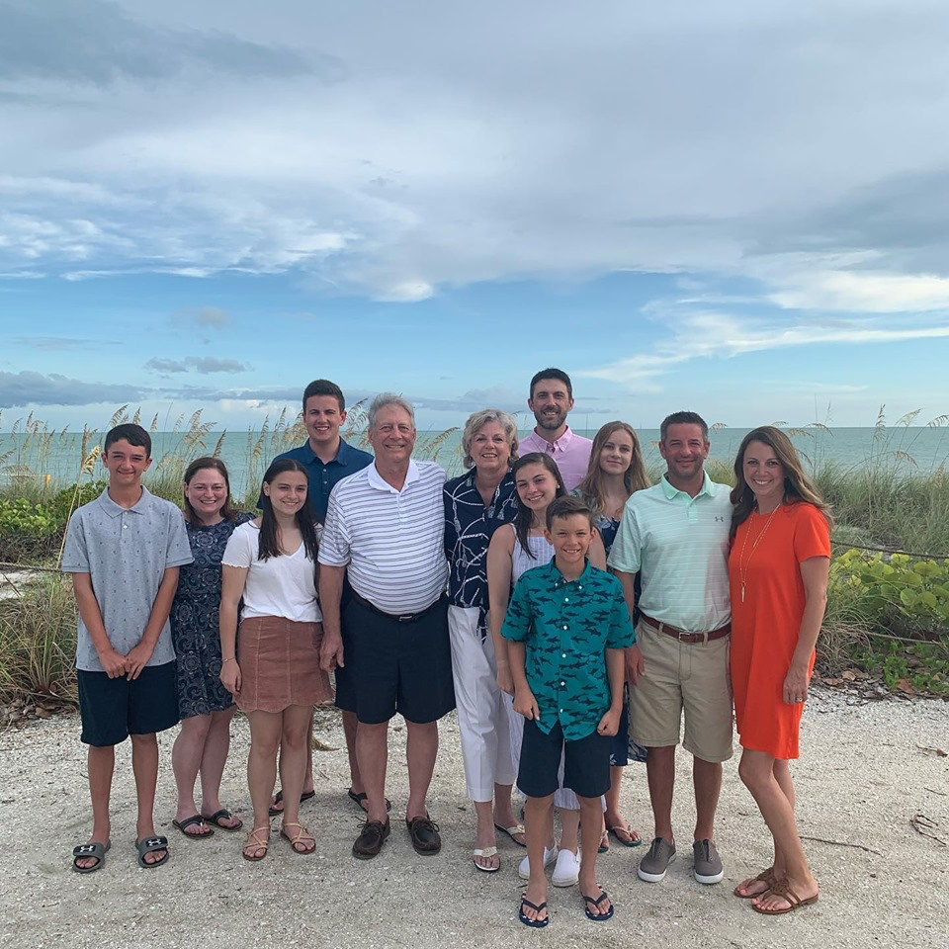

1969: Bob & Lois Acker celebrating their 50th wedding anniversary on Sanibel Island with their children and families

Kathy and I traveled in May on a three week trip to the south coast of the UK with Bob and Sue Pokress, including the Isle of Guernsey where both Sue and Kathy had relatives who immigrated to the United States. One of the many highlights of the UK travels was a weekend visit with Mike and Libby Black in Port Isaac on the north coast of Cornwall. Mike’s story of life following his Coast Guard service is fascinating, and hopefully he will share some of those times with us at the 50th Reunion in 2019, if Libby can convince him to fly across the Pond in an aircraft. What I didn’t know was that Bob was a fanatic of the British sitcom Doc Martin, which is filmed in Port Isaac with no traditional security. On the first day we were in Port Isaac, Bob penetrated the production site and immediately became best buddies with Bert Large, the larger than life character played by Ian McNeice. Bob gave Bert/Ian a Class of 69 Reunion ball cap which he immediately began wearing whenever he was off-camera. One day Bert brought Jessica Ransom, the character actress who plays Doc Martin’s medical receptionist, Morwenna Newcross, to lunch. In the photo of Bob, Mike and myself, Bert/Ian is making a proper Royal Navy salute to everyone in our class after becoming an honorary member of the Class of ‘69. In the second photo, we are standing with Doc Martin’s office and home in the background.

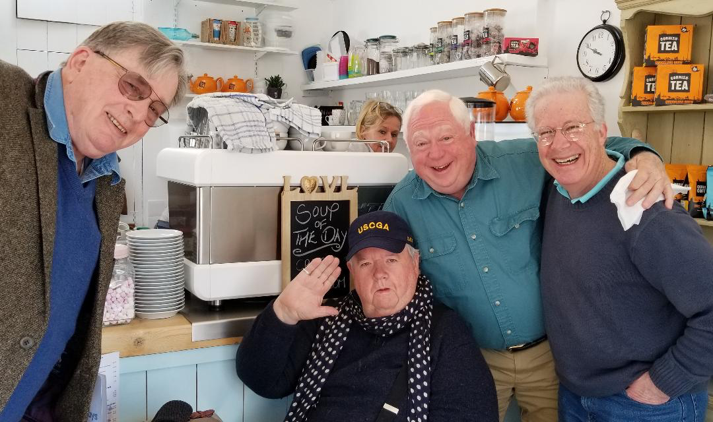

1969: Mike Black, Bob Gravino & Bob Pokress with Bert Large/Ian McNeice of Doc Martin fame; Bert giving a Royal Navy salute with his CGA '69 ball cap.

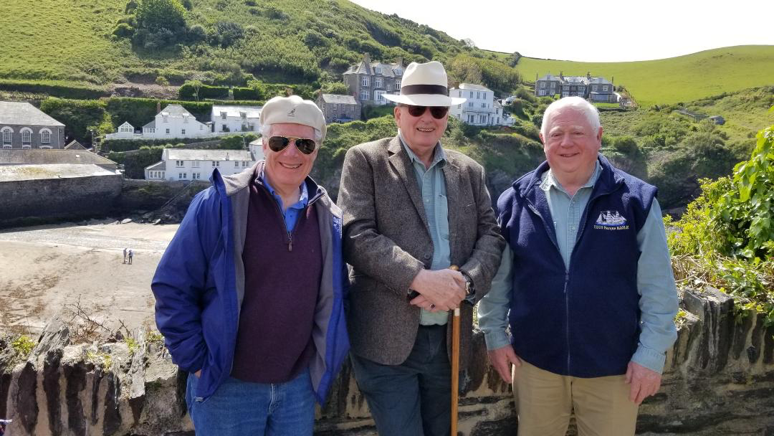

1969: Bob, Mike & Bob with Port Isaac and Doc Martin's house/clinic in the background

After leaving the Coast Guard in 1977, Butch Hartney earned an unlimited Deck Officers license, joined the International Organization of Masters, Mates, and Pilots (IOMMP) and commenced a 27 year career in the maritime industry, where he sailed on the ships of numerous companies. He became a full member of IOMMP in 1987 and was selected by American President Lines (APL) as a permanent senior officer. During his last 17 years he sailed as Master on MSC ships under contract to APL, as well as APL vessels in their fast turn-around, containerized, liner fleet. He retired from IOMMP in 2004 while Master of the President Truman. As part of the USCGA Alumni Associations ‘Link in the Chain’ program he had the experience of riding on the CGC Eagle during a 7 day cadet cruise from Copenhagen to Antwerp this past May. Having been away from the Coast Guard for the last 43 years, this was an opportunity for Butch to catch up on the service and its cadets. His observations on the trip follow: “Except for accommodation spaces, the ship has changed little. An additional small structure has been built on the quarterdeck forward where quartermaster, deck officer, and communication duties can be out of the weather. The rigging of the mizzenmast has been returned to the original German configuration with a middle gaff separating upper from lower mizzen sails instead of a single large sail. The large, open berthing space where we hung our hammocks and folded down our work/dining tables from the sides and through which ran the hammock bin has been halved with only the after end surviving and filled with fixed tables and benches for dining, teaching and meetings. This results in meals being served in two seatings, which I don't recall as the norm. The forward half of the hammock deck has been divided into sexually segregated bunk sleeping quarters, and the long, thwart ship toilet room with the 12 X 12 johns facing each other in the knees to knees position is also gone. I berthed in an officer’s room aft on the port side across from the wardroom, and shared it with a '79 graduate due to Ed Carapezza having to drop out at the last minute due to a medical emergency. I claimed seniority and took the lower berth. I sailed as an Ensign watch officer during the summer of 1969 on a two week cruise to Bermuda and shared a room with a CWO2 Engineman. Sadly, we crossed into a hurricane and after a wild ride with five blown out sails, we limped back to New London and never made it to our destination. The increase in permanent crew on the vessel was noticeable. Cadets, when not on watch, spent most of their time attending classes and instruction. Ship maintenance was done almost exclusively by crew. I witnessed no drills during my week. The few sail setting/trimming evolutions I saw were supervised mainly by crew. The entire voyage south was completed on a port quarter reach with no sails set above the upper tops. Going aloft for cadets is a slow, involved operation as all must put on a cumbersome safety vest with metal rings and large clips, much like a helicopter crewman setup. I knew they had been using harnesses for quite a while but had always pictured these as just belts with a simple thumb clip; not so! I made friends with some of the 4/c aboard and softly queried them as to how their swab year was progressing. I learned that swab year lasts only seven weeks, after which they got carry on and were called "4/c" and never swabs again. They did know ‘How's the Cow’, ‘How long you been in the Coast Guard’, and other ditties, but not as well as I did after 54 years. Most of their recitations ended in ‘or something like that’. The Captain hosted 4-5 cadets in his cabin at noon and evening meals; I never did get invited to his cabin. The most remarkable thing I witnessed was at noon quarters on the same day graduation was held in New London. The Captain congratulated all cadets on being that day promoted one class up. The new 1/c then went to the new 3/c and pinned their new collar/hat insignias on and the crew then went to new 1/c and did the same to them. I found it hard to imagine the Class of '67 doing that to us at the end of swab year. Cadet collar devices are now designed 'a la West Point with a colored shield (color indicating class) and a star/anchor in the middle. A new 3/c presented me one of her old devices as a memento of the occasion. At the last day's quarters the Captain was publicly wishing me goodbye when I asked him for the microphone to say a few words. He reluctantly gave it to me with a whispered ‘make it short’. I gave a short thank you for everything and ended with ‘I must note that while I ended my 4/c year with an air of cynicism, it appears you 4/c just ended yours with an air of optimism. I think you and the service are well served by this.’ This comment was well received by all. Afterwards, the Captain apologized for his reluctance to my speaking on the mike and told me that the previous year an old timer had made some untoward remarks about female cadets, and he was very pleased I hadn't. These are my observations, sprinkled with a few opinions. In the end, I’m glad I went. Too bad more slots were not available. I assume we'll hear more from Bob Pokress and Bill Bissell after their cruise in August.”

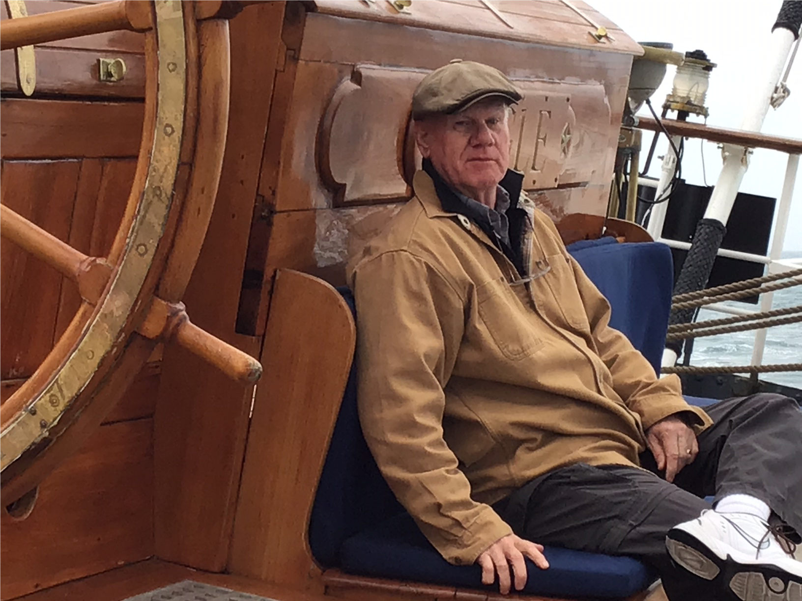

1969: Butch Hartney at sea on the CGC Eagle

Stu White recently returned from a Baltic Sea cruise aboard Le Dumont D'Urville, a 131 meter vessel carrying 180 passengers and 100 crewmembers. The ship visited Copenhagen, Gdansk (including a presentation by Lech Walesa) Tallinn/Estonia, St. Petersburg, Helsinki, Visby/Gotland and Stockholm. “Educational and beautiful sites, so much history. The Captain gave a presentation on the ship and its last weeks in the shipyard; she was on her second cruise since being built. At 131 meters she's bigger than any cutter I sailed on.”

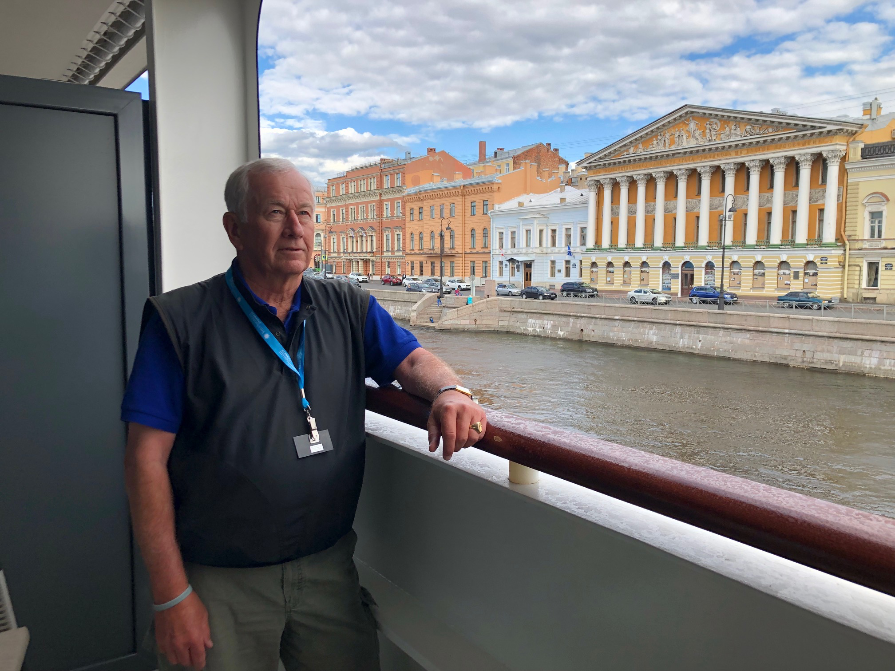

1969: Stu White on his stateroom balcony on the vessel Le Dumont D'Urville in St. Petersburg, Russia

I look forward to seeing many of you at the 50th Reunion on October 4th.

