August 2022
’69 CLASS CORRESPONDENT

CAPT Bob Gravino
P.O. Box 158
Georgetown, ME 04548
(207) 371-2765 (H)
E-mail: rcgravino@aol.com
Website: http://www.uscga69.org

Jim Smith was invited to be a guest of the commanding officer of the CGC Eagle when the vessel made a port call in mid-June to Key West, Florida, as a former commanding officer of Group Key West and a retired O-6 and civic leader residing in the community. Onboard the Eagle was Nate Pokress, grandson of Bob Pokress, who embarked on the Eagle in Corpus Christi to begin his 3/c long cruise. The accompanying photo of Jim and Nate shows them admiring a photo of Nate and his grandfather taken earlier in the year at the Academy. “The next day, Marilyn and I were in Islamorada (mile-marker 86) with California daughter Saralyn and husband where son Cale (CGA '94) and his family live. Busy weekend, but glad I got to meet Nate; he and the Eagle were sailing to Bermuda for their next port of call.”

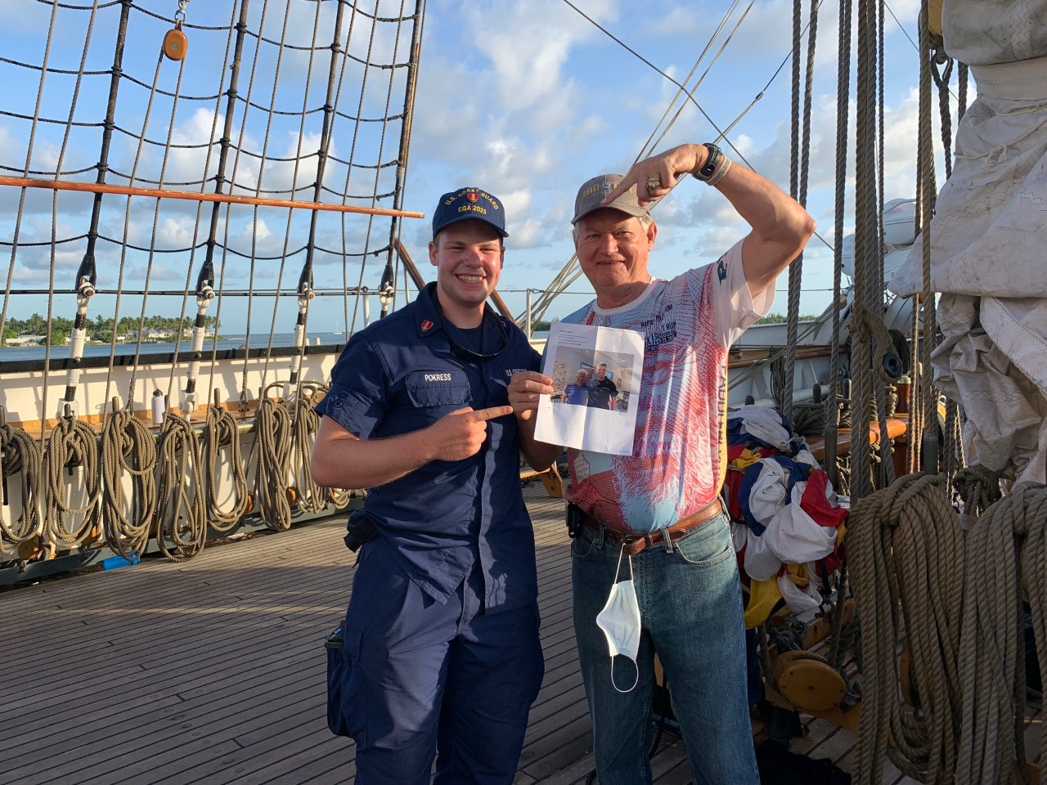

'69: Jim Smith and Nate Pokress on Eagle in Key West

Bill and Lisa Bissell made it back to their home in Branford, Connecticut, for another summer on Long Island Sound. “Neither Lisa nor I have had COVID (fingers crossed). One of my favorite tennis partners from Guilford had a granddaughter from Madison enter the Class of 2026 at the Academy, and he is very proud of her and full of questions. I am so glad I had the opportunity to go on the Eagle swab cruise in 2019, which gave me a much better understanding of the current Swab Summer. I sent you a photo of us sailing by Faulkner's Island off Guilford in Long Island Sound, and the lighthouse in the background is Faulkner's Island Light.” Faulkner's Light initiated my own interest in the Coast Guard in the early 1960’s, and Ensign Robert R. Dudley, CGA ’64, later motivated me to apply to the Academy in 1964.

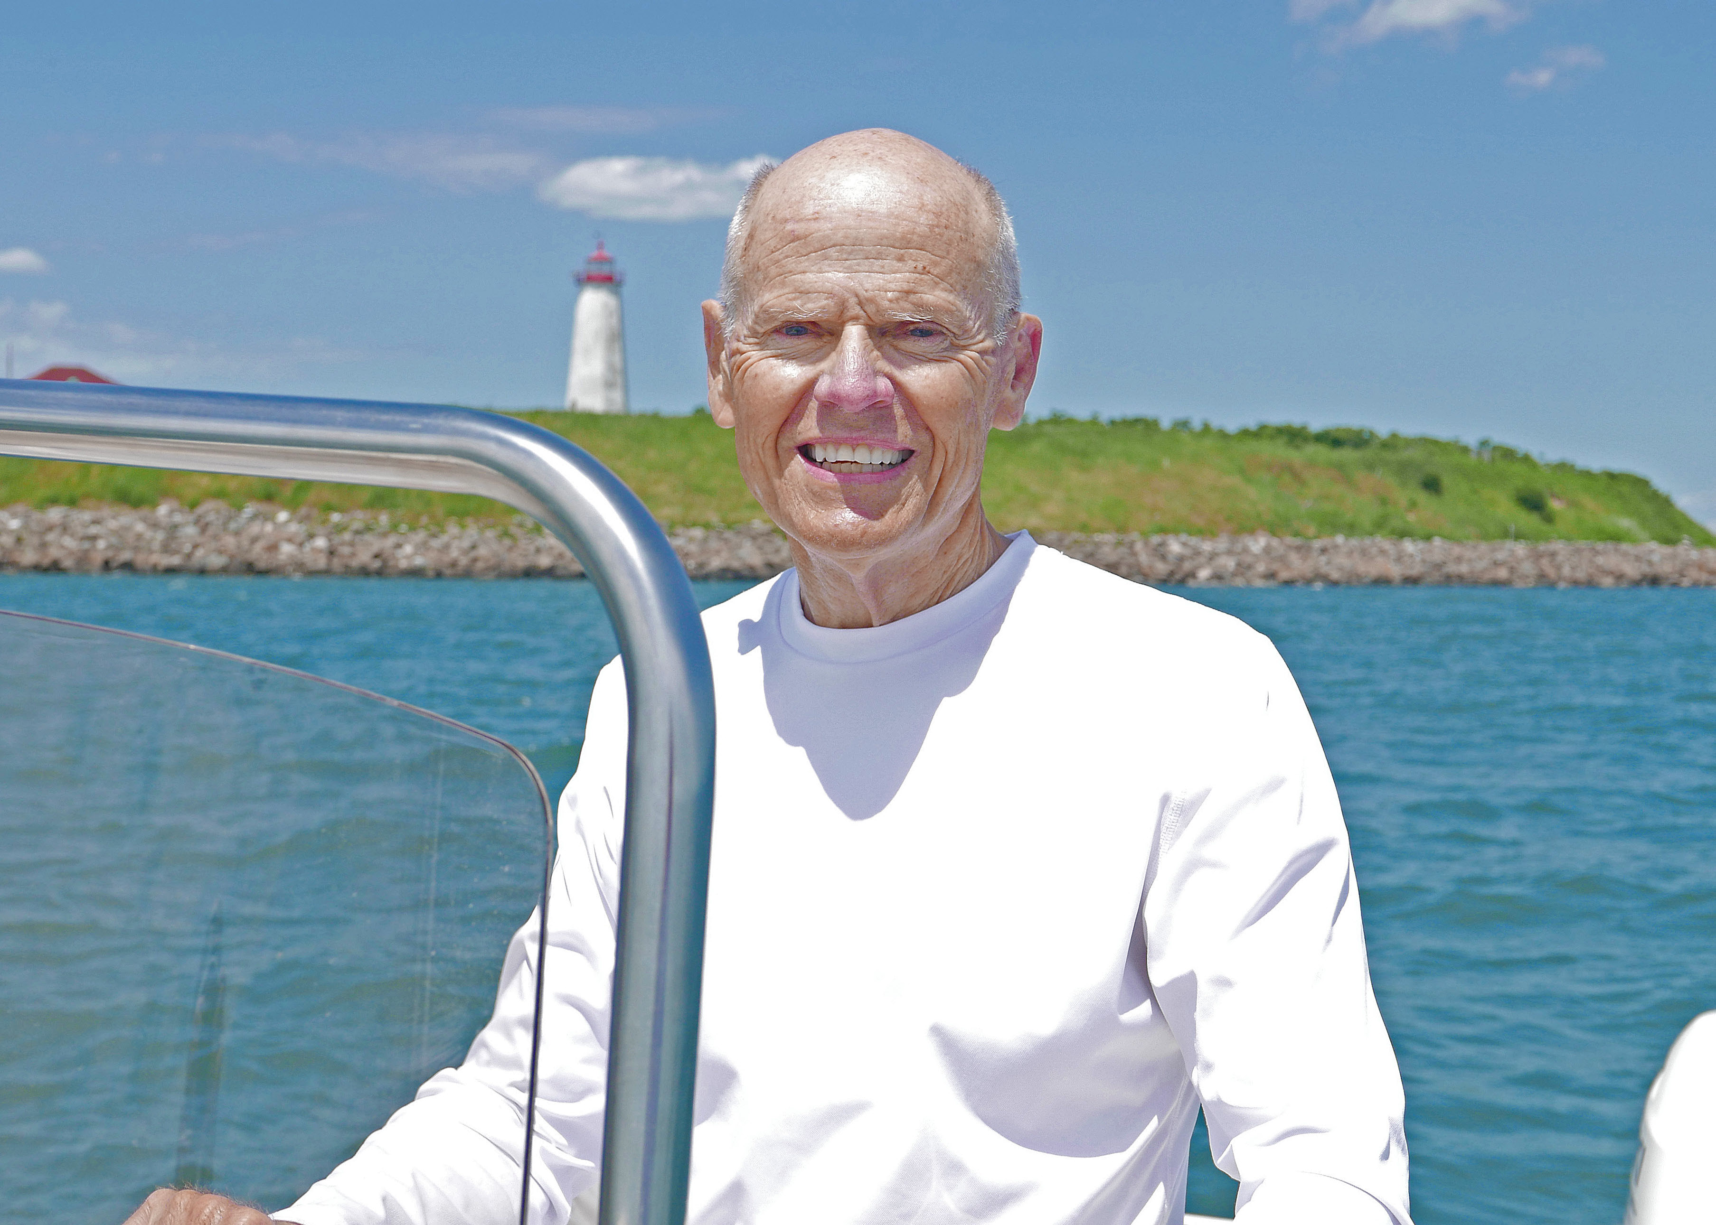

'69: Bill Bissell sailing off Faulkner's Island in Long Island Sound

Chuck Talar sent a photo from his recent visit to the Eagle in Galveston, Texas. “We've reached the point where e-mails from former high school and Academy classmates contain news of one less on the planet. On a more positive note, the Eagle was in Galveston over a weekend in June (her last visit to Galveston was in 1972) and I was able to go on board for a tour. The last time I was on the Eagle was during one of our Homecoming weekends, when she was in New London, which had to be over 30 years ago. I am still teaching full time at St. Thomas University in Houston and still resident at St. John Vianney Church in West Houston. So far, health has held.”

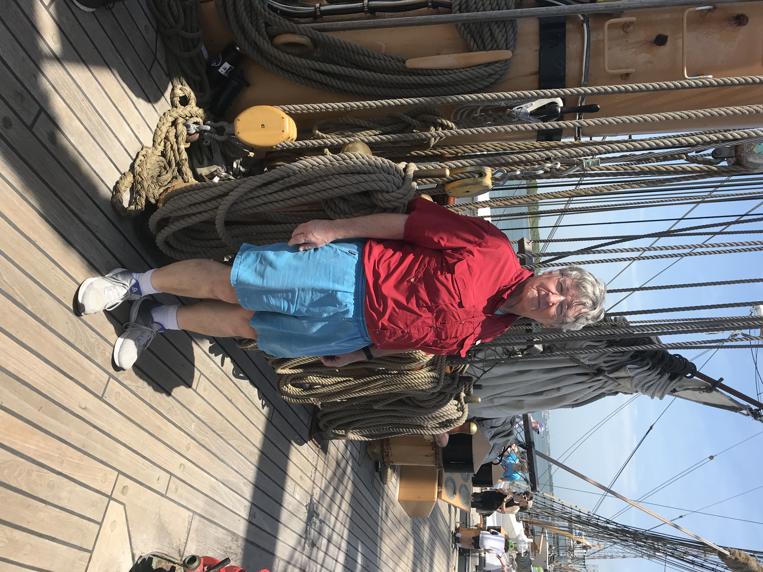

'69: Chuck Talar on-board Eagle in Galveston

Mike Moore updated family activities. “Alice retired from the WIC program last September. She worked at home for well over a year and going back into the office while still doing all her work by phone was the impetus she needed to finally retire. Her retirement has made our travel planning much easier. We took two trips to Hawaii, the first in celebration of Alice's retirement and the second to escape the east coast winter weather. We also took a long-planned Christmas Markets River cruise with several family members, from Basel, Switzerland to Amsterdam, including a pre cruise visit to Lucerne. Jumping through the various COVID hoops proved to be interesting. We found that a Swiss registration took care of our needs while in Europe, and the Hawaii registration was easy. We visited Sacramento, Nashville, and Arlington, Texas several times. In March, we traveled to Nashville to observe our daughter Rebecca's successful Ph.D. dissertation defense at Vanderbilt University. In May, we again traveled to Nashville to see her graduate and be ‘hooded’ by her two mentors. We were thrilled that so many members of our family were in attendance, including our older daughter, Laura, and son, Chris. Rebecca is now in post-doctoral study at Vanderbilt. Incidentally, we recently saw Jim (CGA ’59) and Sharry Foels. Jim was the commanding officer at Coast Guard Air Station Miami for the first three years of my tour there; he is genuinely a good guy.”

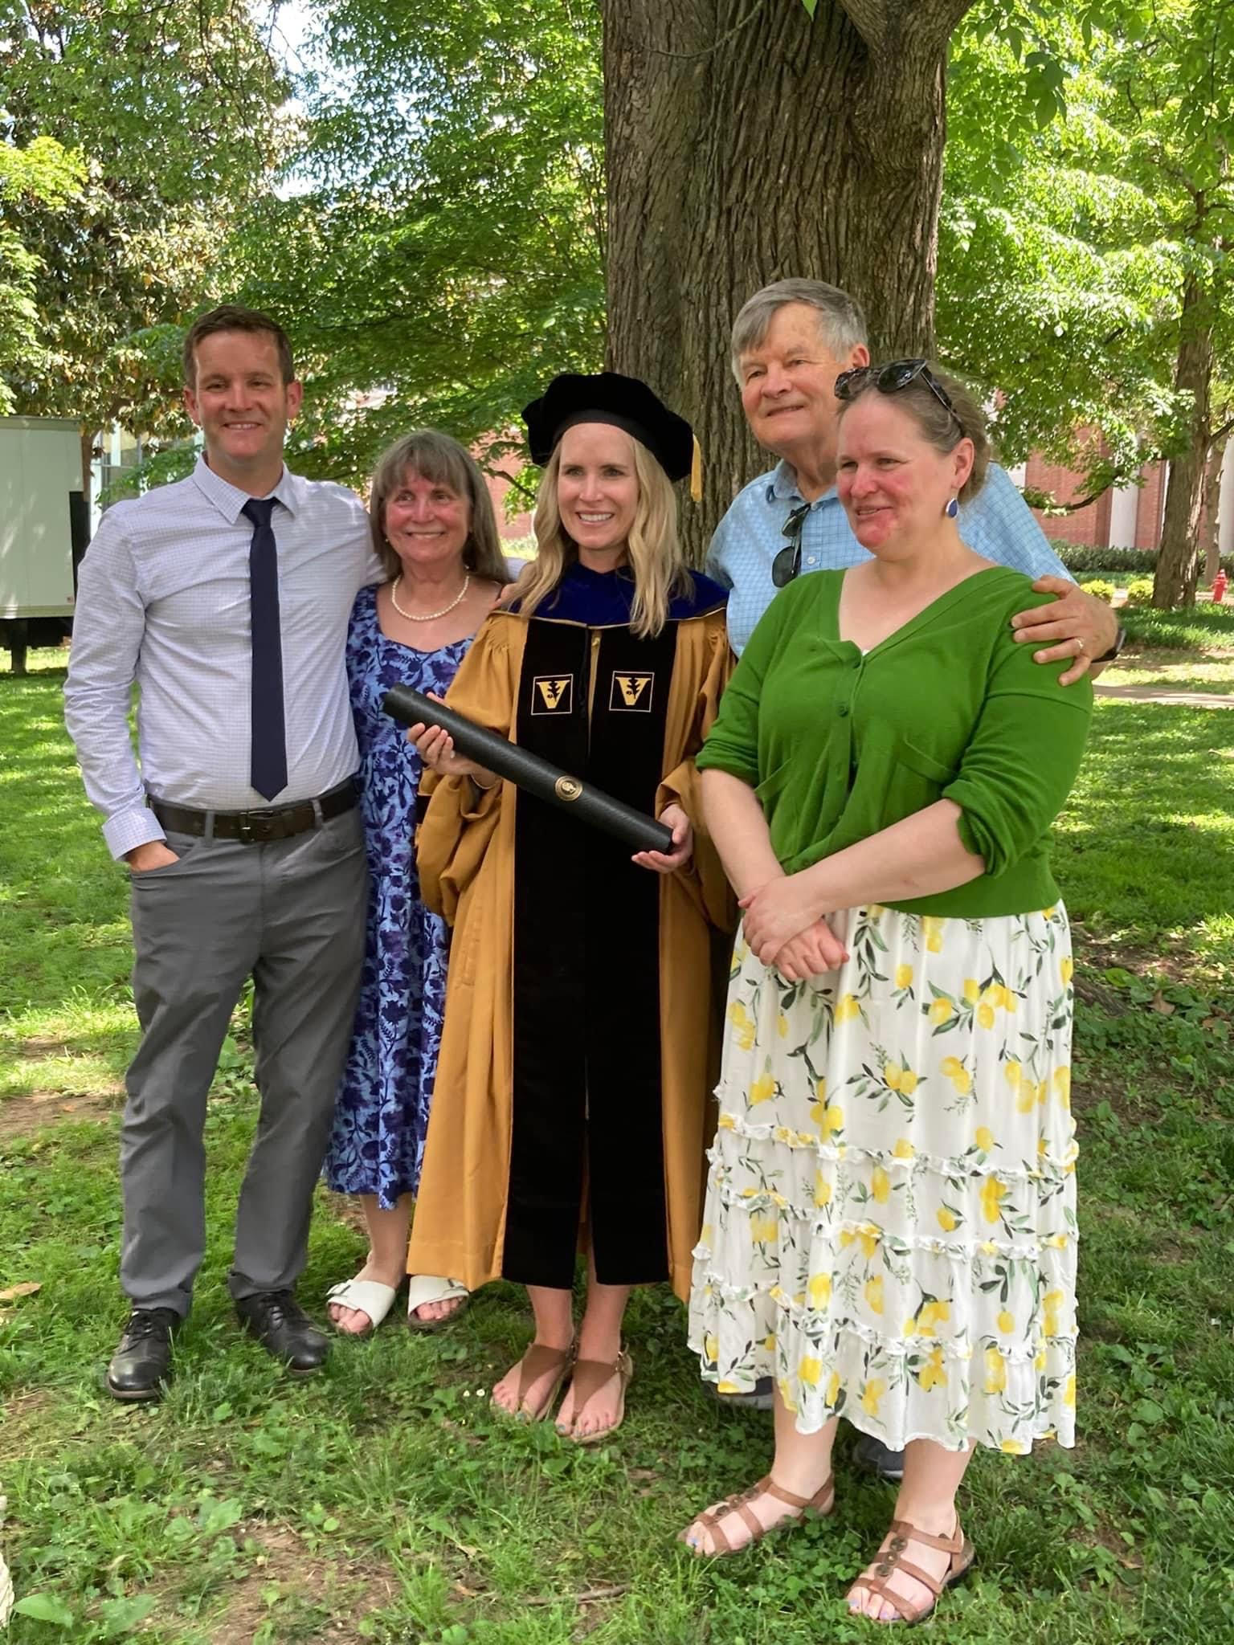

'69: Mike and Alice Moore and family at Vanderbilt University attending Rebecca's graduation

Bob Pokress and John Curtis spent a week in June on the southwestern coast of England as budding actors in the filming of the English television series Doc Martin, starring Martin Clunes, Caroline Catz and Ian McNeice. Read Bob’s article elsewhere in this Bulletin, complete with glamorous photos of our now famous classmates. You may see more of Bob and John’s adventure in the next ’69 Class Notes column.
Paul Prokop is retired in the New Orleans area, enjoying the excruciating heat and humidity of the Gulf Coast but knowing that he will be spending the month of September in their get-away home in the Grand Traverse Bay area of Michigan. He penned his ‘Rest of the Story’ sitting in front of an air conditioning unit in their River Ridge home in Louisiana. “As we all remember, the upper-class leaned heavily on the fourth class to produce spirit signs and events to support the team for upcoming home football games in 1965. One evening, while hanging out in the basement of the Officers’ Club, awaiting the call for an after-dinner Idlers performance, I discovered an unlocked door that led directly to Gunner MacDonald’s gunnery lab, complete with all manner of gunnery equipment and props, including a large, orange dummy torpedo. Having been an aficionado of the TV series The West Point Story (1956-1957), where Military Academy cadets were always pulling spirit building pranks, I spotted an opportunity for the upcoming Norwich University game. With the help of Alpha Company swabs and classmates Tim Josiah, Al Berry, and others, we formulated a plan to schlep the torpedo down to the visitor stands on the football field and hang it and a sign that read ‘Torpedo Norwich’. At ‘zero-dark-thirty’ on the Friday night/Saturday morning before the game, our band of miscreants in dungarees, watch sweaters and watch caps snatched the torpedo and marched it down to the field. The darn thing was big and heavy, and we and the torpedo had to be kept out of sight of the roving security patrol. Al provided line and blocks from one of the yachts that were used to truss up the torpedo to suspend it between two light poles, figuring if we got it high enough and the rig complicated enough, it would be difficult to remove before the game. Unfortunately, the light poles were too limber/not strong enough to suspend the torpedo, so Plan B became placing the torpedo on the stands and suspending the sign. It was magnificent – I wish we had a picture. The bad news was that our installation was removed before the game, so very few got to enjoy our efforts. The good news was that not a word was spoken, nor was a question asked – we had anticipated the possibility of being lined up and interrogated, followed by demerits/tours for breaking and entering, misappropriation of government property, etc., but figured the caper was worth the risk. I hope the security patrol and Gunner MacDonald did not get into serious trouble.”
The Coast Guard Aviation Association publishes a weekly e-mail that summarizes the historical aviation events from that week, with links to a Facebook page and source material, authored by Sean Cross (CAPT, USCG Retired/CGA ’94), the son of Terry Cross (CGA ’70). “TODAY IN COAST GUARD AVIATION HISTORY – 29 JUNE 1992: Captain Paul Garrity, Commanding Officer of Air Station Cape Cod, MA (at the time) earned the 1992 Captain David H. Jarvis Award for Inspirational Leadership. The Captain David H. Jarvis Award is a Navy League award recognizing the Coast Guard officer.…who has made an outstanding contribution to the high standards of leadership traditional in the United States Coast Guard.” I was not aware that Paul had been awarded this prestigious honor and felt that it should be restated for those who also were not aware. Thank you, Sean, and (belatedly), congratulations, Paul!
Dick and Bekki Burke hosted their church’s fifth annual Baby Boomer Group Mystery Night in June at their home in Vacaville, California, and the theme was Roaring 20’s/Great Gatsby. “A couple brought their beautiful 1931 Ford Model ‘A’, complete with rumble seat, to decorate our driveway for the event. The crime victim for the mystery night was poor ‘Dahlia Sparrow’ who met her demise after being attacked with a rock by a jealous girlfriend and then fell into a pool (our swim spa). The murder weapon can be seen in the photo. A wonderful time was had by all, except Dahlia, of course.”

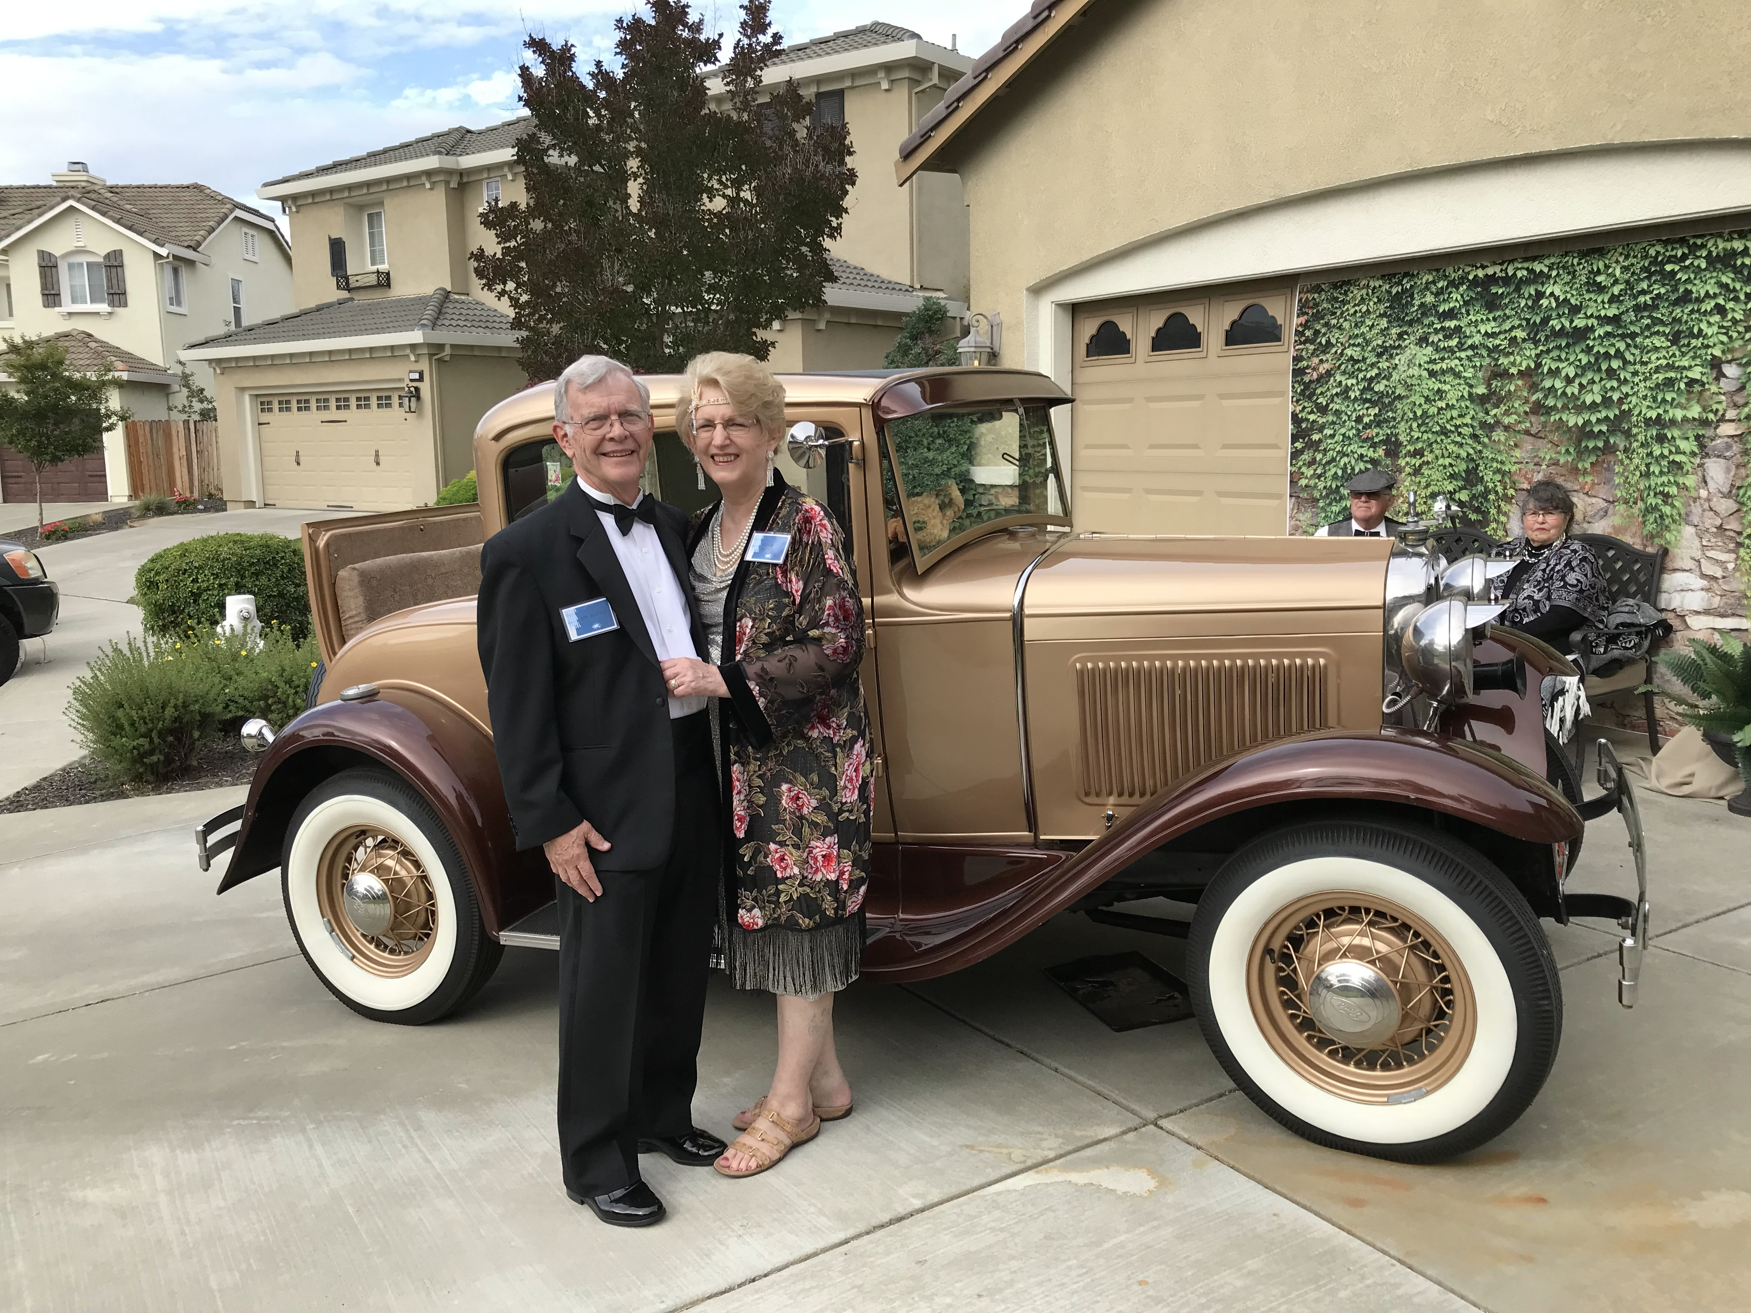

'69: Dick and Bekki Burke with the 1931 Ford Model 'A'

Bruce Griffiths was the guest presenter for a recent Academy Alumni Association Lunch & Learn session titled ‘Leadership in 30 Minutes’, hosted by Alumni Association President Andrea Marcille. In the presentation, Bruce shared insightful tips on how we can be better leaders and managers, now and in the future. As a consultant and founder of Organization Systems International (OSI) in San Diego, Bruce has specialized in assisting organizations choose and develop leaders and leadership teams for over 41 years. He has been a consultant for the United States Departments of Energy, Defense, Interior, and Transportation, and recent private clients have included Nike, The Walt Disney Company, Siemens, and AT&T. To see a recording of the half hour session, contact the Alumni Association for a link.

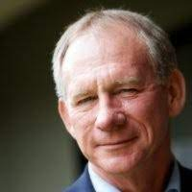

'69: Bruce Griffiths presenting at the Alumni Association's Lunch & Learn

Congratulations to the Class of 1969! We placed 6th overall in the All-Class Challenge with 30% participation and raised $9,945.
I received my copy of the June/July 2022 edition of the Academy Alumni Bulletin and was surprised to see that the photo of Don Walsh that I submitted to the Alumni Association had an incorrect caption. An immediate apology went out to Don. “I am certain that classmates will recognize you as the classmate from Watertown, Connecticut, and I will correct the error in my August/September column. I assure you that this was not intentional, and that I have not reached that stage of life where I confuse Don Walsh with Jerry or Kris Hale. Best to you and Maryann as you continue your search for the perfect location in Italy. I hope this does not mean that I am no longer welcomed to visit you on the Adriatic Coast!” Don’s response. “Not to worry - you're always welcome. Just bring a photo ID so that I know that you are not Jerry Hale in disguise.”

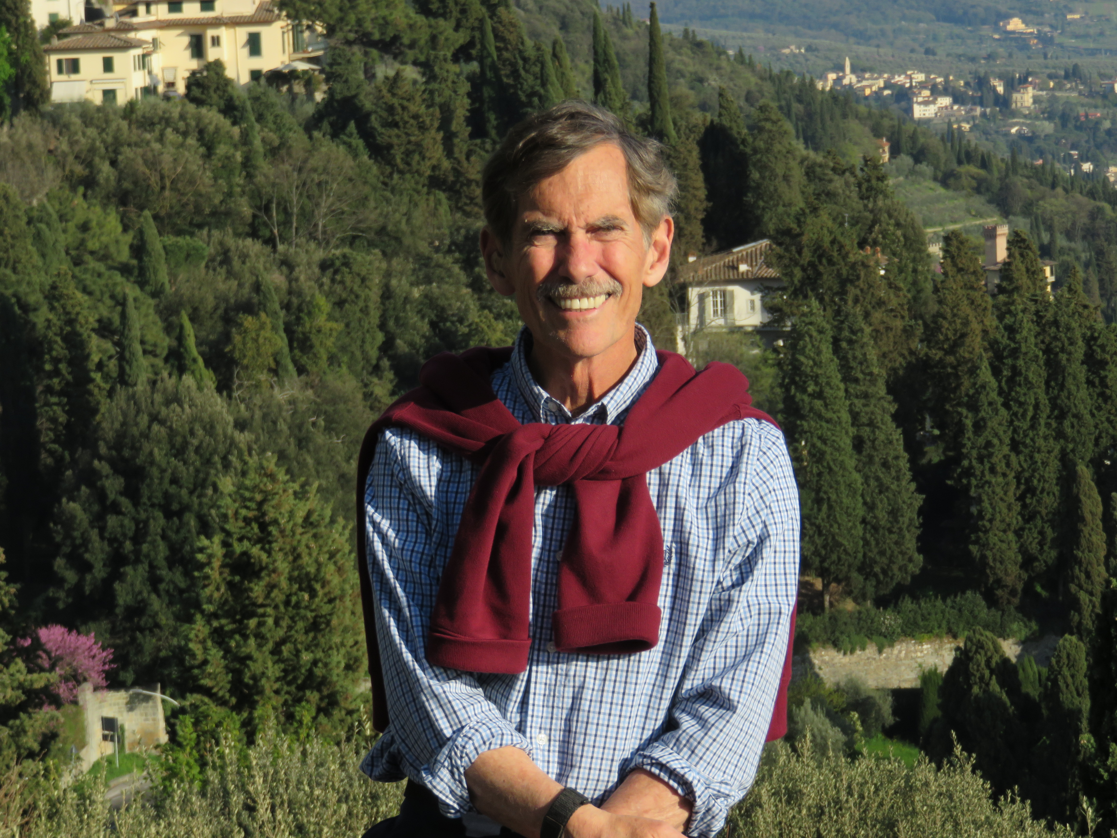

'69: Don Walsh in Calabria, Italy in 2019

