December 2007

’69 CLASS CORRESPONDENT

CAPT Bob Gravino
2 Summer Street
Ipswich, MA 01938
(978) 356-0825 (H)
E-mail: rcgravino@aol.com
Class Website: http://mywebpages.comcast.net/ckreiler/index.htm

MIKE and ALICE MOORE were in New England in late September for the marriage of their son Chris to Meaghan O’Connell at the old South Church in Portsmouth, New Hampshire. Their wedding ceremony included an arch of swords with five Navy Lieutenants and one Marine Corps 1LT. MIKE reports that oldest daughter Laura gave birth to her third boy on July 18. Younger daughter Rebecca graduates from the University of Alabama in December with a B.S. in Chemical Engineering and is applying to several dental schools, with plans to finance her future through the Navy, Air Force or Public Health Service. MIKE commutes from Severna Park, Maryland to the Dallas-Fort Worth metroplex and works as the Chief Pilot of a start up airline, writing manuals and answering questions about airline certification. ALICE works as a WIC counselor and certifier in Maryland. For birthday gifts this year, Rebecca gave MIKE and ALICE tickets to the Tennessee-Alabama football game in Tuscaloosa. MIKE did not share who he rooted for at the game.

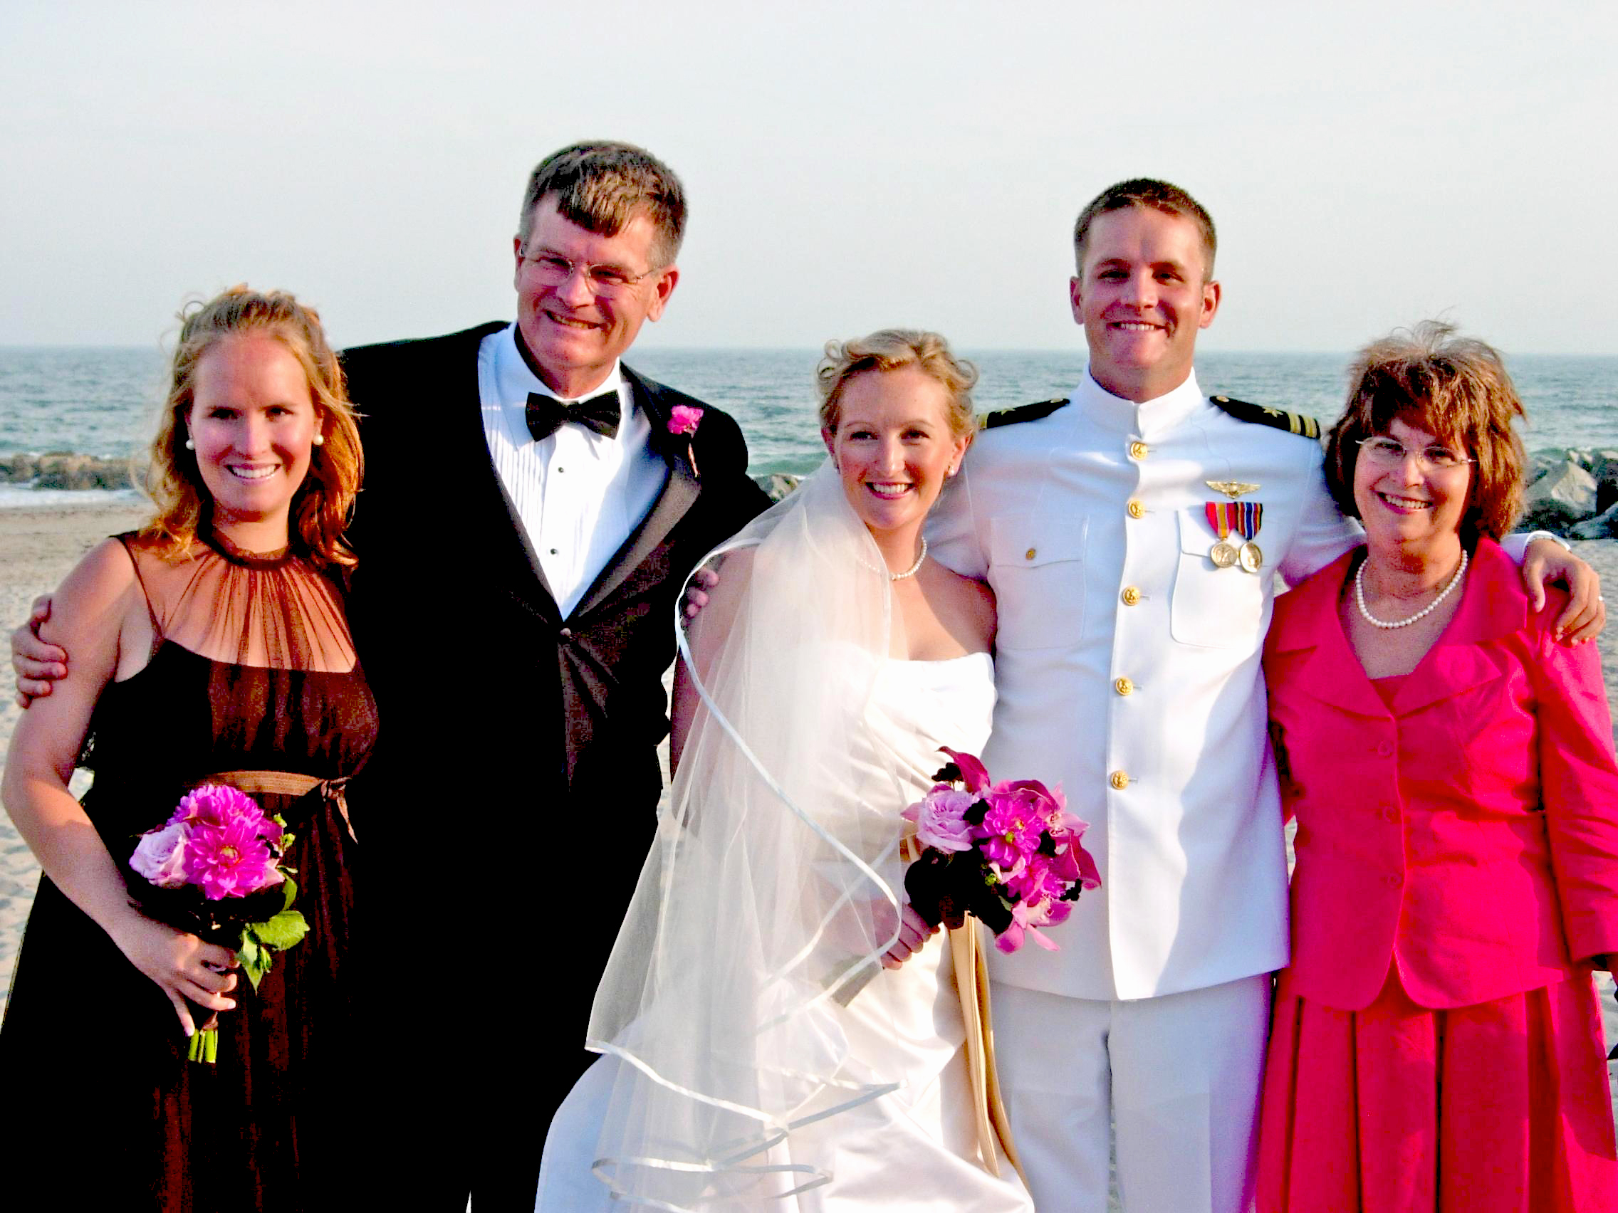

JOHN and LESLEY MINER (new e-mail address: jkandlcminer@aol.com) and BRUCE GRIFFITHS have superbly documented the Class trip to the Grand Tetons in September. First up, LESLEY: “Here are a few highlights from JOHN & LESLEY’S (and JAY & JANE’S, HARRY & SHERRIE’S, RON & MARIANNE’S, BRUCE & GAIL’S, JIM & CINDY’S, and RICH & ANNETTE’S) excellent adventure. A national park out west was on the “must see” list for many of us and with a glowing recommendation from PETER KISSINGER, the MINER’S, SNYDER’S, GRETO’S, GRIFFITH’S, BURK’S, and FORD’S arranged to spend a week at Jackson Lake Lodge in Grand Teton National Park. HARRY and SHERRIE LORD live just over the mountain from Wyoming in Idaho and joined us for several activities. We had a wonderful time – the area is astonishingly lovely. The weather was perfect and we did just about everything we could think of to enjoy our visit. Our activities included a trail ride (YeHaw), a bus tour highlighting Yellowstone Park, a hot air balloon ride (the best way to view the elk herds), a float trip down the Snake River, a tram ride up Rendezvous Mountain, a chuck wagon meal with cowboy entertainment, a little golf, a little shopping, some lovely hikes, and lots of catching up on news with old and new friends. Between the seven couples, we took enough photos to keep our family and friends bored or entertained for years. Ask us – we would love to share.” Now JOHN: “We have so many photos between the seven couples that we could fill a book. GRIFF is in charge of sending you the “GRAVINO” (that’s the name we have assigned to the obligatory group photo). I have one good picture of BRUCE, JAY, RICH, and me on a mountain top. Unfortunately, RON and HARRY were somewhere else that day. I have one great golf story. BRUCE, JIM and I were playing and on the last hole a red fox came out on the course and stole a golf ball. The fox took it into a sand trap and when I went to get it he was acting just like one of my dogs and wanted to play. It was really fun.” And finally, BRUCE: “It was a grand week in the Grand Tetons! At our cowboy dinner, GAIL got one shot of all us ‘69ers, including HARRY LORD. I’ve also included a photo of most of us ascending on a chilly Wyoming morning in a balloon. Between the seven couples, we probably have 2000 images – so if you need more, we got ‘em!”

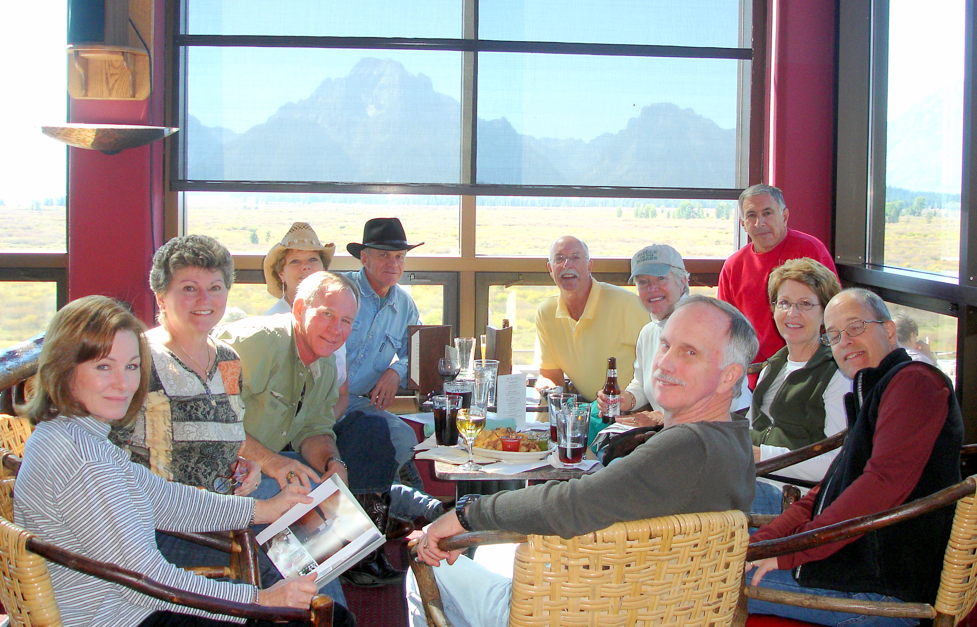

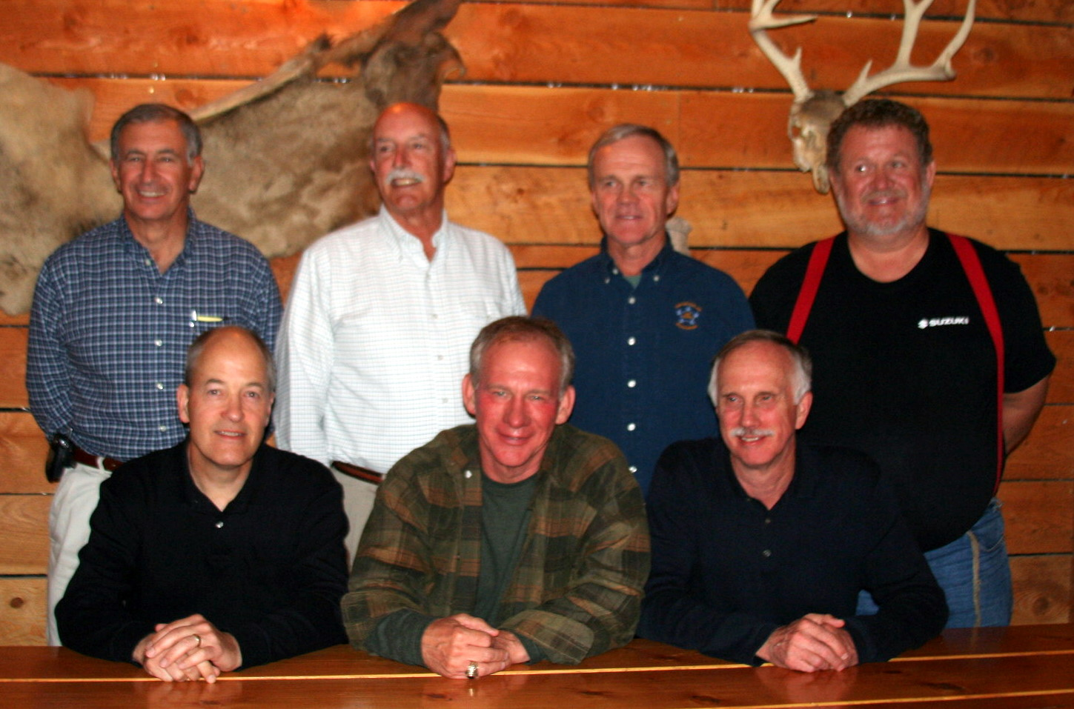

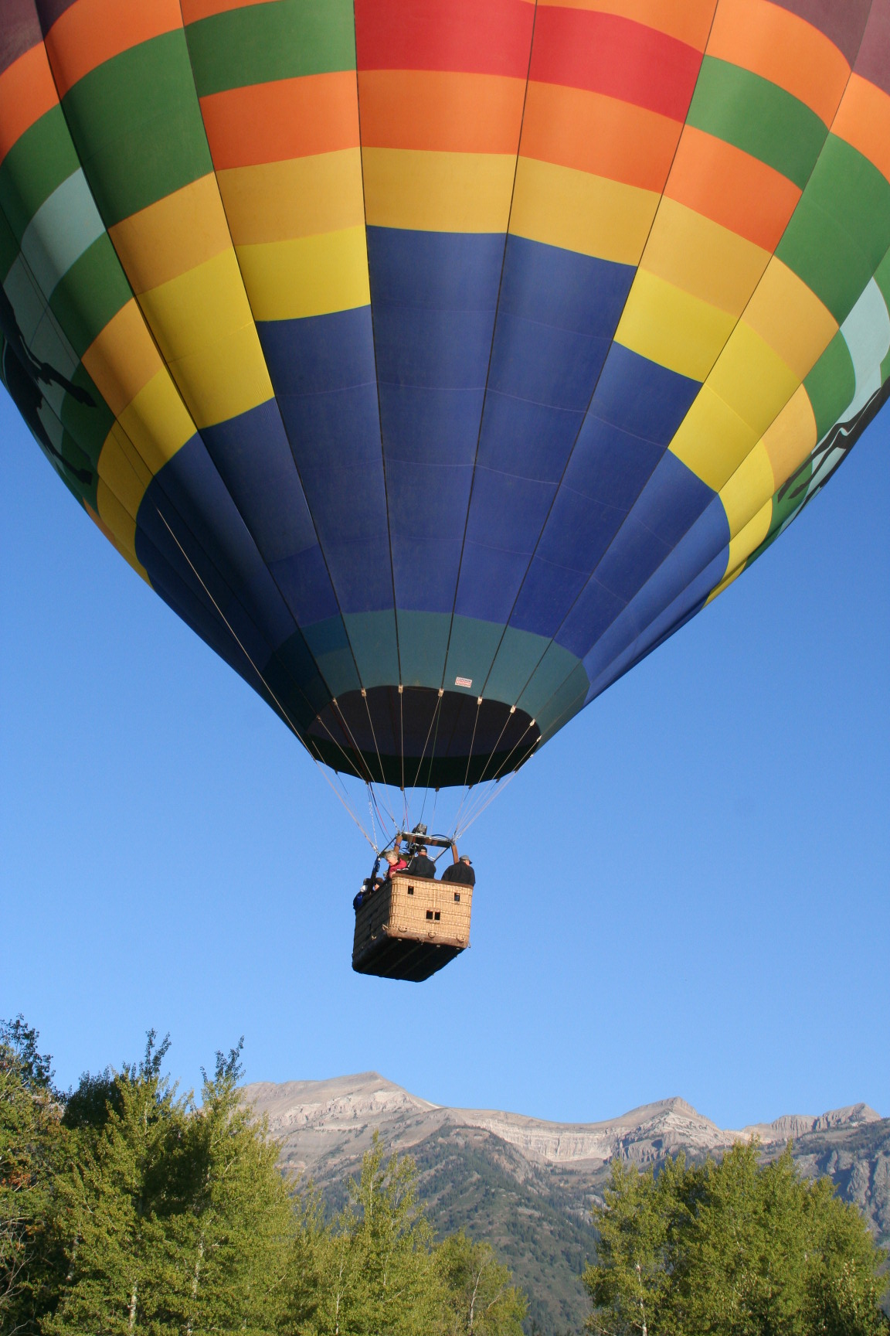

I received an e-mail from DREW GERFIN and noted that he has a Trinidad cellular telephone number. Is there something going on in Picayune, Mississippi that needs looking into? Overseas accounts? Rum running?

In late September I sent out a class e-mail with an update on DOC SHRADER. I am reprinting portions of it here for those who did not receive it, whether classmates or former shipmates of DOC’S. “I received an e-mail from Jim Sylvester (CGA ’71), President of the Academy Alumni Association, concerning DOC SHRADER. Jim had recently been in Juneau with Mike Conway, a classmate, who has been in touch with DOC and GLORIA. I spoke with GLORIA and she has “cleared for release” the following information that Mike passed along. ‘DOC is in a nursing home in Bel Air, Maryland, about ½ hour north of Baltimore off of I-95. His phone number is 410-420-9466 and he receives mail at 618 Yarmouth Lane, Bel Air, MD 21014. DOC and GLORIA are among the best people on the planet. DOC is as sharp as a whip and one of the most positive persons I know, but he is severely physically restricted.’ DOC retired from the Coast Guard in the early 1980s after being diagnosed with MS, and worked for many years as the Facilities Director at a college north of Baltimore. He has been at the nursing home for the past six years. Anyone wanting to communicate with DOC can contact him at the telephone number or address listed above. The e-mail address for his computer at the nursing home is draseley@aol.com.”

I came across a news release from Reuters that quoted TIM JOSIAH describing the homeland defense market. TIM is vice president for Homeland Security at Raytheon Company.

JIM SMITH has volunteered to share with us the return to the stage of the 1960s hit band, The Gents! For those who have not heard, The Gents formed again over the past year for a surprise appearance at CGA ‘67’s 40th Reunion. “Homecoming was outstanding! 88 degrees, football team won big, CGA was beautiful. First time I’ve seen the Alumni Building, and also the new lower field athletic facilities. And The Gents were a smash hit. The Class of ’67 was stunned. We had a professional “sound man” that Jay Clow knew, and it made quite a difference. The Class didn’t really know we had practiced…they thought maybe we’d just stand up and take a bow for old time’s sake. But when we started playing MUSIC, holy crap, Batman, they loved it! First, Jim Townley had put together a computer presentation with video of their Class on the Eagle, followed by the “British Invasion” of the Beatles, and how CGA defended the homeland against the Fab Four with its own secret weapon, The Gents. We started with “Not Fade Away” by the Rolling Stones, and then Paul Pluta explained that The Gents had not faded away, we had just been on a 40 year break. Our last song was the band’s anthem, “We Gotta Get Outta This Place”, which of course everyone loved. We had an encore ready to go, but beforehand we weren’t confident that the crowd would want to hear an encore, so we had a plant in the audience (Joe Angelico), just to make sure it happened. Wow, we didn’t need Joe! So we then played “Gloria”, probably the best we’ve ever played it, and Paul Pluta had special verses made up for certain members of the Class…Chad Doherty, Rick Larrabee, Steve Schember, and more. The crowd went wild! Altogether we played 11 oldies for about 45 minutes. The Class had a DJ beforehand and afterwards. The sound man also recorded the music, so I think we’ll all have CDs sometime in the future. Also, we had a 1965 photo of The Gents taken out by the old CGA North Gate…we took that same photo again, 42 years later. That’ll be put in the memory box! Wish you coudda been there. Somehow, Archie Gardner and Jay McBride sneaked in. We won’t be surprised (actually we are hoping) that ’68 and ’69 will want us to make an appearance at their/our 40th, too!” My apologies to ’67, but The Gents and the memories that they conjure up belong to all of us, and this was too good a story to pass up.

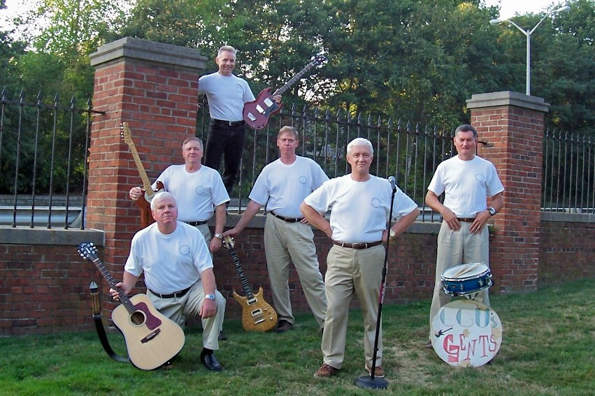

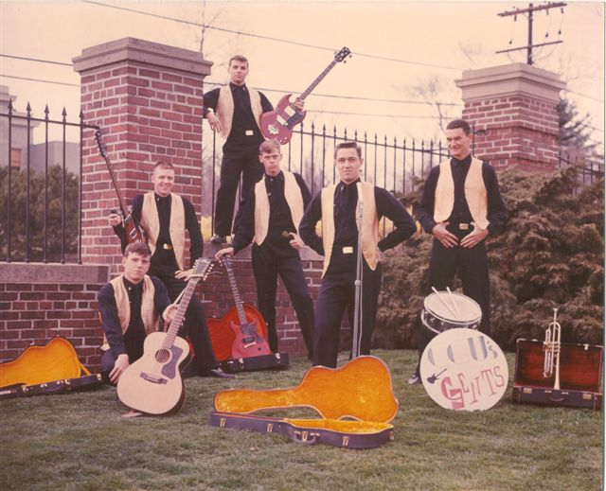

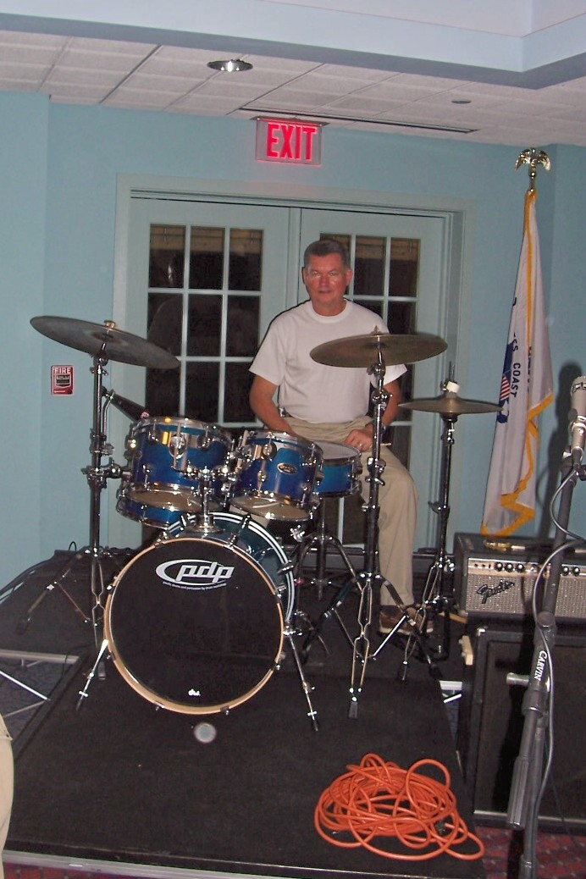

The following e-mail from Amy (Jentoft) Hussar hit my computer in mid-October. “I came across the February 2006 Coast Guard Academy Bulletin when I googled my dad’s name, and thought I’d give you his contact information in case you didn’t have it. He’s still in the UP (Upper Peninsula of Michigan), and always will be (not me – both my husband and I served in the Army for five years so we’ve been all over). E-mail address: jentofta@aol.com. Home address: 2650 West Grove Street, Marquette, MI 49855. Cell phone: 906-250-8492. Home phone: 906-226-6431. He spends most of his time at his camp on Lake Superior (Huron Bay), so he’s not always around to check his e-mail.”

A note from GARY PAVLIK: “Our oldest child, Emily, is now an O-3 MD in the USAF Medical Corp. She, and her husband Bart Kneip, reported to her first duty station in San Antonio this June after finishing a three year emergency medicine internship in Houston. She is currently scheduled to deploy to Iraq for five months in late 2008 or early 2009.”

An interesting and educational update from DON DEBOK: “Since getting my Certified Financial Planner (CFP) designation, I have served as a part-time faculty member at the University of California, Irvine. I have authored four on-line courses in their Personal Financial Planning curriculum. The program is designed to provide the education that career changers need to obtain certification as a CFP. A year ago they asked me to prepare a course on financial planning for the mass market, under a grant by the CFP Board. The course is part of the open architecture movement and is available free to anyone that chooses to participate. The title is The Fundamentals of Personal Financial Planning. It is now complete and available on-line at http://ocw.uci.edu/courses/AR0102092/. For those that are interested, there are eight modules with from one to five lessons. It will take 20 to 25 hours to complete. Maybe only 15 for a CGA graduate.”

Mark McDermott, CGA ’67, sent an e-mail informing me of the death of MARK ANDERSEN on October 14 in Downingtown, Pennsylvania. MARK was a member of the classes of ’68 and ’69, graduating in 1964 from Old Lyme High School with RICH LOSEA, Marc MacDonald (CGA ’68), and Butch Minson (CGA ’68). In a follow-up e-mail with Mark McDermott, he passed along the following: “It’s a small world. I came to rural southeastern Pennsylvania in the mid-seventies to take a job with the state’s thoroughbred breeders association. After being here about two years, I was in a crowded restaurant-bar one evening, and over the din I heard “Swabbo”. There are many things I have forgotten about those years of my life, but this is not one, and I immediately turned to see this combination hippie-mountain man in blonde tresses and an unruly beard, welcoming me with a wide grin on his face. It was MARK. Turned out he was living on a nearby horse farm owned and operated by one of the directors of my association. We spoke for a while, laughed at all the things ex-cadets laugh about, and over the next fifteen years, saw each other quite a few times. I learned this about him: MARK was his own person, living originally in a tenant house on the farm with no electricity or water that he eventually fixed up quite nicely. He was a free thinker and philosopher, with a confident social conscience. He played hard, and he worked hard at the important things. He did good deeds for many, many people, and expected nothing in return. He later left the farm for a more conventional life, and I lost contact with him. Only through third-hand conversations with mutual acquaintances was I periodically updated. I had heard he was sick, but I failed to reconnect, and on a morning last week, I sadly learned of his passing. He was a good guy, someone I am proud to say I knew. A Quaker service should suit his memory well. Have all your boys lift a cold one in his honor.”

The death notice that Mark McDermott sent mentioned that ALAN VLACH was MARK’S best friend. AL, like MARK, was another ’69 Classmate who left CGA before graduation. DAN ERSLAN has e-mailed that he and AL have passed telephone messages a couple of times over the past few months, but they have never reached each other to converse. DAN included AL’S address and telephone number: 14 Loon Cove, Trenton, ME. 207-664-0696.

