December 2019
69 CLASS CORRESPONDENT

CAPT Bob Gravino
2 Summer Street
Ipswich, MA 01938
(978) 356-0825 (H)
E-mail: rcgravino@aol.com
Website: http://www.uscga69.org

The excitement and emotion of the 50th Reunion weekend is hard to describe; it was a once in a lifetime experience. The weekend was one great event after another: connecting with classmates not seen in up to 50 years; remembering those who are no longer with us at the Class Memorial Service; the Medallion Ceremony and the bond that it strengthened with the Academy and with the Corps of Cadets; the class pride at the unveiling and dedication of the Monument to George Washington; the review of the Corps of Cadets; the musically inspired Class Walk On; the victory of the football team against Catholic University on Cadet Memorial Field; the pleasure of remembering cadet dances being entertained by The Gents; and the production of an outstanding Golden Tide Rips. Such a weekend can never be repeated.
The Class owes Bob and Barbara Thorne a special thanks for all that they have done planning and executing our 50th Reunion, as well as the previous reunions that they’ve organized. Bob was ably assisted by Paul Bodenhofer on reunion events, Wayne Gronlund and Mike Sprague on the Golden Tide Rips, Jeff Robbins as transportation coordinator, Bruce and Gail Griffiths and Jane Snyder on the Memorial Service, and Bob Pokress handling the theatrics and musical presentations. Dan Garrison and the Class Gift Committee spent over two years on the Monument to George Washington. We thank them on their achievement, a significant reminder of the importance of the Coast Guard and the Academy to our nation. Not to be overlooked were the efforts of Andrea Marcille and the staff of the Alumni Association, without whose guidance and support the 50th Reunion would have not been the success it was.
Doug Brown set an Academy sports record in the discus in the spring of 1969 with a throw of 159 feet, 8 inches. Doug’s record remained unbroken for an amazing 50 years until this past spring when Cadet 2/c Ben Zarlengo (CGA ‘20) broke the record with a throw of 163 feet, 1 inch, at an invitational meet at Connecticut College. At the Academy, Doug was a three sport athlete, earning varsity letters in soccer, basketball and outdoor track and a JV letter in football, and he was a featured athlete in the January 1969 Navy Times as a three sport athlete. Along with Greg Magee, Doug competed in the NCAA National Championship and the Armed Forces Games, where he surpassed his Academy record, establishing his career best throw of the discus of 171 feet, 3 inches. Doug followed his successful 20 career in the Coast Guard with a two year position with AT&T Transoceanic Cable Ship Company as a ship building project engineer in Singapore, and then took an academic position at the United States Merchant Marine Academy, where he served as an engineering instructor, assistant professor, full professor, assistant department head, and department head, retiring from Kings Point in 2011 after 20 years. While on the academic staff at the Merchant Marine Academy, Doug was involved as a coach and advisor to a variety of collegiate and intramural sports teams, and was honored over his time there with four prestigious Kings Point awards for his exemplary dedication and contributions to academics, athletics, and students. Besides the B.S. in Engineering from the Academy and an MBA from Harvard earned while stationed at the district office in Boston, Doug has an M.S. in Energy Management (with distinction) from the New York Institute of Technology awarded in 1996.

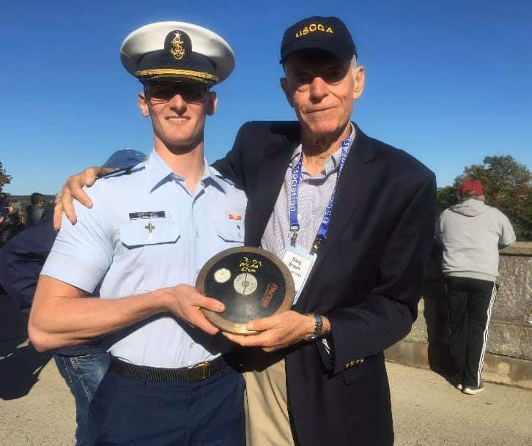

1969: Cadet 1/c Ben Zarlengo showing Doug Brown the record breaking discus during Homecoming Weekend

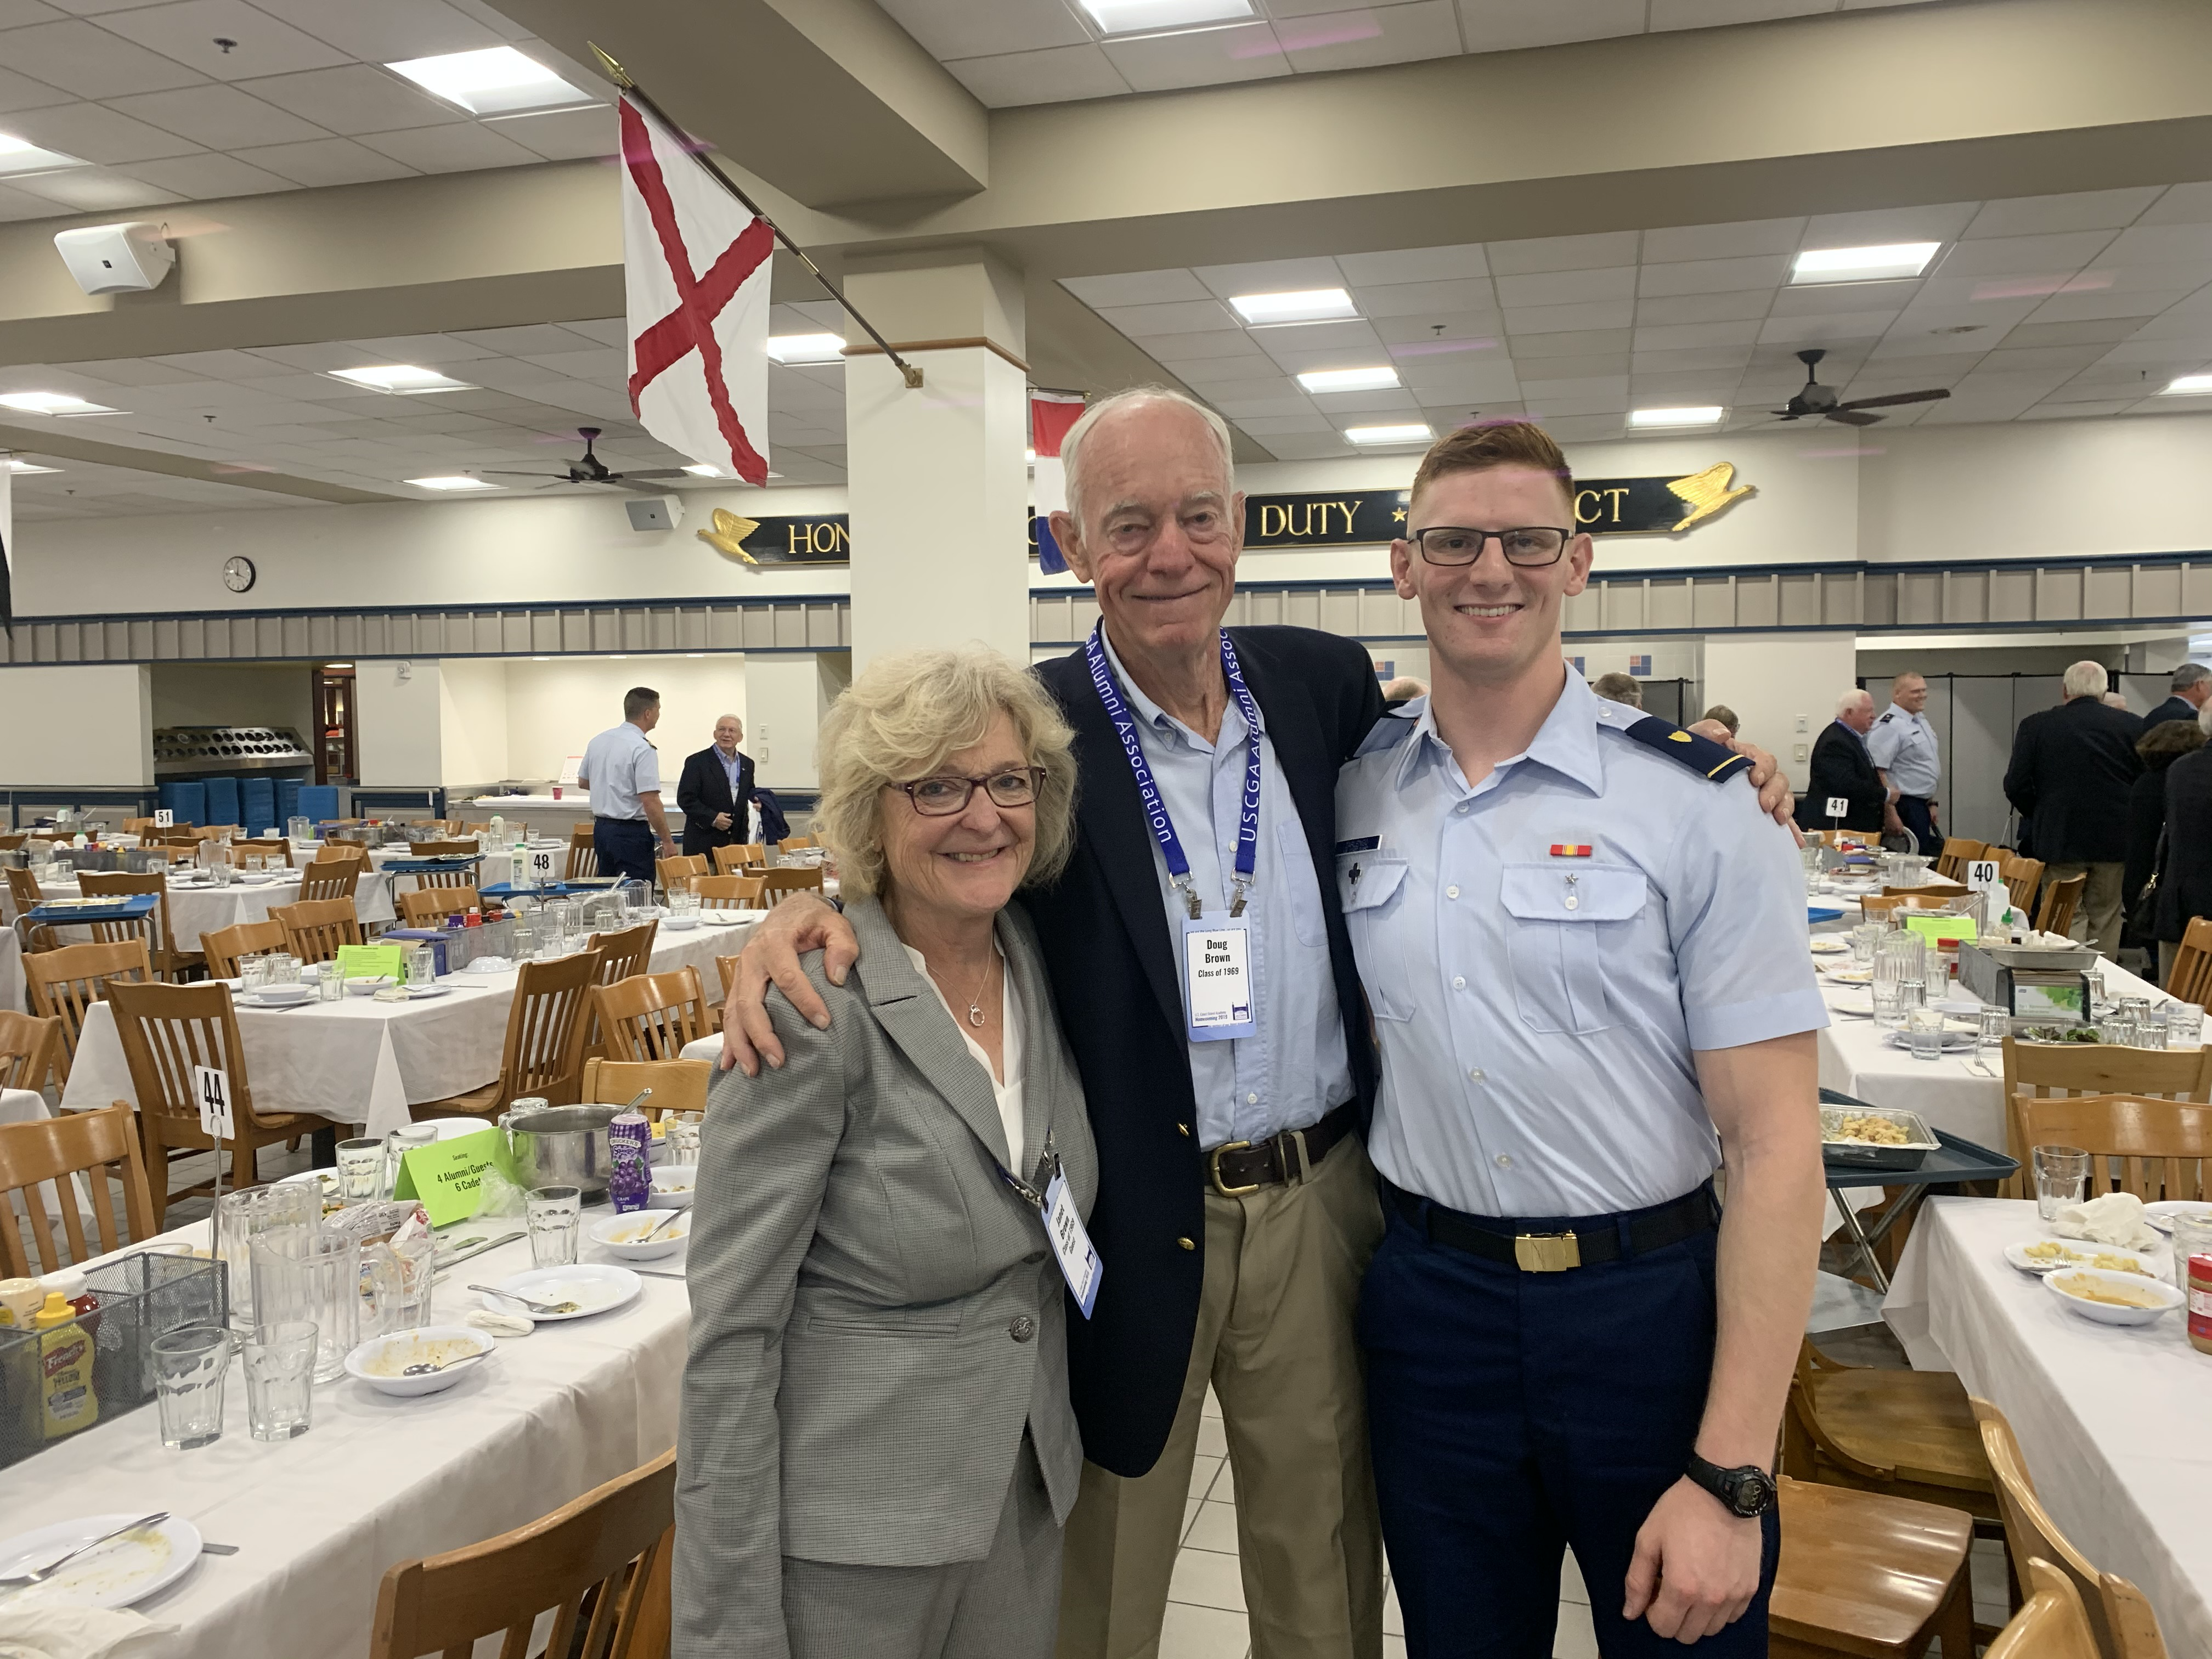

1969: Janet & Doug Brown with Cadet 1/c Ben Zarlengo in the Cadet Wardroom at Homecoming Luncheon

Jim Robinson, our Link-in-the-Chain classmate in Texas, has been the point of contact with Ben Zarlengo’s mother, Kristen, during the time that Ben and his brother Joe (CGA ‘17) have been at the Academy. Jim sent me the following letter that Kristen wrote regarding Ben and his time at the Academy. “I want to thank all who have preserved the Link-in-the-Chain and Homecoming traditions. This year has been a very meaningful time for my son, Ben. During the 2019 Track and Field Outdoor season, Ben broke Doug Brown’s 50 year discus record. This encounter of men, 50 years apart, but both with an Academy and sports bond, was the most significant moment of hope and affirmation that I’ve observed Ben experience as a cadet. I’m very grateful that Jim Robinson arranged for Ben and Doug to meet at this year’s Homecoming. I have been a CGA mom for many years, and I’ve stood in the wings through many ups and downs for my sons. The thing I could never do for Ben, which Jim and Doug did for him, is to provide a long-game perspective. During the 2019 Homecoming weekend, Ben was able to spend time with two men who have shown him that perhaps he too will one day look back and remember only the good relationships at the Academy, and to forget the very real struggles and frustrations. He learned through them that the Academy might just offer him intangible gifts he has yet to unwrap. These two ‘69 graduates did wonders for his spirit, moral and hopes that his future as an officer in the Coast Guard might, after all, be meaningful. So, thank you to everyone who brought these guys together. The ‘Links’ can really make a difference; Ben is proof.”
Mike and Judy Billingsley’s granddaughter, Kaitlyn, graduated from the U.S. Marine Corps’ Officer Candidate School at Quantico on August 17th. Kaitlyn is the daughter of Tammy Billingsley Buck and her husband, Richard, of Dawsonville, Georgia, and she will be commissioned in the Marine Corps after graduation from Embry Riddle next May, where she has been a NROTC Scholarship student. As Mike commented: “We are more than a little bit proud!”

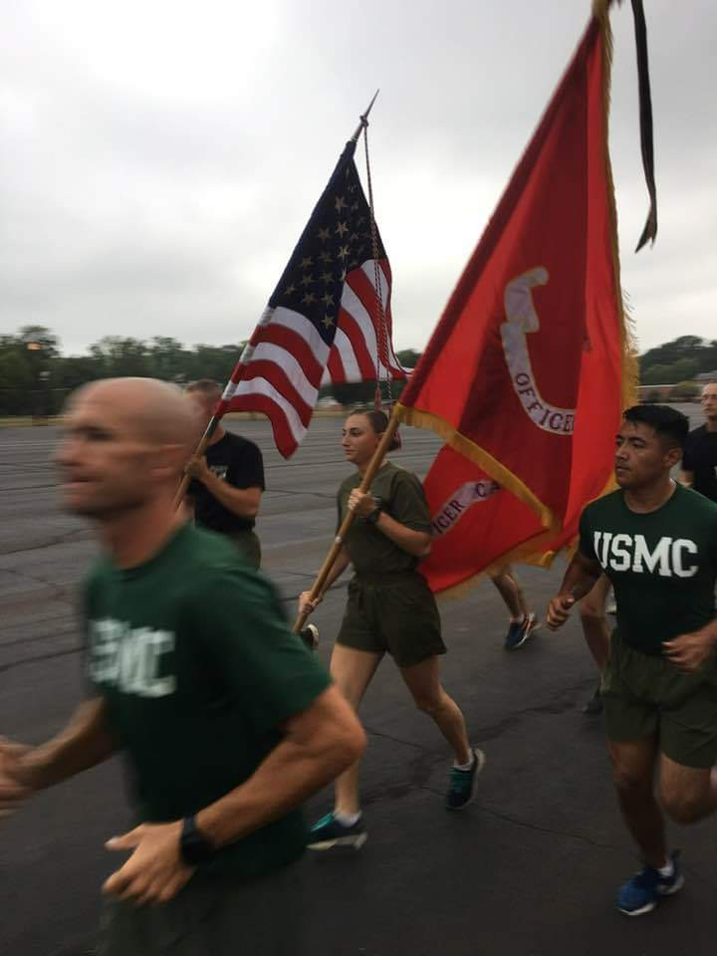

1969: Mike & Judy Billingsley's granddaughter, Kaitlyn, carrying the USMC Flag at Quantico

While in Texas in mid-October playing in Jim Robinson’s Sun City Member Guest Golf Tournament, Stu White and Jim met up with Pablo Rodriguez at the Iron Works Barbecue in Austin. Stu’s comment: “Great food, but better than that was catching up with Pablo after 50 years. A memorable time!”

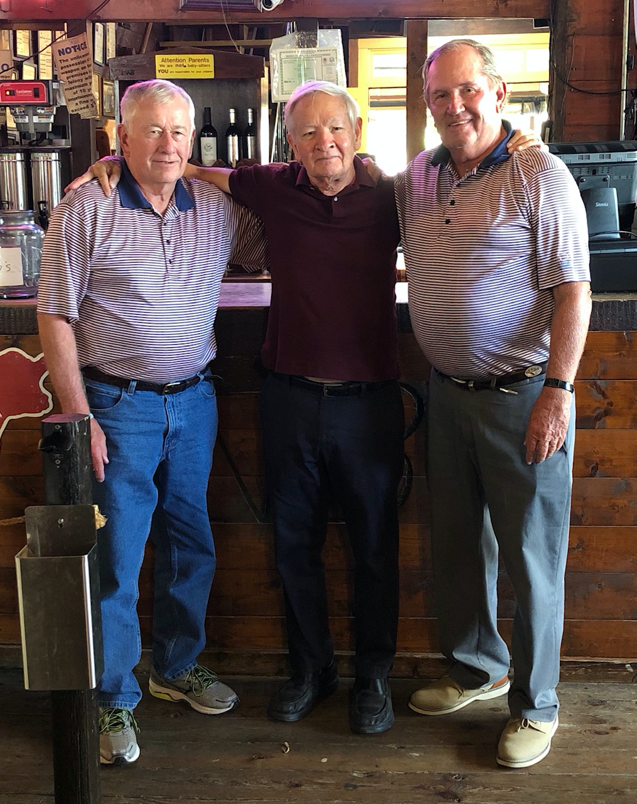

1969: Stu White, Pablo Rodriguez & Jim Robinson reconnect in Austin

The Burton Island Association Reunion was held in late September, and Fred and Linda Adamchak and Jim and Linda Robinson came north to Portland, Maine, to join the festivities. The CGC Burton Island was homeported in Long Beach and was Jim’s first assignment after graduation; Fred reported to the icebreaker after a short tour on the Wachusett in Seattle. Fred and Linda were driving Downeast to Bar Harbor after the conclusion of the reunion, and Kathy and I were able to join them at the Maine Maritime Museum and then for lunch in Bath and an afternoon at our home in Georgetown.

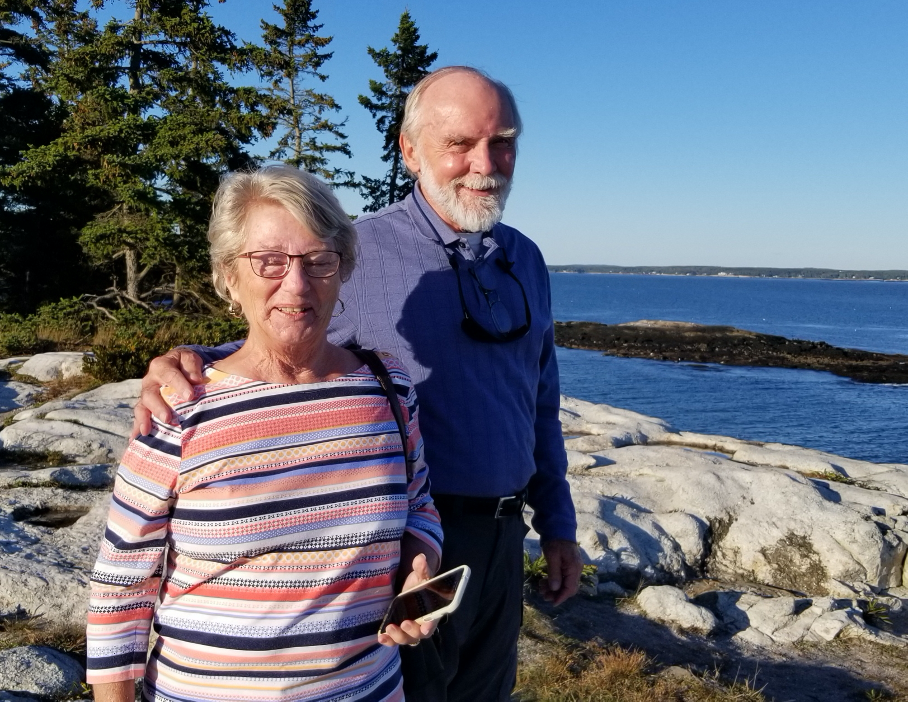

1969: Linda & Fred Adamchak at Reid State Park, Georgetown, Maine

Jim Smith has a story that must be told. “Over the past 50+ years I may have told a few people that I was ‘first in my class’. Let me explain. In June of 1965, about thirty 4/c cadets from the Class of 1968 went before an Executive Board that decided a few of us would be given a second chance. I went home on leave undecided about returning to CGA. The prospect of another Swab Year was the downside, but I was drumming for The Gents and had a new girlfriend (Marilyn). I had hopes, so let’s go for it! The Class of 1969 reported to the Academy on July 12, 1965. Four cadet ‘reverters’ reported into the Class of 1969 the weekend before. They were me, Tim McCloskey, Tommy Porter and Jimmy Dipasqua. That Monday, each of us reverters took turns in front of Chase Hall welcoming our new Class to CGA, thinking ‘Do they know what they are getting into?’ Tim, Tommy and Jimmy resigned before Christmas 1965, leaving me the only original reverter to the Class of 1969 who (finally) graduated. So, that explains ‘first in my class’; the first cadet to enter the Class of 1969 who later graduated. I’ve been waiting 54 years to say this: I’M VERY GLAD I CAME BACK. I am most proud I spent all four of your CGA years with you. And the next 50 years married to that girlfriend. And The Gents are still in the picture! The 50th Reunion was an excellent reminder of what it feels like to be around the best classmates, teammates and friends. Go Bears!”

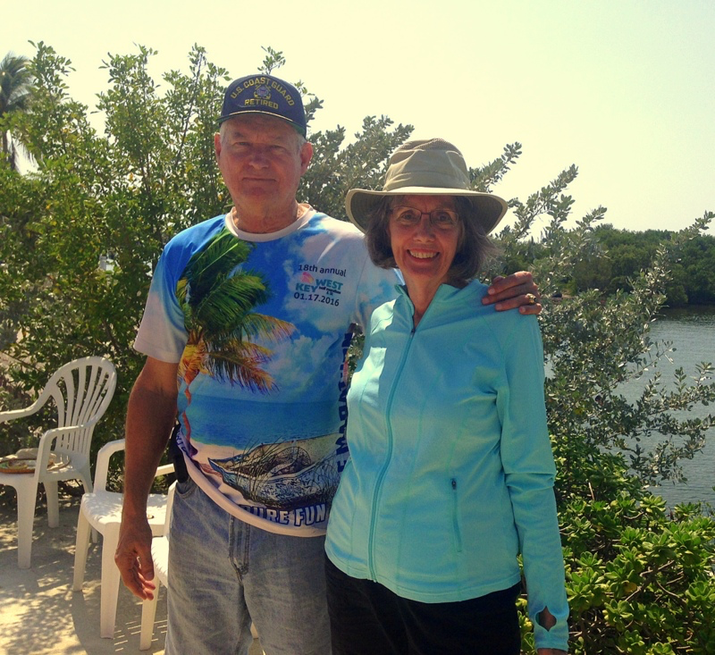

1969: Jim & Marilyn Smith: First in the Class of 1969!

