December 2020
’69 CLASS CORRESPONDENT

CAPT Bob Gravino
2 Summer Street
Ipswich, MA 01938
(978) 356-0825 (H)
E-mail: rcgravino@aol.com
Website: http://www.uscga69.org

In Memoriam
Captain Arne J. Soreng, USCGA 1949
October 12, 2020

Sad news has been received from Joanne Soreng, daughter of our class advisor Captain Arne Soreng, that Captain Soreng died in Vancouver, Washington on October 12, 2020 after a long illness. Captain Soreng was a 1949 graduate of the Coast Guard Academy and a Coast Guard aviator. He joined us at many Class of 1969 reunions, most recently hosting a class of 1969 mini-reunion in Vancouver in 2017, and our class dedicated our Golden Tide Rips 50th reunion yearbook to Captain Soreng last fall. As Stu White wrote, “Arne Soreng was a splendid example of a Coast Guard officer for us to emulate. Arne will be truly missed.”

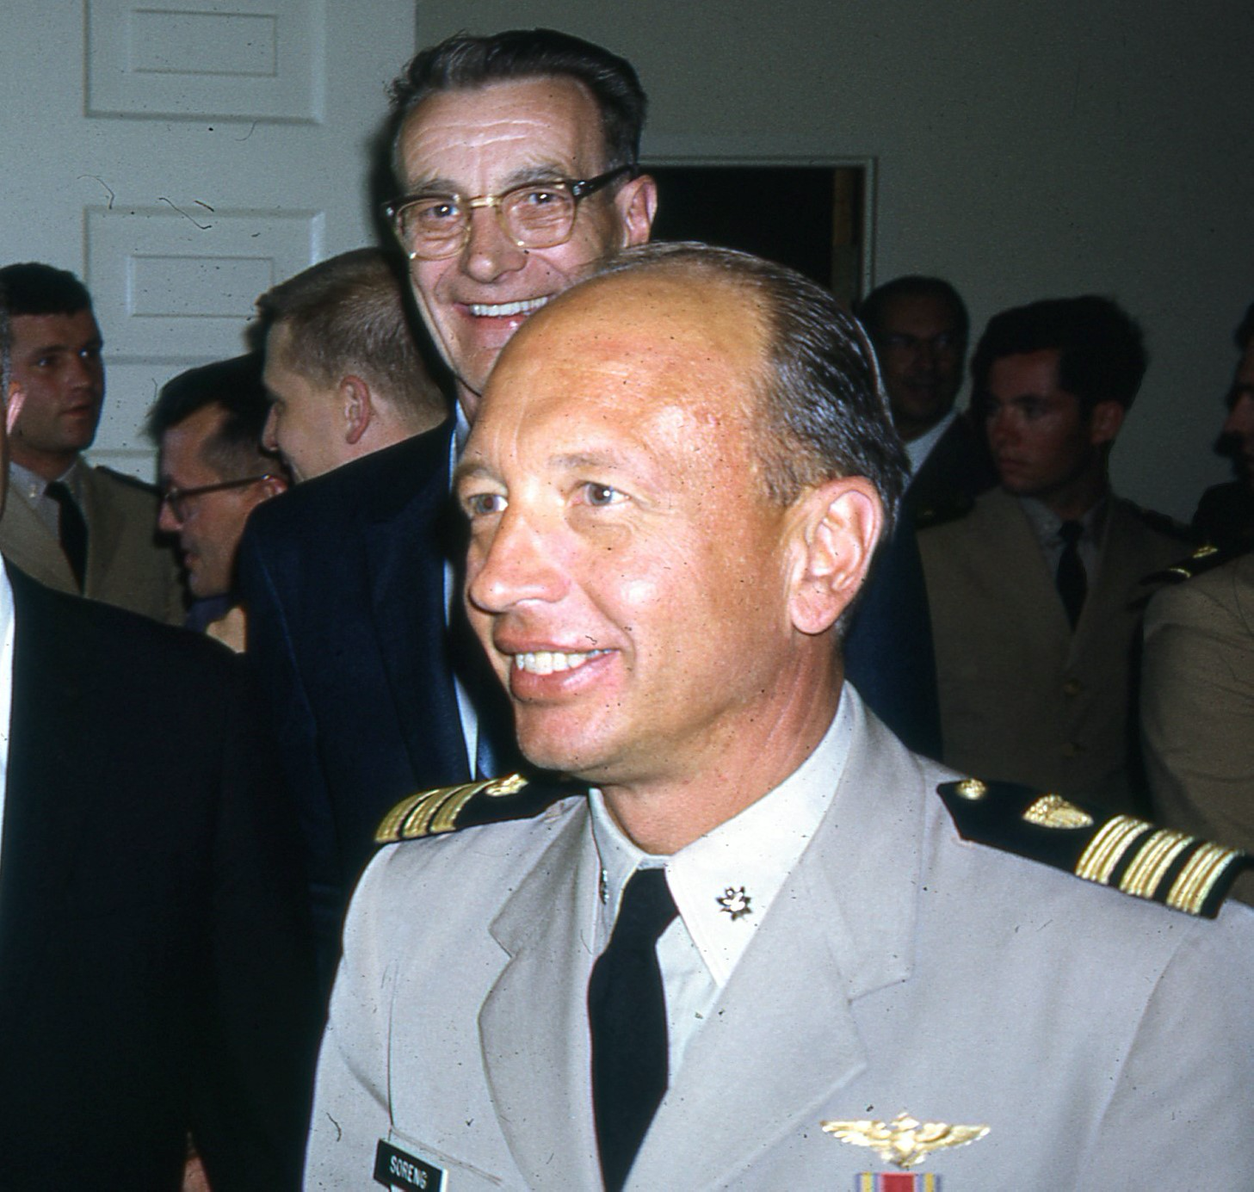

69: Arne Soreng

Jim Robinson was recognized in the CGA AA e-Newsletter in September for his volunteer work supporting veterans in Williamson County, Texas. Jim chairs the Veterans Memorial Advisory Group in Williamsburg County: building community relationships, coordinating veterans’ affairs and organizing events on Memorial Day and Veterans Day on the Veterans Memorial Plaza in Sun City, Texas. The Veterans Memorial Advisory Group also makes recommendations regarding maintenance of the Georgetown-Williamson County Veterans Memorial Plaza, and raises funds through memorial brick sales.

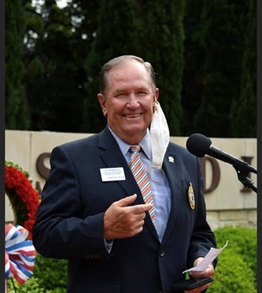

'69: Jim Robinson unmasked

Jerry and Kris Hale spent a week in Montana in early October visiting their daughter Kendra and her family. Kendra, who lives with cancer, is thankful and feeling very blessed with growing kids at home, renovations to their “forever” home close to being done, business and marriage good, and grown kids out there making a difference. Jerry and Kris appreciate our continued prayers for Kendra and her family.

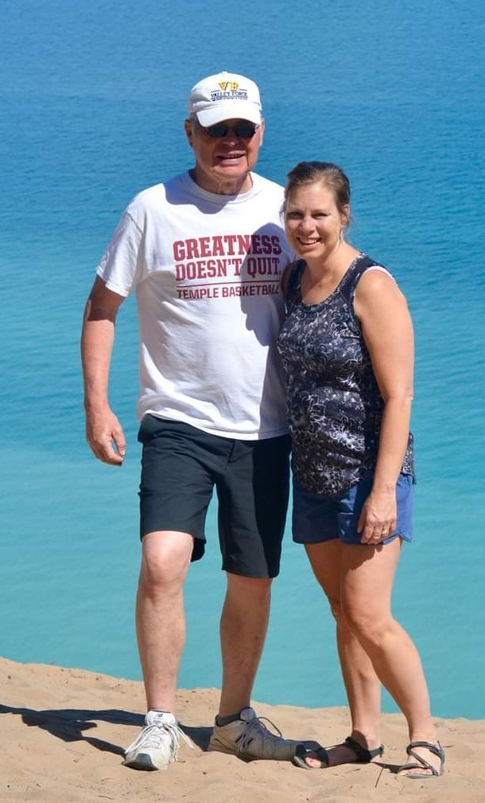

'69: Jerry & Kendra Hale

Paul and Molly Prokop reported from Louisiana earlier this fall: “Hurricane Laura was a giant non-event (no rain, some wind) for New Orleans, despite all the meteorologists crying wolf for days and days. We got 5 inches of rain the day after from a trailing band, but we can handle that without issue. After 25 years here, I think we are better at predicting Louisiana storm paths than the recently arrived TV weather persons. We have enjoyed your daily updates from Maine and wished we were in Michigan doing the same.” They traveled to Michigan on vacation and saw campaign signs for former classmate Jack Bergman, who represents Michigan’s 1st Congressional District (northern Michigan and the Upper Peninsula) in the U.S. House of Representatives. Jack handily won reelection in the November elections.

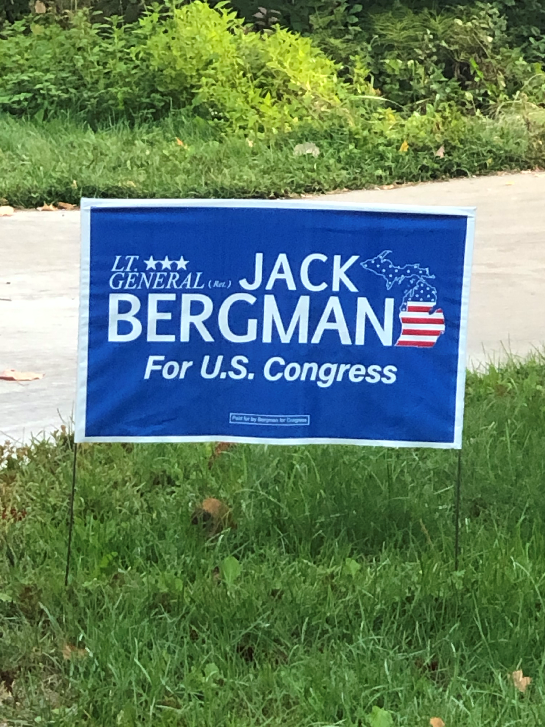

'69: Jack Bergman's Congressional Race

Bob Thorne and Steve Schember (’67) shared stories of a memorable basketball game against the University of Toledo when we were cadets. Steve had driven down to Toledo from Ann Arbor, Michigan to watch, and Bob played on the CGA team. As Steve remembered, CGA’s team was “not a bad D-III team. But Toledo was ranked in the top 10 in the nation! They had a 7’ center. Steve Mix and John Brisker both went on to become NBA All Stars. It was a total mismatch….. I recall going to the locker room after the game and all you guys were just smiling and shaking your heads. It had to have been an interesting experience to find out how the big boys play the game.” Bob Thorne added, “In the Toledo paper the next day, the sports headline was ‘SOS... Toledo sinks the Coast Guard 101-48.’ I had the pleasure of guarding Brisker. I remember him taking a jump shot at the foul line. All I saw was his shorts. Steve Mix, 6’7”, had more than 1,600 points in his three year career and he played for Philadelphia. I think Brisker led the scoring in the ABA. I have a photo with Mix that makes me looking like I was blocking the ball. He was actually bringing the ball in. Just before the game started, our team was waiting at our bench when the lights went out in the large gym. Suddenly, the Toledo team burst through a big ring of ‘fire’ (actually floodlights shining on each player) on to the floor. The crowd roared and we were stunned when we saw how big our opponents were. On that road trip, we beat Division-III Lake Forest in Chicago area by a few points. Our team had Larry Parkin (’68), Jim Hested (’68) who led the country in fouls (!), Doug Brown, Bill Bowen, Charlie Huber, Dave Dubois, and me, and a few others.”

George Bond is staying busy teaching Coast Guard Auxiliary classes. “I am doing 3 AUXLAMS. The first was done with West Coast members, the second two with East Coast largely in Virginia. These are the first ones done online, using Zoom. The final one will be in November after which I retire from the Auxiliary after over 23 years. We are mostly staying home other than for food and medical. Painting the trim, weeding, and other activities around the house help stave off boredom.”

Pablo Rodiguez writes from Texas that he is “just stayin' alive, as the Bee Gees put it, and hoping all my classmates are doing likewise. You know, I bought a windward blue 1969 Pontiac Firebird my 1/c year. Mine was an overhead cam 6, not a monster, but I really liked it, although it almost killed me in 1970 - I spent 3 /1/2 months in the hospital, 1 month unconscious, but you know, 50 years later I still dream of it occasionally. I guess the only thing worse than being young and foolish is being old and foolish. My goodbye wish for classmates I may meet here (very few) is 'May your name not be the subject line of a Bob Gravino email to the class anytime soon.’ Stay Safe, and Go Bears.”

Bob Pokress recently read a New York Times article that brought back a memory: “As soon as I read Jerry Seinfeld calling out ‘some putz on LinkedIn’ in his article in today’s NY Times, I recalled when Dan Carney and I were lookouts on the mid watch one night on our Swab cruise to Bermuda on the Rockaway and we decided, just for the hell of it, to practice our Morse Code using the signal light to send some kind of put down comment to a couple of our classmates also on the mid watch on the Unimak steaming alongside us. And when they replied to our New York vernacular asking us what we meant by our referring to someone as a schmuck, we replied, by signal light, ‘a schmuck is a putz.’ And then the CO of the Rockaway walked off the Rockaway’s bridge and up to us to remind us that he still remembered his Morse Code from HIS Swab year and had been following our signal light exchange with our buddies on the Unimak. How we avoided getting bounced for our New York vernacular-laced signal light exchange that night remains a mystery!”

John and Anne Curtis travelled in the Northwest in mid-September and sent the following: “Anne and I are hanging around the central Oregon coast now while the West Coast is burning. Smoke levels at home in western Washington are higher than in the Florence, OR area so for the sake of our lungs we are staying put here until conditions improve. We also stopped at the Coquille River Light and Heceta Head Light - Yacquina Bay Light is next on our way home. Oregon beaches are among the most spectacular in the world, except now the extreme low visibility from the smoke and fog makes the experience disappointing.”

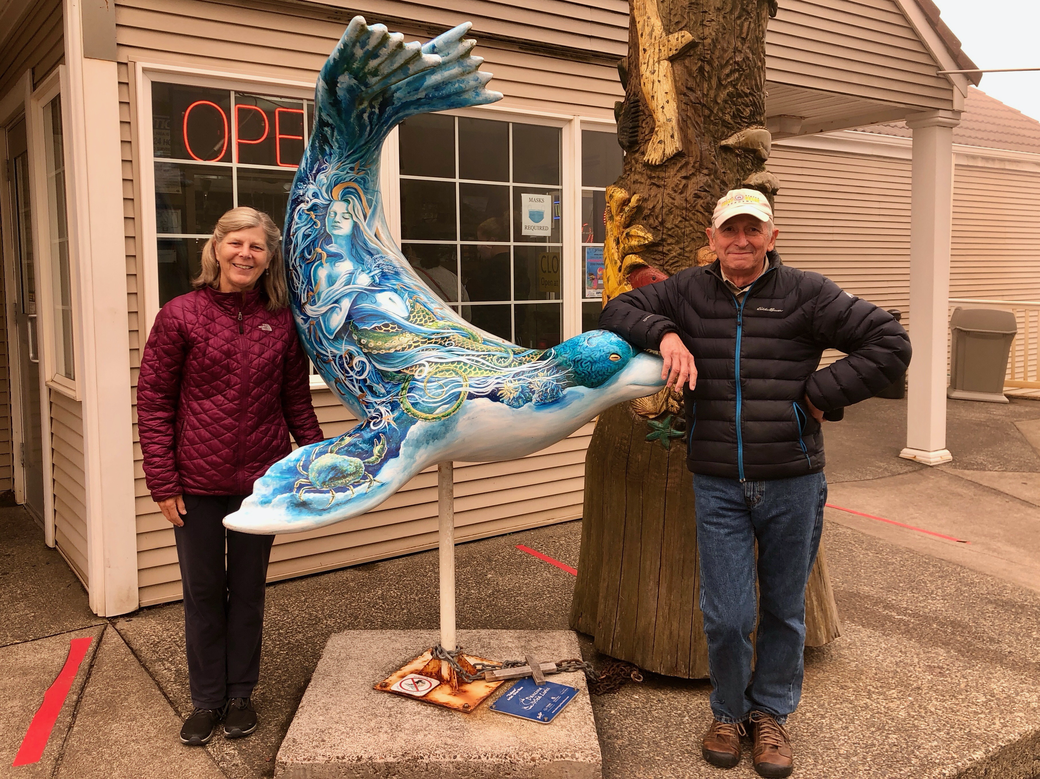

'69: John & Anne Curtis

Steve Hungness sent a photo of Doug Brown, team mate and co-captain during the undefeated 1969 Academy Track and Field Season, on the occasion of cutting the championship season cake. The team tied with Boston College as New England Champions that year. Steve added, “Nice work by all recently to get Doug recognition for his record feat.”

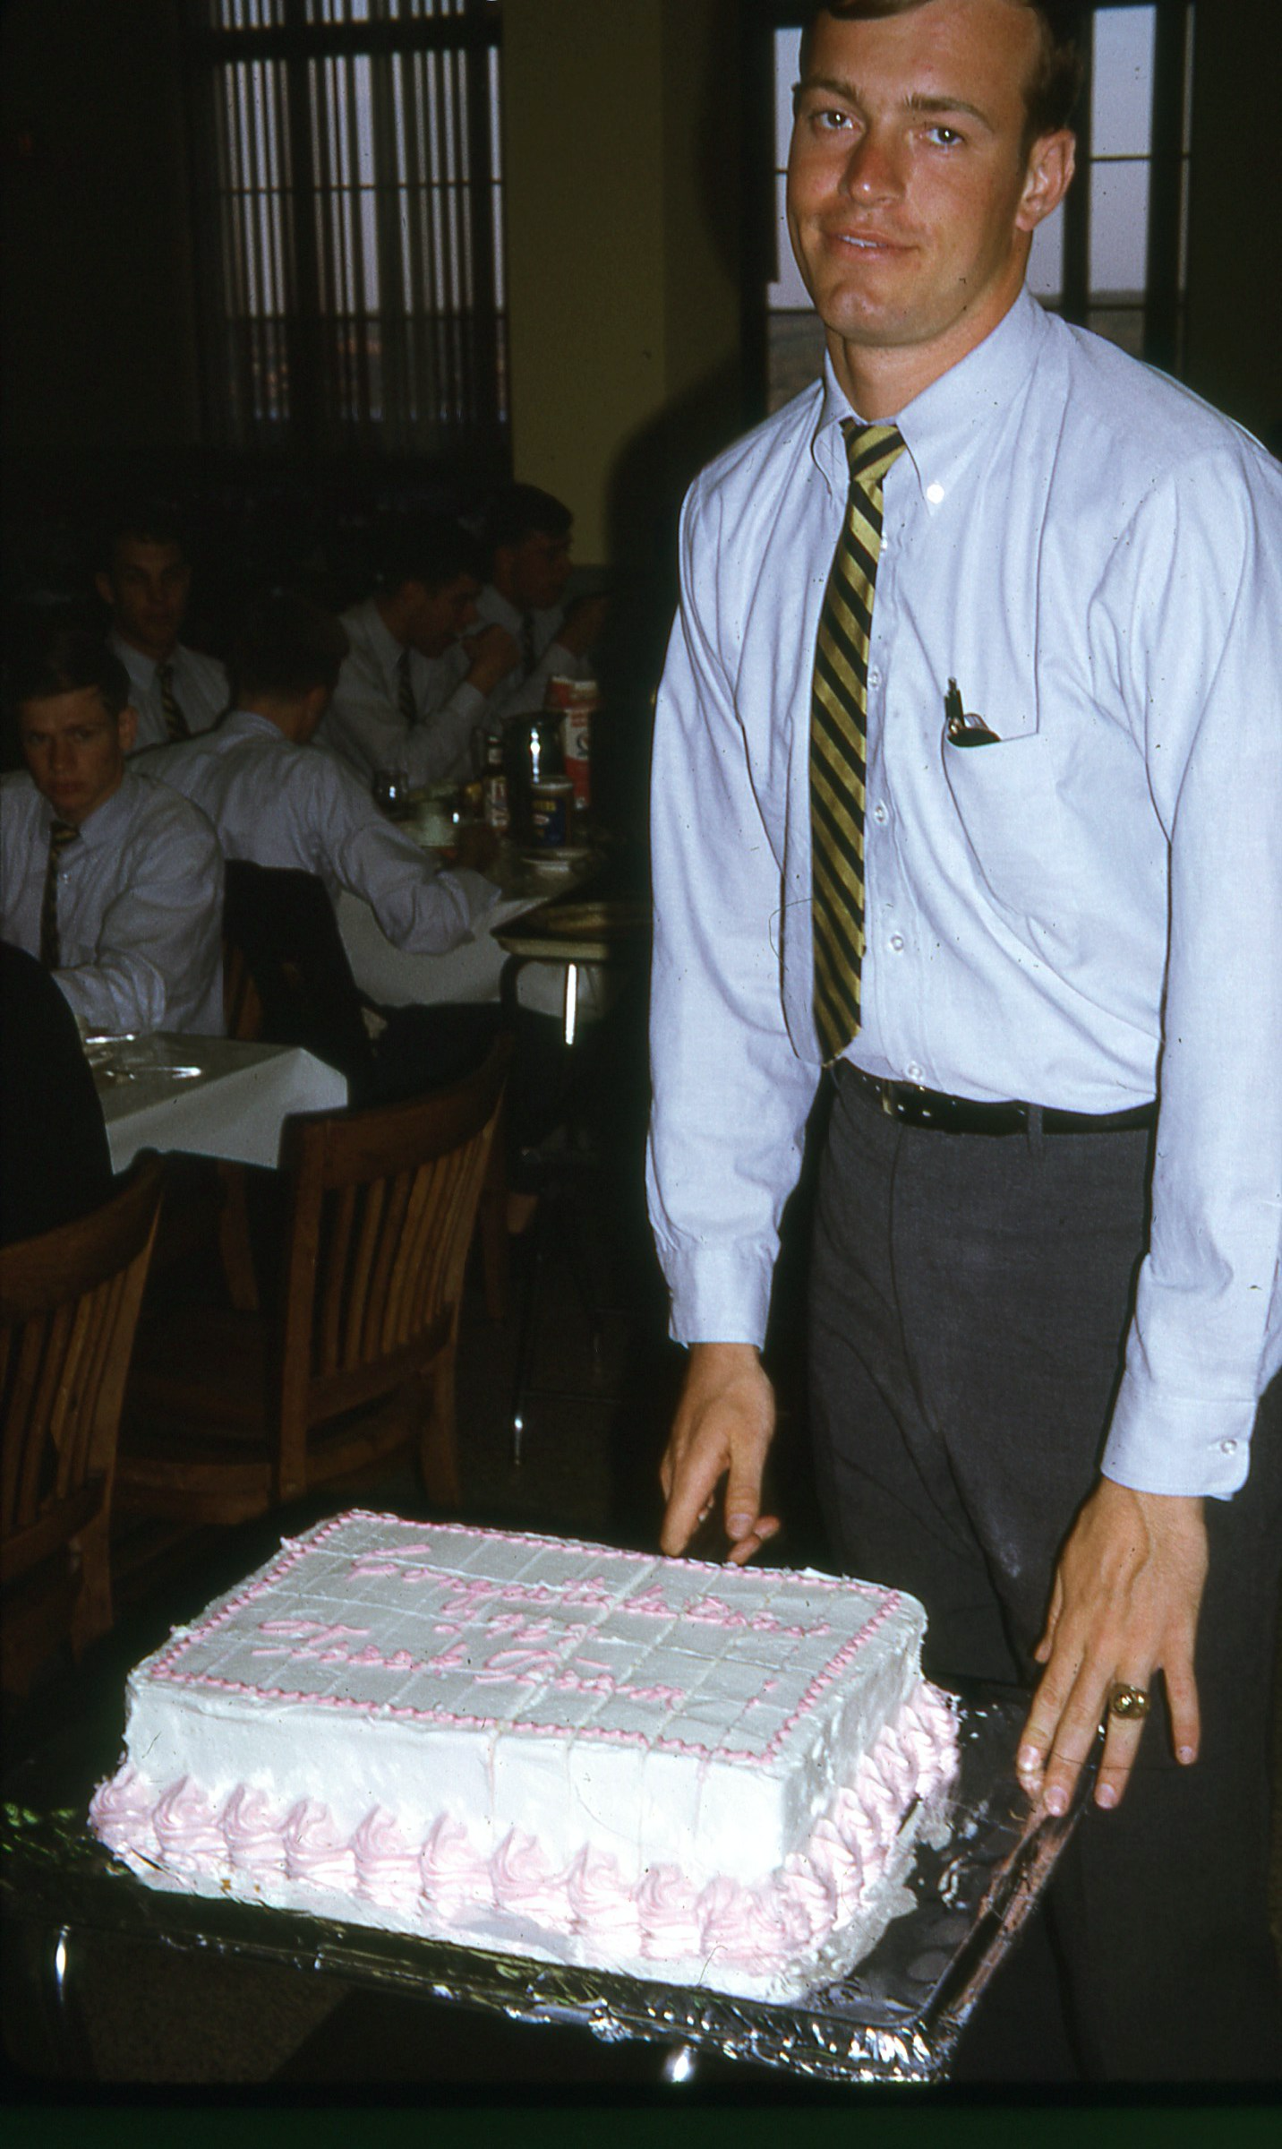

69': Doug Brown cutting the championship season cake

