February 2014

’69 CLASS CORRESPONDENT

CAPT Bob Gravino
2 Summer Street
Ipswich, MA 01938
(978) 356-0825 (H)
E-mail: rcgravino@aol.com
Website: http://www.uscga69.org

After many years of requests, our respected and loved class advisor, Arne Soreng (CGA ’49), has provided a photo of himself in retirement. A resident of Vancouver, Washington, he still finds the time and energy to enjoy the waters of the Northwest Coast. In a holiday greeting, he wished everyone in the great Class of 1969 a Merry Christmas and a Happy New Year. He can be reached at arne49@msn.com.

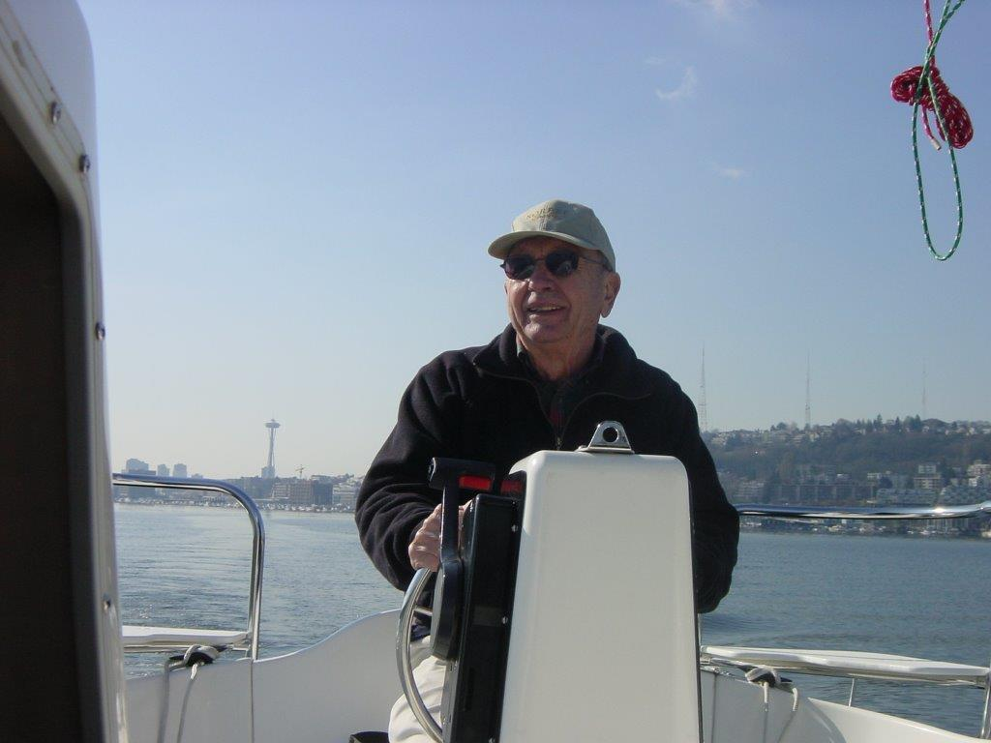

1969: Class Advisor, Arne Soreng (CGA '49), at the helm and in command

Jim and Pat Hartney took a trip to Australia and New Zealand last spring, sailing round trip from San Francisco on the Queen Elizabeth and returning on the P&O Arcadia, island hopping along the way. They spent a total of 37 days in transit and two weeks touring by car in both countries. Jim says the best part of the trip was the time spent in and around Queenstown on the South Island of New Zealand. “....spectacular, a combination of Swiss Alps and Norwegian Fjords. First picture is of us in Russel, New Zealand, and the second is Pat getting "Haka" lessons from one of the locals.”

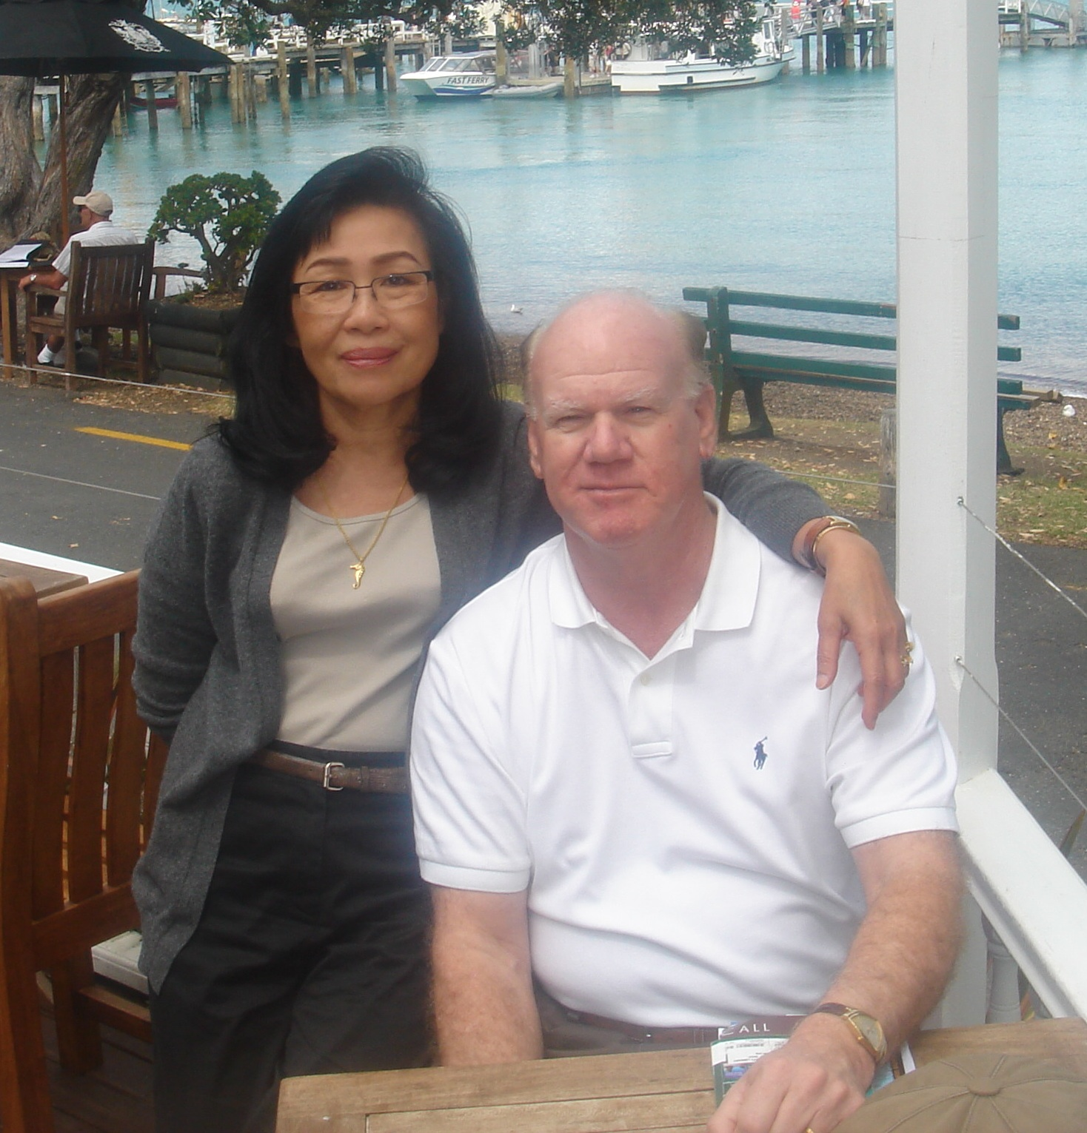

1969: Pat & Jim Hartney in New Zealand



1969: Pat Hartney receiving "Haka" Lessons in New Zealand

As President Ronald Regan would have said to Mike Billingsley, “there you go again, Mike!” When Mike left the Coast Guard in 1989, he took a direction very different from his time as a Coast Guard aviator with an advanced degree in avionics engineering. He entered the Virginia Theological Seminary in Alexandria, Virginia, and three years later was ordained an Episcopalian priest. Mike’s Christmas letter evoked another “there you go again” reaction. 2013 was Judy’s first full year of retirement, and she was uncertain if she was going to stay retired. She decided to hold off on a decision until they came back from Mike’s sabbatical last spring at St. George’s College in Jerusalem. They attended a course titled “The Palestine of Jesus in Eastertide”, which traced Jesus’s life from his birth in Bethlehem, to his childhood and youth in Nazareth, to his ministry in Galilee and death and resurrection in Jerusalem. The course was transformative. Mike later met with the Dean of Saint George’s College and was offered a position as Chaplain to the College in 2014. After visiting family and friends in California, Maine, Washington, D.C., and Atlanta, and retiring from his parish ministry in Hopkinton, Massachusetts, on January 1, 2014, Mike and Judy were off to Jerusalem on January 5, 2014. “We wish everyone a Merry Christmas and a Happy and Healthy New Year. If this is your year to visit the Holy Land, you’ve got friends there who would love to see you! Our prayers for peace in the Middle East have taken on new meaning!”

Greg Shaw is still celebrating the victorious Boston Red Sox. “Three World Championships in ten years, after an 86 year drought, is something special. Patti and I located to Toanao, Virginia (about ten miles north of Williamsburg) in November, and I am phasing out of The George Washington University teaching and research position, with one or two days a week in D.C. At the end of May 2014, it will be total retirement. I played golf with Charlie Huber, John Miner and Woody Stoeger recently. I stunk, but it was a lot of fun to catch up.”
A short note from George Naccara that he retired from the Transportation Security Agency on Friday, January 10, 2014, and began work on Monday, January 13 as the Chief Security Officer for The Massachusetts Port Authority (Massport).
Fred Adamchak sent photos of the CGA ’69 Williamsburg contingent, minus Woody Stoeger who was away traveling. They met for dinner and a few bottles of wine, and after dinner enjoyed pies made by the Master Pie Chef – Charlie Huber. Fred’s comment: “Charlie is the only person I know who has a pie cook book, and actually follows the recipes.” Included in the photos: Fred, Rich and Beth Vlaun, Don and Dottie Grosse, Greg and Patti Shaw, and Charlie and Sue Huber. Linda Adamchak was the photographer.

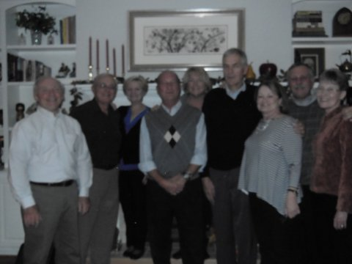

1969: Pie and wine in Williamsburg

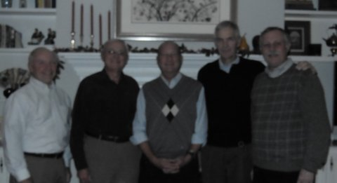

1969: Wine and pie in Williamsburg

The December 2013 Classnotes column in The Bulletin described a long weekend that John and Lesley Miner spent with Bruce and Gail Griffiths in San Diego. Now the “rest of the story” concerning that weekend from Lesley. “I want to explain the ‘Hawaiian outrigger experience' that Bruce described to you. Bruce belongs to an organization called the Kanaka Outrigger Canoe Club; men in the San Diego area who race their outriggers throughout the Pacific. Last year Bruce offered a ‘paddle out’ to scatter the ashes of my parents, Captain and Mrs. Steven Carkeek (CGA ’42), who wished to have their ashes scattered at sea. My father grew up in Southern California and his remaining relatives still live in the San Diego area, so it seemed especially fitting. Bruce and his Kanaka friends did a lovely service, complete with tea leaves and lei's on the canoes. We paddled out into San Diego Harbor from Shelter Island; my brother and I scattered the ashes; other paddlers scattered Plumeria blossoms; and we all wished my folks a final safe voyage. It was a moving and most fitting final goodbye for my father, who was, like the Kanakas, a true waterman. John and I are enormously grateful to Bruce and Gail for making this happen.”

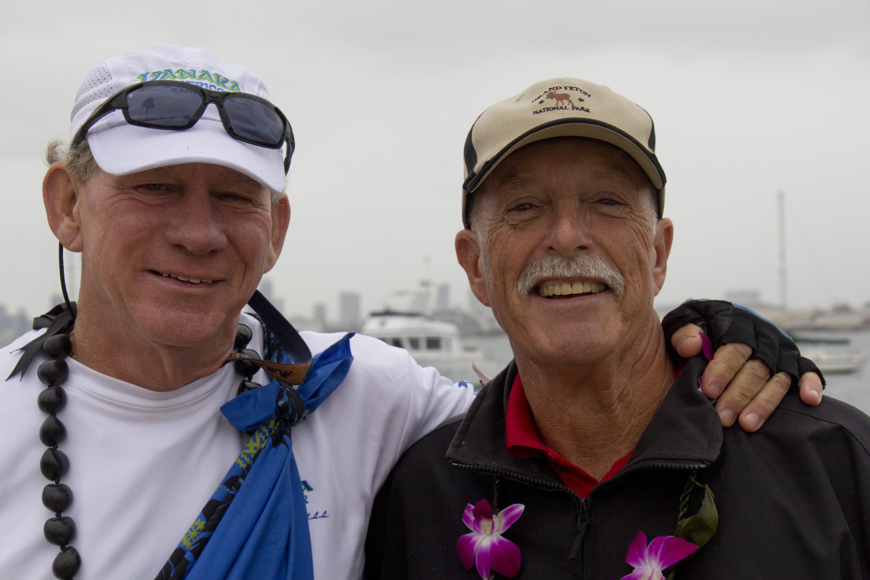

1969: Bruce & John at the Paddle Out

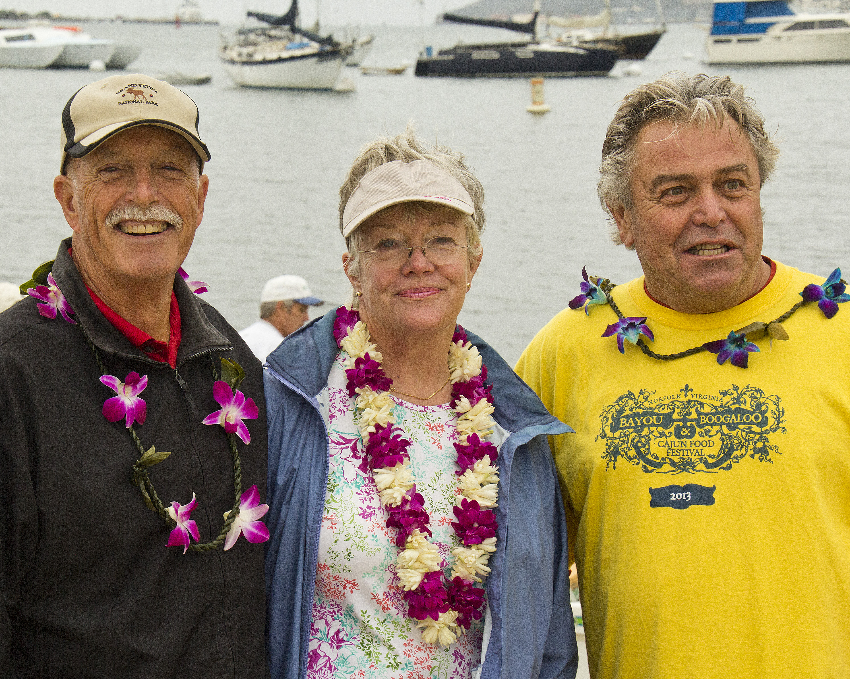

1969: John & Lesley on the beach before the Paddle Out

