February 2018
’69 CLASS CORRESPONDENT

CAPT Bob Gravino
2 Summer Street
Ipswich, MA 01938
(978) 356-0825 (H)
E-mail: rcgravino@aol.com
Website: http://www.uscga69.org

Steve Hungness retired on December 31, 2017 from the U.S. Army Corps of Engineers as the Chief of Operations of the Chicago District, having served 26½ years with the Corps of Engineers and a total of 52½ years of government service. Steve and Marlies have plans to attend the 50th Reunion in 2019. Included is a photo of them from their recent wedding.

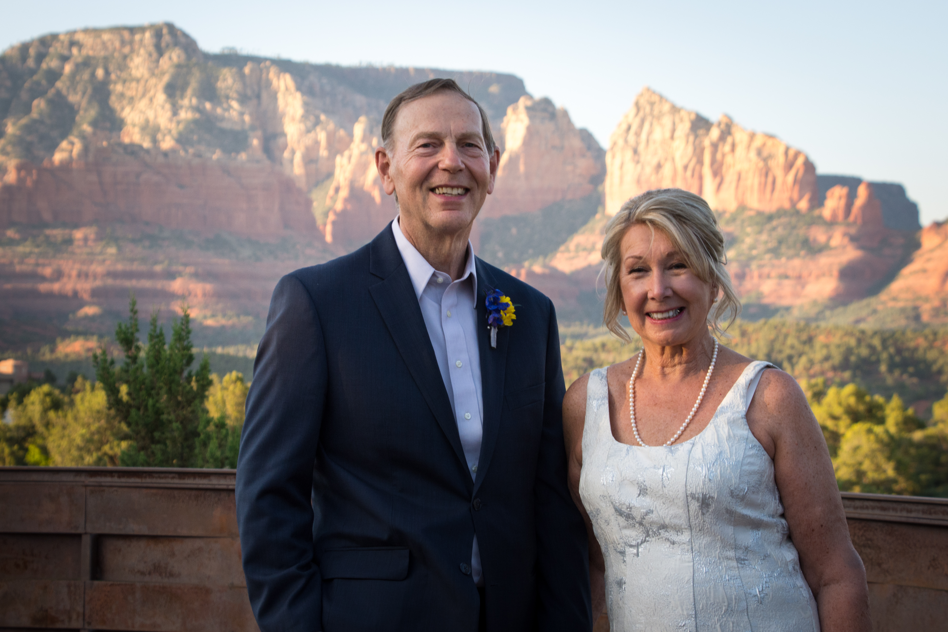

69: Steve & Marlies Hungness

Fred Schmitt celebrated his 70th birthday with his sons Charlie and Mike over the Thanksgiving weekend by hiking the Profile Trail and climbing Calloway Peak (5,946 ft.) on Grandfather Mountain, North Carolina, which is close to where he lives. Fred said that Jessie was more than happy to stay home with the grandkids.

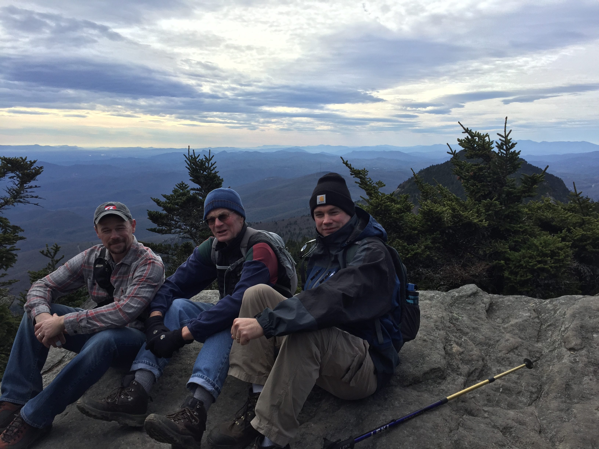

69: Fred Schmitt and sons Charlie and Mike

Jim Robinson commented after the notice of Jack McGrath’s death listed Jack’s hometown as Newington, Connecticut. “There were two Class of 1969 appointments to the Academy for James Robinson. The other was to James N. Robinson of Newington, Connecticut. His appointment was mailed to me and visa verses. Both James N. and James L. were on uniform issue and roster lists when we first arrived in 1965, but James N. didn't show.”

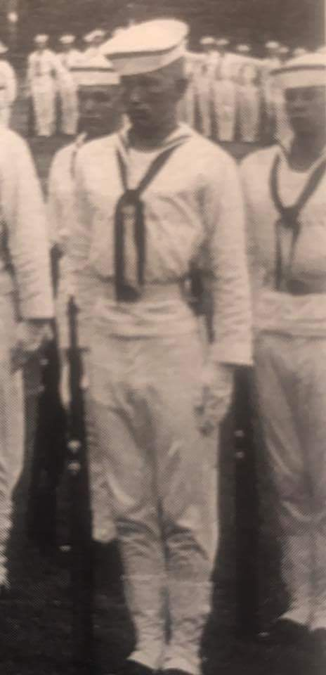

69: The real James L. Robinson, Summer of 1965

Dale Gebhardt sent a synopsis of his life since we left CGA in ’69. “After engineering assignments aboard cutters Campbell (327’) and Cook Inlet (311’) in Portland, Maine and Vietnam, I left active duty and returned to the Mahoning Valley in Northeast Ohio (Youngstown/Warren). After a one day job search, my resume landed on the desk of the Engineering Manager of the Power-Strut Division of VanHuffel Tube Corporation in Warren, Ohio. He happened to be Carl LaLonde, a member of CGA Class of ’57. I’m sure it wasn’t my engineering prowess that caught his attention, but rather his thought that taking a chance on a CGA graduate was a good bet. So I landed the job of Structural Design Engineer at Power-Strut and embarked on a 44 year career in the STRUT Industry. STRUT is a generic term for Continuous-Slot Metal Framing, roll formed steel channels and fittings that is similar to an industrial Erector Set. Products are used in a variety of applications: electrical/mechanical supports, elevators, conveyors, laboratory furniture, X-Ray supports, and grid ceilings and concrete embeds for curtainwall retention on high rise buildings. Six months after finding a job, I met Evelyn, and we were married a year later. Over the next five years we had two sons. In 1977 steel mills began closing and much of the industrial and manufacturing base of what was once known as the Steel Valley was shuttered or sold off. The Power-Strut Division was sold to a Chicago firm in 1985. We turned down a job in the big city in favor of staying in a small town in Ohio, with the vision of resurrecting a Strut company and putting some of the displaced factory workers back to work. I know that only happens in Hallmark Christmas movies, but in the end, it all worked out for the best. The new company (Flex-Strut) that we started, has expanded five times to over 115,000 square feet, employing 90 people with annual revenues in excess of $25,000,000. Carl, who hired me in 1974, came back to work part-time for Flex-Strut as a project engineer. Evelyn and I retired at the end of 2017, and our sons, Dale Jr., (a PE and age 42) and Doug (MBA and age 38) became Co-Presidents of Flex-Strut on January 1st. It has been a satisfying journey. We have 5 grandchildren and plan to return for the 50th Reunion in 2019.”

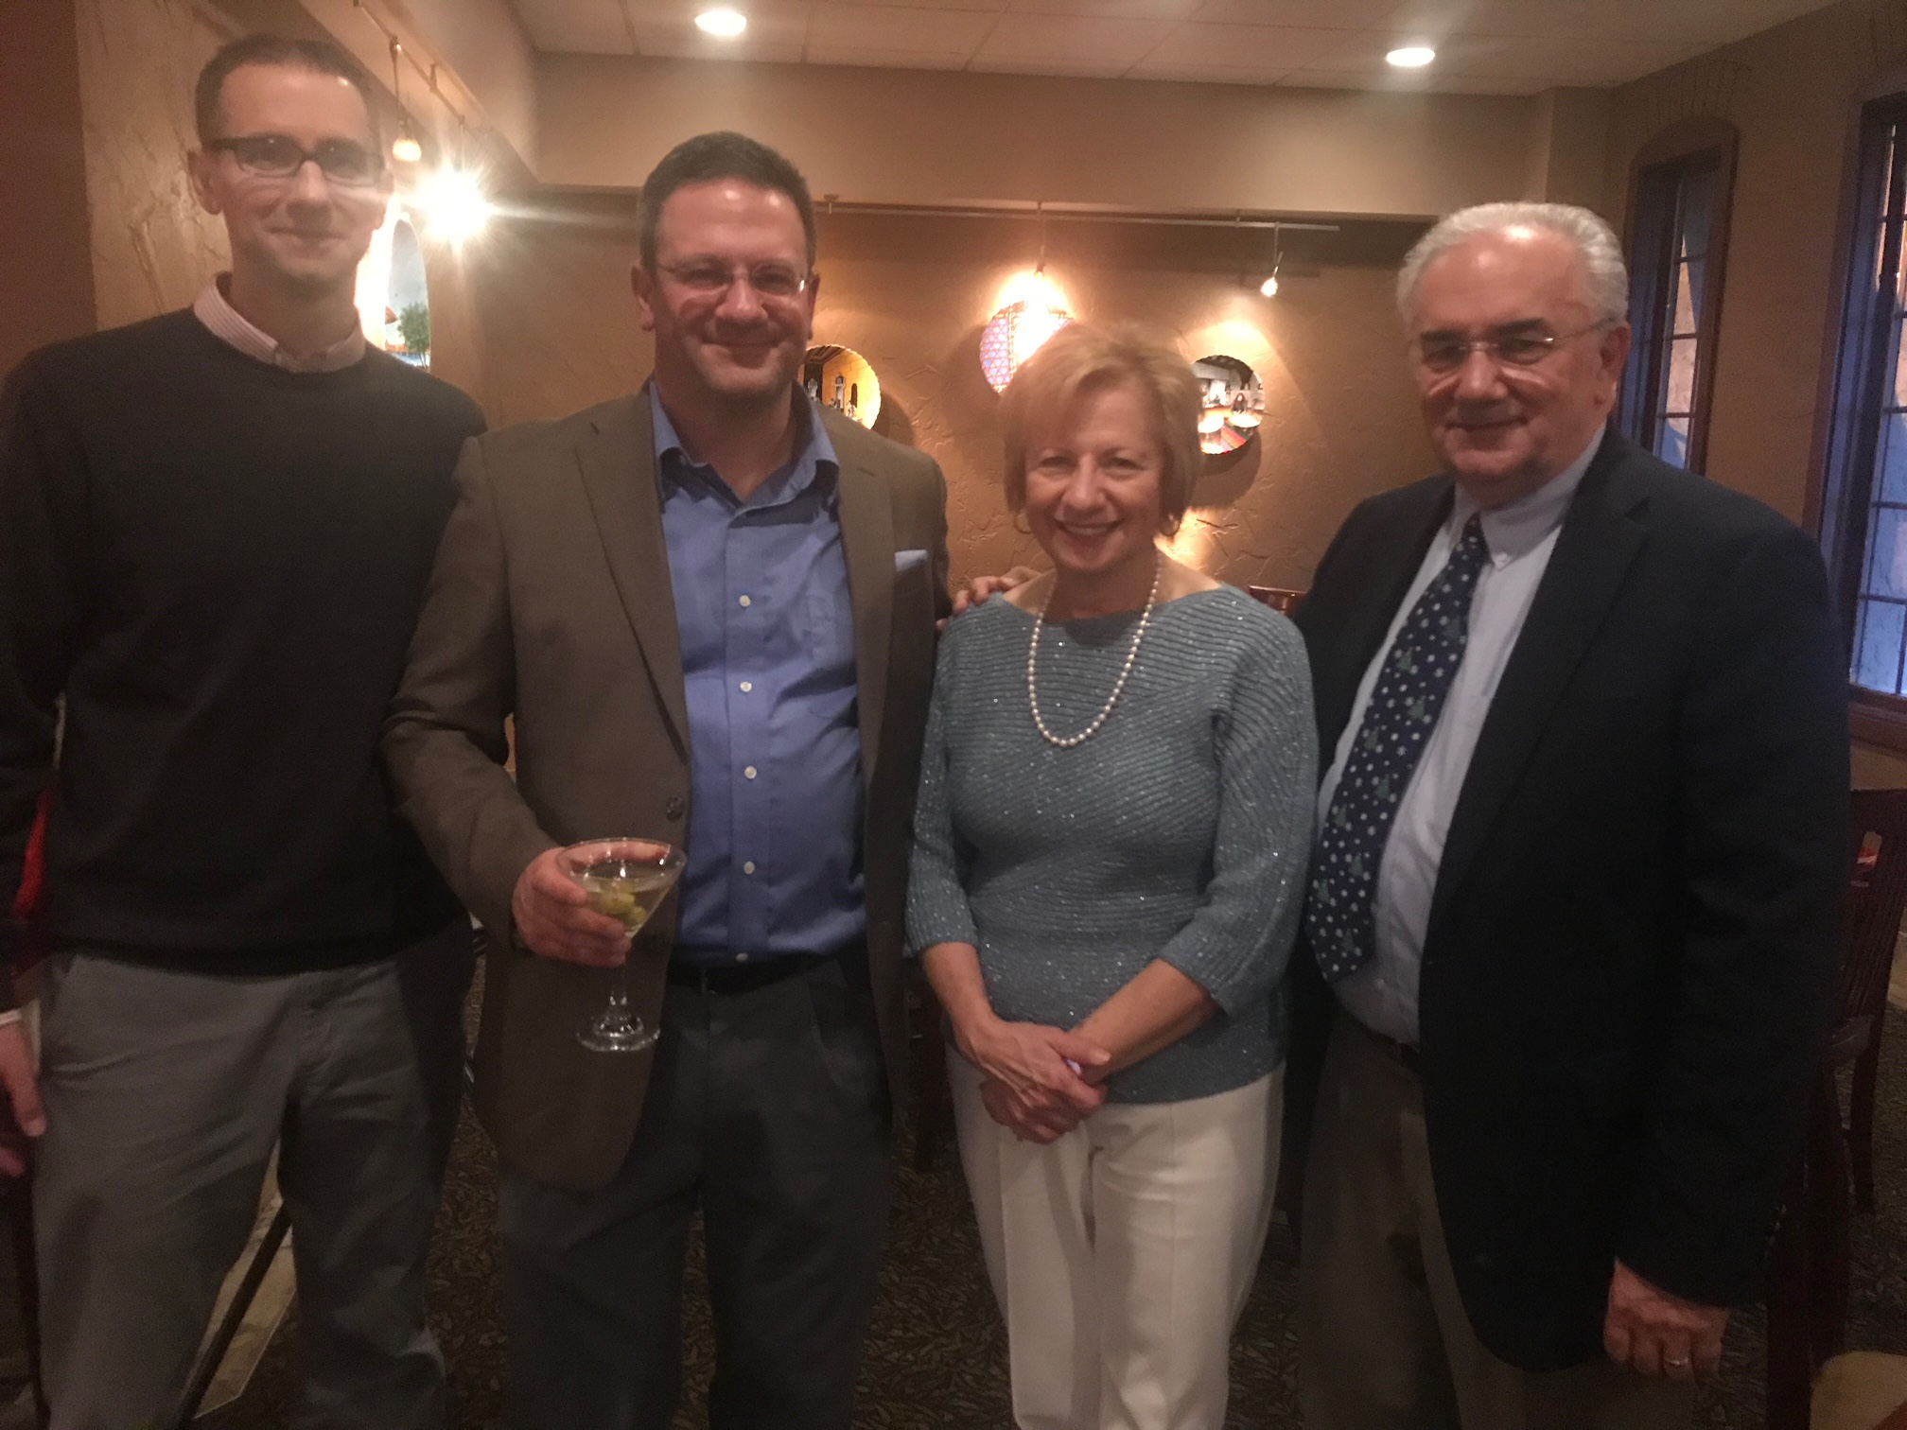

69: Dale & Evelyn Gebhardt and sons Doug & Dale, Jr.

Arne Soreng’s (CGA ’49) Christmas note this year included the following. “Believe it or not, I turned 90 this year! Several young men (your scribe’s Italics) from the Coast Guard Academy Class of 1969 came to Vancouver to visit; how nice to see them! I had been their class advisor all those years ago.” His handwritten comment stated: “Still operating slowly on two feet! John Curtis put together a great mini reunion! He is capable +.” The Class thanks John and Anne Curtis, Bruce and Gail Griffiths, Phil Hawkins, Forrest and Pat Hetland, Dave Humphreys, Jane Snyder, and Stu White for representing us all and acknowledging what Arne has done for the Class and meant to us all these years.

Ed Danner sent this update. “I've been catching up on a serious health issue that arose on October 18th. That morning, Kathy noticed some unusual behavior on my part and talked me into going to the ER, only to be flown by helicopter to Columbus after suffering a major stroke on the right side of my brain attributable to atrial fibrillation. I had no idea I had a problem with a resting heart rate of 40bpm. Apparently I had a massive blood clot which blocked my right carotid artery and the right side of my brain. I miraculously survived and have no residual deficits. We had a good Christmas and subdued New Year, and I know 2018 will be better.”

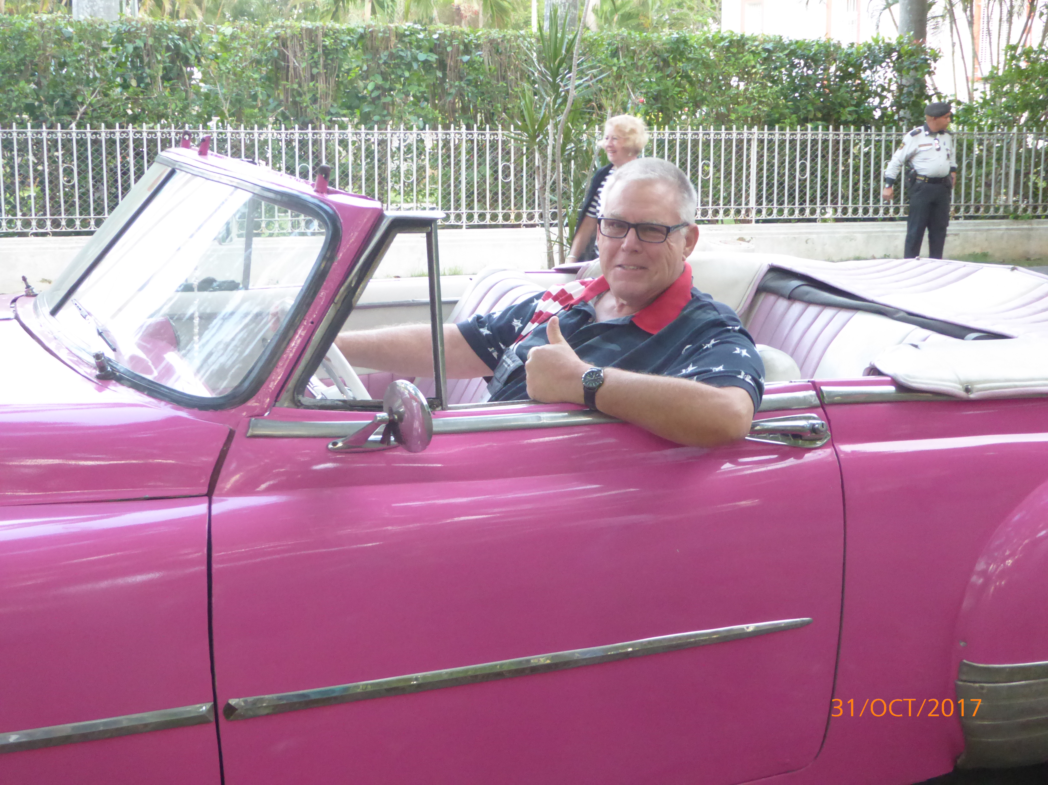

69: Mark Present stepping back in time in Havana, Cuba

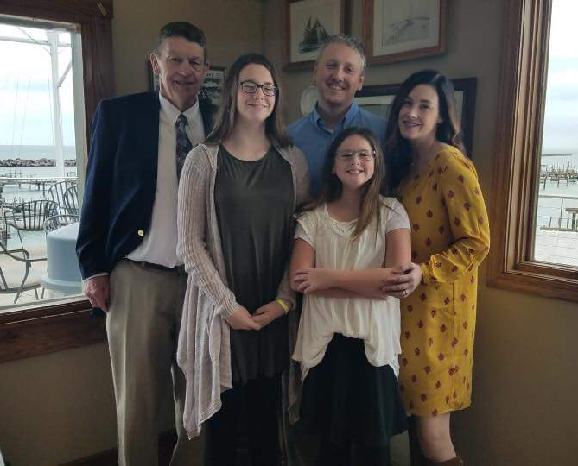

69: Dave Blomberg with Carole's family

Another Dumb Ensign story, this one from Bob Pokress. “What a great, fun idea from Tim Cenna! To keep things going and build some momentum to make this a regular thing in our class notes, here’s mine. Among the multitudinous collateral duties we all had to take on in addition to being Deck or Engineering Watch Officers as new Ensigns on the cutters we went to, one of mine was Commissary Officer of the CGC Mariposa, the 180’ buoy tender that I reported to after graduation. Naturally, I personally did a full inventory of the food stores and various refrigeration lockers and took note of the fact that the meat locker had a big cut of pastrami, a big cut of corned beef, and a big beef tongue, the trinity of cold cuts and deli sandwiches for those of us who grew up in New York. So naturally, once I took over as Commissary Officer, I suggested to the Mariposa's CS1 that he do a cold cuts platter for a Friday noon meal at some point. What I did not know was that there was a backstory to the beef tongue in the Mariposa’s meat locker. So when the steward set that platter of cold cuts on the table in the wardroom for a Friday noon meal weeks later, our skipper bellowed at me, ‘Mr. Pokress, is that “THE TONGUE” ?’ (Yes, he really bellowed "THE TONGUE” in all caps). ‘That tongue has been in the meat locker SINCE THE WAR! Didn’t you ask about it when you took the inventory?’ By war, he meant World War II. Turns out the tongue had been sitting in the Mariposa’s meat locker for 25 years, with its freezer burns carefully disguised so that it looked okay to serve (and okay for inventory accounting purposes so it would not have to be written off on the ship’s commissary books since all of the Mariposa’s skippers had had an aversion to taking commissary write-offs when food went bad). It was never to be served in a meal, either. That’s when I learned the important life-lesson memorialized by President Reagan in a nuclear arms agreement almost 20 years later; trust, but verify.”

