June 2011
’69 CLASS CORRESPONDENT

CAPT Bob Gravino
2 Summer Street
Ipswich, MA 01938
(978) 356-0825 (H)
E-mail: rcgravino@aol.com
Web: http://www.uscga69.org

GREG SHAW has once again documented the end of winter and the arrival of spring. The Fifteenth Annual Spring Training Baseball Trip was to the Phoenix area this year. Shown at an Arizona Diamondbacks game are GREG, Paul Pluta, ’67, Jack Harrald, ’64, and Steve Froehlich, ’73. In the middle of the group is Mr. Roland Hemond, Special Assistant to the President of the Arizona Diamondbacks, three times Major League Baseball Executive of the Year, and former US Coast Guard Yeoman. GREG and Paul are plank owners of the annual event, having attended all fifteen years since 1997.

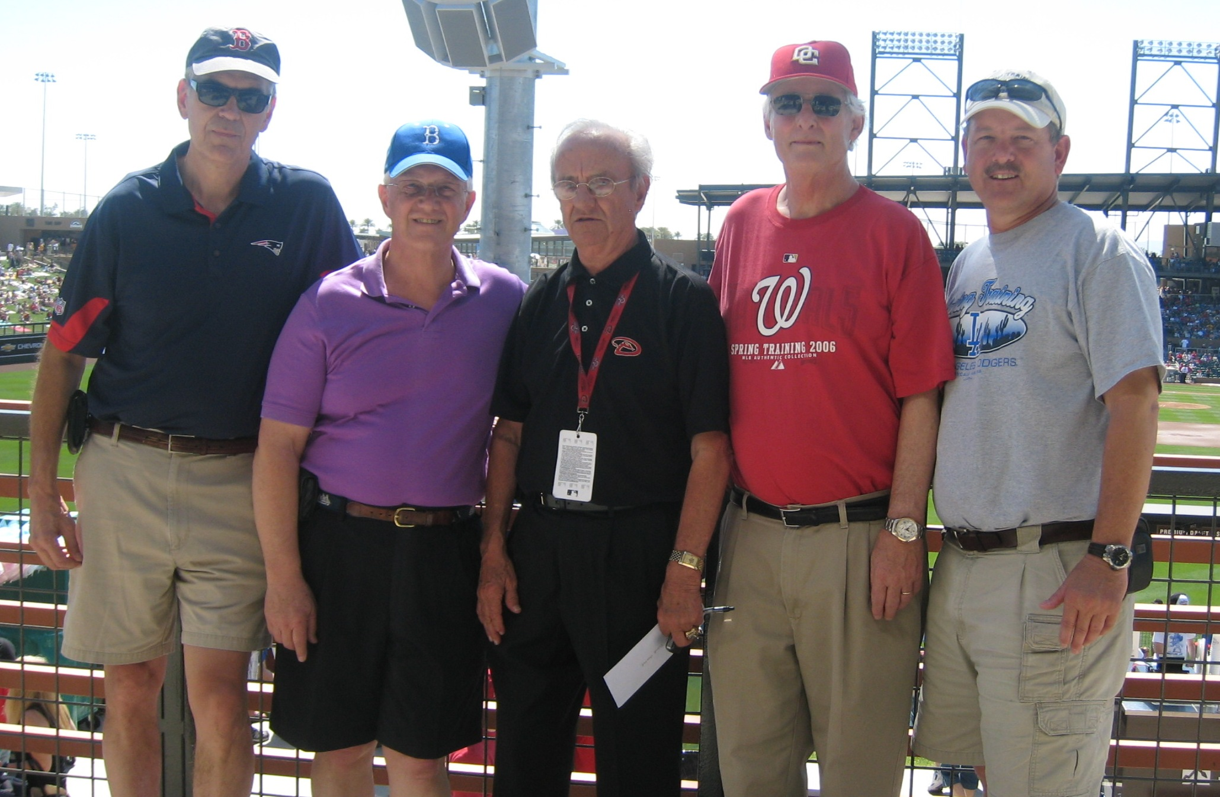

1969: Coast Guard Academy Boys of Summer in Phoenix

GREG also sent along a note announcing the arrival of a grandson. “As of February 25, PATTI and I are grandparents. Alexander Feldman arrived five weeks early at 5 pounds 6 ounces and is doing great, as is our daughter. Once I get the baby in a Red Sox outfit, I’ll send a picture.”

ROB HENRY sent a photo, along with an update: “The HENRYS are alive and well and growing. Grandchild number two, William James Henry, was born February 24, to our oldest son Chris. Caitlin, their first child, is two and taking all this in stride. Our youngest son, Michael, will be completing his doctorate in computer engineering at Virginia Tech in the fall. The marine industry is still keeping me busy with the sinking last July of DUKW 34 in Philadelphia, the latest NTSB accident launch. Between family, job, tennis (WHITNEY), sailing on the Chesapeake and the beach house in Delaware, we’re settled in here for the long haul, at least until 2014 and possible retirement. If you can ignore the traffic, politics, weather and cost of living, Fairfax County is actually a nice place to live.”

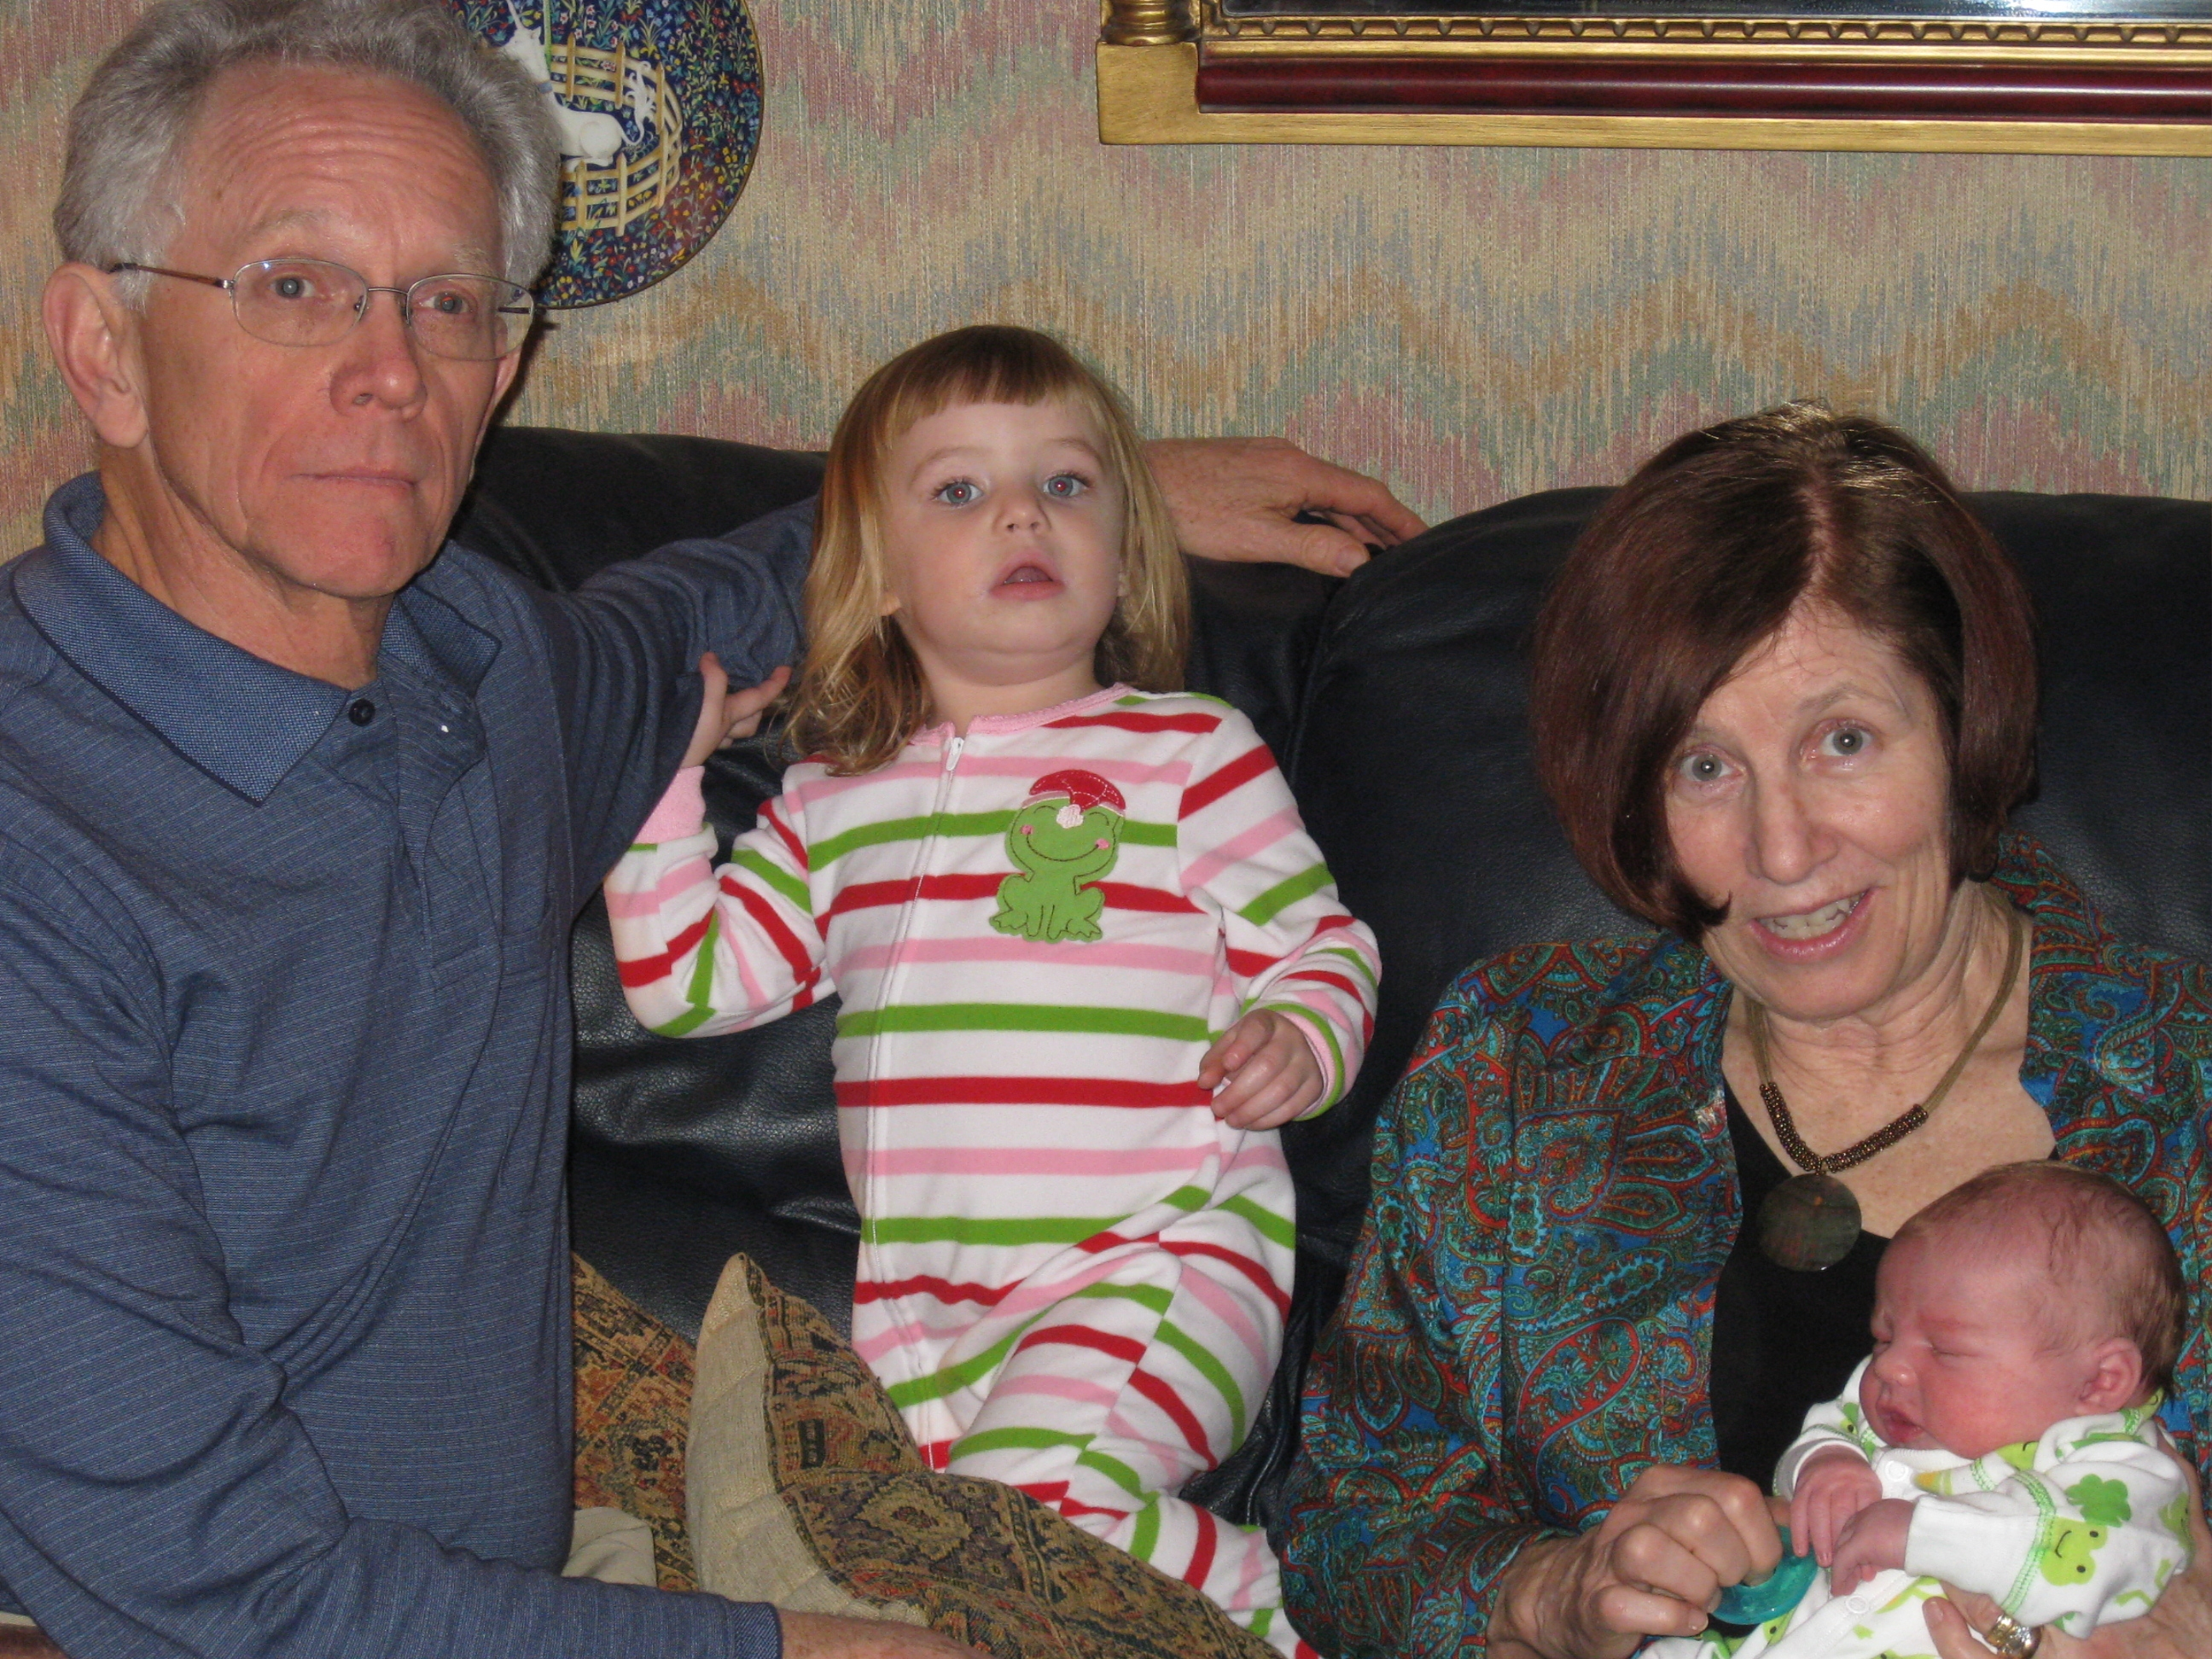

1969: ROB & WHITNEY HENRY and grandchildren

MARK PRESENT was able to use his chauffer cap when his niece and her husband made their first visit to California. MARK and PAULA gave them a tour of Napa with stops at Beringer, Castello di Amorosa and V. Sattui wineries.

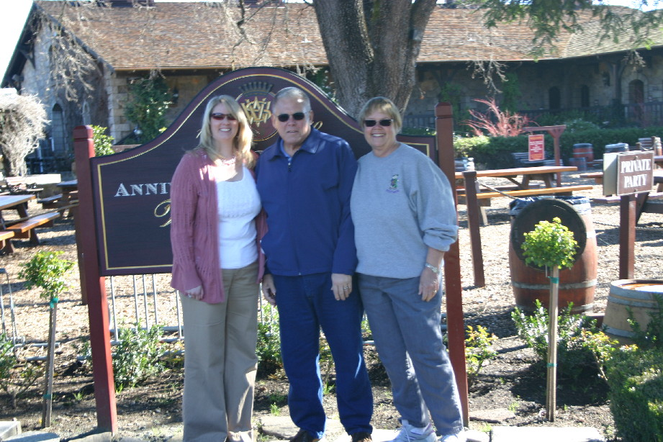

1969: MARK & PAULA PRESENT and niece enjoying Napa

GEORGE BOND retired last year after teaching high school math: “I remain busy with the Coast Guard Auxiliary, teaching the Leadership and Management course, working on the Instructors guide and writing a volunteer management module. I also substitute teach in Stafford which completes a circle as my first paid position was there as a summer school teacher. GAYLE and I just had our sixth grandchild - Tate Alexander Sorrell, Gwen's second. He grew over an inch the first couple of days. In mid-May, we both are off to Anchorage for a weekend AUXLAM course, to Juneau to see Coast Guard friends, and then to Seattle to conduct another weekend course. I return in time to head up to Cape May for another weekend course, and immediately thereafter out to Alameda for a week-long regular course. My Auxiliary job is a volunteer job with benefits!”

