June 2012
’69 CLASS CORRESPONDENT

CAPT Bob Gravino
2 Summer Street
Ipswich, MA 01938
(978) 356-0825 (H)
E-mail: rcgravino@aol.com
Web: http://www.uscga69.org

GREG SHAW has once again documented the end of winter and the arrival of spring. The Sixteenth Annual Spring Training Baseball Trip this year was to West Palm Beach, to catch the Florida east coast teams. Shown in the photo are Jack Harrald, ’64, Steve Froehlich, ’73, GREG, Bob Johanson, ’55, Paul Pluta, ’67, and Rudy Peschel, ’63. GREG and Paul are plank owners of the annual event, having attended all sixteen years since 1997. GREG noted that he is still a professor at George Washington University but will cut back to half time at the end of the spring semester as he phases in to full retirement.

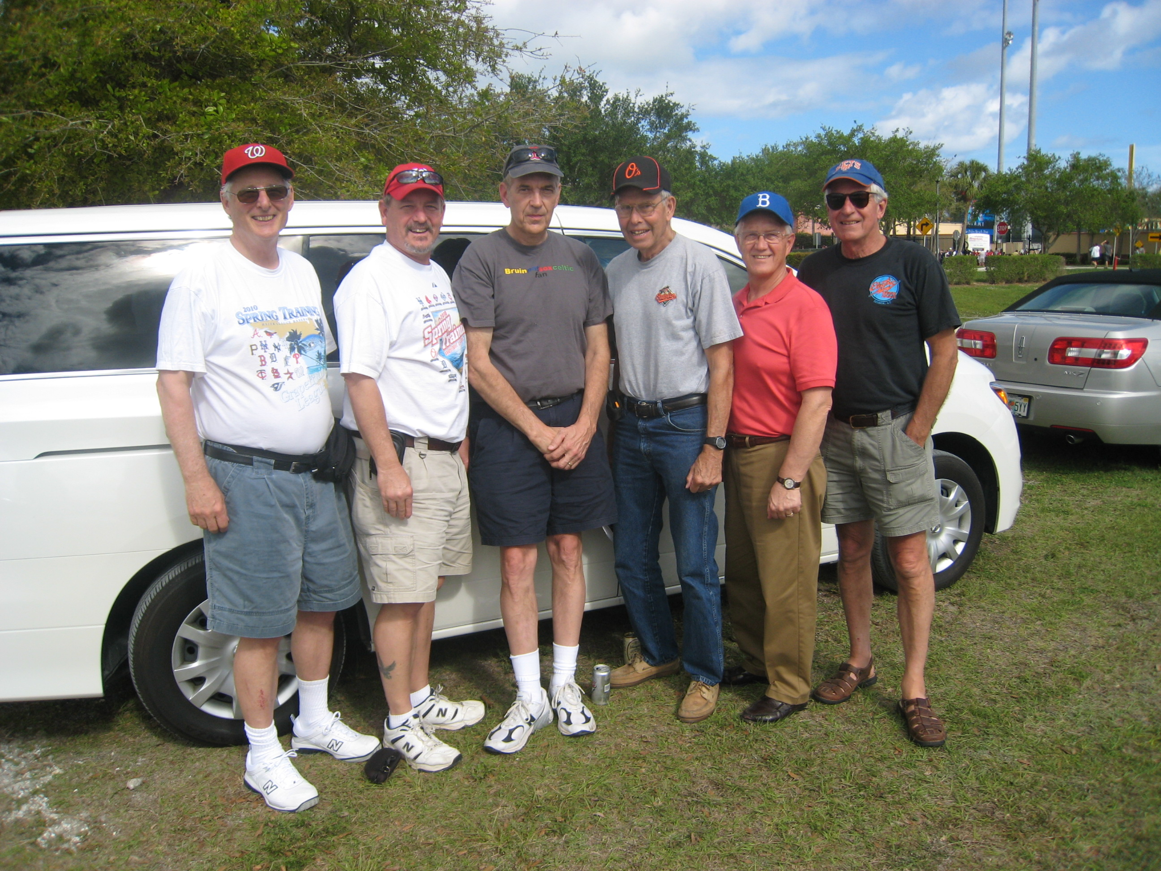

1969: Coast Guard Academy Boys of Summer in West Palm Beach

JIM HARTNEY (jrhartney@comcast.net) sent me the following: “I saw the photo of FOREST and PAT HETLAND on an elephant in Chiang Mai, Thailand in the April Alumni Bulletin, and it sent me down memory lane. The attached photo was taken in 1973 on the road to my LORAN C station just east of Chiang Mai. I’m giving the reenlistment oath to a DC1 from the station. We gave the driver a six pack of Coke for the use of his pachyderm and he was delighted. Why the oath on the elephant? At the time, it was the fad for the Pacific Stars and Stripes to publish photos of unusual reenlistment venues. This one did get published. I thought you and FOREST might find it interesting.”

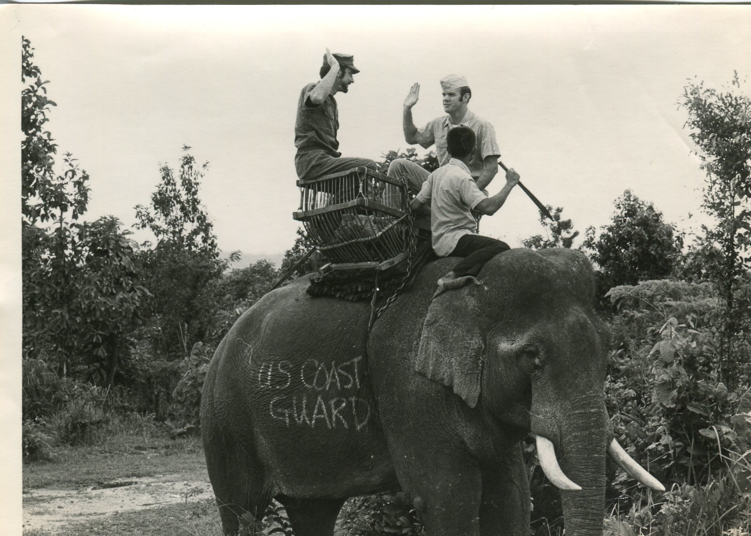

1969: JIM HARTNEY conducting a reenlistment in Thailand, circa 1973

BOB ILLMAN (rsillman@knology.net) is a Friend on Facebook, where I connected with him and found the accompanying photo. “The photo was taken in Montgomery, Alabama with our grandson, Preston. We are still in Huntsville, where we moved in 2000 from the San Francisco Bay area. I came here to lead Westminster Christian Schools, and moved back to church planting in 2007. I now pastor Connections Presbyterian Church, which is a small, conservative, Associate Reformed Presbyterian congregation. SALLY and I enjoy 9 grandchildren scattered from Kansas City to Cambridge, England, via Marion, Arkansas and Montgomery, where they live with our two sons and two daughters, along with appropriate spouses.”

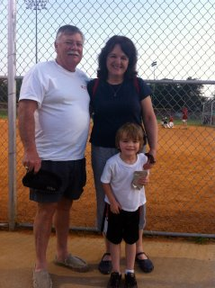

1969: BOB & SALLY ILLMAN with grandson Preston

ANDY ANDERSON sent a recent photo of himself, ANN, their daughter Kate and granddaughter Harper taken at the South Florida Highland Games. ANDY continues his involvement with the U.S. Coast Guard Pipe Band and the Coast Guard Auxiliary. He added: “I will be retiring soon, but in the interim I am working full time and keeping all the dinner plates spinning. My health continues to improve and I am looking forward to some time off in North Carolina this summer.”

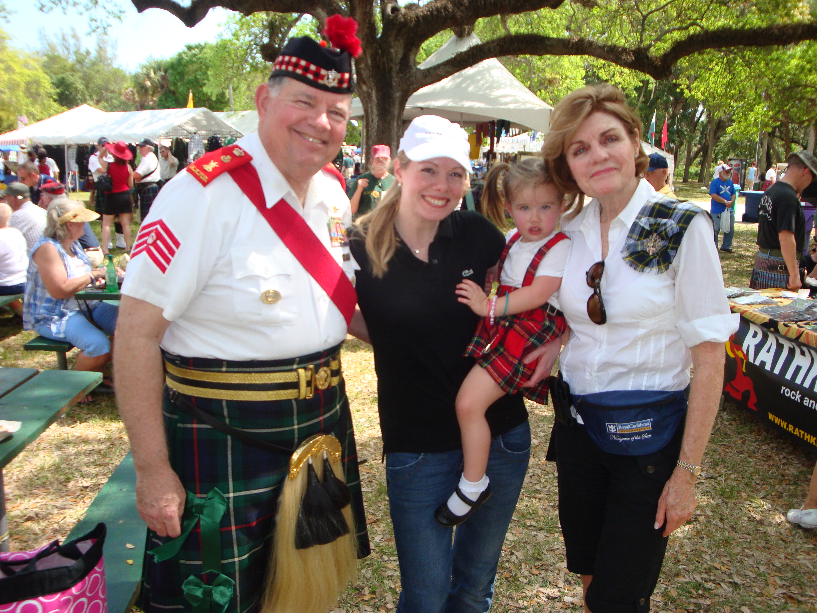

1969: ANDY & ANN ANDERSON with daughter Kate and granddaughter Harper

Two weeks after I heard from ANDY, I received an e-mail from Bill Thomas, CGA ’70, who is ANDY’S brother-in-law and a good friend living in Windermere, on the northeast coast of Florida in Orange County. With ANDY’s permission, I include Bill’s update: “As you know, ANDY is much too shy to tell anyone what he is up to, so I thought I would. After several years of experiencing every type of chemo, ANDY has moved up to an advanced experimental radiation treatment where arteries carry the radiation directly to the battle zones. In between, or despite, bouts of side effects, he continues his admiralty practice at Houck-Anderson, recently including 16 hour days during a federal court trial. ANN and ANDY also spend lots of time doting on their two year old granddaughter Harper. In his spare time ANDY is commander of the local Coast Guard Auxiliary Flotilla, Auxiliary Legal Officer for the district, and an instructor for Auxiliary navigation and seamanship courses. Along with GEORGE BOND, he was a presenter at a recent national Auxiliary conference in St. Louis. He is still the Drum Major for the Coast Guard Pipe Band. A few years ago he led the band in the New York City St. Patrick’s Day Parade six weeks after having part of a lung removed, and he still makes the annual pilgrimage to Grand Haven to march on Coast Guard Day. Periodically he teaches Admiralty courses at a local law school. None of this ‘work’ or medical stuff stops ANDY from the pursuit of hobbies or other miscellaneous skullduggery. He has given up some of his activities of years past, such as rugby and Civil War battle reenactment, and now follows more sedate pursuits such as trips to the shooting range to demonstrate laser sights on various items from his arsenal. At Christmas he began flying his radio controlled Coast Guard helicopter in an attempt to add pilot qualifications to his seagoing command experience and to become a Coast Guard Pterodactyl. He spent a recent Saturday morning speedway comparative testing of the not yet released 2013 Lexus GS against comparable BMW and Mercedes Benz models. In addition to drafting at 120+ on the straightaways, he did four wheel drifts through the curves and hairpins on the Road Course at the Palm Beach International Raceway. Then it was on to the UDT-Seal Museum in Ft. Pierce, Florida. Then ANDY and I joined Capt. Bob Sitton, former commanding officer of Group Miami, for a supper of swapping sea stories. After that it was on to see the movie Act of Valor. Only then would ANDY acknowledge that he was exhausted and hit the sack to be ready to meet the next day’s battles. Not bad for someone from one of those “odd” year classes!”

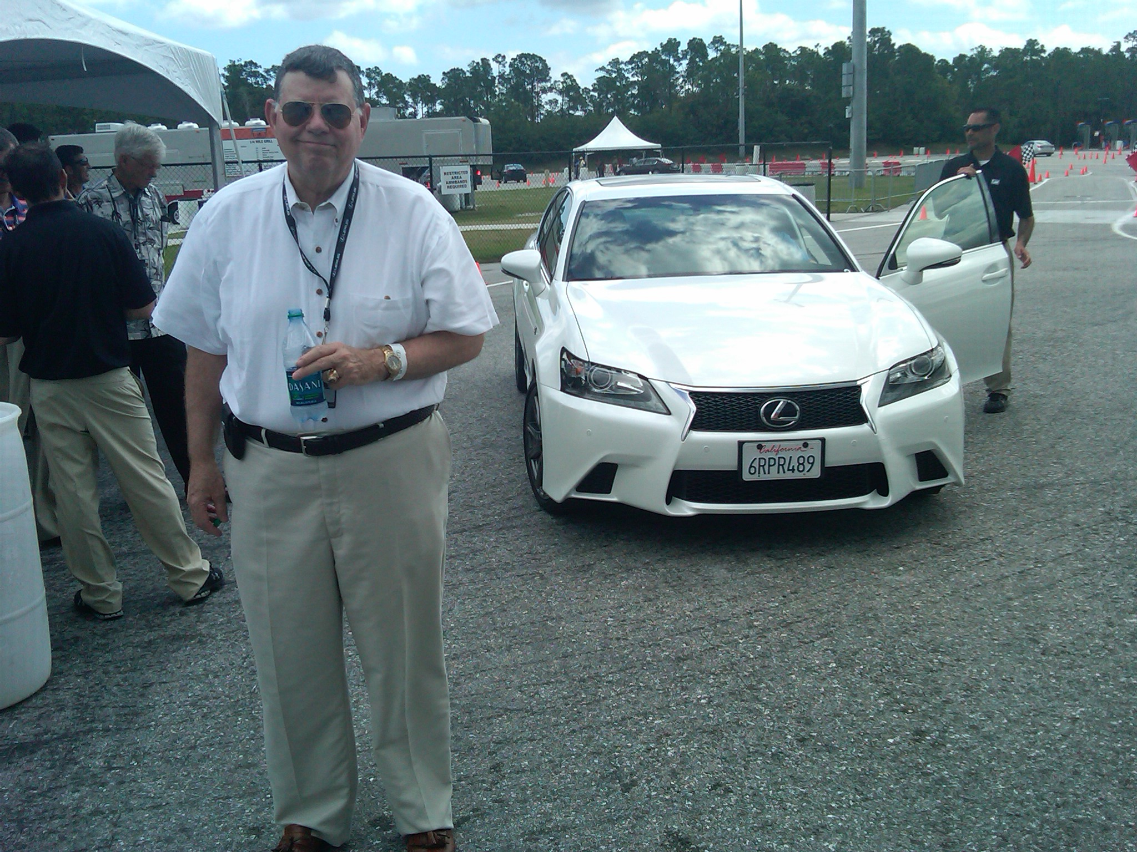

1969: ANDY ANDERSON at Palm Beach International Raceway

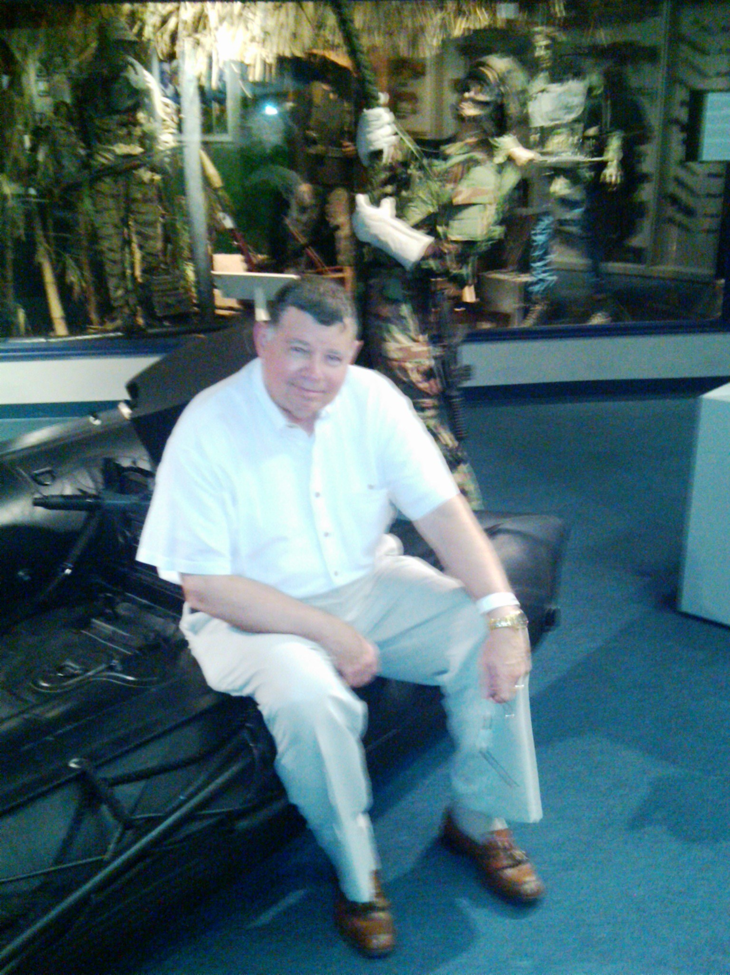

1969: ANDY ANDERSON at the SEAL Museum in Ft. Pierce

STU WHITE sent a photo from the Otto Graham Legacy Fund Golf Classic played at the Bay Hill Club and Lodge in Orlando, Florida. The class was well represented by STU and RUBE OLSON. Rounding out their foursome were friends of Bill Thompson, CGA ’64. Arnold Palmer spoke briefly at the awards banquet, relating experiences he had while serving in the Coast Guard. STU got together with VINCE KINAL for an afternoon and after the practice round on Sunday.

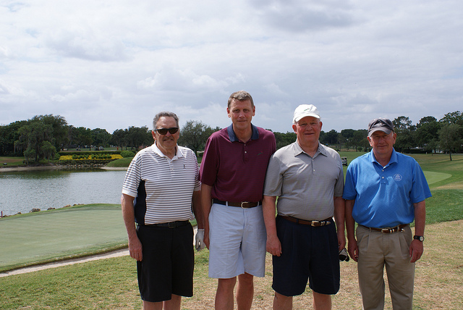

1969: RUBE OLSON & STU WHITE at the Otto Graham Legacy Fund Golf Classic.

The April Bulletin included a photo of BOB GLYNN’s grandson Liam swimming underwater. Unfortunately, the caption under the photo incorrectly read “Liam training to be a CG Reserve Swimmer”, rather than “Liam training to be a CG Rescue Swimmer”, which I submitted.

