June 2018
’69 CLASS CORRESPONDENT

CAPT Bob Gravino
2 Summer Street
Ipswich, MA 01938
(978) 356-0825 (H)
E-mail: rcgravino@aol.com
Website: http://www.uscga69.org

Greg Shaw documented the end of winter and the arrival of spring this year with the Twenty Second Annual Spring Training Baseball Trip, spending five days in the Tampa area and seeing four games featuring Toronto, Philadelphia, Pittsburg and the New York Yankees. Greg is the only plank owner of the annual event who has attended all twenty two trips since 1997. This year’s attendees included Bill Bowen, Vince Kinal, Greg Shaw, Paul Pluta (‘67), Mike Bohlman (‘66), Jim Prondzinski (Tech Director ICC), Jim Paskewich (‘68), Jim Card (‘64), Steve Schember (‘67), Bill Thompson (‘64), Chris Kreiler, and Jack Harrald (‘64). The Class of 1969 won the highest attendance award for the third straight year. Greg and Bill voted to change our 50th Reunion class gift to a statue of Ted Williams. Nobody on the trip could find fault with that suggestion.

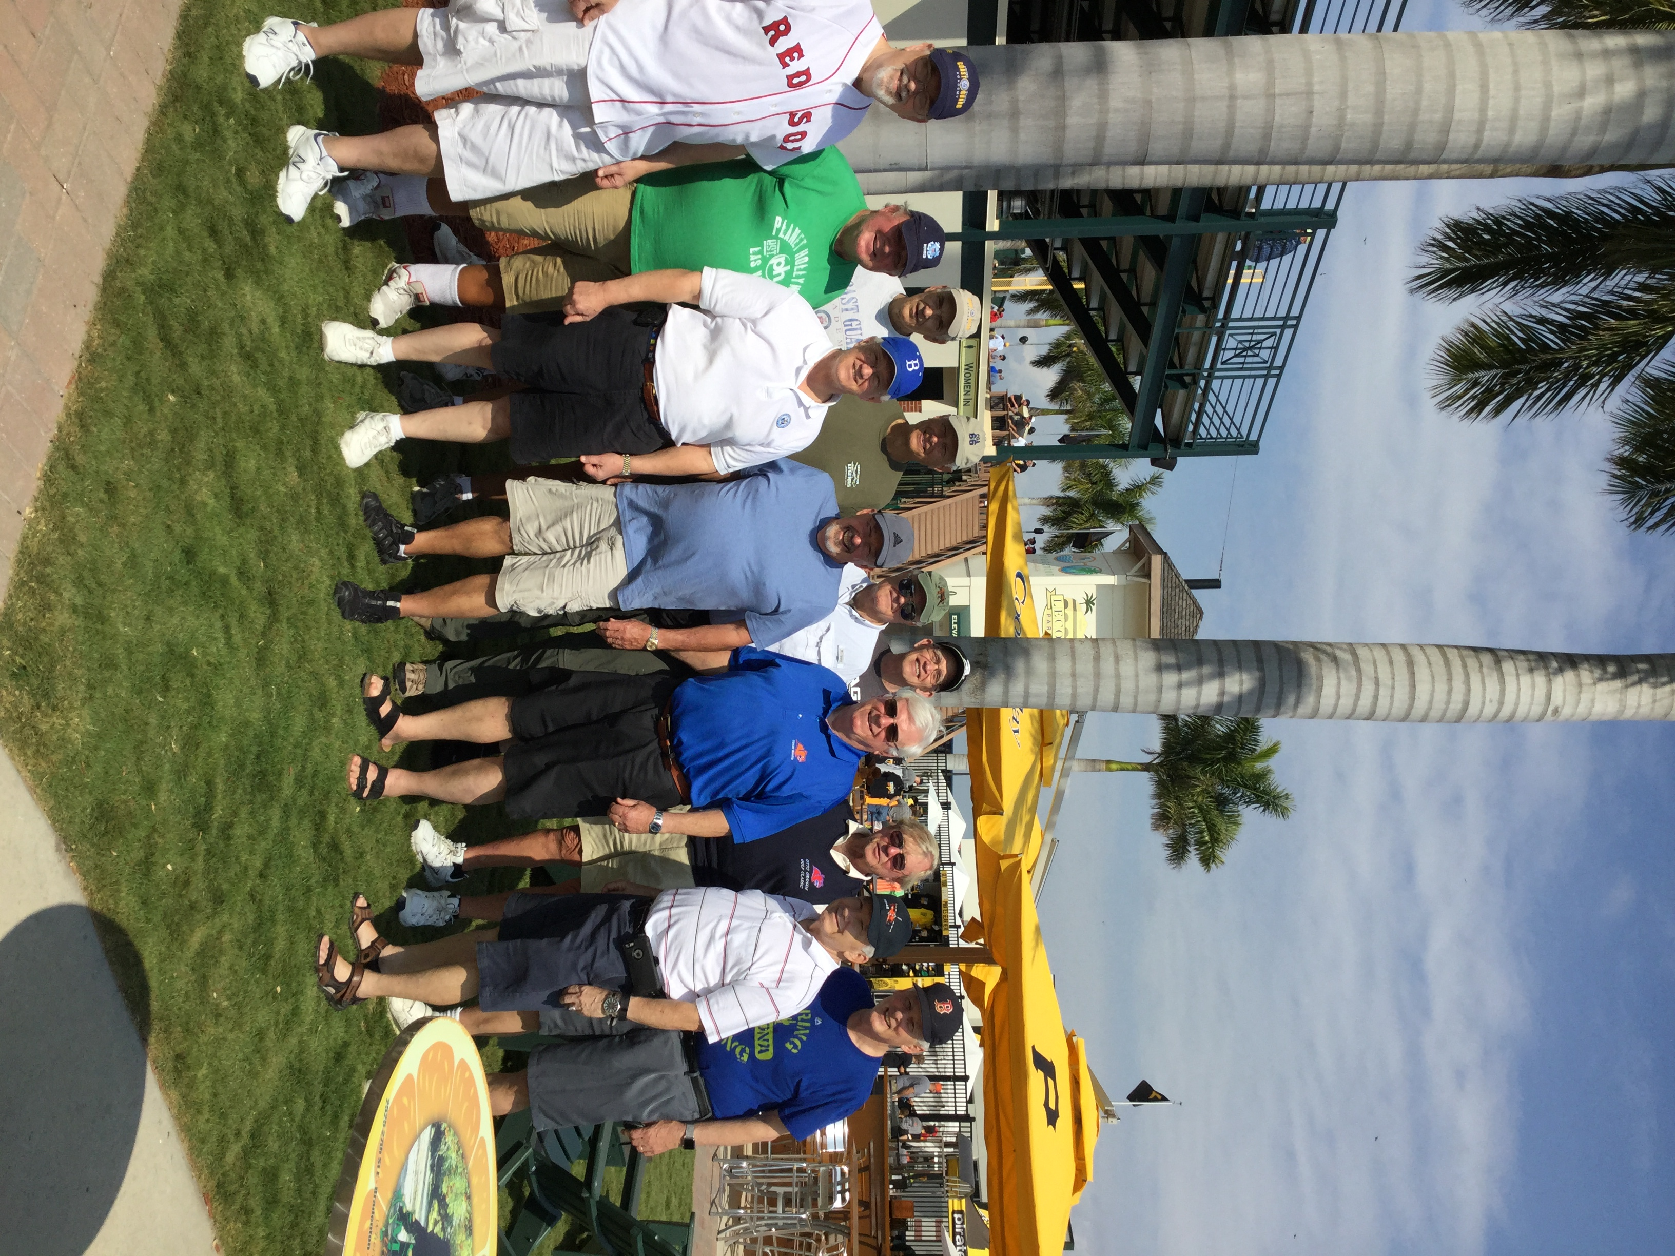

1969: The Boys of Summer 2018

Dan Garrison and the 50th Reunion Class Gift Committee (Jim Burk, Fred Schmitt, Wayne Gronlund, Tim Josiah, Jim Hull, Stu White, Bob Pokress and Rube Olsen) sent out an e-mail update on the class gift in early May. The update is reprinted in part for those not included on the Class e-mail list. “Thanks to your enthusiastic response, we have achieved our initial fundraising goal, with a small margin for safety. We are now proceeding with our proposed gift. Our authorized vendor has been directed to reserve foundry capacity to produce the George Washington Statue and ensure that it is available for installation prior to our 50th Homecoming celebration on October 5, 2019. 72 of us have completed donations to the Class Gift through our existing class fund with new donations totaling over $157,000 and an additional $9,000 on the way. Notably, three of those contributions came from spouses of classmates who have passed away, and we are particularly thankful for their desire to participate. With the prior class fund balance of approximately $20,000, we now have $186,000 to support the project…. Thanks again for your generous support of the Class Gift!”
The Class of 1969 is involved in two major Alumni Association programs that have offered us the chance to form a special bond and lasting link with the Academy Class of 2019. Before arrival of the Class of 2019 to the Academy in the summer of 2015, New London area classmates volunteered to become an integral part of the Link-in-the-Chain Program that connects current cadet classes with the class that graduated 50 years before them. The most recent activity of the Link-in-the-Chain was the Golden Legacy/Passing of the Rings Ceremony, where donated class rings are melted down and mixed with new gold to forge the class rings for the next generation of Coast Guard officers. Wayne Gronlund volunteered to head-up this program for the Class, and five classmates and one spouse of a classmate stepped forward to donate their rings and/or miniatures: Fred Adamchak, Dave Blomberg, Ted Colburn, Wayne Gronlund, Mark Present and Jane Snyder. The Alumni Association created a video of the melting of the seven Class of 1969 donated rings at the Pease and Curren Foundry in Warwick, Rhode Island; the following is a link to the video: https://vimeo.com/264463855. Wayne and Debbie represented the Class at the Class of 2019’s Ring Dance, where at the dinner before the dance, Wayne gave a short talk to the assembled guests, and the President of the Class of 2019 presented Wayne with one of their class rings as a thank you to the Class for our Link-in-the-Chain support.

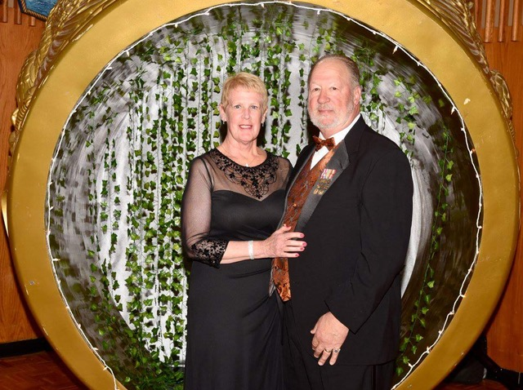

1969: Wayne & Debbie Gronlund at the Class of 2019 Ring Dance

Included with this column is a photo of Jerry and Kris Hale taken on March 31st, with their grandchildren, Annabelle Lyn (age 2) and Maelyn Audra (born March 8th), the children of their son Ben and daughter-in-law Jessica. Jerry is the speaker this year at the Tecumseh Memorial Day Parade in Michigan (his hometown), followed by a two week trip to China that includes an unusual mission. “There is a significant memorial in Nanjing to the Chinese and American aviators killed in China during World War II. One of those KIA was a P-51 pilot from Tecumseh, USMA ('43). His name is not on the memorial, probably because he died on July 25, 1945 at a time when there was chaos in China with the sudden end of the war. My mission is to get his name added to the memorial.” More to follow in the August edition of The Bulletin.

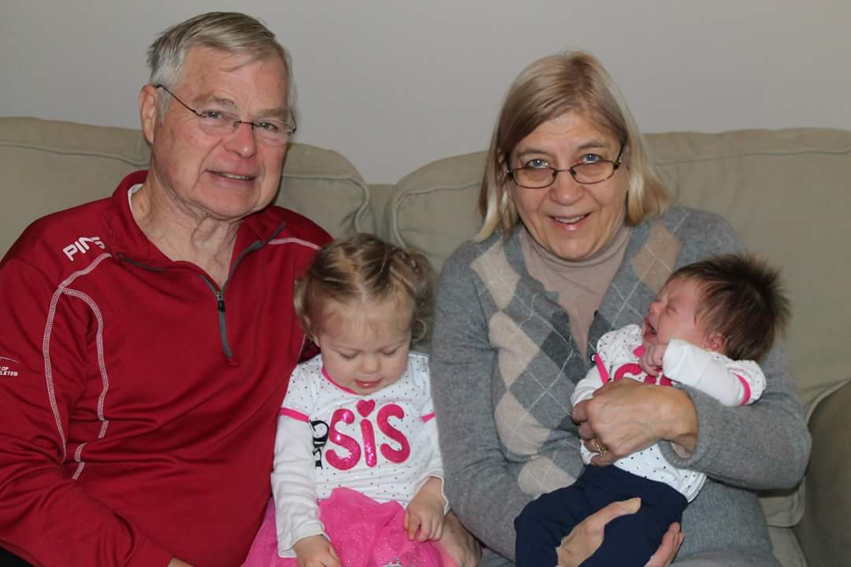

1969: Jerry & Kris Hale with granddaughters

An interesting story from Bill Bowen. “A classmate from my high school has been looking for another classmate that he says went to the Academy after graduation in 1965. His name is Joe Johnson. I checked our website for old e-mails but cannot find this person. I do not remember Joe Johnson either from high school or our class. Do you have a list of everyone who got a nomination, showed up and then left? Not sure how I missed a classmate from my high school who was in our class, but my memory is not as good as it used to be. Any help would be appreciated.” My response: “The Alumni Association Bulletin of September - October 1965 has a listing of those who entered the Academy with the Class of 1969, and included is the name Joseph E. Johnson, Miami, Florida. My notes only indicate that he left the Class; no dates or other information. The name is familiar, but I have no recollection of him. You may want to contact the admissions office to see if they have any information on him. Does your high school yearbook have a photo or write-up on him? If you find him, send me some details for Classnotes.” The reply from Bill: “Will pass this on. Maybe this Joe Johnson only stopped at the Academy for a cup of coffee and moved on. My high school class graduated 1,350, so I did not know everyone.” Don’t feel bad, Bill. Ask Paul Prokop and Jon Vaughn about the time they double dated at the Beverly, Massachusetts, High School junior prom in 1964, and when they met at the Academy sometime during Swab Year, they thought they recognized each other from somewhere in their past.
Barry and Bettymarie Kane’s daughter, Amanda, was married and had two ceremonies; one in a Catholic Church, and a second at a Charlottesville, Virginia, vineyard on April 21st. Classmates attending the vineyard ceremony were Stu White, Dan Garrison, Greg Shaw, Rich Vlaun and Tim Josiah.

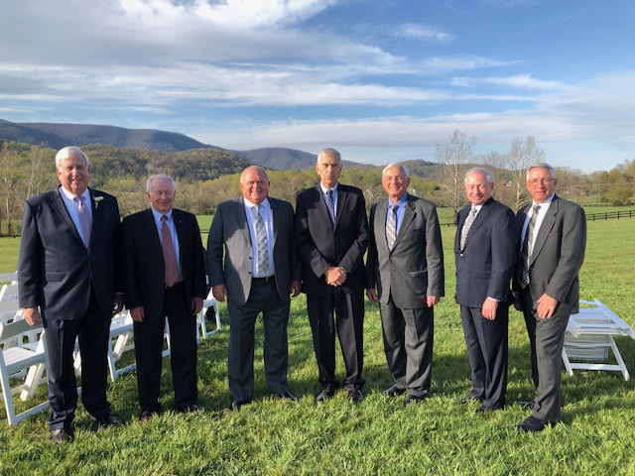

1969: Classmates at the Marriage of Barry & Bettymarie Kane's daughter Amanda

Stu White sent an update on his travels since the beginning of the year. “I am back from the Otto Graham Golf Classic at Arnold Palmer's Bay Hill Club and Lodge; playing at Fishers Island Club later this year. I met with Ron Hoover (‘68) on the way down and played a few rounds with CGA '68 guys at Walt Disney Golf World, and spent the end of February and beginning of March skiing in Vail, Colorado. In late March I flew to Egypt with friends and visited Cairo, Luxor, Aswan, Lake Nasser and the Nile River. Egypt wasn't on my Bucket List but it was an opportunity to add Africa to the list of continents visited - makes seven. Only the Indian Ocean is left to say that I have sailed on all five. As an aside, the Nubian temples were raised 70 meters and moved 50-60 kilometers when Lake Nasser was formed behind the High Aswan Dam. UNESCO encouraged nations of the world to do this. When these projects were undertaken, I was more aware of life at sea, flight training and Vietnam protests. Truly a worthwhile project. Temples were collocated so they could more easily be visited and viewed by the public.”

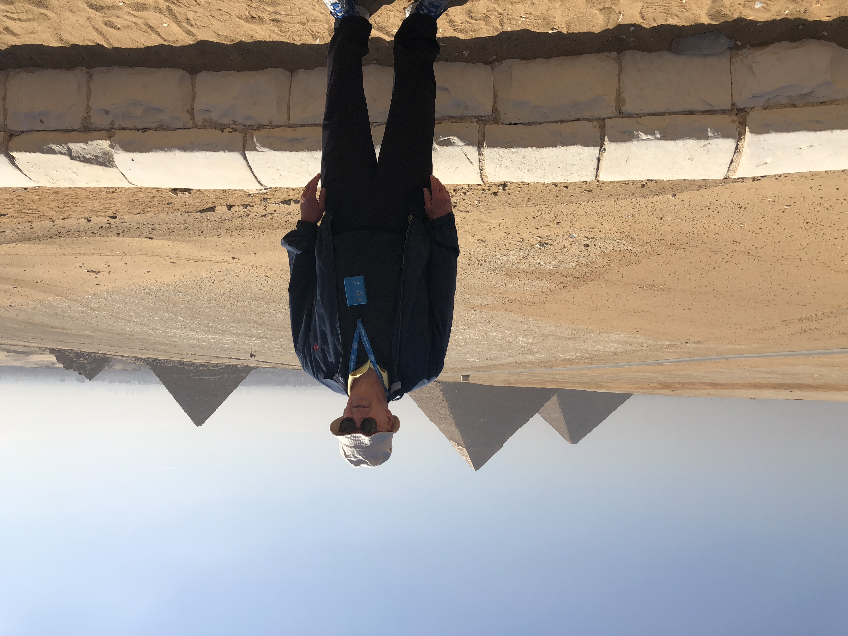

1969: Stu White and the pyramids in Egypt

John and Anne Curtis visited Bruce and Gail Griffiths in Southern California, and as Bruce tells it, they brought some Seattle rain with them. The photo shows that they did have the sun peek through during a tour of La Jolla.

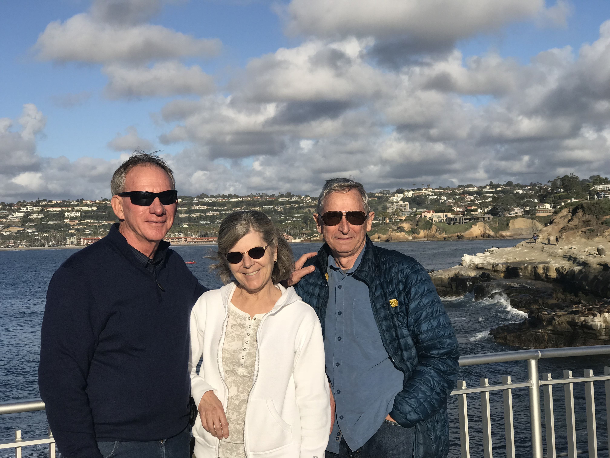

1969: John & Anne Curtis with Bruce Griffiths in La Jolla

Walt and Kathy McDougall welcomed a new granddaughter (granddaughter number two) in late March, born to their son and daughter-in-law, who live in Ashville, North Carolina.
Word from Buck Baley (‘72) and Greg Ketchen (‘70) on Cape Cod is that Pat Garrity is active with the Coast Guard Heritage Museum in Barnstable as a docent and all-around volunteer. It should also be mentioned that three of our Class of ‘69 spouses have contributed to the 50th Class Reunion gift. Our thanks to Pat, Sue Wheatley and Jane Snyder for their thoughtfulness in remembering Paul, Larry and Jay and for staying in contact. We appreciate your continued involvement with the Class.

