June 2021
’69 CLASS CORRESPONDENT

CAPT Bob Gravino
2 Summer Street
Ipswich, MA 01938
(978) 356-0825 (H)
E-mail: rcgravino@aol.com
Website: http://www.uscga69.org

Dan Garrison thanks Classmates and spouses who have already made contributions for the class gift maintenance endowment. For those of you not yet committed, the Class needs your support and asks that you take another look at the gift committee’s proposal and add your contribution as soon as possible. Contact Dan with any questions.
John Zeigler’s wife Carol shared a nice photo of John and Fred Wilder taken at the 50th Reunion, and John provided this personal update. “I swam in one adult masters swim meet in Charleston, South Carolina, in December for the South Carolina Masters Championship. It was my meet to die for and I survived the travel, three-day meet, and swam eight races. With split times for longer races, I earned eleven national Top Ten Times in my new 75-79 age group. Best of all I was first in the 800 short course meters freestyle race to win All-American honors, my second award since my 200-meter breaststroke in 1986.”

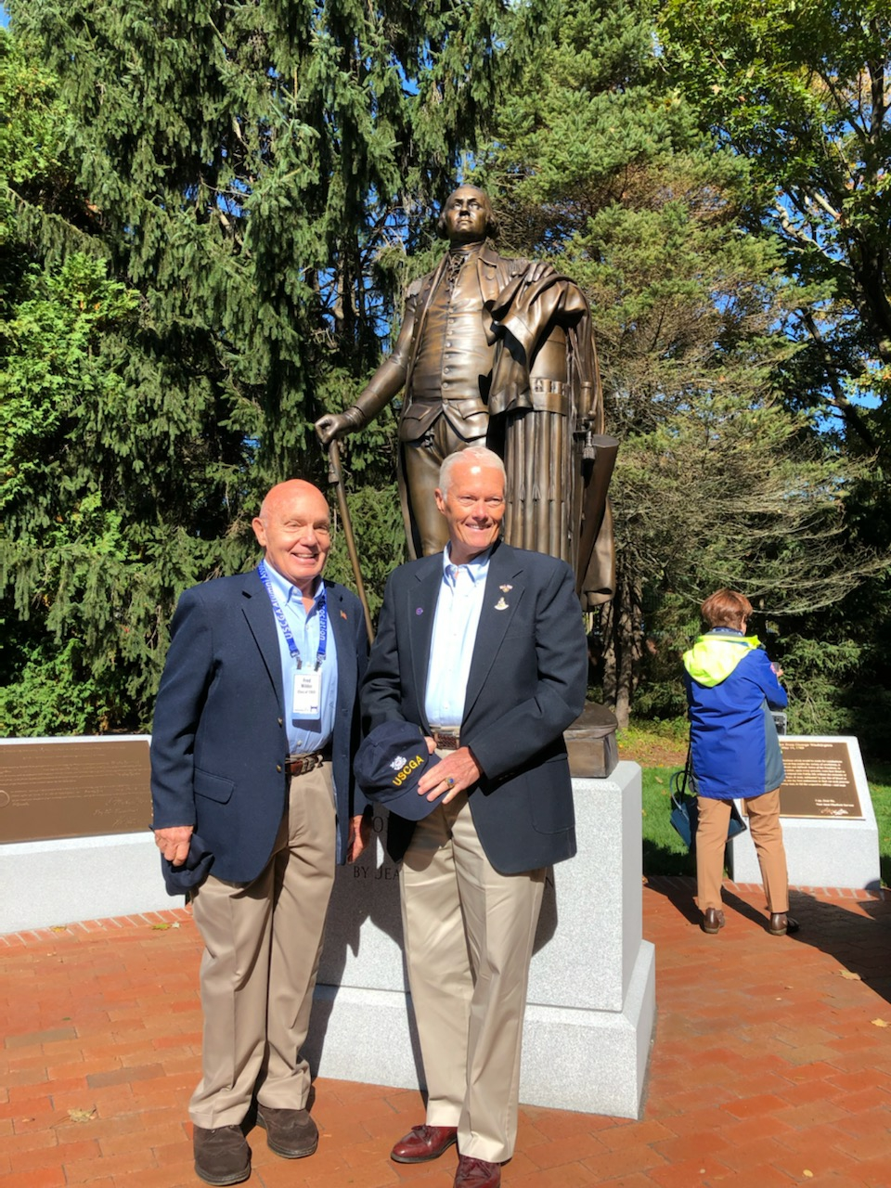

69: John Zeigler & Fred Wilder at the 50th Reunion

John and Lesley Miner celebrated John’s 75th birthday in March with Charlie and Sue Huber and Fred and Linda Adamchak. The accompanying photo was taken on the Miner’s indoor putting pool table, where the team of Charlie, Fred and Linda won the two matches held. “Williamsburg, Virginia is lovely in the spring, and classmates in the area are doing well. Please visit when you can.”

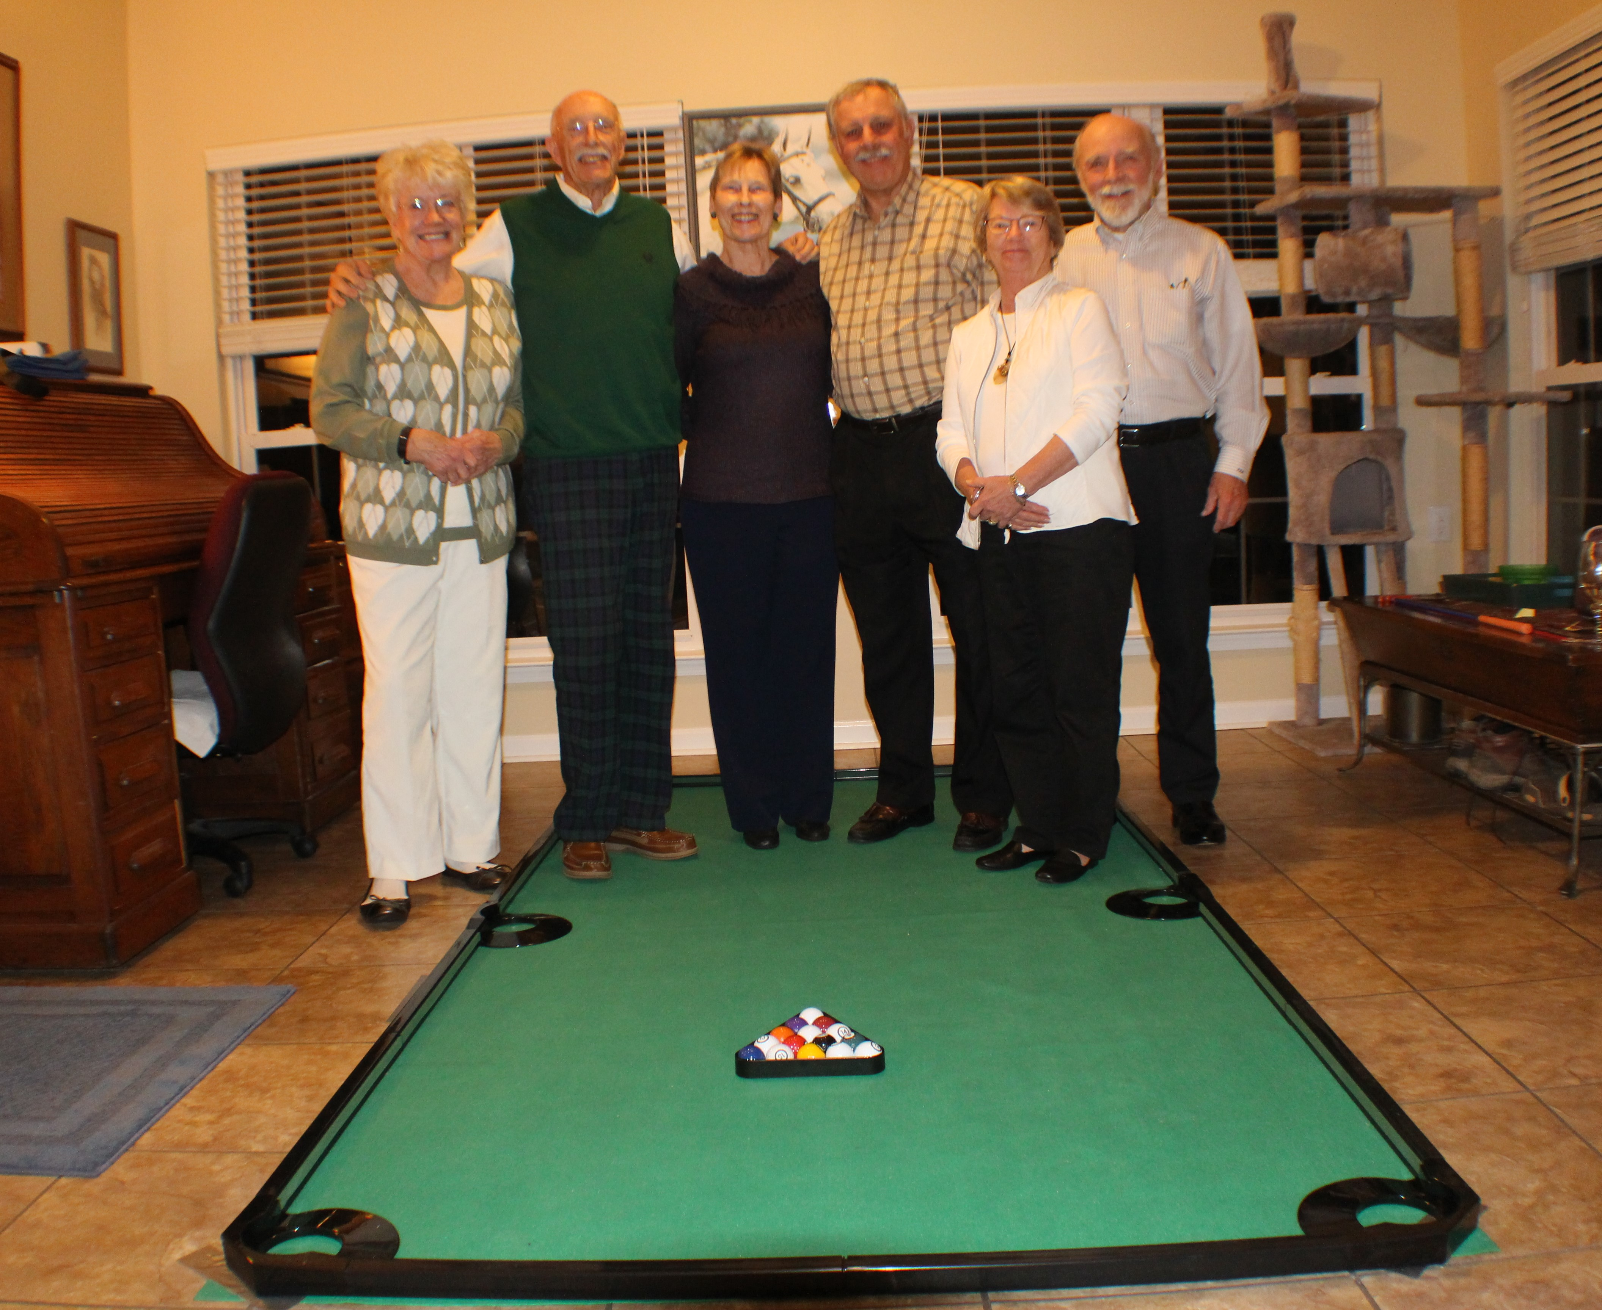

69: Miners, Hubers & Adamchaks celebrating John's 75th Birthday

At Peter Kissinger's Celebration of Life two years ago in April, the speaker from the International Road Assessment Programme (iRAP) announced that an annual award would be given in Peter's name to the person most deserving to be acknowledged for his/her contribution to worldwide road safety. iRAP (https://www.irap.org/) is the umbrella program for Road Assessment Programmes (RAPs) worldwide that are working to save lives and prevent serious injuries on the world's roads. Their vision is for a world free of high-risk roads. Dave Anderson sent me the following. “The Peter Kissinger iRAP Transportation Award is a great way to honor Peter and acknowledge his contributions to transportation safety. I attended the ceremony on Zoom, along with others from around the globe. Willie asked if I would like to listen in, and I was honored to be invited. Peter was instrumental in the formation of iRAP, and Willie has been intimately involved in the selection of the award winners. I have told Willie on numerous occasions how impressive it is for Peter to be honored in such a manner. Members of our Coast Guard serving in the focus area of Marine Safety and other programs work in many ways to prevent accidents on the waterways of the world. iRAP has the same goals in mind for preventing accidents on roadways.”

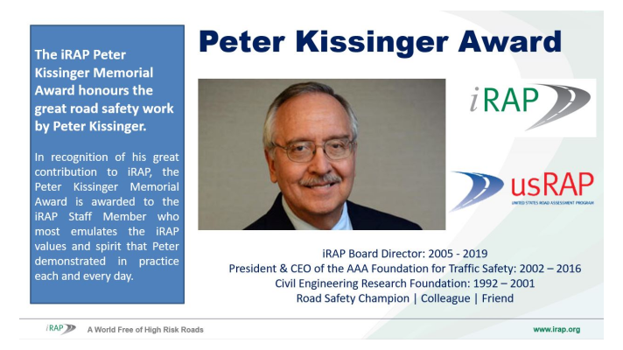

69: Peter Kissinger International Road Assessment Programme Award

Paul Bodenhofer underwent kidney transplant surgery in early April at Hartford Hospital in Connecticut. Paul and Candace’s daughter Kristen was a perfect match and donated one of her kidneys to her father. The operation was a complete success, and Paul and Kristen are doing well.

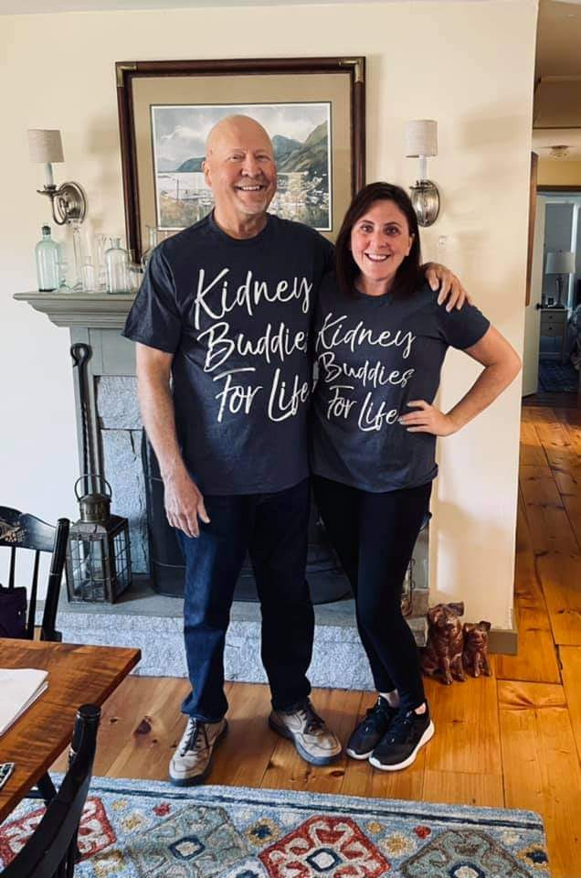

69: Paul Bodenhofer & Daughter Kristen

Jerry Hale took a break from the winter chill of Pennsylvania in early April and spent some time in Florida, visiting friends and former shipmates. One of the friends who he visited was one of the chaplains assigned to Governors Island during Jerry’s tour in New York. “I have provided a photo of me with Chaplain Stan Beach taken at his retirement home in Seminole, Florida. Stan was the senior U.S. Navy Chaplain on Governors Island in the early 1980's where he was dual hatted as the first Chaplain of the Coast Guard. Despite the tradition of only naming military buildings after deceased national heroes, an exception was made to allow an unusual tribute for Stan. The facility housing the U.S. Naval Chaplaincy School and Center in Newport, Rhode Island, is named The Stanley J. Beach Hall, in honor of his 30 years of service as a U.S. Navy Chaplain and his actions while assigned to the Third Battalion, Fourth Marines in Vietnam in September 1966, when the 3rd Battalion was engaged in combat with a North Vietnamese Army Division. While continually traversing the battlefield, ministering to wounded Marines and carrying them to the rear for medical treatment, Stan sustained severe leg and stomach injuries which ultimately led to the loss of his leg. He was awarded the Bronze Star for Valor for these actions. During his previous seven months in the combat zone, he had distinguished himself as a chaplain to the Marines and was awarded the Navy Commendation Medal for Valor and the Purple Heart. Stan served another 21 years after his Vietnam combat tour, in various roles and levels of ministry and leadership, including his tour with the Coast Guard and as the Director of the U.S. Naval Chaplaincy School.”

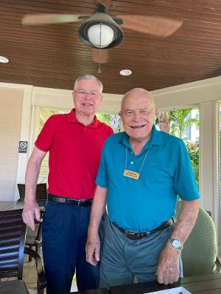

69: Jerry Hale & Chaplain Stan Beach

Kathy and I spent a few days on Cape Cod in early April and visited the Coast Guard Heritage Museum in Barnstable. The museum is a volunteer organization supported by many former Coast Guard members who have an interest in telling the Coast Guard story and preserving and promoting the history of the Coast Guard and its predecessors, specifically in the seacoast waters of New England. Active volunteers at the museum include Pat Garrity, Greg Ketchen ’70, Jim Sylvester ’71, Buck Baley ’72, Phil Dolan ’58 and George Howe ’77. Paul Garrity was an active volunteer with the Museum, and Pat has continued Paul’s spirit of volunteerism. Displayed in the Museum are Coast Guard aircraft models and uniform items donated by Pat from Paul’s service in the Coast Guard, including his Aviation Greens and flight suit. Pat is a director of the museum, 2nd Vice President, editor of the Museum newsletter, a docent, and active in membership development and fundraising. Pat funded the framing of the 20” x 24” rendering of Alexander Hamilton that Bob and Barbara Thorne donated to the Museum last summer. Bob commissioned the original portrait by East Lyme, Connecticut artist Christopher Zhang as part of our Class Gift. The 30” x 36” original was presented to the Academy at the Class 50th Reunion ceremonies in October 2019, and it now hangs in Hamilton Hall at the Academy. The accompanying photo is a group of Academy alumni and wives about to enjoy dinner and conversation at a seafood restaurant along the Cape Cod Canal; Kathy and Bob Gravino; Jane and Greg Ketchen ’70; Nancy and Buck Baley ’72; Pat Garrity; and Jim and Peg Sylvester ’71.

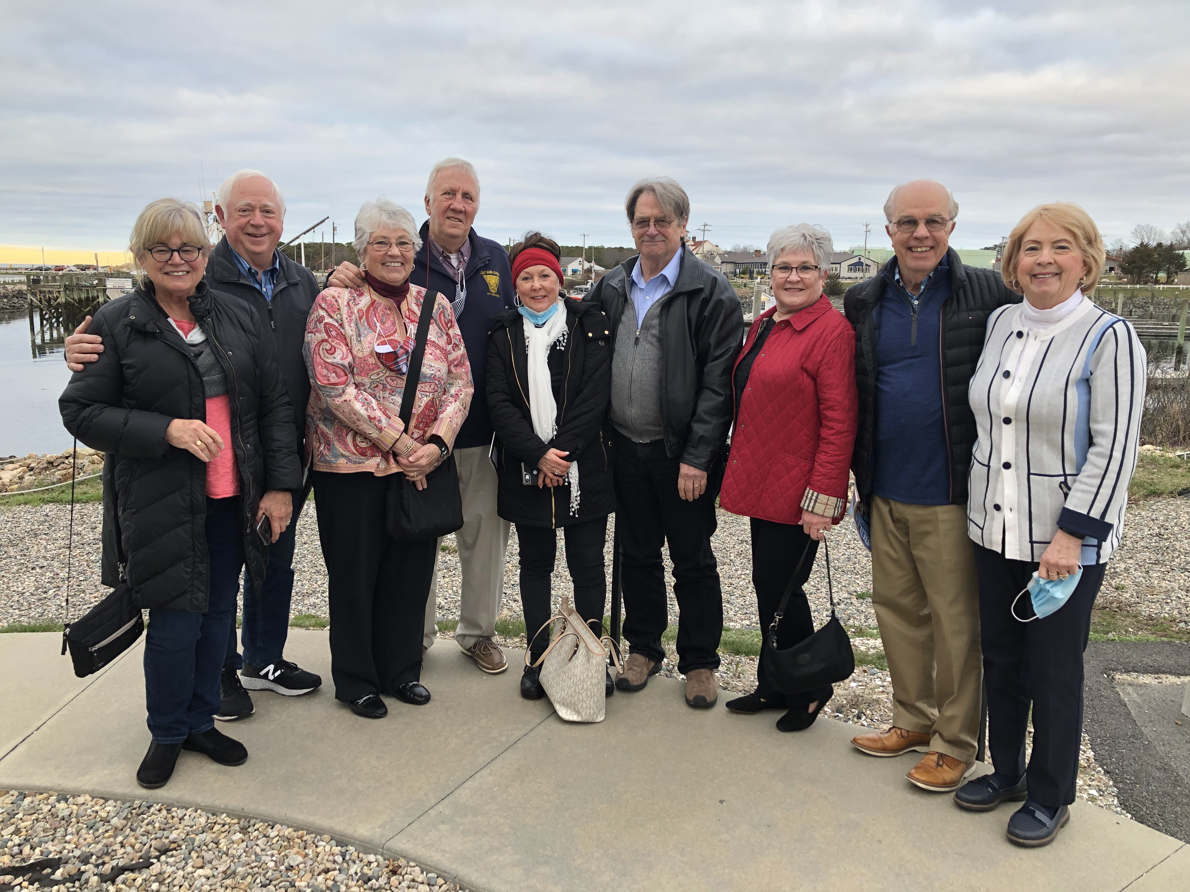

69: Coast Guard Heritage Museum Supporters

