October 2009
’69 CLASS CORRESPONDENT

CAPT Bob Gravino
2 Summer Street
Ipswich, MA 01938
(978) 356-0825 (H)
E-mail: rcgravino@aol.com
Class Website: http://mywebpages.comcast.net/ckreiler/index.htm

STU WHITE visited his brother and family in Minnesota and attended several days of PGA Championship at Hazeltine, having had the opportunity to play the course the previous summer. He spent a day with TOM and KAREN RUTENBERG in Minneapolis, attending the Polish Festival and having dinner at the Monte Carlo Restaurant in the warehouse district where TOM and KAREN live.

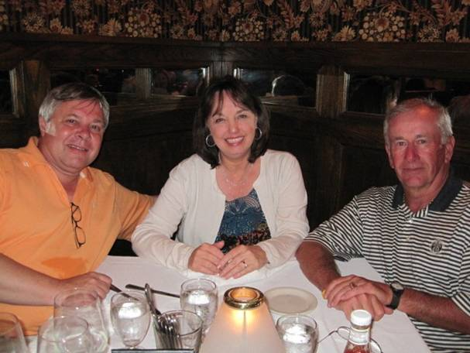

1969: TOM & KAREN RUTENBERG with STU WHITE.

PAUL and PAT GARRITY now have five grandchildren, four grandsons and one granddaughter. Their youngest daughter, Kristine, gave birth to her first child, Gavin Paul O’Brien, on July 29, in Boston. A photo of the proud grandparents is attached.

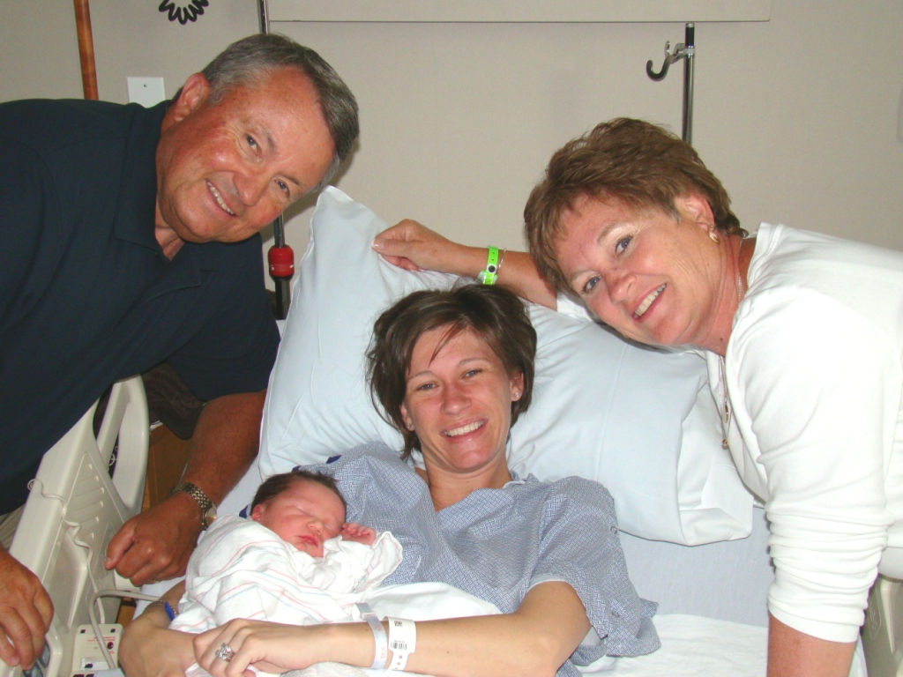

JIM DOHERTY was awarded an Honorary Fellowship in the Royal Institute of Navigation (RIN) in July for lifetime contributions to the art and science of navigation. RIN is an equivalent professional association in the United Kingdom to the Institute of Navigation (ION) in the United States. The ceremony was held at the Royal Geographical Society in London, and RIN’s patron, Prince Philip, Duke of Edinburgh, made the presentation. PATTI accompanied JIM, and at the reception after the ceremony, they spent an evening in conversation with the prince. They made a side trip to the north of Wales to visit friends, watch sunsets over the Irish Sea, tour villages and castles, and sample fine brews in local pubs. Their host in Wales had been president of RIN when JIM was president of ION several years ago.

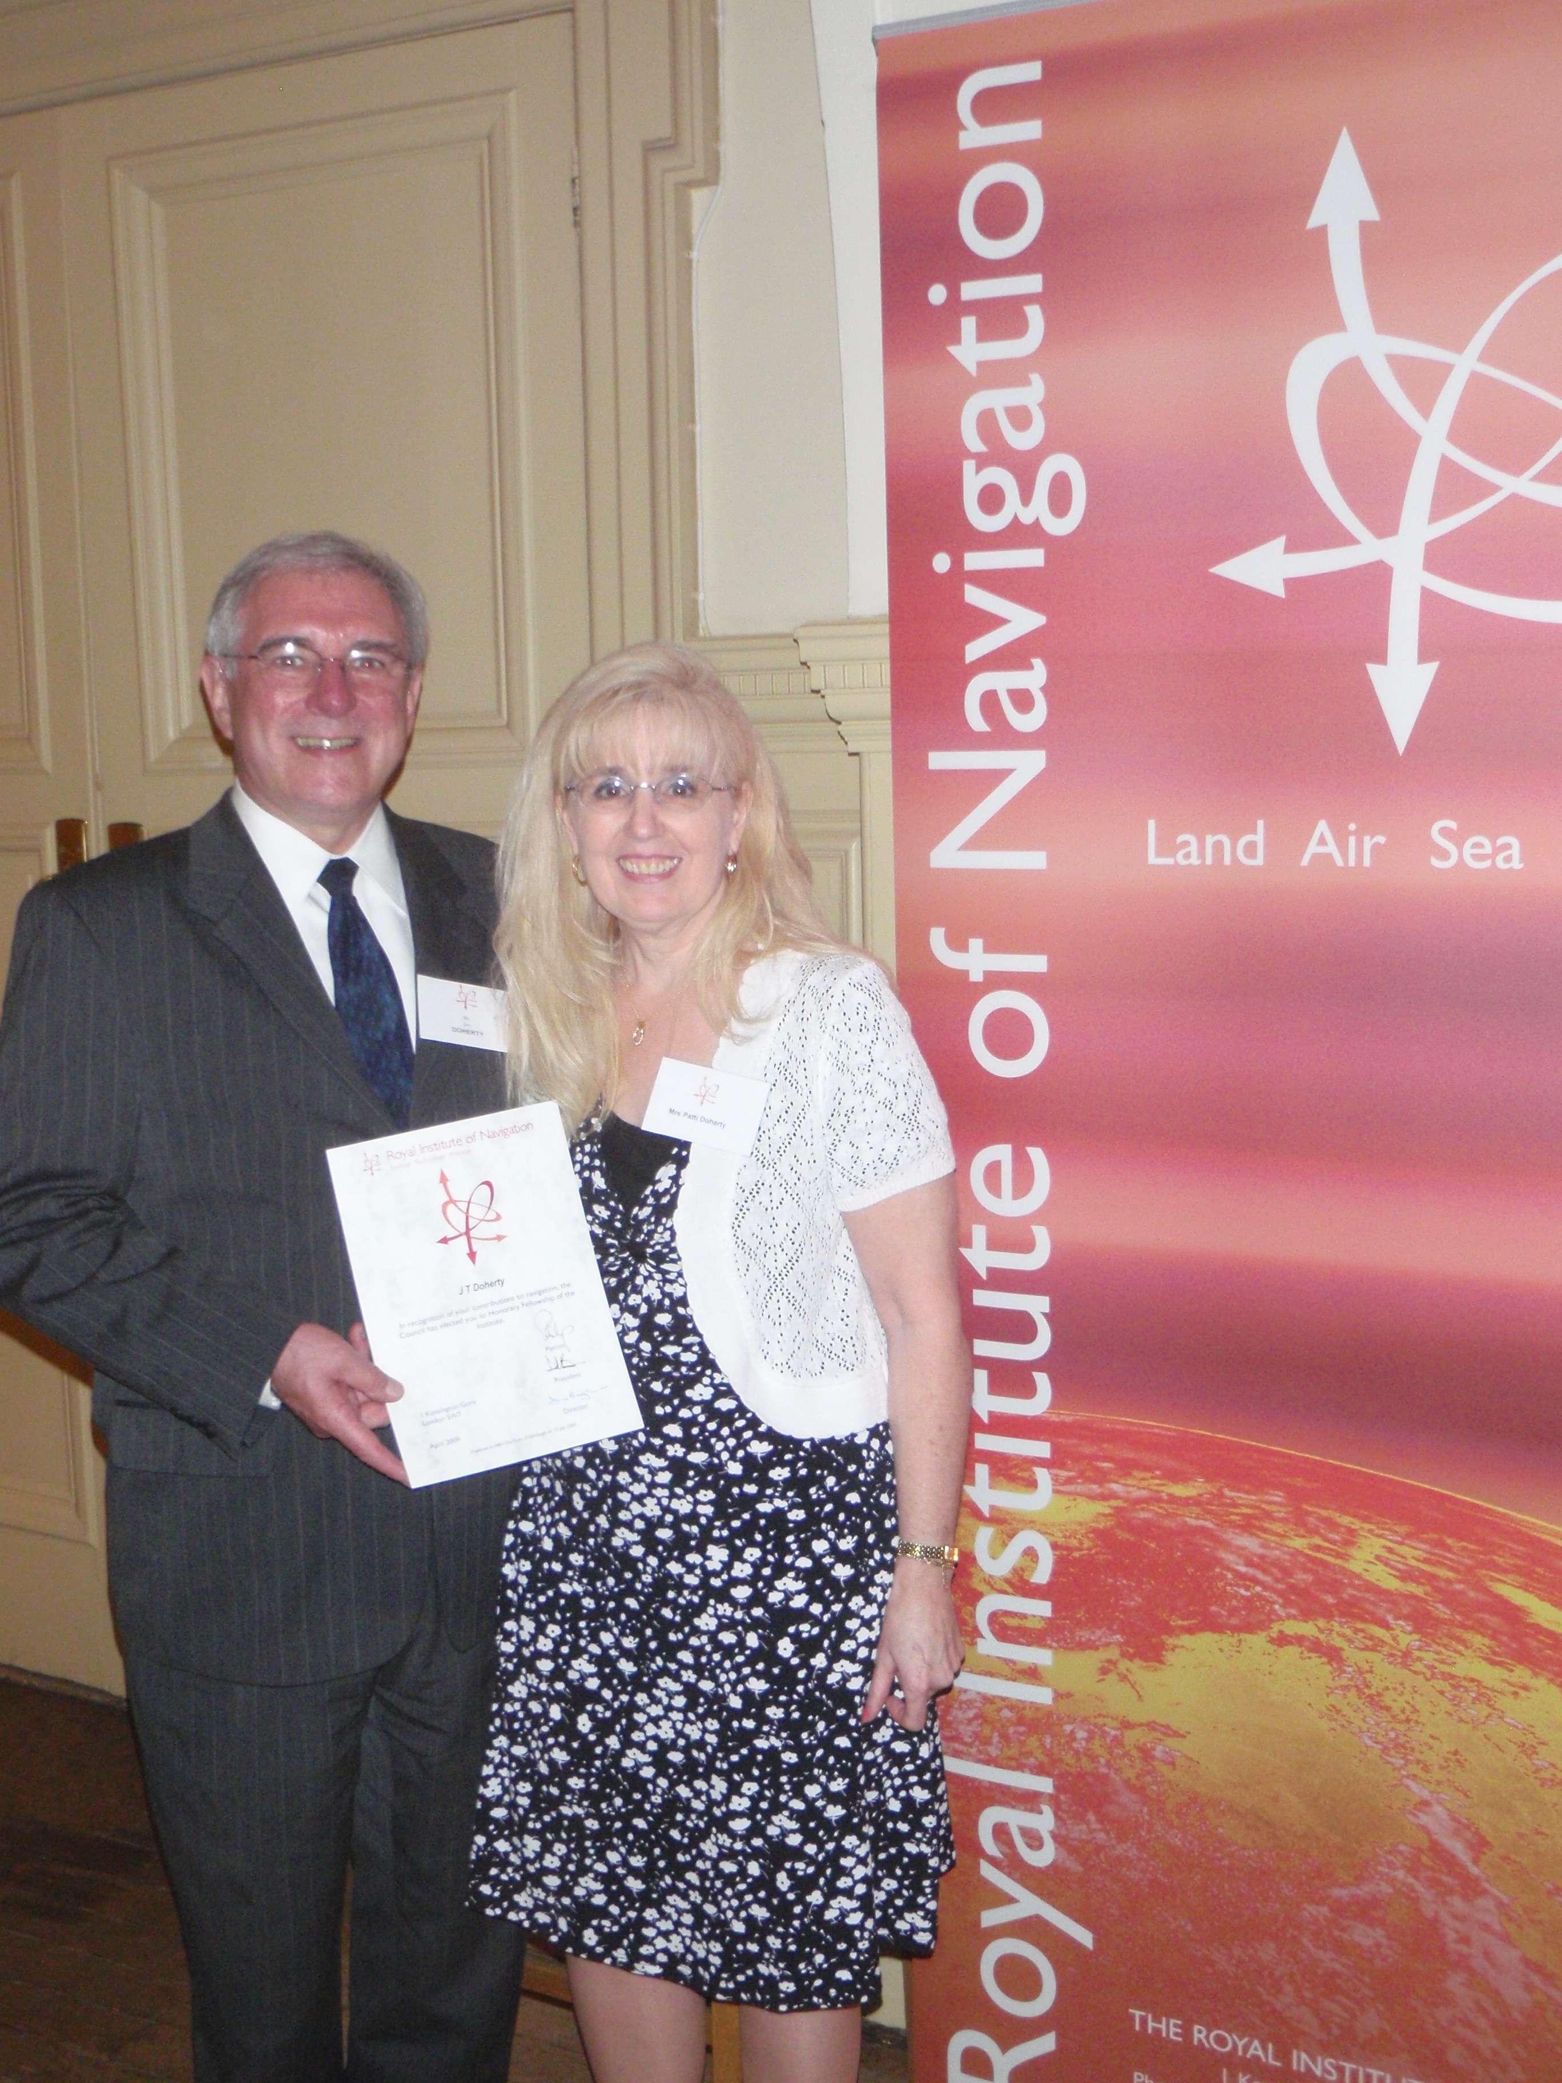

1969: JIM & PATTI DOHERTY at the Royal Institute of Navigation

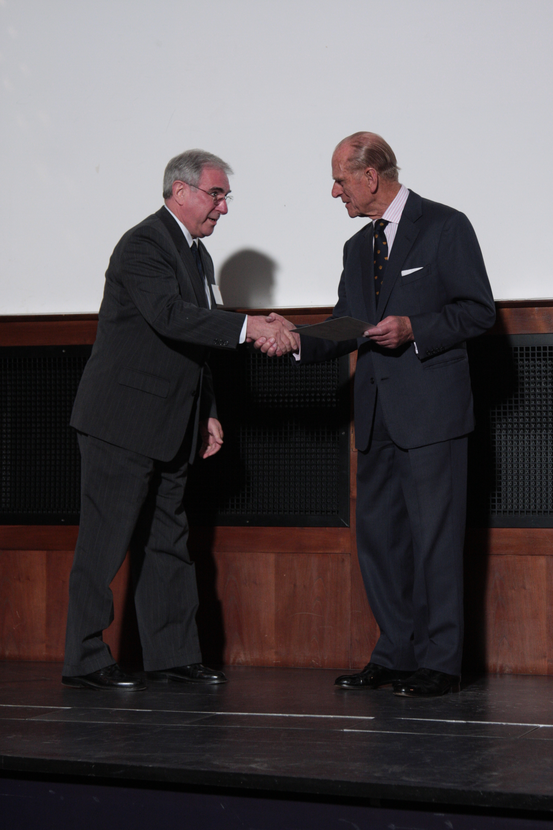

1969: Prince Philip presenting JIM DOHERTY his Honorary Fellowship.

GARY PAVLIK sent a photo of his daughter Emily, granddaughter Madelyn and Emily’s godmother, JANET BROWN. GARY sent the following: “Our only grandchild, Madelyn Grace Kneip is 16 months old. Daughter Emily returned in May to Lackland Air Force Base in Texas from Iraq and is back at the level one trauma center on base in a teaching/attending position. DOUG BROWN is still teaching at Kings Point. DOUG and JANET’s youngest just graduated from Kings Point, took a Coast Guard commission, and reported to a cutter in Alameda. Their oldest, Dave, is an Air Force Academy graduate, was married in June, and is stationed in Southern California. NANCY and I live near Newport, Rhode Island, and built what we think is our last house. I’m still working in sales and NANCY is using her University of California Berkeley master of library science degree in a local school system.”

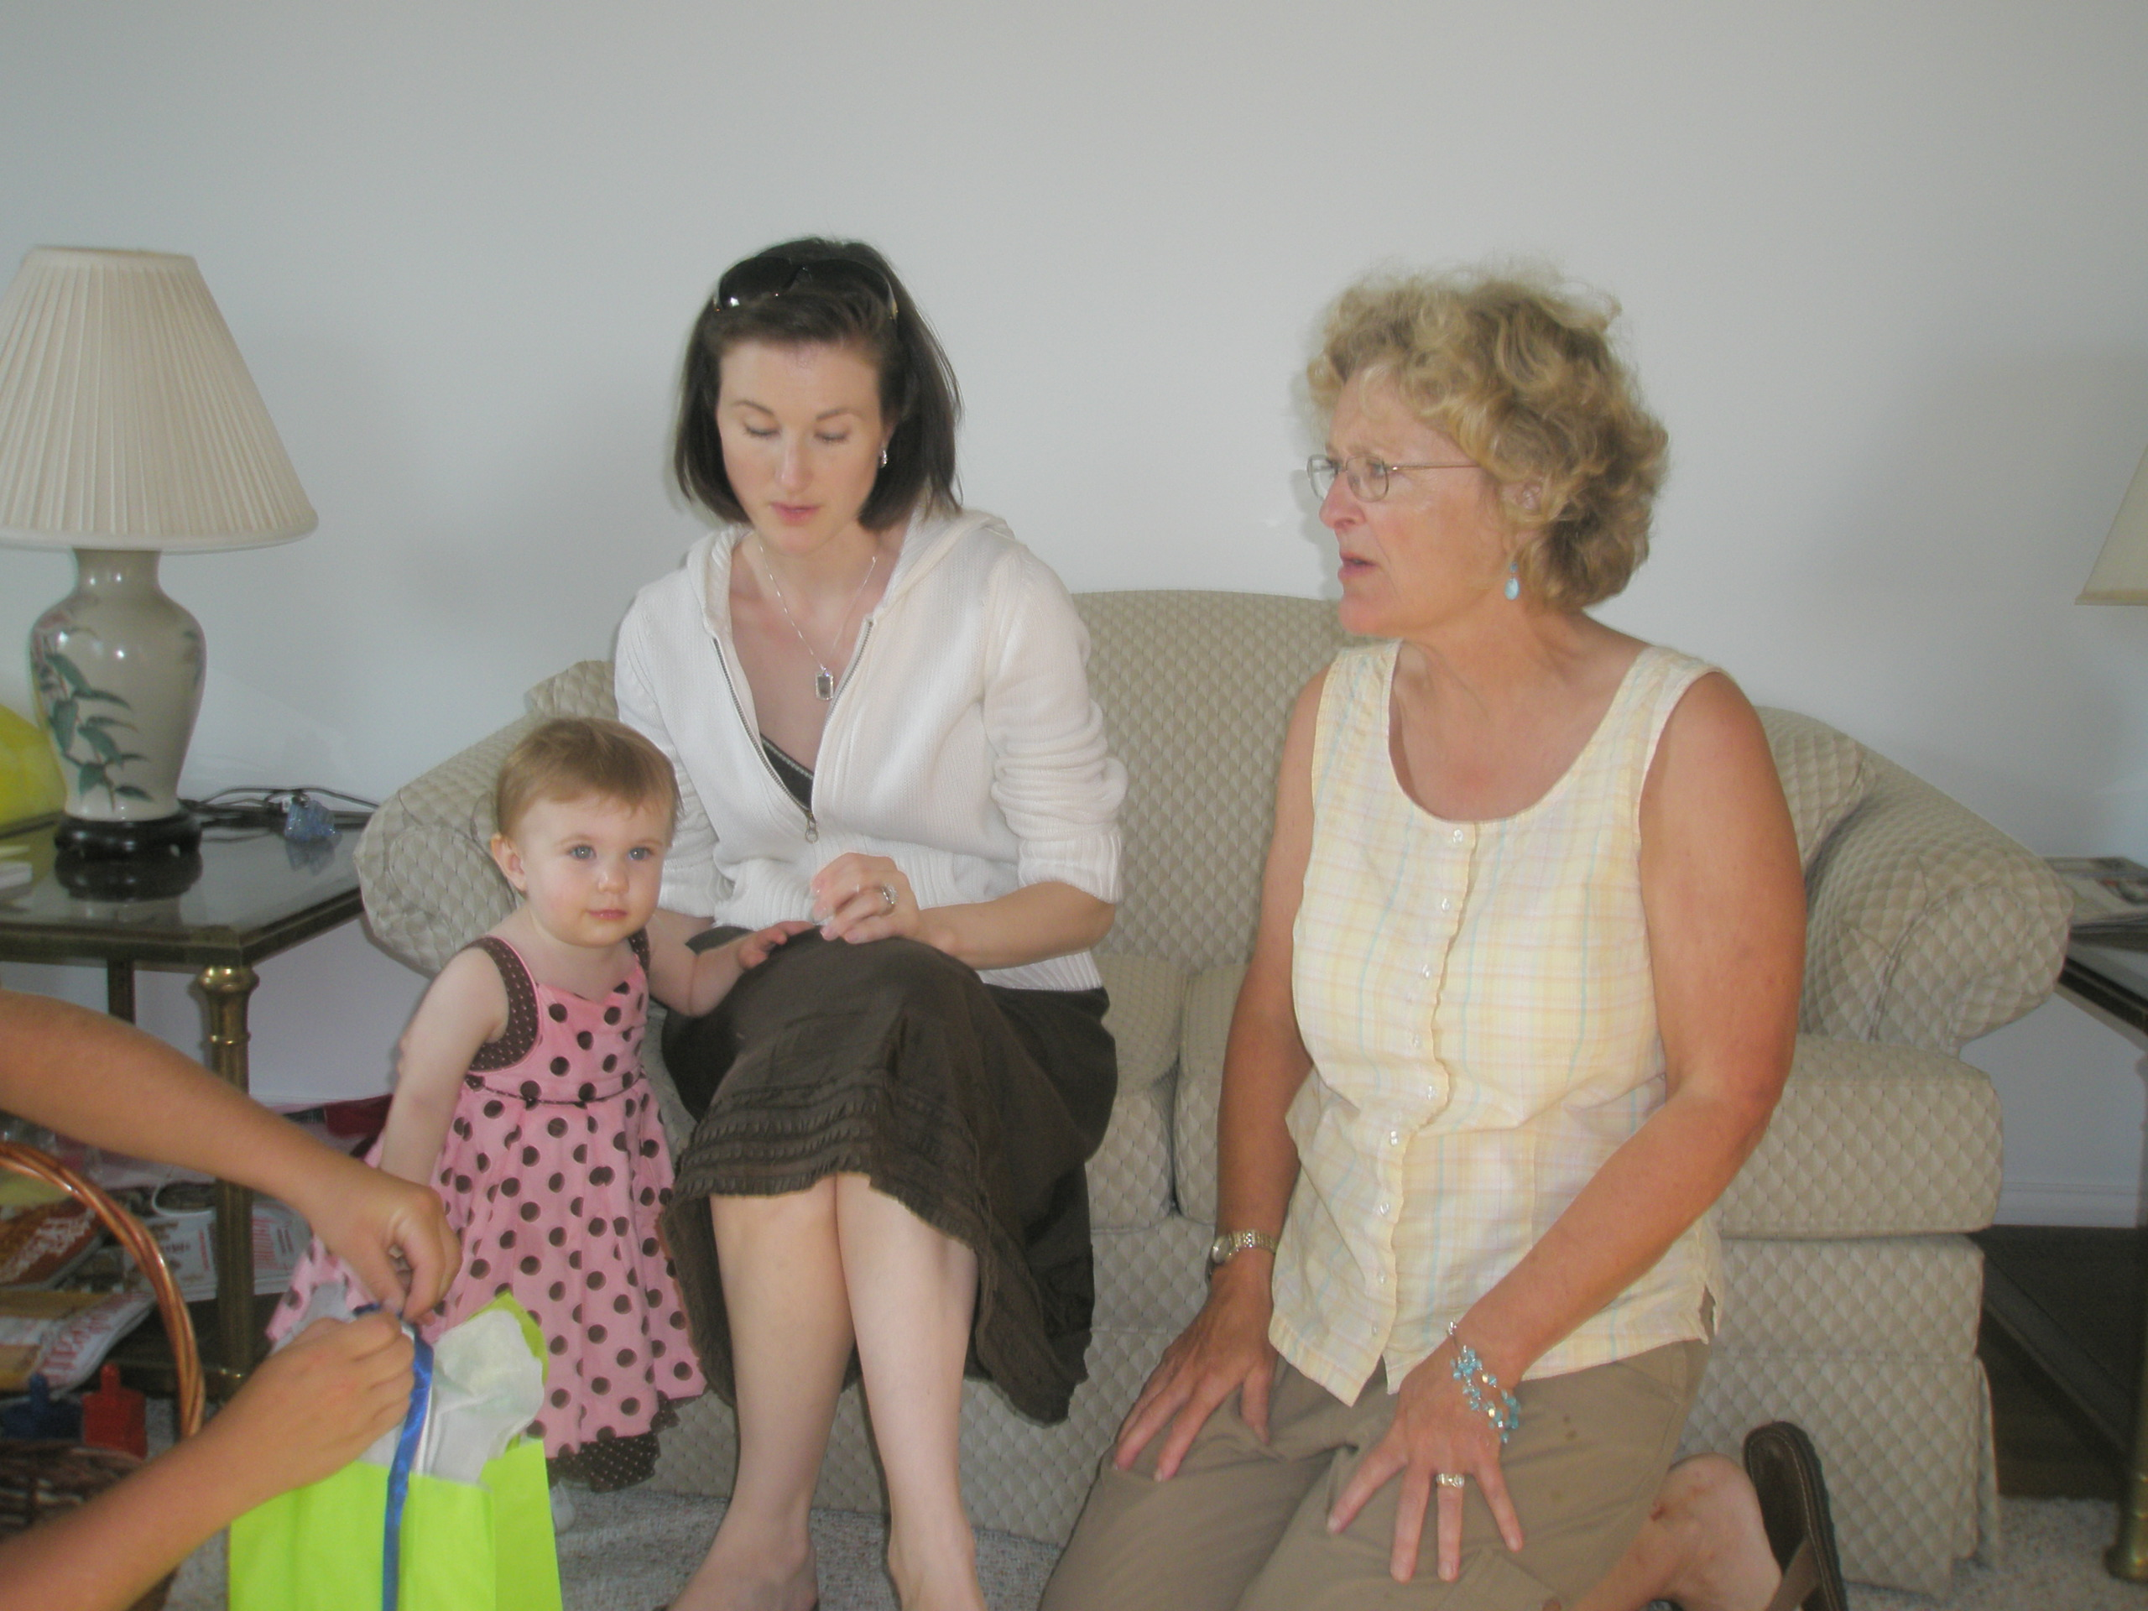

1969: GARY PAVLIK’S daughter, granddaughter and JANET BROWN

Our Key West Classmate and frequent field reporter, JIM SMITH, sent this newsbyte on July 28th: “The NBC Today Show is in Key West this morning, with Matt Lauer and Al Roker doing 5-minute “vacation” segments. Good PR for the Conch Republic. Then they cut away to New York City where Meredith Viera did a spot on the dangers of text-messaging while driving. And guess who offered expert commentary? Our own PETE KISSINGER!”

DICK BURKE had planned to attend Homecoming for the 40th Reunion, but his travel plans changed this year when: (1) daughter Tricia had 7th grandchild (Lilyana) in Fayetteville, North Carolina—east coast trip #1; (2) granddaughter Kylee (age 12) sang at Carnegie Hall in New York City with the Tucson Girls Chorus—east coast trip #2; (3) daughter Heather had 8th grandchild (Katelynn) in Richmond, Virginia—east coast trip #3. “Including daughter Debbi’s daughter Naomi being born here in Vacaville, California, in October 2008, we’ve been blessed with three granddaughters from three different daughters in 10 months. We’re enjoying all of them (the daughters and the granddaughters). Tricia and Lilyana stayed with us for about a month this summer while her husband (active duty Army Captain, Special Operations psychologist) was in Iraq. They’ll be back visiting us at the end of the year when her husband returns to Iraq for a three month tour.”

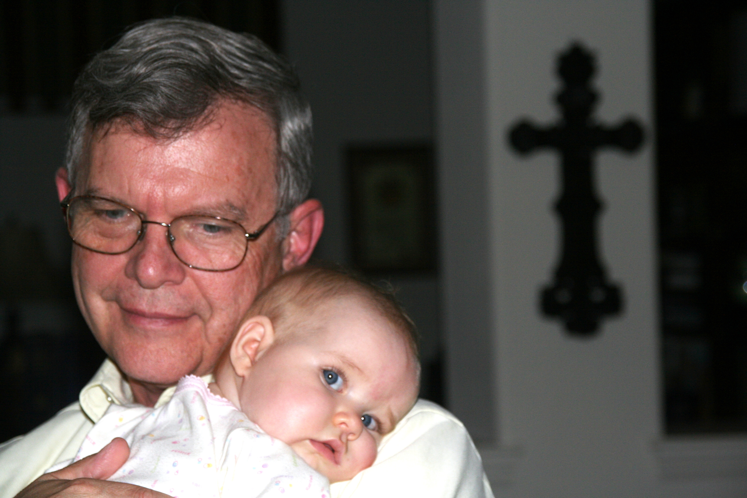

1969: DICK BURKE and granddaughter Lilyana

MIKE MOORE sent the following update: “ALICE and I will not be able to attend the 40th Reunion due to a family wedding in Chattanooga. I am disappointed in not being able to be at the Academy, to visit with classmates, swap stories and catch up on our lives. I am working as Chief Pilot on the start up for Small Community Airlines. I stay with our daughter and her family while I am in the Dallas-Fort Worth area. It’s a great excuse for ALICE to come down and see the grandsons. ALICE works for WIC in Anne Arundel County, Maryland. Our son Chris has been transferred to the west coast Navy Fleet Replacement Squadron, HSM-41, where he will transition to the MH-60R helicopter as an instructor and concurrently serve as a NATOPS evaluator for the SH-60B until it is retired from west coast squadrons. (Class Correspondent’s Note: I love that aviator talk!). Our younger daughter Rebecca works as a cruise staff member on the Norwegian Cruise Line’s Pride of America out of Honolulu. She received her Coast Guard certification to work as a crewmember aboard a cruise ship. ALICE, Rebecca, five members of ALICE’s family and I sailed on a cruise to Alaska aboard the Holland America’s Westerdam in May.”



1969: MIKE & ALICE MOORE with daughter Rebecca on Alaskan cruise

New e-mail address for DOC SHRADER: draseley@verizon.net.

As many of you know from class e-mail correspondence, RICH LOSEA suffered a mild right sided stroke on June 25th. He was hospitalized in Chesapeake Regional Hospital, spent time in the acute rehab unit, and was discharged in mid July to continue outpatient therapy from home. I spoke to RICH today (September 1st), and he tells me that he is “feeling good, getting bored being at home, is looking to return to work by the end of the month, and is in his 66th day of not smoking”. He thanked all those classmates and friends who remembered him in their thoughts and prayers during his recovery. In his own words, “the Gods were smiling on me”.

