October 2014
’69 CLASS CORRESPONDENT

CAPT Bob Gravino
2 Summer Street
Ipswich, MA 01938
(978) 356-0825 (H)
E-mail: rcgravino@aol.com
Website: http://www.uscga69.org

Barry and Bettymarie Kane have been traveling; I received this in June. “We returned from Europe - all modes of transport - planes, trains, automobiles and boats. Visited Czech Republic, Austria, Germany, France and Switzerland.” A man of few words, I received the following in August: “On land-sea tour. Fairbanks to Whittier by land, Whittier to Vancouver by ship.”

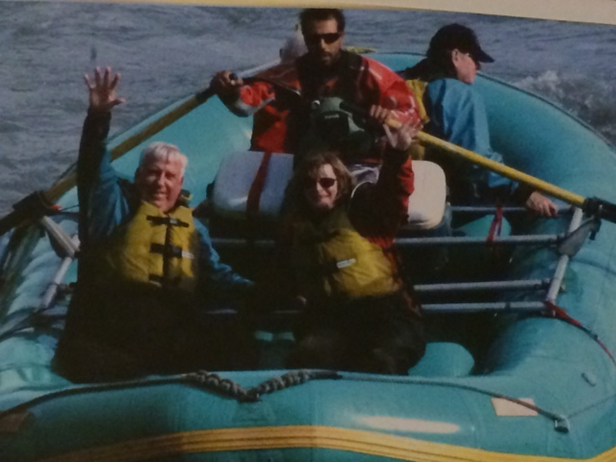

1969: Barry & Bettymarie Kane white water rafting in Denali, Alaska

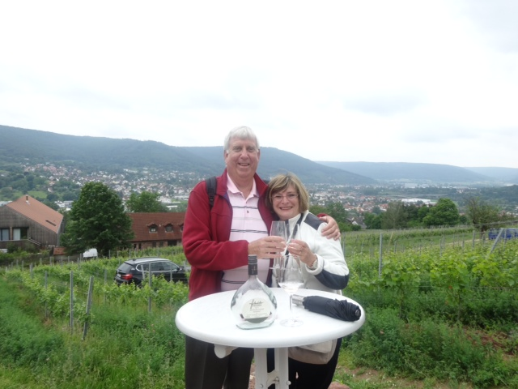

1969: Barry & Bettymarie in Europe

When you ask Jerry Hale what he did during the summer school break, expect to hear about an adventure. “This year I was again invited to travel to China in June with a team of two American and five Chinese high school cadets from Valley Forge Military Academy (VFMA), where I serve as school chaplain. We joined a group of former American military officers for two weeks of cross cultural exchange, character based leadership seminars, and recruiting opportunities for VFMA. The American contingent flew into Hong Kong and joined our Chinese counterparts in nearby Shenzhen where we participated in the three-day American Centers for Cultural Exchange Conference, joining representatives of 20 American Universities and their Chinese institutional partners to better understand and improve Sino-American educational cultural exchange. We met with graduate students at the Shenzhen campus of Beijing University and a group of leaders of local NGO’s to discuss character based leadership and matters of faith, and took part in recruiting events sponsored by the largest educational consulting company in Southern China. The parents of one of the cadets are members of the company management team and sponsored meals for our team at local restaurants. They also provided transportation to Guangzhou for a visit to the historic Wampoa Military Academy. The school was founded in 1924 by Sun Yat-Sen, Chiang Kai-Shek and Zhou Enlia. Officers were trained there that fought on both sides of the Chinese Civil War. During our second week we traveled to Tiayuan in Northern China and attended a local church, visited the rural village of Beichang, and toured the ancient walled city of Pingyao. Leaving our Chinese cadets behind, the Americans traveled to Beijing by fast train for the final two days of our Asian adventure where we made trips to the Great Wall, Tiananmen Square, and the Forbidden City. Similar to last year, I was overwhelmed by the gracious hospitality of our Chinese hosts and hope that this end-of-school-year China tour will become an annual event for Valley Forge cadets. The picture is a group of us out in the hinterland where we delivered Bibles and books to start a church library. The woman who accepted the books for the church is the sister of the local ‘international coordinator,’ a retired air force colonel in the Peoples Liberation Army. The group we traveled with has been coming to this village for 15 years and is now well-accepted by the local Communist officials.”



1969: Jerry Hale and VFMA Team delivering books

I spoke with Pat Garrity as I was finishing up this column (September 1st) and asked how Paul’s on-going cancer treatment was progressing. Paul has completed his seventh and final round of chemotherapy and is doing well, his condition moving in a positive direction as a result of the chemo. He is scheduled for a second Whipple Procedure on September 8th to remove tumors in his pancreas. Pat wanted to again thank all those who are keeping Paul in their thoughts and prayers.
Thanks to some great investigative work by Jack McGowan, Bob Callahan has been relocated. “I’ve found him! I had a long and wonderful conversation with Bob yesterday morning. He and his wife Carole live in Stonington, Connecticut and have been in the vicinity for many years. Bob and I were classmates in Stamford (Connecticut) Catholic High School together so we had a lot to catch up on. He’s a finance guy and after years of working with the majors struck out on his own with his CPA sheepskin. He asked that I pass on his contact information to you. I told him to expect info from you on the Homecoming events in the hope that he can be enticed to make an appearance after all these years. Hennie and I will try to meet up with him and Carole while we are in New London in the event that he is unable to make Homecoming.” Bob Callahan, 29 Wilbur Hill Lane, Stonington, CT 06378, (860) 535-9458 (home), rcccpa@gmail.com.
Jim Smith sent some details of a gig performed this summer by The Gents at the Coast Guard Festival in Grand Haven, Michigan. “Lots of stories to tell from this year’s Festival in Grand Haven, Michigan! The Gents were asked to play at a Street Dance on July 29th...beautiful evening, professional audio crew, semi-trailer stage and thousands of new fans. They really are Coast Guard City USA. Marilyn bought a T-shirt that said ‘Grand Haven, just like Key West except colder’. She took this photo of Bob Pokress and me. Nice shirt, eh? Maybe Bob can give you the low-down on exactly what he was doing in Grand Haven (?).”
Now the low-down on what Bob Pokress was doing in Grand Haven with The Gents. “Okay, here's the whole story behind being with The Gents. There have been numerous myths circulating for decades about The Gents, the rock icons who turned the world of music on its head when they had their breakout U.S. tour in 1963 and turned New London into a global Mecca for rock music. But no carefully researched biopic of this legendary group that redefined rock music over 50 years ago had ever been made. So I decided to join them on their latest reunion tour, ‘The Gents, 2014 - The Assisted Living Centers Tour’, to put on film, for the first time, the music and the history of this legendary band - as told, for the first time, by each member. The band made famous for turning down a highly publicized invitation to appear on the Ed Sullivan Show in February 1964 so as to let a small band of four guys out of Liverpool, England get the gig, since they needed the money more than The Gents did. A band made even more famous for turning down, in 1969, being the opening band at some back woods concert being held on (I kid you not) a farm field/cow pasture in Woodstock, New York because the mud from the field would have smudged their world-renowned spit-shined shoes, the best-shined shoes in all of rockdom. I met up with the band in Grand Haven for the start of their latest tour, where they would be performing for the tens of millions of Baby Boomers who couldn't get tickets to the sold out Gents stadium concerts of the '60s. I've been able to capture, on film, the hysteria the Gents are generating among the thousands of septuagenarian groupies who follow them from town to town and show to show. Spielberg couldn't get The Gents to do a film for him, Marty Scorsese pleaded and failed to get them to do a sequel to his ‘No Direction Home’ rockumentary, but I've got The Gents, for the first time during their 50+ year rock career. We now have on film, for posterity, the background stories behind these music legends - the lives, the loves, the music rivalries! Inside stories that would make the front page of People Magazine and 49 years ago would have garnered carry-on for the entire year if kept under rap. Now it can all be told! (For artistic reasons, I have refused the band's request to colorize their hair back to brown and black.) To have its world premier at CGA ‘69's Homecoming Weekend, October, 2014. Rock on!”

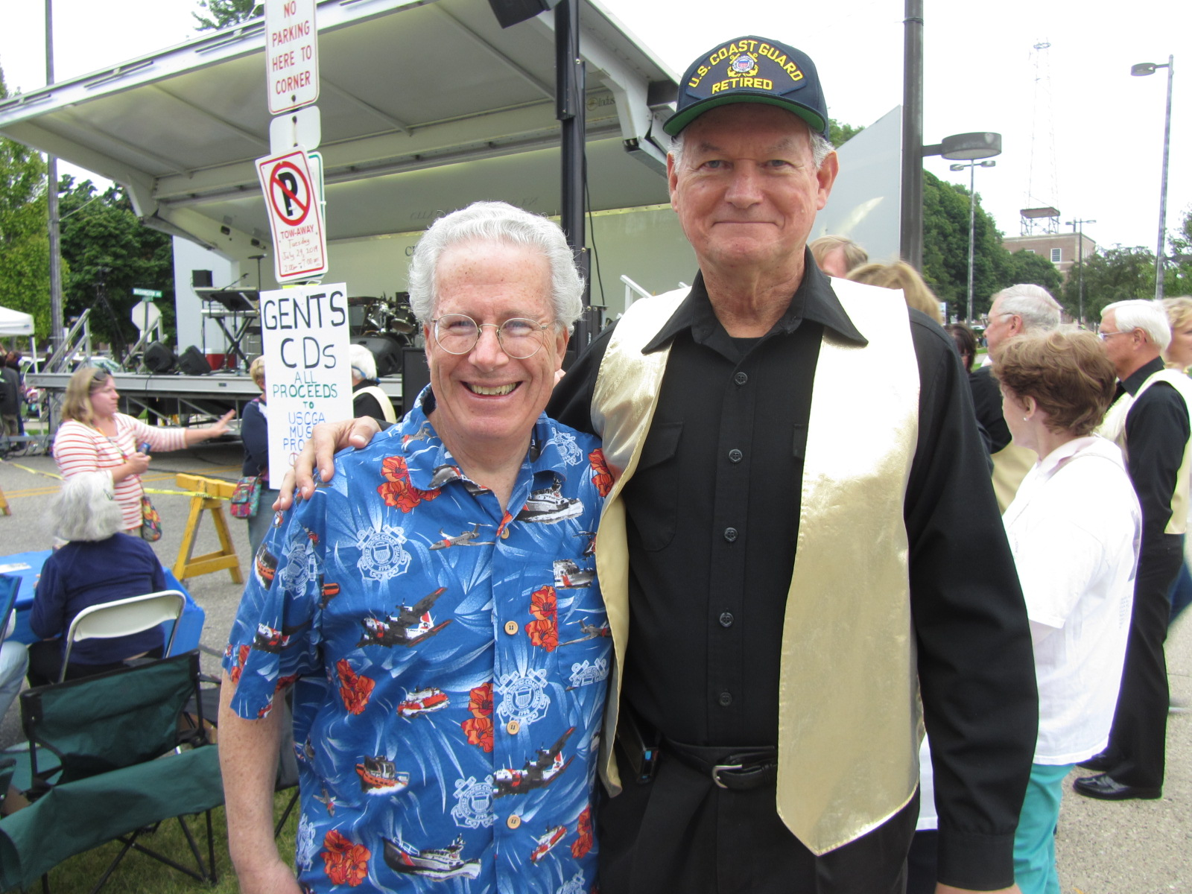

1969: Bob Pokress & Jim Smith in Grand Haven, Michigan

Andy Anderson came close to catching The Gents’ 2014 ‘Assisted Living Centers Tour’ with Bob Pokress. “Talk about ships passing in the night! I attend the Grand Haven Coast Guard Festival every year as the Drum Major with the U.S. Coast Guard Pipe Band. The Coast Guard Pipe Band has played at the National Coast Guard Memorial Service on Friday and marched in the Grand Parade on Saturday for the past 12 years. This year we led the Grand Parade as the only Coast Guard marching unit. I wish I had known The Gents and Bob and Jim were going to be in Grand Haven this year.”

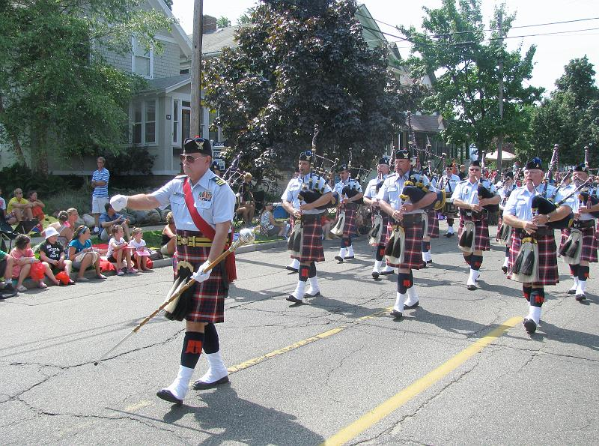

1969: Andy Anderson at the 2014 Coast Guard Festival in Grand Haven

Wayne Gronlund was the first Class Correspondent for the ’69 Class Notes and wrote his first column for the August/September 1986 Alumni Bulletin. He handed off the Class Correspondent duties to me at our 20th Reunion, and my first column was published in the October/November 1989 Bulletin. I have been writing about Rich and Beth Vlaun’s son Mark (CGA ’94) almost since I began writing the column. I finally met him at the retirement ceremony of Dan Neptun in Springfield, Virginia in July. The Commandant was the presiding official and Mark had accompanied him to the ceremony.

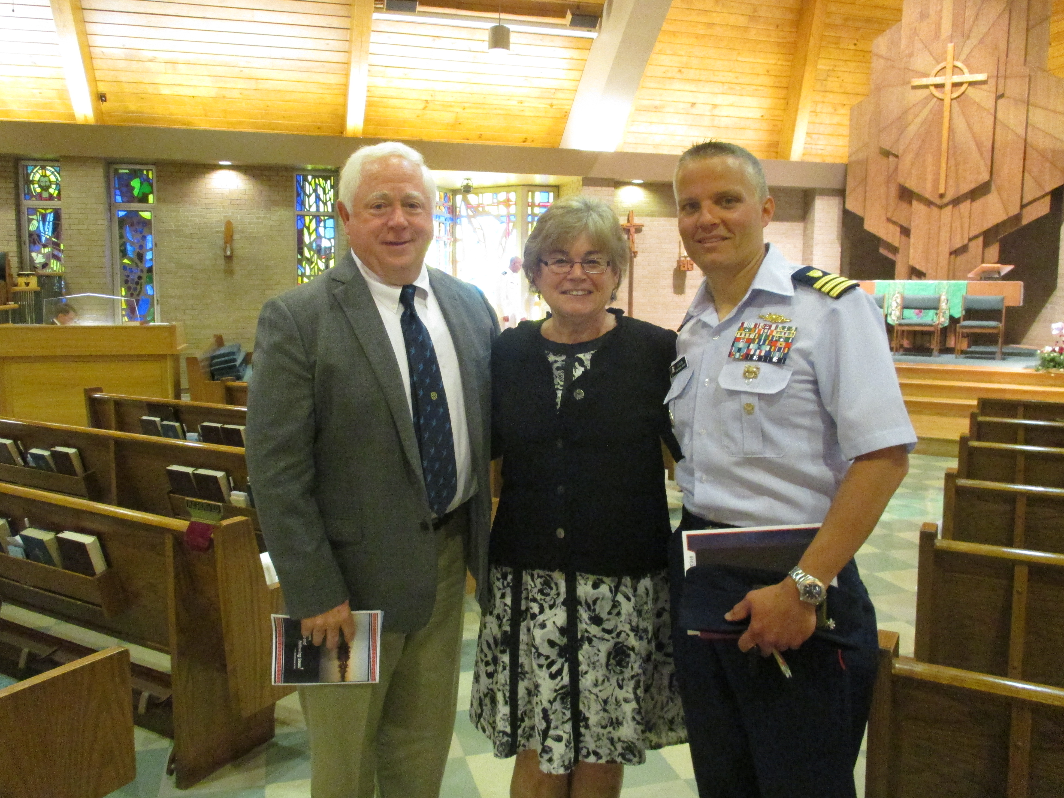

1969: Bob & Kathy Gravino with Mark Vlaun (CGA '94)

Rob Henry retired from the National Transportation Safety Board on May 31st. To ease into a new life style, he and Whitney spent a few weeks in France and now are enjoying their two grandkids, trips to their Delaware beach house and the Catalina 25’ they dock at Harrington Harbor on Chesapeake Bay.

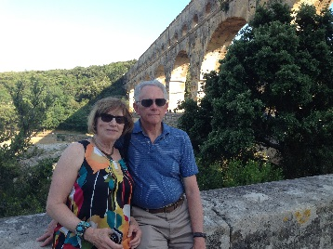

1969: Rob & Whitney Henry at the Roman Aqueduct in Nimes, France

Jay Snyder was buried on August 11th at Arlington National Cemetery with full military honors. Many of those in attendance sent notes saying that it was a moving ceremony with Jay's entire family present. Bob Trainor (CGA ’71) sent me a list of those attending: Bob Acker, John Miner, Gerry Hale, Randy Squires, Stu White, Rob Henry, Tom Rutenberg, Ron Greto, John Curtis, Greg Shaw, and Tim Josiah. Others included Ed Labuda (CGA ’70), Biff Holt (CGA ’68) and Ben Stoppe (CGA ’72).
Chuck Talar sends from the University of St. Thomas in Houston, Texas: “We are of an age where class news consists mainly of medical news, it seems. My own contribution is being diagnosed with three blocked arteries (90%) after experiencing ‘unstable angina’ (not precisely a heart attack, but for all intents and purposes, a heart attack). I had seven stents put in (avoiding, thankfully, bypass surgery) and feel a lot better. The procedure was done on a Monday and I was back saying Sunday Mass that week; though little else for awhile. The university has graciously moved my sabbatical to this fall so I won't have to go back immediately to a full teaching schedule. The sabbatical will facilitate making the necessary lifestyle changes that I have to incorporate. I've become very conscious of eating and the stress of a university having a small faculty and teaching overloads, living in a parish with the usual amount of parish work, doing a lot of writing and publishing; a schedule that now has to change.” Chuck will not be able to attend Homecoming for the 45th Reunion. “It seems my international conferencing is fated to conflict with class reunions (I missed a high school class reunion because of a Rome trip a few summers ago). This time, those are the exact dates I have to be in Germany. So, with hopes for the 50th.”
This past June 4th, Rick Gupman sent me an e-mail noting the importance of this date in 1969. “I had a hangover and a wristwatch at a gas station in Rhode Island as security to cover the cost of the gas and a fuse for the tail lights on my Jag so that I could get back to the Academy by 0200. Well, anyway, congratulations.” In response, I sent the following to the Class. “Rick Gupman sent me a short reminder this morning: 45 years ago on this day and date, we began a new adventure. Congratulations! I hope it has been a good ride. Good health and happiness to all.” I received numerous replies to my e-mail; here are some of the best.
Bob Pokress: “You know how they say it's common for many college grads to have recurring nightmares that they are going into a final exam having cut attending class all semester and never having done any of the reading assignments. Well my recurring nightmare is waking up on 6/4/69 and discovering I can't find any of the pieces to my dress whites (remember how the brass buttons detached so the blouse could be washed, starched and pressed) and I don't know what the drill is for the graduation ceremony, having been AWOL when they did the graduation rehearsal. Anyone have extra buttons, an extra pair of shoulder boards and an extra pair of white bucks?”
Bob Thorne: “I thought I was not going to graduate when George Naccara, standing next to me during the repeating of our Oath of our Office, stated his name as Frank Nitti (famous mobster in the Al Capone era). I immediately broke out in laughter and I swear the Commandant, Admiral Chet Bender, was looking directly at me at that very moment, when I envisioned that he was going to pull me out of line.”
Jim Smith: “Great ride! Graduated (finally), commissioned and married on 6/4/1969. Very efficient, that mass production stuff. Then headed-off to Hawaii. We were just kids, and the world was our Key Lime Pie.”
Bruce Griffiths: “I was recently describing our day of graduation to my youngest, who received his Bachelor’s from UC Berkeley last week (a very different graduation event at Bezerkeley!). June 4th 1969 was a very proud day for my father, CMSgt. Harley E. Griffiths, USAF, who got to award my commission and render the first salute I received as an officer (I gave him a $1 coin for the first salute). He passed in 1999 from Alzheimer’s but a few weeks ago I flew in the last airborne B-24 as a tribute to his 43 B-24 strikes in the Pacific in WWII as a radio operator and waste gunner. He saw me head to Viet Nam in 1969 to serve with Tom Rutenberg and Ed Walsh on the CGC Spencer (WHEC-36). The Summer of ’69 was indeed a memorable one.”
Bill Bowen: “My two memories of the day were sitting in the right hand section as we faced the stage. That was the lower half of the class and thinking that five years seemed like an eternity before I could get out and get a real job. Then as I was leaving my Dad, sitting in the back seat of my ‘68 Chevy Impala (which I still have) asked me if I wanted to take one last look. Nope, I just wanted to get out of there. Now I look forward to our once every five year visit back there and wonder how I could have felt like that.”
Ed Danner: “To all my friends and former classmates that I came to know during the '65/'66 Swab year: I applaud your courage, commitment, and service in the United States Coast Guard. During that summer, I was rehabbing a broken right shoulder in anticipation of becoming the starting QB for Susquehanna University and had been named one of the tri-captains of the team. I can never forget Swab year and share the more memorable times with my children and grandchildren. I will always remember the relationships developed during a year of esprit de corps, unity, hard work, and the fostering of mental toughness and ‘trained initiative’! Congratulations. I am honored to be included in your e-mail chain. Thanks so much. I really value being in touch with you all.”
George Naccara: “Remember it so well. Bob Thorne and I maintained that we were never actually commissioned – for over 33 years! Ah, the pleasant memories as we only remember the good times from those days.”
Darryle Waldron: "The Guard no more in '74 was on many minds that day! Some made it to 20, 30, and longer. We are thankful for what those four years did for us, and to us, shaping our lives in many ways. I salute all of you and hope to see you in October. We are currently on a month-long road trip across the country and then back to Juneau. See you this fall.”
The Class e-mail list now includes new addresses for Doug and Janet Brown, Harry Lord, Pete Connelly, and Roni Senno Lavache. For those not aware, when I submit my column to the Alumni Association, I also include Chris Kreiler on the e-mail, who adds the Class Notes column to the Class web site. On occasion, there may be additional photos on the web site, since the Bulletin editor does not always publish all the photos that I submit. Check out the web site at www.uscga69.org, which also includes past Class Notes columns.

