October 2020
’69 CLASS CORRESPONDENT

CAPT Bob Gravino
2 Summer Street
Ipswich, MA 01938
(978) 356-0825 (H)
E-mail: rcgravino@aol.com
Website: http://www.uscga69.org

In Memoriam
Gregory Hathaway Magee
“Greg”
September 10, 2020

It is with sorrow we report the passing of our classmate, Greg Magee, after a prolonged battle with Alzheimer's. After 30 years with the Coast Guard, he retired in Elizabeth City, North Carolina, enjoying a waterfront home and the company of good neighbors. Greg worked as a facilities manager for Elizabeth City State University for several years and volunteered for the American Red Cross. Although Alzheimer's robbed him of his short term memory, he had strong and fond memories of his time in the Coast Guard. He was able to watch the broadcast of his son Greg '94 taking command of Sector San Juan this past June, a command Greg held in the early 1990's. Greg is survived by his son Greg and wife Christy, and brother Jack.

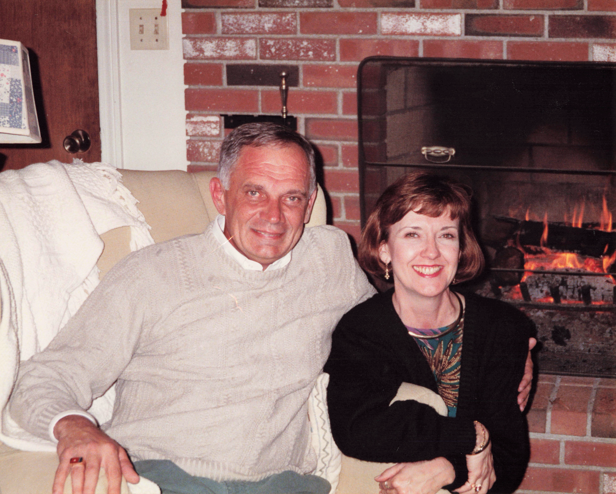

69: Greg Magee with his late wife Nancy

Bill Bissell reports that he is completely retired, 51 years after graduation from the Academy. “The civil court system in California closed down in March due to the pandemic, and I took that event as a sign that I should close down also. Lisa and I flew to Connecticut shortly thereafter on a 737 with less than 60 passengers, and we have been in Branford ever since. Despite being on Long Island Sound, Branford is rural and social distancing is easily accomplished. Lisa believes that idle hands are the devil’s workshop and is convinced that she now has a full time gardener. Alas, this is New England, and all that I seem to be able to grow is rocks.” Bill and Lisa returned to their home in the San Francisco Bay area in early October, not having done the traveling in New England this summer that they had expected. Bill still enjoys tennis, and he tells me that he spends time playing tennis at my old high school in neighboring Guilford.

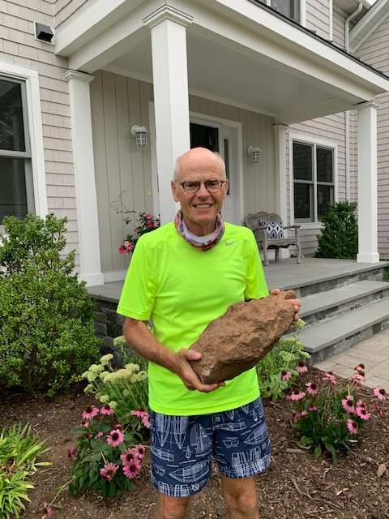

'69: Bill Bissell planting rocks in Lisa's Branford rock garden

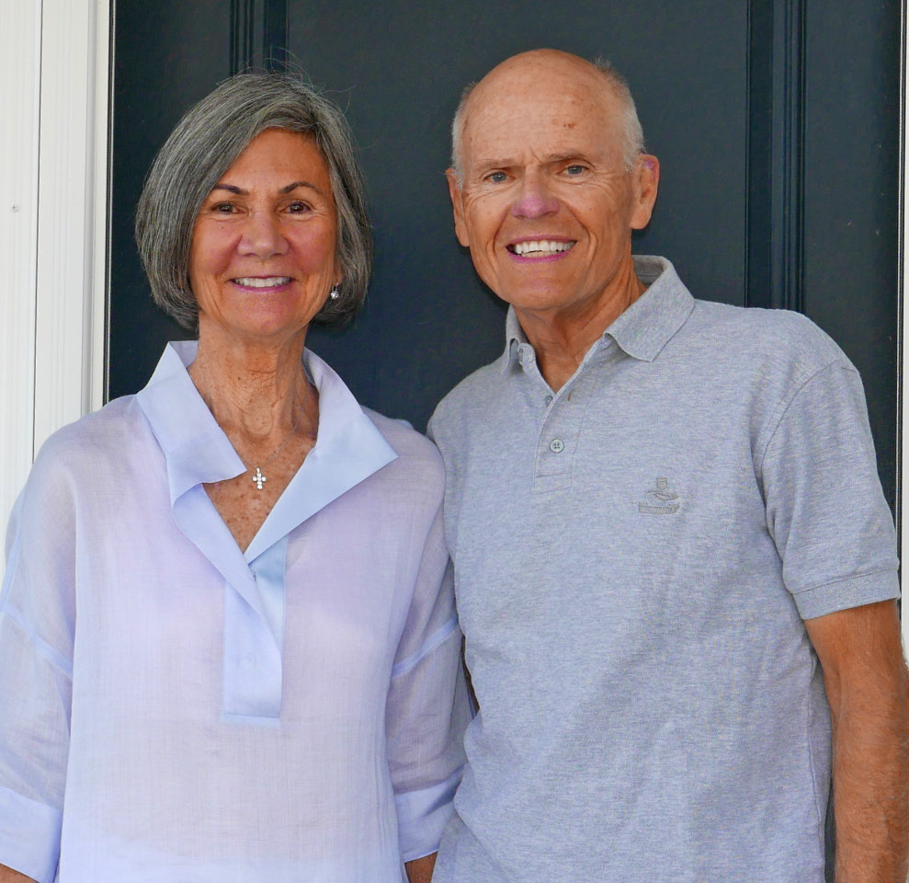

69: Bill & Lisa Bissell

Bob Pokress traveled to the Academy in September to present a framed photo to the Academy Alumni Association of Fred Schmitt and our class rendering honors to President Washington at the dedication ceremony of our 50th Reunion gift to the Academy. The text under the photo reads: The Class of 1969 Rendering Honors to President Washington, Dedication Ceremony of the Class of 1969’s 50th Reunion Gift to the Academy, October 4, 2019. The photo was accepted by Bob McKenna ’89, Vice President of Development, on behalf of the Association, and will be hung in a prominent location on the second deck of the Association’s Headquarters where visitors can admire it.

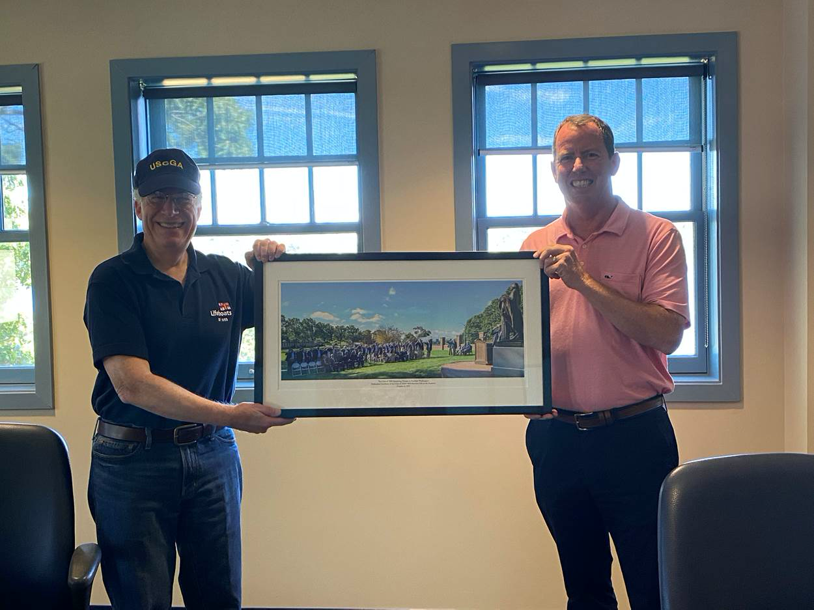

69: Bob Pokress presenting 50th Reunion Gift Photo to the Alumni Association

Chuck Hill notified me in July that Living Classrooms Foundation and Historic Ships in Baltimore decided to remove the name of the former USCGC Taney in support of the local and national call to remove symbols venerating oppression and racial injustice. The President of Living Classrooms Foundation stated: “We are not erasing history, nor is it our intention to minimize the service and sacrifice of the men and women who have served with honor aboard the US Coast Guard Cutter Taney. Our intention is to learn from history and celebrate the legacy of the ship and those who served aboard. The ship will be referred to by its hull identification, WHEC 37, which stands for High Endurance Cutter.” Taney is a national historic landmark and the last surviving warship from the attack on Pearl Harbor. Since 1994, Living Classrooms has been the steward of the cutter and has operated the ship as a museum for the general public and a memorial to the men and women who served aboard her and in the armed forces. The Taney was named after Roger B. Taney because of his position as Secretary of the Treasury during the Presidency of Andrew Jackson. Taney is best known as the Chief Justice of the U.S. Supreme Court who delivered the majority opinion in the Dred Scott v. Sandford case, which declared that all African Americans – slave or free – were not U.S. citizens at the time of the country’s founding and could not become citizens. Taney believed this decision could end the sectional conflict over the expansion of slavery, and declared that the Missouri Compromise was unconstitutional; that Congress had no power to regulate slavery in the territories; that slavery could become legal throughout the nation; and that Dred Scott, despite the years he spent in a free state that allowed slaves to claim their freedom, was still a slave. This decision perpetuated and enhanced the legal foundation of structural racism and contributed directly to events leading to the Civil War.
Dave Humphreys was assigned to the CGC Taney in San Francisco after graduation. When contacted, Dave sent the following. “I was the only member of the class of ’69 assigned to USCGC Taney. I reported aboard via high line from a Navy oiler in early July 1969 off the coast of Vietnam. There were three junior officers from the class of ’68 already aboard, including Bud Guest. As a crew we were all very proud of Taney’s long and historic service. I now live near a retired forestry executive here in Dallas, Oregon, who was an RD2 on Taney during the Market Time deployment; we exchange sea stories remembering old shipmates when we run into each. I served as Student Engineer and eventually, after returning to Alameda in 1970, as DCA until I was transferred to the USCGC Winona in Port Angeles, Washington. When Winona was decommissioned I was assigned to the Coast Guard Yard in Baltimore as Ship’s Superintendent. While in Baltimore I saw a statue of Roger B. Taney and looked him up in the library. I was surprised and disturbed to learn his part as the Chief Justice of the Supreme Court in the Dred Scott decision. I will always remember WHEC 37 and the shipmates with whom I served proudly. I will not have any problems forgetting Roger B. Taney due to his terrible ruling that led to the Civil War.”
Dave Anderson gave a heads-up of a posting on Face Book in August by Pete Aalberg’s daughter, Jaime Van Del Rosario. “Last week we said a final goodbye to an amazing person. We took the 1,600 mile journey from Tampa together one last time, and scattered Pete’s ashes in the bay in front of the Maine cottage where he spent so many decades. Family and close friends were there to see him off, and many will think of him whenever they pass through the thread beyond Witch Island where he left his mark with art. Saying goodbye was bittersweet, but the memories are all wonderful and will forever bring a watery smile to my face.”
Lesley and John Miner report that Fred Adamchak was the keynote speaker at a Patriots Colony Guest Speaker Series in Williamsburg, Virginia. The Patriots Colony community was still on lock down, (no gatherings, no guests, masks must be worn) so the presentation was done on their TV channel. Appropriately, the topic of Fred’s talk was Operation Deep Freeze '71!

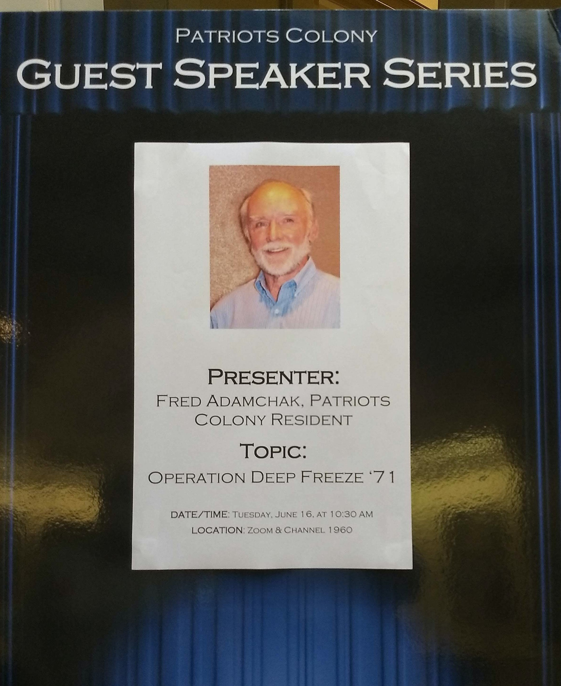

69: Fred Adamchak presenting Operation Deep Freeze '71 talk at Patriots Colony

Bob and Barbara Thorne have donated a beautiful 20” x 24” rendering of Alexander Hamilton, Father of the Coast Guard, to the Coast Guard Heritage Museum in Barnstable, Massachusetts. Bob commissioned the original portrait by East Lyme, Connecticut artist Christopher Zhang as part of our Class Gift. The 30” x 36” original was presented to the Academy at the Class 50th Reunion ceremonies in October 2019, and it now hangs in Hamilton Hall at the Academy. Pat Garrity, Greg Ketchen ’71, and Buck Baley ’72 are three strong volunteers at the museum on Cape Cod.
Rich Vlaun, John Miner and Charlie Huber participated in the Academy Alumni Association sponsored Long Blue Line Virtual Golf Open this summer. Although they didn’t win any top spots, the attached photo won them an award for Best Dressed, and each received a $50 gift certificate to the Academy Go Bears Store. Rich’s comment: “Scary!”

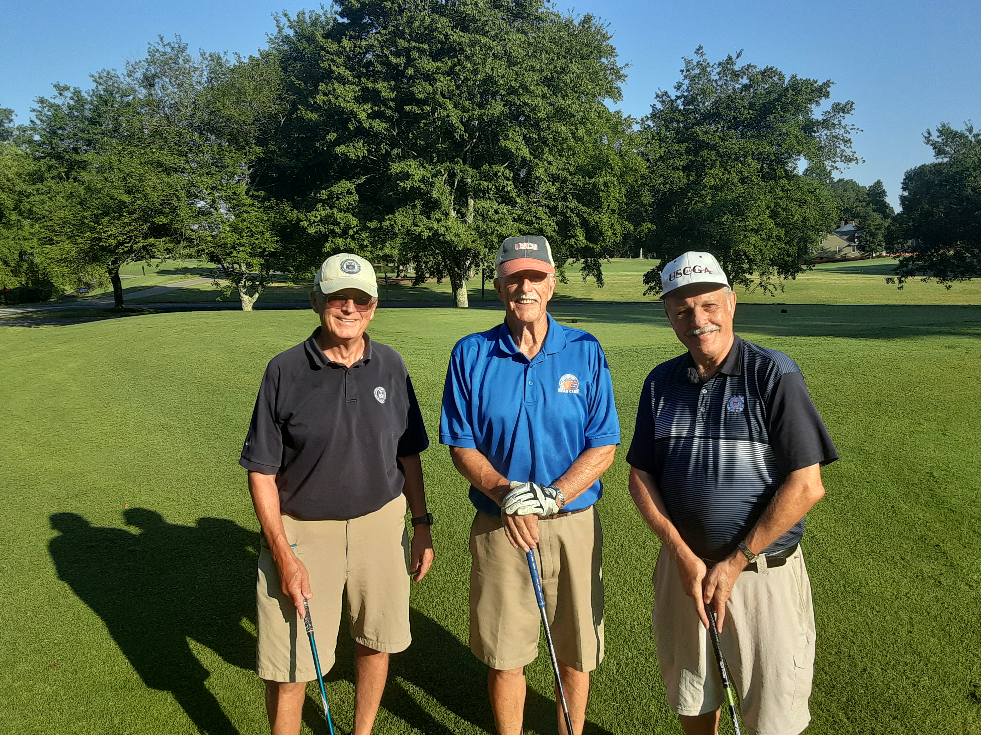

69: Rich Vlaun, John Miner & Charlie Huber sweep the Long Blue Line Visual Golf Open

Chuck Talar was scheduled to speak in New Zealand at an academic conference in August, and attend a second conference in Boston in November, but both were cancelled due to COVID-19 concerns. Chuck began the academic year in late August teaching on-line at the University of Saint Thomas in Houston, Texas, and serves as a priest in residence at St. John Vianney Catholic Church in Houston, a mega-church of over 12,000 parishioners, assisting with a schedule of three Masses per day, complete with social distancing and restricted occupancy. Chuck has renewed his Alumni Association membership, so look him up in the upcoming November 2020 Membership Directory and drop him a note.
Mike Moore administered the oath of office on July 4th on Facetime to his son Chris upon his promotion to Commander in the U.S. Navy Reserves, Mike from his home in Severna Park, Maryland, and Chris in front of his home in New Hampshire. The oath was witnessed by Alice standing by Mike, and by Chris's wife Meaghan, daughter Jocelyn, son Archer, and his in-laws at his end. After the oath, Meaghan pinned on his silver oak leafs. By chance, Mike was listening to Sirius XM channel 6 (60’s music) on July 12th, and the song We Gotta Get Out Of This Place was played. “Hearing the Class of ‘69 unofficial anthem opened a floodgate of memories, beginning with the trials and tribulations of Swab Year, the rigor of academics, the good times at the Academy and on cruises, graduation, and a highly rewarding career.”
Stu White volunteered and was selected in August to participate in a COVID-19 vaccine trial in Raleigh, North Carolina, and the initial visit involved four hours of tests. "During the screening process at Wake Research for the Pfizer vaccine candidate trial, a couple of medical issues came up making me ineligible to participate; fortunately, nothing serious. These findings will not prohibit me from getting vaccinated once one or more vaccines are approved."

