October 2021
’69 CLASS CORRESPONDENT

CAPT Bob Gravino
P.O. Box 158
Georgetown, ME 04548
(207) 371-2765 (H)
E-mail: rcgravino@aol.com
Website: http://www.uscga69.org

Mike Moore thanked Dan Garrison for passing along RADM Kelly’s update on how the Class of 2021 had used the Washington Statue in their graduation week activities. “I was gratified to read that the Academy was putting our gift to good use in a variety of ways. Your Coast Guard Day e-mail evoked memories of that day 56 years ago. Your memory of that day, along with that of Bob Pokress, is very much the same as mine. It was a glimmer of hope in what had been a tough slog up to that point. Mystic Seaport was quite the eye opener for me. As a kid who grew up in east Tennessee, hundreds of miles from the Atlantic Ocean and the Gulf of Mexico, my knowledge of the ‘sea and its lore’ were books and movies. Mystic Seaport was a catalyst in my development of a love for all things nautical. A brief family update for class notes. COVID-19 has had a significant effect on our usual travel. We have visited our daughter and her family in Arlington, Texas; our daughter in Nashville; and Alice’s family in California, although these visits have not been as frequent as we would like. Alice and I celebrated our 49th wedding anniversary on June 24th during a visit with our son and his family in New Hampshire for the first time in eighteen months. The next day we celebrated the 50th anniversary of my Winging Ceremony in Pensacola, Florida. This event changed the trajectory of our lives significantly. It was my honor and privilege to fly Coast Guard aircraft on a great variety of missions for nearly thirteen years. After retiring from the Coast Guard, I was able to fly for an airline for twelve years and serve as chief pilot (and a lot more) for a startup airline. We all are aware of the number of our wedding anniversary, family birthdays, and graduation from the Academy. Other anniversaries usually pass with little or no notice, and almost certainly no celebration. For me, the 50th anniversary of my designation as a Coast Guard Aviator was an exception. So, what did we do to celebrate this event? We continued our relatively low-key celebration of our 49th wedding anniversary.” Included is a recent photo of Mike, Alice, daughter Rebecca and her boyfriend at a Baltimore Orioles game.

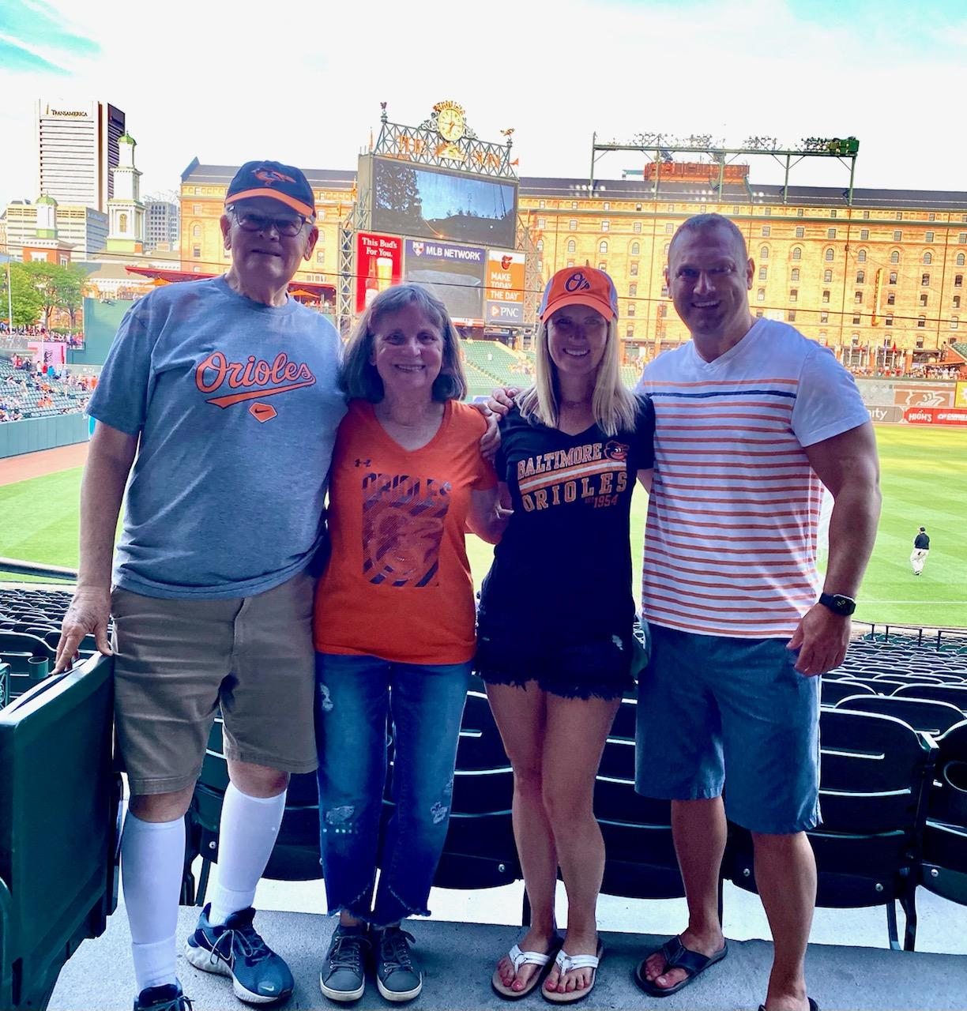

69: Mike & Alice Moore at a Baltimore Orioles Baseball Game

On August 4th I sent an e-mail to the Class in honor of the Coast Guard’s 231st Birthday, asking if classmates remembered what they were doing on August 4, 1965? Included in the birthday e-mail was a quote from page 175 of the '69 Tide Rips.
‘...we were released to the outside world on Coast Guard Day; our first Academy box lunch in hand, we ventured to the old whaling seaport of Mystic. Overwhelmed by the experience we reluctantly departed to Ocean Beach where we were an immediate hit in our C.G. sweatshirts and blue bathing suits.’
Jim Smith had some memories. “My memory is Mystic Seaport first, then Ocean Beach in the afternoon … of my 2nd Swab Summer. My most vivid memory is that late in the afternoon, we four ‘reverters’ (Jimmy Dipasqua, Tim McCloskey, Tommy Porter and me) were in the Ocean Beach locker room discussing what we should tell our new classmates. Should we let them continue to enjoy the last free minutes of liberty, innocent and unaware? Or should we tell them all-hell-is-going-to-break-loose when we get back to Chase Hall … because we had been totally screwed-up and a public embarrassment all day? We decided to say nothing and let them enjoy one more cheeseburger and a milkshake. Good decision!”
Bob Pokress commented on the Academy news release that described RADM Kelly’s participation in a dunk tank activity at the Academy in celebration of Coast Guard Day. “I keep trying to visualize Superintendents Bender and Engel doing a dunk tank on Coast Guard Day during our time at the Academy, and my brain keeps replying, Error. Error. Error.”
From a not-to-be-named classmate: “I remember Bender…. he gave me a Class 1 at Christmas for getting back late because the plane I had tickets for had a maintenance issue and was delayed. Never forgave him. And helped move his car to the bandstand!”
From Jim Burk: “You’re one up on me. I never knew that Bender was a Superintendent. Nor at that point in my cadet evolution, did I care.”
Jim Robinson commented on Jerry Hale’s mention of Navy Chaplain Stan Beach in the June 2021 Class Notes column. “From 1980 - 1983 I served as Planning Officer for the Second District in St. Louis and was tasked by RADM Venzke to coordinate agenda items for a Flag Officers’ Conference. One item was my recommendation that the Coast Guard have our own Chaplains. RADM Venzke laughed, saying ‘You don’t want me to take this to the Commandant, do you?’ I was serving as an O-4 in an O-5 billet, and I boldly responded in the affirmative! He ran it by the District Chief of Staff and Division Chiefs and sent it forth as an agenda item. It turned out to be a no-brainer!”
Included is a photo of the marriage of Jerry and Kris Hale’s granddaughter Hannah (the Hale’s daughter Kendra’s oldest child) to 1st Lt. Caleb Parsons, USMA '19, on June 26th in West Yellowstone, Montana. Kris made Hannah's wedding gown from scratch. The venue was the Union Pacific Dining Lodge, a historic building built in 1925.

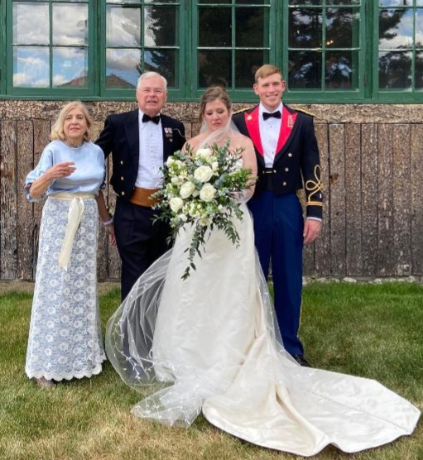

69: Jerry & Kris Hale at granddaughter Hannah's Wedding

Many in the Class expressed concern for how our Gulf Coast Classmates fared as Hurricane Ida made landfall in Louisiana. The following Classmates checked in to let us know how they did.
George Bond (8/31/21): “We made it through the hurricane and are now without power, so no air conditioning or electrical appliances. We will be heading to one of our daughters this weekend. Without power, most of the city is closed! Fortunately, there was no street flooding which was good.” (9/3/21): “Gayle and I left New Orleans which still has no power to stay with daughter Kate in Charlotte, North Carolina. Due to the continued lack of power in Louisiana, we are staying here longer. We had no real damage unless the shingles in our yard were from our roof! Waiting for the USAA appraiser. Wind was high and the rain was blowing so not sure how much we got but our rain barrels are filled. Good seeing green rolling hills! Walking the dog this morning on a crisp day without humidity; enjoyable but harder than walking the dog in New Orleans, as there are hills here, it is not flat like home.”
Drew Gerfin (8/31/21): “Safe here in Picayune, 300 feet above sea level and 26 miles inland. We had some strong winds and on-and-off heavy rain, minimal tree limbs down, but no house damage. I have a house full of thirteen family evacuees. Lost power for a few hours, ran my generator, then power restored. Lots of food, games, books, and great conversations. Very bad situation in the greater New Orleans area, which the news has covered thoroughly. Thanks to everyone for asking about us. Stay safe and SEMPER PARATUS!”
Paul Prokop (8/31/21): “We are okay, summary to follow when we get e-mail restored.” I reached out by e-mail to Paul on 9/8/21, with ‘no joy’. All must be good.
Pete Lenes (8/31/21): “We are fine. Mostly a rain event in Gulfport, Mississippi. Drew, Paul, and George were probably hit harder than us. We had a few wind gusts of 60 mph and a 7–12-foot tidal surge. We are far enough inland and 50 feet above sea level so had no concern with surge. Lower lying areas had some issues with flooding. We did have five inches of rain on Friday, unassociated with Ida, and then we had about 12 inches of rain as the hurricane passed through. Hurricane Zeta took care of several trees in our and the neighbors' yards, so we no longer had to worry about them. Fred Wilder called this morning to check on me, thanks, Fred. Hope everybody else who might be in the path of the storm stays safe.”
I called Vince Kinal after I read that his hometown of Manville, New Jersey, had suffered significant flooding because of Ida. He and Kathy live in the Tampa – St. Petersburg area of Florida and have not been affected by any hurricanes thus far this year.
Kathy and I visited with Ted and Doretta Colburn over the Labor Day Weekend during a Celebration of Life in Georgetown for Ted’s brother-in-law. Doretta is an ordained Congregational minister and officiated at the event. Ted and Doretta own and operate Beech Hill Farm and Bison Ranch in North Waterford, Maine.

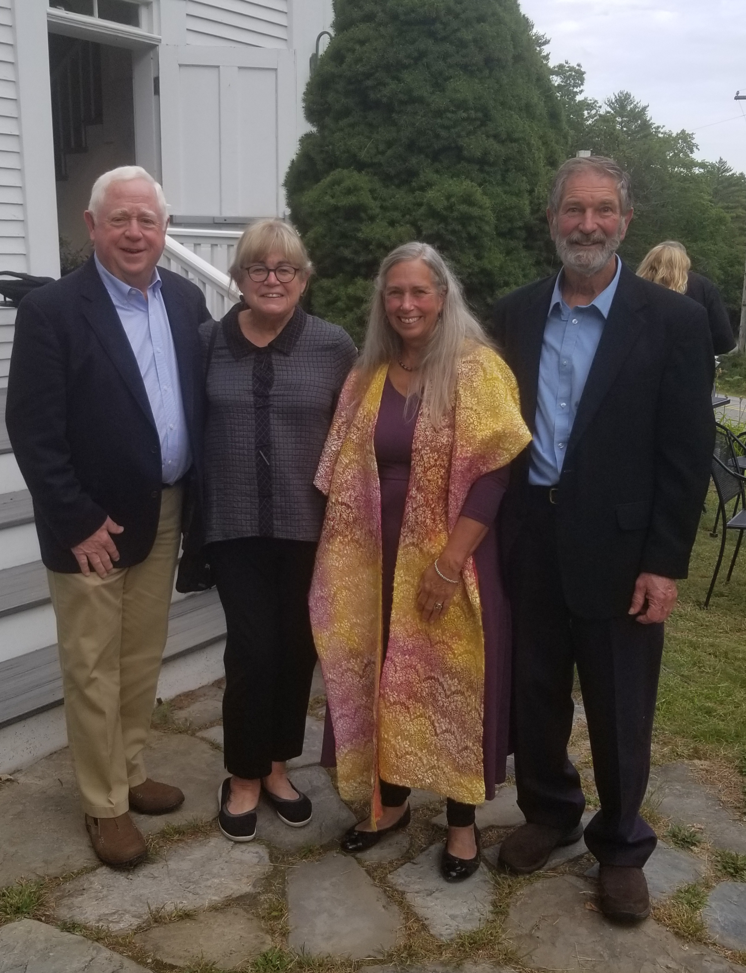

69: Bob & Kathy Gravino and Doretta & Ted Colburn

I came across a Face Book photo of Bob Donnee and his beautiful grandchildren, Grant and Nora. Bob gave up the cold climate of his native Connecticut to settle in Alabama after retirement from the Coast Guard and mentioned that his only regret is that New England lobster is outrageously expensive in the south.

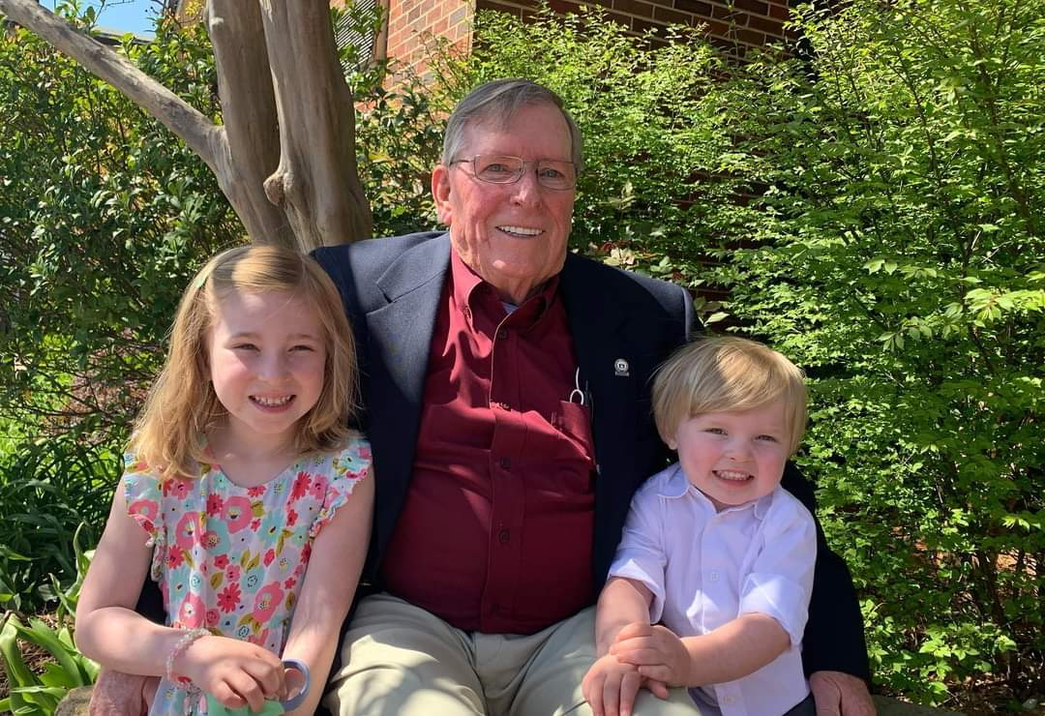

69: Bob Donnee and grandchildren Nora and Grant

Does anyone recognize this photo of a famous golfer from the Class of ’69? If you correctly name that Classmate, you win a one-way ticket to Harrisburg, Pennsylvania.

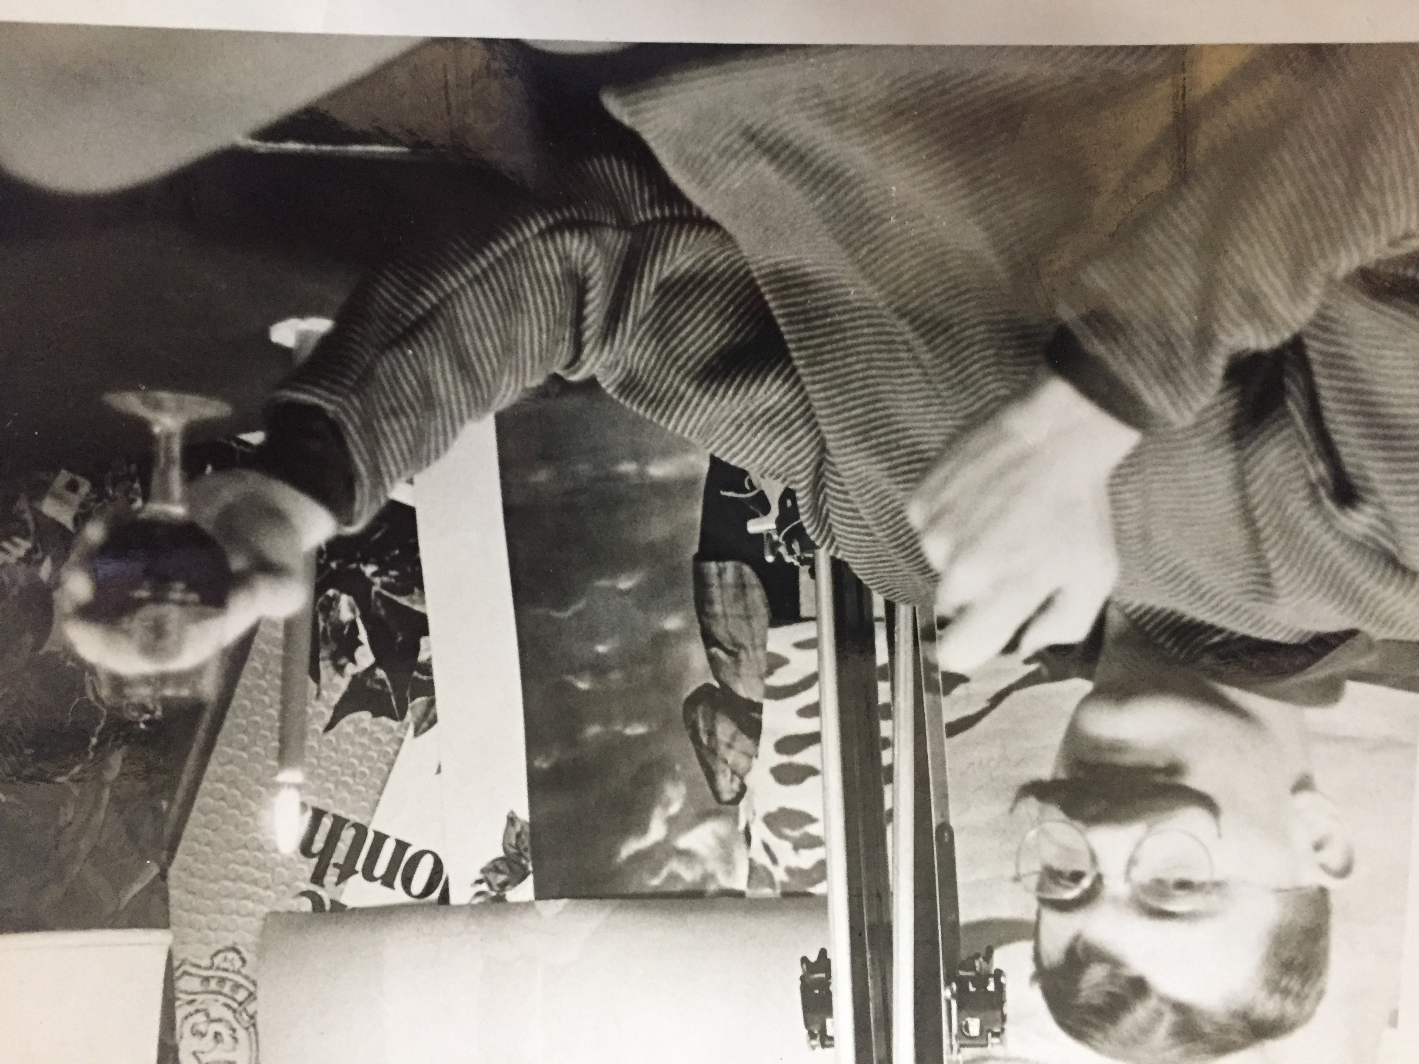

69: Illustrious Class of '69 Golfer

