October 2022
’69 CLASS CORRESPONDENT

CAPT Bob Gravino
P.O. Box 158
Georgetown, ME 04548
(207) 371-2765 (H)
E-mail: rcgravino@aol.com
Website: http://www.uscga69.org

Stu White abandoned his pandemic isolation in North Carolina and is again adding up frequent flyer miles. The following is his synopsis of a European cruise in May. “Cruise from Lisbon, Portugal to London, United Kingdom on Ponant’s Le Bellot (184 passenger capacity and 118 crew). From Lisbon sailed to Leixoes (Oporto), Portugal; La Coruna, Spain; Santander/Bilbao, Spain; Saint-Malo (Mont Saint-Michel), France; Caen, France; and finished in London. Trip was highlighted by my second visit to the Guggenheim Museum in Bilbao (Motion-Autos Art Architecture exhibit of classic cars); St-Laurent Cemetery (largest American cemetery with ceremony conducted by David Eisenhower); and sailing up the Thames River passing under the Tower Bridge and tying up starboard side to HMS Belfast. I could have spent more time in Normandy, but the limited time there was worth it. Had lunch at the Omaha Beach Golf Club but was not able to play the course. The photo of David and Julie showed their appreciation of my I Like Ike hat, which I received as a member of the Eisenhower Foundation.” In early August, Stu took an Alaskan cruise out of Juneau, arriving early to play golf on Mendenhall Golf Course, notching his 50th state to have played in. “While not up to the shape of Pinehurst, it is a golf course.” Returning home to Pinehurst, Stu felt a cold or flu coming on; took a COVID-19 rapid test and tested positive. On his doctor’s advice, he took Paxlovid and experienced only mild symptoms. Fortunately, he was quadruple vaccinated and double boosted.

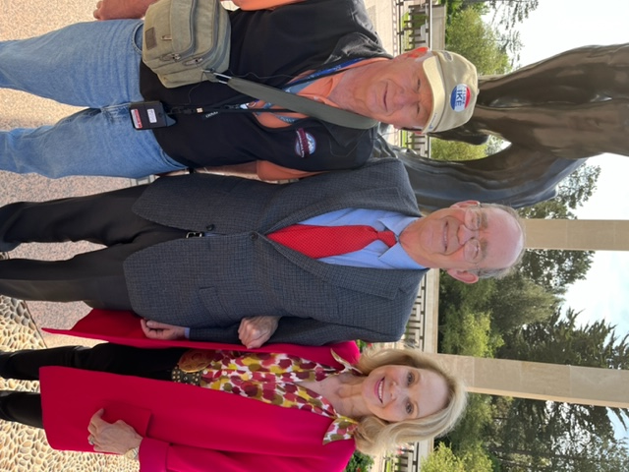

69: Stu White, David Eisenhower & Julie Nixon Eisenhower

Bruce Griffiths was in Seattle for a conference and extended a day to see Jane Snyder and visit the new Nordic Museum in Ballard. “Jane is truly a special human being, and Gail and I value our friendship with her! Unfortunately, I missed John and Anne Curtis who were out of town.”

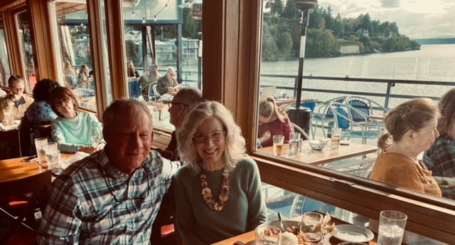

69: Bruce Griffiths & Jane Snyder

Tim Josiah was no longer using his 16’ Alden ocean shell and donated it to the Academy. The attached photo shows Tim and Bill Randall (’82), the Academy’s Director of Rowing, accepting the ocean shell from Tim for transport to New London. Tim commented: “Bill knows many of our classmates including Barry Kane from Barry’s time as an instructor at the Academy. Barry later hired Bill for his first job after retiring from the Coast Guard. Bill knows Bob Pokress and Bob’s grandson Nate who rowed varsity heavyweight as a swab this past year.” Barry added: “Bill was one of my students and I gave him his first job in 2002 as an EE project manager at Signal Corporation while he was waiting for a GS position. Really great guy. Others that I hired included Stu White and Ron Frazier (’71).”

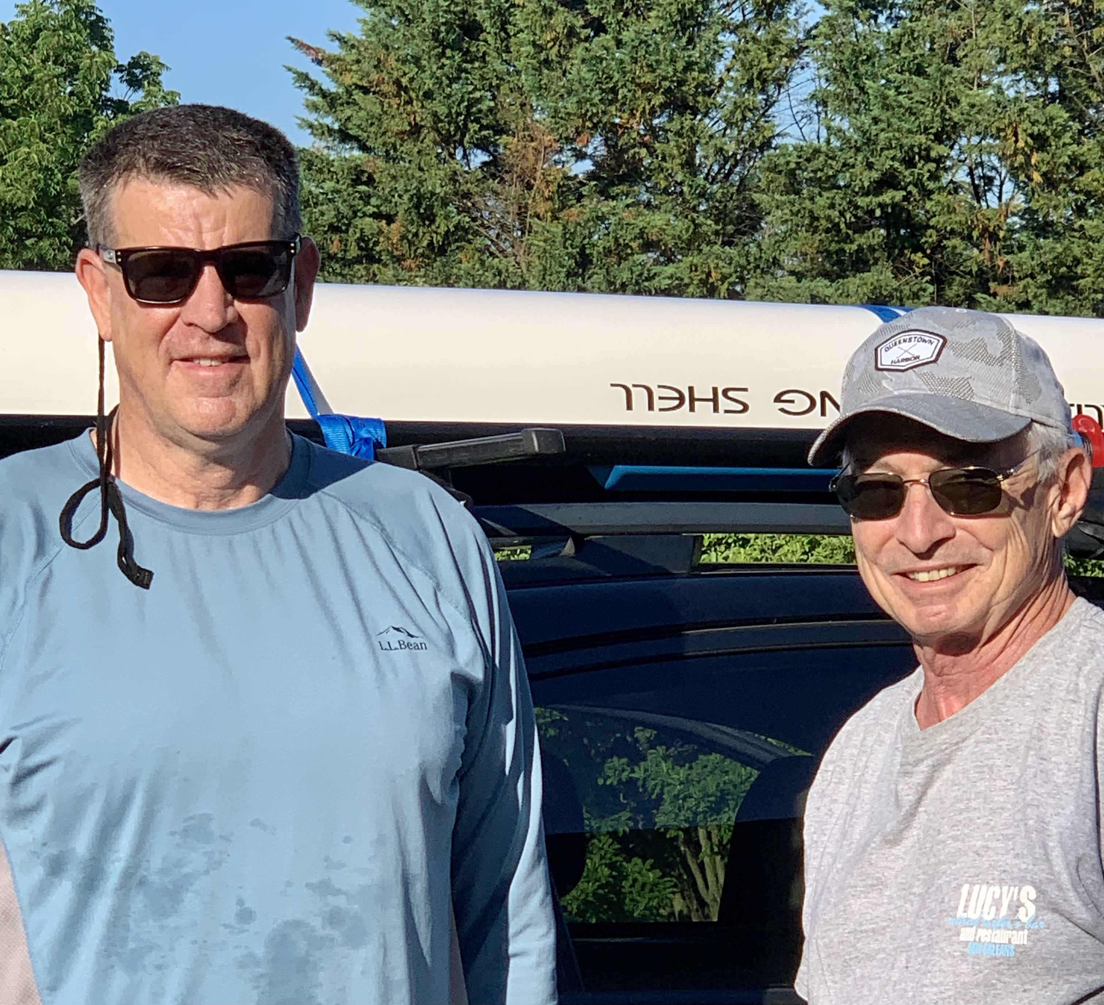

69': Bill Randall & Tim Josiah

John Miner shared a photo and comments about the Coast Guard Day Dinner celebrated in Williamsburg, Virginia. “Eleven of us shared a table at Patriots Colony to celebrate Coast Guard Day. We are surrounded by substantial numbers of other service members and feel it's important to stress our seniority! Pictured are Fred and Linda Adamchak, Lesley and John Miner, Sue and Charlie Huber, Anne and Rex Prosser, Rich and Beth Vlaun and Anita Sullens. Anita is the widow of Richard Sullens who retired from the Coast Guard after 27 years. He was an electrical engineer and worked with Loran Navigation Systems. Rex and Ann Prosser arrived at Patriots Colony about the same time we did and was the Coast Guard’s first Marine Safety Industrial Hygienist. The Prosser’s left Governors Island just as we arrived, where they lived in Ft. Jay, as did Lesley and I.”

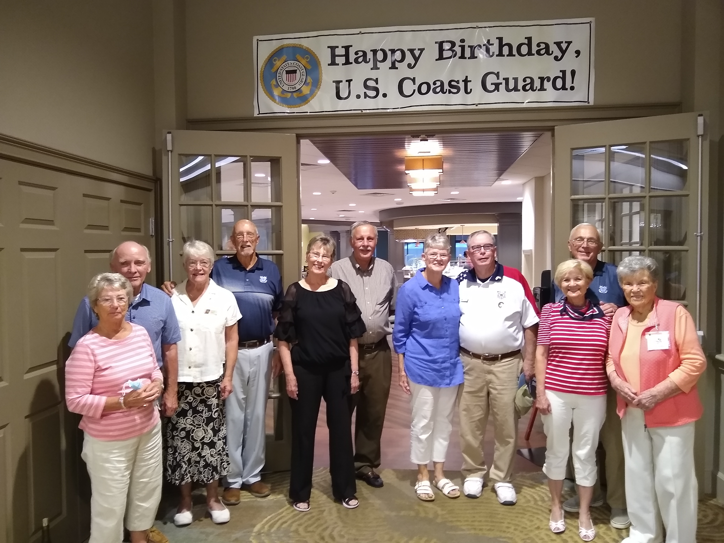

69: Coast Guard Day Dinner Celebration at Patriots Colony in Williamsburg

Mike Black (blackoxford@gmail.com) sent the Class the following sad news: “My daughter Olivia, 37 years old, died of a cerebral hemorrhage on August 27th at the Preston Royal Infirmary. She suffered intensely through most of her life with bravery, wit, and charm. Our grief is immense. Please keep her and us in your prayers.” Mike is a retired senior fellow and librarian from Oxford University in England.
Jerry and Kris Hale spent their summer vacation in Leelanau, Michigan, surrounded by children and grandchildren. “Here is our family photo plus names. The photo was taken at Laurentide Winery in Lake Leelanau, northeast of Traverse City. Son Nat and JoAnne will be married (first time for both) on November 5th in Orange County, Virginia. In the photo, left to right: Nat Hale and fiancé JoAnne; granddaughters Annabelle (6) and Maelyn (4) Hale; Jerry and Kris; Cliff (Laura's boyfriend); granddaughter Vera (11) Wieman and daughter Laura; and Jessica and son Ben Hale (the parents of the two younger girls).”

69: Jerry & Kris Hale and family on vacation in Lake Leelanau, Michigan

I received a new condolence posted on the tribute published after his death to Pete Aalberg, who died shortly after he attended our 50th Reunion in 2019. It is an excellent comment on the positive life and influence that Pete left as his legacy to others. The contribution can be viewed at https://floridamortuary.com/tribute/details/166721/Peter-Aalberg/obituary.html. "Sad to find that Mr. Aalberg has passed. He was my teacher for Photography and Sculpture at Hillsborough High School. To his family, I am sorry for your loss. He was a profound influence on me, and I still have a love for photography to this day. All it took was some encouraging words from him to get me started. As far as sculpture, my time spent in that class was not much of a success. At that point in my teenage life, I was hardly ever in class, even the ones I liked or teachers I liked. I did the bare minimum, and I passed but I always felt I let Mr. Aalberg down. When someone sees something in you and gives you extra encouragement then you just don’t match that encouragement with effort it has to be frustrating. So, to Mr. Aalberg, I am sorry I wasted your efforts in that class, but overall, you helped me appreciate art and that appreciation has always been a part of my life. That appreciation brought me to this memorial page tonight, because even now, 30+ years later, I was thinking of a picture you once showed me of one of your sculptures and had a feeling I would find some pictures online. I know it wasn’t just me that was influenced by you, so here’s to you, old salt, you will be missed."
Stu White documented this summer’s 2022 Paul Garrity Memorial Western Carolina Senior Sensitive Golf Experience with descriptors and photo. “The event returned to Pinehurst this year with a full field of players and was held from August 29th thru September 2nd. In addition to Jim Burk, John Miner, Fred Schmitt, Tim Josiah, and Ron Greto, we were joined by Ron Hindman (a regular for this event) and Mark McDermott ('67). Mark proved his golf ability besides training us those few years ago at CGA. Despite the forecast for rain, it never materialized, and the weather was hot and sunny. Competition was played on two Pinehurst courses, #6 and #3 (one of which will not be used again) and two courses close by. We warmed up on Thistle Dhu, an 18-hole diabolical putting course. We also played the 9-hole par three course - The Cradle. It was a successful event. Golfing participants, left to right: Ron Greto, Fred Schmitt, John Miner, Stu White, Jim Burk, Ron Hindman, Mark McDermott, Tim Josiah.”

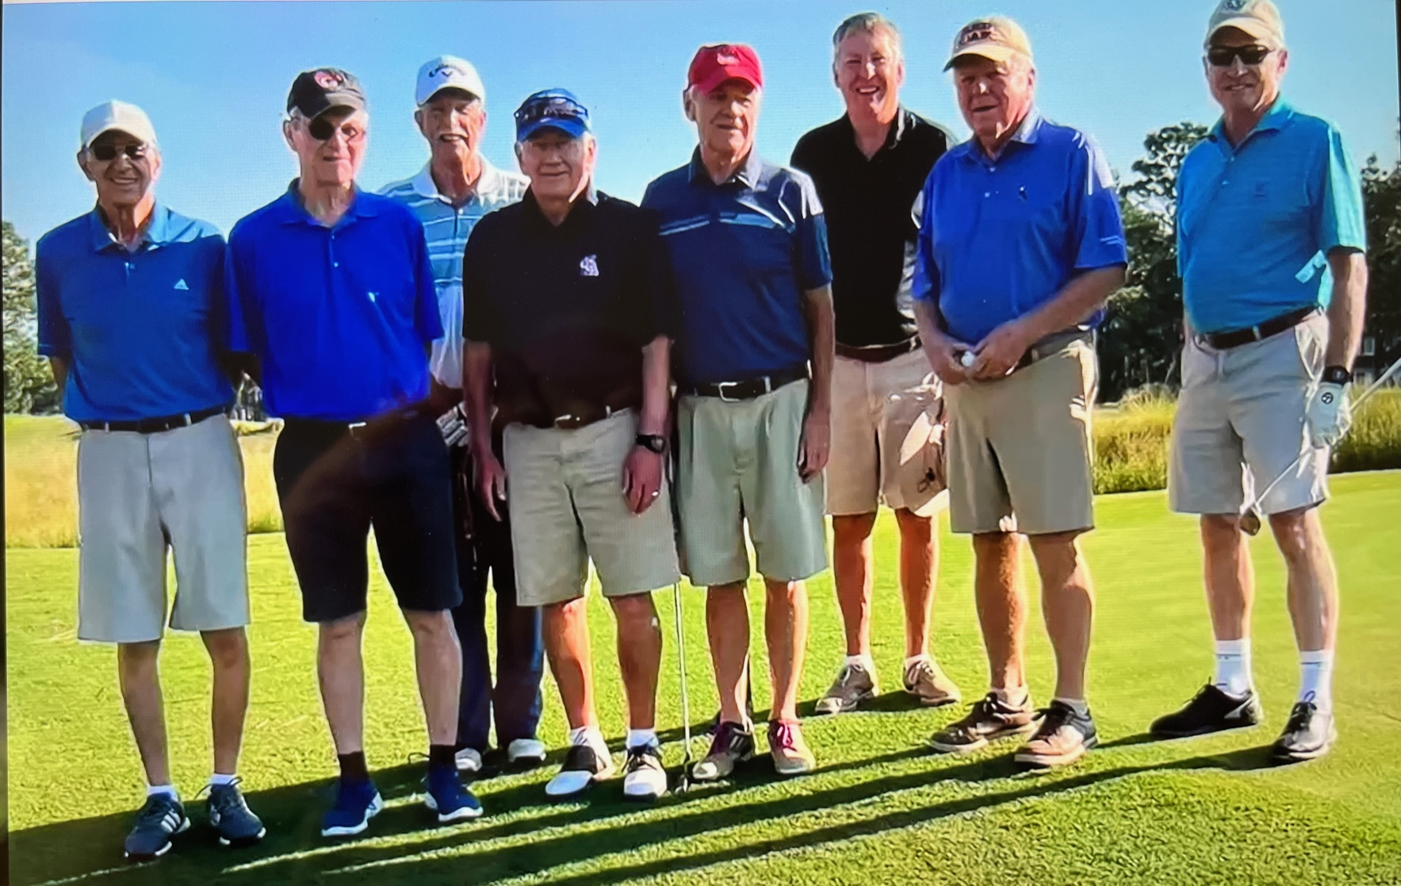

69: The 2022 Paul Garrity Memorial Western Carolina Senior Sensitive Golf Experience

Question of the Column: Name the twelve Summer Ensigns from the Class of 1965 who guided us through our Swab Summer and oversaw the Class of 1967 as they introduced us to the joys of the Coast Guard Academy. If you name all twelve correctly, our former Academy Superintendent Rube Olsen has again offered a week’s stay in the original wing of Chase Hall. For every one ensign that you incorrectly name, an extra day will be added to your one week stay.

